**APP**

User manual

V1.0

**Table of Contents**

First Use 3

Register A New Account 4

New Device Added 5

Login 7

Home 8

Device List 12

Data Analysis 14

System Settings 16

Basic Information Displayed and Modification 17

Appendix

Forgot Password 18

Q&A 21

1. **First use**

To use the App, you need to apply for an account before you can log in.

|  |  |  |
| --- | --- | --- |
| 1. Account field |  | 1. Password field |
| 1. Memorize password and account after login.   (Refer to page 6). |
| 1. Registration   (Refer to page 4). | 1. Forgot password   (See page 16). |

* 1. **Register a new account**

On the login page, click Register to open the registration page.

|  |  |  |
| --- | --- | --- |
| 1. Name field   (required)  Text, numbers or symbols are acceptable, must be at least six characters (inclusive) |  | 1. Password field   (required)  Password must be at least six characters (inclusive) |
| 1. Nickname field   (can be omitted) | 1. Phone field   (can be omitted) |
| 1. Mobile phone field   (can be omitted) | 1. Email field   (required)  When applying for an account, modifying information or forgetting a password, the system will use this email to send a message to the user. |
| 1. Press Save and the completion page will pop up, the register is completed. |

* 1. **New Device Added**

|  |  |
| --- | --- |
| **Step 1**. When you log in the APP, click on the second page (List). |  |
| **Step 2**. Click the ADD icon in the upper right corner of the page |  |
| **Step 3**. Go to the Add Device page |  |
| 1. MAC address of Device   The MAC of the device will be copied here by the engineer during installation (as shown below).   1. The name of the Device   User-defined character count of 255 characters.   1. Remark   User-defined character count of 255 characters and cannot be modified after setting.   1. If you do not add devices, press cancel to leave this page. 2. After the data is set, press Save to return to the device list. |

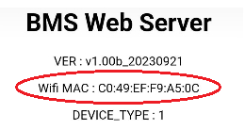

1. **Login page**

After registering a new account, users can enter their account number and password on the login page and click login to enter the APP.

If the user does not check Remember Me box, the system will ask the account and password when you open the APP.

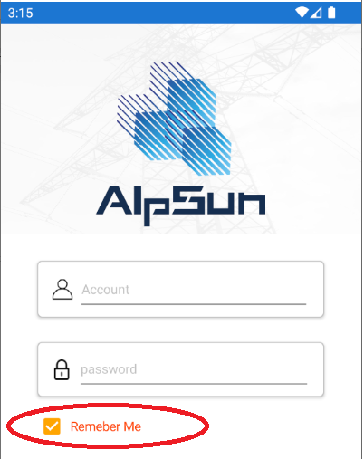

1. **Home (  ).**

After logging in to the system, the home page will show "Please go to list page to add device and selecting one device" (as shown on the left).

If the user has already added a new device, just select the device name in the "change" button to show the real-time device information (as shown on the right).

|  |  |
| --- | --- |
|  |  |

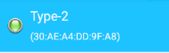

|  |  |
| --- | --- |
| Voltage |  |
| Description：Voltage  (all batteries combined) |
| Current |  |
| Description：Current |
| Power |  |
| Description：Power |
| Temperatures |  |
| Description：Temperatures |
| Safety Status |  |
| Description：BMS Safety Status |
| Relative  State of change |  |
| Description：Battery Capacity |
| Cycle Count |  |
| Description：Battery cycle count  Indicates the number of complete charging and discharging cycles of the battery。 |
| State of Health |  |
| Description：Status of device health  100% is very healthy。  0 is not healthy。 |
| Alert |  |
| Description：Device alert。  The number below it is the number that has not been read by the user.  Click button，The alert list will be opened and the system will clear the unread numbers to 0.  This warning contains all information about the battery of the device selected by the user.  The upper left corner is the device name.  The upper right corner is the date and time of occurrence.  Below is the events of occurred. |
| Change device | CHANGE |
| System setting |  |
| * Green light means the device is online; * Red light means the device is offline   The upper right side is the device name.  the lower side is the device MAC address. |  |

1. **Device list (  ).**

After entering this page, the system will directly display all the devices that the user has set.

Each device will display, device name (user-defined), device remark (user-defined), and device MAC address.

|  |  |
| --- | --- |
|  |  |
| MAC address |
| The name of the device |
| Device remark |

Press and hold the device icon to delete it

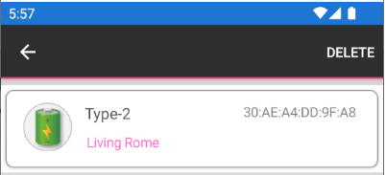

When you click on a device, the hardware information will be displayed.

|  |  |
| --- | --- |
| There are three batteries in this device, and the information represents the battery ID, battery serial number, Manufacturer name, and battery date. |  |

1. **Data analysis (  ).**

After entering the system, today's analysis charts will be directly displayed. The charts are in sequence:

Power, Battery Capacity, and Temperature 1~6 in order.

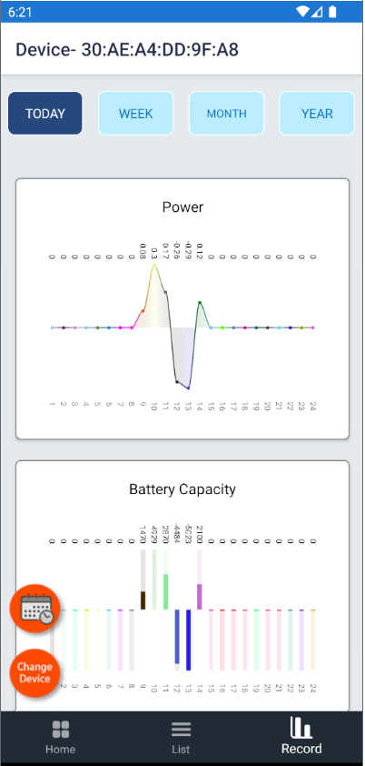

The upper button allows you to choose to display today's, this week's, this month's, and year's analysis charts

The two buttons on the bottom left is means:

Select date：the user can select the date they want to watch the analysis, and the system will display the analysis chart for the current day.

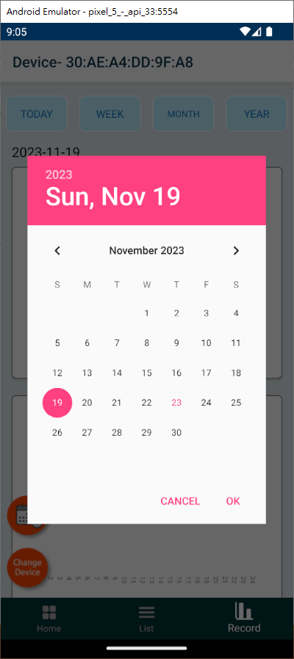

Note: If you click on the same day repeatedly, the date chart will not change.

Change device, if the user wants to switch the device for analysis, click to switch the device.

1. **System settings**

There is a gear icon  at the top right of the  homepage, and when you click it, you will into the system settings page

|  |  |
| --- | --- |
|  | Click this icon to display the basic information of the user. |
| Click this icon, you will log out of the system and go to the login page. |
| After clicking on >, the company's information will be display. |
| After clicking >, you can leave message to contact us. |
| Click > to get answers to general questions. If you have any other questions, please use "Contact Us" to leave a message. |
| After clicking >, you can open the user’s manual for this APP. |

1. **Basic information is displayed and modified**

Except for the membership number, other information can be modified, but the user name, password, and email are required fields and cannot be blank.

When the modification is completed, press Save to complete the modification.

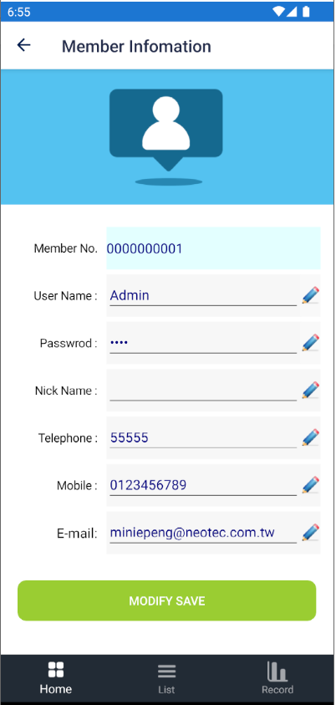

**Appendix**

1. **Forgot password**

If you forget your password, you can click "Forgot Password" at the bottom right corner of the login page

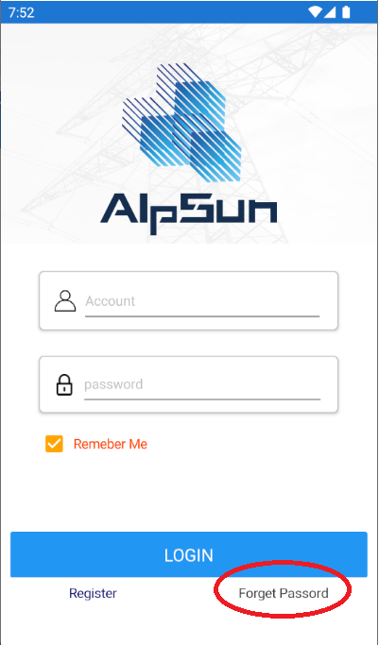

The system will open the following page, please enter the email address provided when you registered, click send and the system will send a password change mail to this mailbox.

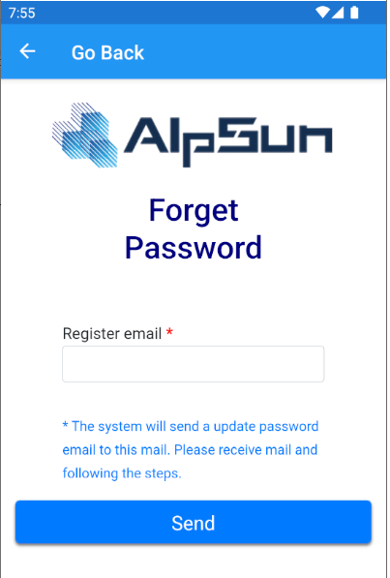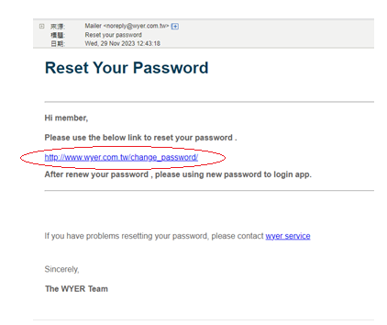

When user click the link of the mail, the following page will be displayed, please enter the new password, confirm the password again, and press Save, and the user can log in to the system with the new password.

When the user completes changing their password, the system will send a notification mail to user to inform them that the password has changed.

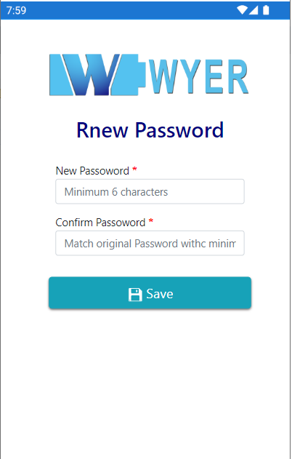 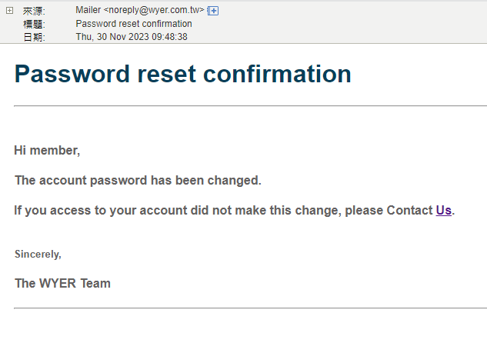

1. **Q&A問答**
2. The machine light does not come on.

Please press the button again for 5 seconds, then restart the machine to see if the light is not on or is off.

If the light still does not come on after 5 seconds, please contact the factory service personnel.

1. The machine flashes a red light.

A flashing red light indicates that the system has detected an abnormality and taken appropriate protective measures, and the red light will not flash when the protected phenomenon disappears.

If you have any questions, please contact the original customer service staff.

1. All five lights on the machine are not on.

See Question 1

1. There is no information on the APP homepage.

Please add a new device on the second page of the screen and tap the device you want to display.

1. How to close.

Please press and hold the button for 5 seconds and you will see 5 LEDs turn off in turn, and then the power will turn off.