* Households by Type (Family, Non-Family, Marriage Status, Children, Gender)

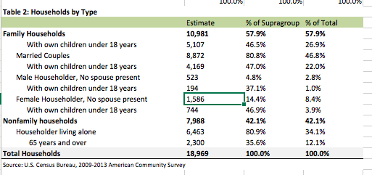

What a pain.

* Vacancy Rate
* Home Sales by Type
* Median Home Prices
* Change in Householder Age
* Income Limits
* Fair Market Rents
* Cost Burden by Household Type (Cost Burden and Severe Cost Burden, Count & Percent)
* Cost Burden by Household Type , Low-Income Households
* Housing Problems for Households at 80-120% of AMI
* Cost Burden Households by Income (Extremel, Very, Low, Middle, All)
* Cost Burden by Household Type, Low-, Very-Low, and Extremely-Low-Income Households

Done:

* Average Household Sizes by Tenure
* Unemployment by Educational Attainment
* Housing Tenure by Age of Householder
  + Uses extensively the Census API. Warning!

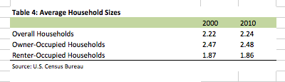

Data not in browser. Using census.

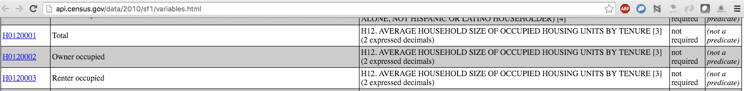



We need to develop a census 2000 to census 2010 column name crosswalk