S4 Handbook of Methods

3HAB 0001-59
Version 2

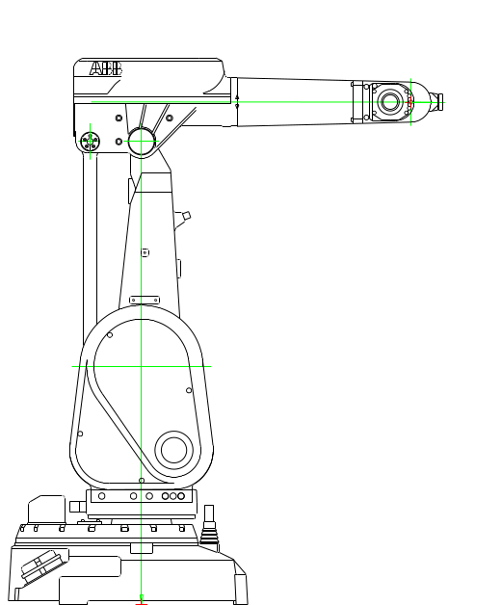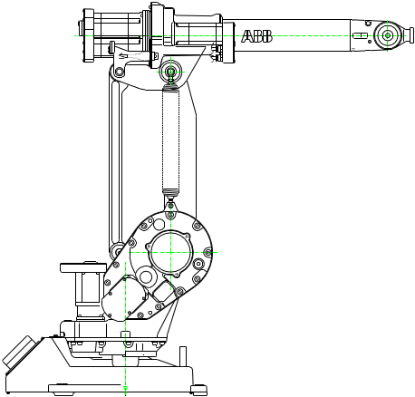

Program development procedure
Design guidelines

CONTENTS

Part A - Robot program development procedure

Part B - Program design guidelines

Version 2

About S4 Handbook of Methods
This handbook is the result of a committee work by the S4 Expert Team, composed of participants from the ABB Flexible Automation Business area. It has been edited by Gunnar Edling, ABB Flexible Automation AB.

The information in this document is subject to changes without notice and should not be construed as a commitment by ABB Flexible Automation ABB. ABB Flexible Automation AB assumes no responsibility for any errors that appear in this document.

Copies of this Handbook can be ordered from ABB Flexible Automation AB dept. B. It also available in the S4 ShareWare Lotus Notes database.

Article number 3HAB 0001-59  Issue: Version 2  February 1997 | ABB Flexible Automation AB  Dept. B  S-721 75 Västerås, Sweden

Part A - Robot program development procedure

Contents

1 Introduction
1.1 Project model
1.2 Quality assurance
1.3 Responsibilities

2 Program development activities
2.1 Summary
2.2 Function analysis
2.3 System design
2.4 Program design
2.4.1 Introduction
2.4.2 Main steps
2.4.3 JSP - Diagram
2.4.4 Pseudo Code
2.5 Programming
2.6 Internal testing
2.7 Customer acceptance
2.8 Close down

3 Documentation
3.1 General
3.2 Filing
3.3 Document forms
- System description
- System design specification
- Program specification
- Test & Review record

Enclosure: A-1.1 Glossary of terms

1 Introduction

1.1 General
ABB Flexible Automation Business area has decided that Quality systems shall conform to the ISO 9001 standard. A quality system is the base to secure:
- Functionality
- Performance
- Quality
- Customer satisfaction
- Project profitability
The base is ISO 9001, which in these issues emphasis:
- Identification of requirements (design input)
- Documentation of design output
- Review of design
- Testing

The objectives of this handbook are to give input to:
- instructions and procedures to be implemented in the local
Quality/Procedure manuals
Chapter 1 and 2
- forms to be used in the project work when documenting the robot
programs and the development procedure.
Section 3.3

To explain some common used expressions there is an enclosure A-1.1 Glossary of terms at the end of Part A.

1.1 Project model
In order to successfully accomplish system order ABB Robotics has developed a Project Management model.
The project model divides a system project into 6 phases. A milestone is an important check point, e.g. when all activities in a phase are finished.

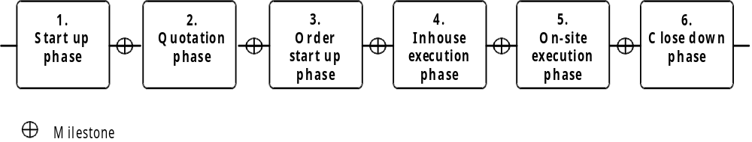

Basic Project model

The project work is performed in activities. An activity shall have a person responsible for it, a description of the work to be done and defined results. The figure below shows the activities, which are actual in the robot program development. The actives covered in this manual have bold headlines.

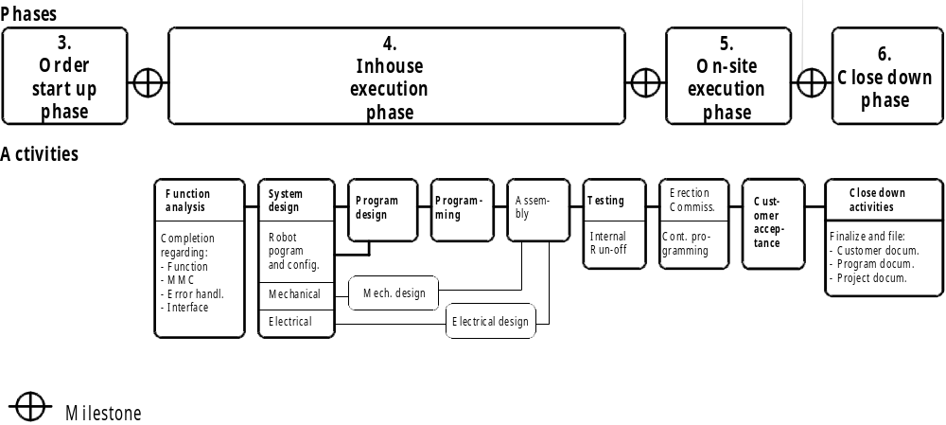

Robot Program development procedure

1.2 Quality assurance
The proposed procedure in this handbook implies a number of steps always to be taken in order to fulfil the demands in ISO 9001.
Scope of work
The principal procedure shall always be followed. The amount of work and the output in terms of documentation shall however be adapted to the complexity and type of task.
Reviews
If there is a decision to produce a document, it shall also be reviewed.
Reviews are essential to secure the quality. A review can be made in a meeting or just by another person who checks the output, normally a document or drawing and fills in a review record covering:
- checked items
- eventual required actions
- date and signature
At internal tests and reviews it is recommended to use the "Test&Review" form enclosed in section 3.3.
The reviewer returns the document and the filled in form. If there are any actions/comments these shall be closed. When the action is made, it is closed with date and signature by the responsible person. But there is generally no need of a new review.

Note: In all cases design reviews and tests must be made and documented and records filed.

Corrective actions
Sometimes is not enough only to correct the solution and documentation of the present project. Procedures and standard documentation might be changed in order avoid to repeat the error. There shall be routines to collect necessary information. analyse causes, decide actions and follow up the results.
Project meetings, project reports and close down reports are important sources of information.

1.3 Responsibilities
The project manager has the overall responsibility in order to fulfil requirements, time schedule, profitability etc.
He has to engage the necessary resources for project work, reviews etc. Depending on the complexity and size of work he shall determine the required amount of work and documentation in order fulfil the demands of the quality system, the customer etc.
The accomplishment of all the defined activities and reviews of documents to be produced are also the responsibility of the project manager.
The responsibility, to verify that the procedures, guidelines etc. are followed in the project work, rests upon the Project (Operations) manager, Review personnel and when existing the Steering committee.
Responsibility for each activity rests upon the project leader or a by him assigned person.
The responsibility of corrective actions and to achieve continuos improvements rests normally upon the line organisation, operations manger, sales manager etc.
The responsibility of the Quality controller or an another assigned function, to establish and verify the utilisation of procedures and design guidelines within the local company, shall be determined.
These responsibilities shall be stated in the local Quality/Procedures manual.

2 Program development activities

2.1 Summary
The figure below summarises the activities defined in the Robot program development procedure and the recommended documents to be produced.
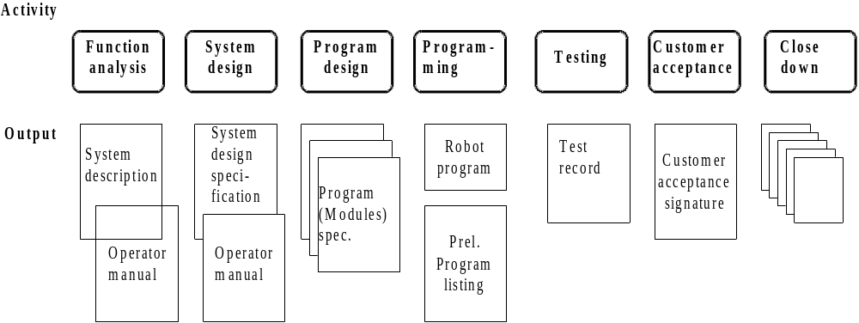

Note: According to ISO 9001 documentation of; Design output, Design reviews and Test results, is mandatory

2.2 Function analysis
The objectives of the functions analysis are to specify the system with a customer oriented approach. During this work attention must also be given to functions and performance which are depending on the robot program and the robot controller.
The requirements origin from the customer specification and our quotation. Often it is necessary to pay attention to our intended solution in terms of functionality and performance.
The System description shall be function not solution oriented. An excellent way for example, is to define the man-machine communication by writing the Operator manual. A form to be used when documenting the result is enclosed in section 3.3.
At internal review of the System description, use the "Test&Review" form enclosed in section 3.3.
A customer review of the System description is recommended.

2.3 System design
System design is to identify and structure a solution on a modular level addressing both hardware and software. It shall also identify which standard solutions can be used and which solutions must be developed within the project. This is specially important when developing large and/or complex robot programs.

The work is based on the System description and previous experiences from identical or similar systems made earlier at your company or other companies in the Business Area.
The output the, System design specification, is often a working document, which means that it normally is not updated due to later design changes. A form to be used when documenting the result is enclosed in section 3.3.
At internal review of the System design specification use the "Test&Review" form enclosed in section 3.3.

2.4 Program design
2.4.1 Introduction
Based on the System design specification, a Program design - the Program specification - should be worked out. This activity is to determine the overall design of the robot program before the programming work starts. Major changes at a later stage will hurt the time schedule and the project profitability badly.
By using a Structured programming approach it will result in a logical, readable and robust program.
The proposed method, the JSP (Jackson Structured Programming) diagrams is named from a programming guru, Michael Jackson. It is basically a way of designing a program, using a specific notation, which will guarantee a well structured program.
The output, Program specification, is normally a working document, which later is complemented/replaced by the Program listing. A form to be used when documenting the result is enclosed in section 3.3.
At internal review of the Program specification use the "Test&Review" form enclosed in section 3.3.

2.4.2 Main steps

1. Identify major operations to be performed by the robot and give a short description of each.

2. Create a structured program structure using the JSP method 2 to 3 levels deep, Super block and sub-blocks.The metod is described below.

3. Identify additional tasks to be made by the robot. For example Operator dialogue, Maintenance, Cell/fixture control, Communication ......
It is also important to describe, for each set of operation or process, what problems or errors might arise during the execution, and what should be done to recover from such errors.
Can or should this tasks be made in the program sequence, in parallell (Multitasking), by interrupt or in error handling?

4. For each block, which could be a module or one or several routines, the following three questions should be answered:
I. Input. What is required for this part or routine to produce the result?
II. Process. What operations are needed to produce the result?
III. Output. What result should be produced from this part or from this routine?

5. Repeat these steps until a sufficient detailed strucutre is achieved, Stepwise refinement.
When going deeper down in sub-blocks the ”Pseudo code” method might be more compact and faster than the JSP method. It gives however not automatically a structured program. It is described below
6. Create a program hierarchy.
The program might be divided into a number of modules. It is recommended to have separate modules for different objects, which are to be processed by the robot.
This is also recommended if some parts are to be reused in other programs, or if already existing modules may be used or if the program will include a great number of data (>200 data of the same type).
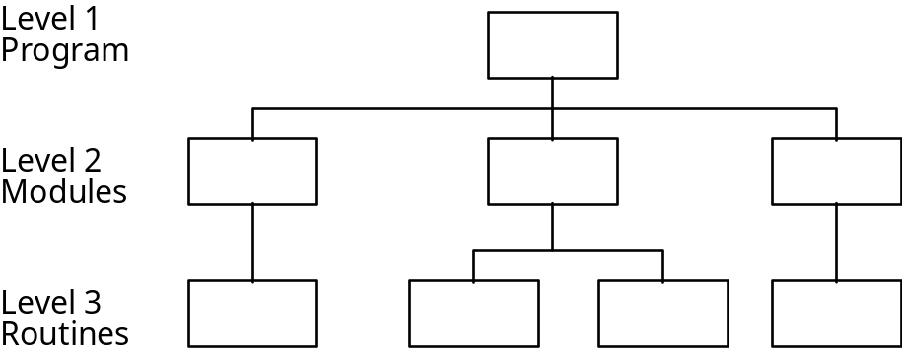

2.4.3 JSP - Diagram
A JSP (Jackson Structured Programming) diagram is basically a way of designing a program, using a specific notation, which will guarantee a well structured program. A well structured program is easy to read and easy to follow.
The program flow should only use the standardized elements, sequence, selection and iteration and, of course, routine calls.
- Sequence is an unbroken number of instructions. Such a sequence may also be called a block.
- Selection is a check point, where a condition is checked. Depending on the result, the program flow will continue in different branches. A very important characteristic of a selection is that all branches will continue from the same spot. A selection with all its branches will also form a block.
- In Rapid, selections may be progammed using the statements
- IF..., Compact IF... and TEST.
- Iteration also is a check point, where a condition is tested. If the condition is true, a sequence is repeted, until the condition turns false.
- In Rapid, iterations may be programmed using the statements
- FOR... and WHILE.

JSP-Notation:

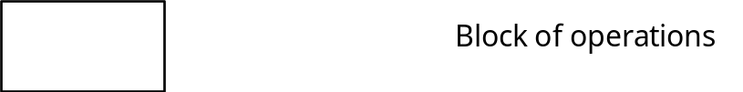

This symbol is generally used to show a number of operations, a subprogram or a routine call.

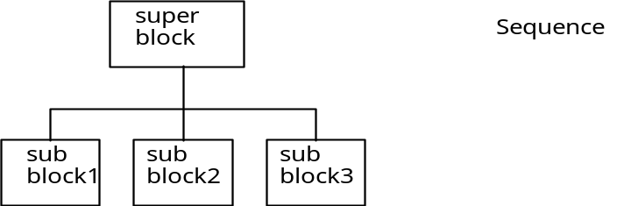

In the figure above the "super block" is broken down into three "sub blocks" executed in the indicated order.
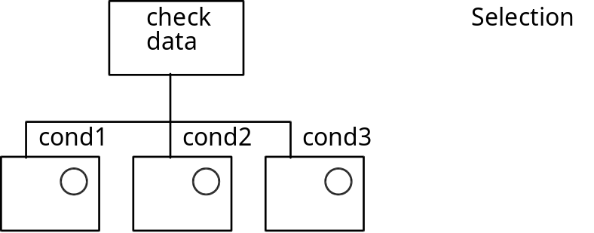

In the figure above, the selection block comprices three different branches, indicated by a block with a circle. Only one branch is executed and only if the condition is true. When the branch is ready or if no condition is true, execution will continue with the block after the check data block.

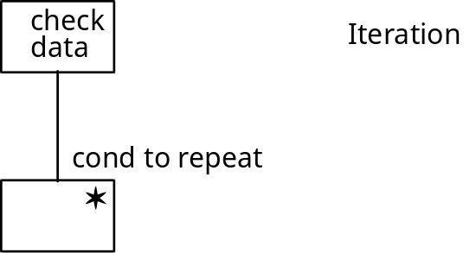

In the figure above, the iteration block comprices a sub block, which is repeated as long as the condition is true.

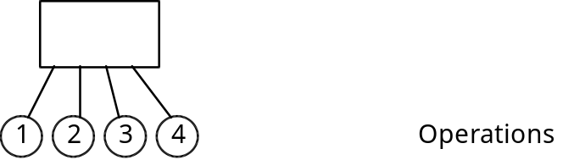
This symbol is used to show "leaf" operations, which are not to be broken down further. The different operations may be described in an operation list like:
1. operation 1
2. operation 2
3. operation 3
etc.

2.4.4 Pseudo Code
When programming complex tasks it is often efficient to create a pseudo-code before the actual code writing starts.
It is a very good complement to the JSP diagram when going deeper down in the program as it is quicker to do.
This will give the structure and also identify the needs of local variables, labels etc. It shall have a high level approach (in free English) but follow the basic RAPID structure and rules. An examples is given below.
" Write ""welcome "" on teach pendant display for 5 s";
choice:
"Show actual queue and operator choices via sdisplay";
" Perform operator order (call Corresponding subroutine)
- Start (production) and run until queue is empty
- next(skip current batch in queue)
- edit(queue)";
Goto choice;
Normally the pseudo-code is only used initially and is not filed.

2.5 Programming
The code writing shall be made according to Robot program design guidelines in Part B. The work is recommended to be made in two steps. Step 1is mainly made "off-line" and step 2 mainly on shop floor/site with help of the teach pendant. In simple cases however is often feasible to do the "code writing" together with the positioning programming at the shop floor/site

Step 1 Code writing
- System configuration
- Modules and routines declarations
- Data declarations
- Program flow and logic routines
Step 2 Position programming
- Physical calibration (TCP's, Co-ordinate systems)
- Positioning instructions
- Robtargets
- Fine tuning
The program code is documented with the Program listing.
At internal review of the Program code use the "Test&Review" form enclosed in section 3.3.

2.6 Internal testing
Check of own work
Each programmer is expected to test his/her made program parts.
Code test
In case of complicated programs a Code test is recommended.
- Each possible user input or data input must be checked
- Each code sequence must be executed at least once
- Each explicit customer requirement must be checked
- Before starting the testing, a formal test plan should be written, describing in detail the different test cases. The test cases must be designed, so that all aspects as described above are fully covered from the tests.

Robot program tests
A formal test of the robot program is only made if this is decided. Normally the program is tested as a part of the Internal run-off.

Debugging
If errors or malfunctions are detected when testing, the code has to be debugged. Since errors most often include wrong or inaccurate movements, debugging must be performed in a real robot. Debugging is still based on experience, know-how and intuition. Some hints are given below:
- Directly after an error has occurred, stop the robot and make a dump of the whole of the program memory, including all system modules (Save program and Save modules). This is a base for analyzing the current values of variables etc.
- Program breakpoints (BREAK instruction) in critical sequences. This will force the robot to stop immediately. Then variables and other data may be checked or changed before the robot is restarted.
- Add extra instructions (TPWrite instructions) to display information and variable data when the robot is running.
Internal Run-off
The objectives of the internal run-off test is to make a comprehensive test to validate that the system fulfils the requirements.
There shall be a test plan enclosed to the record stated what has been tested. It shall include both normal and error situations. Input to the test plan are standardised checklists, System description, Operator manual etc.
Responsible for testing shall be a person not directly involved in the project.
To document the test results use the "Test&Review" form enclosed in section 3.3.

2.7 Customer Acceptance
The customer acceptance (Factory Acceptance Test and Site Acceptance Test) is made according the companies standardised procedure or according to the contract if it covers this issue. The scope is normally reduced compared to the Internal run-off.
To document the customer acceptance and have his signature, there is normally a standardised form in each company.

2.8 Close down
This section focus on the program development issues in the Close down phase. The main work is to check and if necessary finalise:
* that specified documentation is complete and updated
* file documentation and records
The Documentation of a robot program is of extreme importance to:
* Our customer
* The service organisation
* Ourselves in future work
in order to
* Run the system
* Service problem solving of the system
* Develop the system (Add new parts, adapt to changes etc.)

To meet these requirements the documentation is recommended to comprise the document types listed below. Most of these documents are produced during the program development work and the final work is mainly to structure them.
Examples of documents to be included in the documentation are:
* Customer documentation  - Program structure  - I/O lists  - Data (Registers)  - Program listing  - Operator manual  -  - | * Project documentation (internal)  - System description  - Test records  - Review records  -  -
* Design documentation (internal)
- Program structure
- I/O lists
- Data (Registers)
- Program listing (With headers and comments)
- Routine description (ShareWare)
-
-

To secure that the documentation is complete, checklists are recommended.

3 Documentation

3.1 General
The results of the steps in the robot program development work are documents. The visible final result is also a document; the program listing. The writing and control of documents are consequently very essential.
The following sections cover:
Filing of documents
To secure that the user have access to the program and associated documentation in force.
Note ISO 9001 regulates also the control of Quality documents, which includes several of the document types covered in this handbook
Document forms
To be used in the program development work

3.2 Filing of program documentation
To secure that all have access to the valid version of the program documentation it is important to file it in a defined way.
The following principles are recommended:

1 Program documentation shall be filed as non-visible comments in the program code according to alternative II in figure below.

2 Other documentation is made in Microsoft Word (or other well-known word processing program).

3 All documentation regarding a system is filed in one directory with a name identifying the robot system . If there are several robots in a system there should be sub-directories for each individual robot. This directory can be filed in the robot memory. See alternative III in figure below.
By entering information to the System parameters in the S4 controller, the Robot file manager also can handle additional file types like doc. This makes is possible to file the complete documentation in the robot ram disc. The service engineer or whoever needs it can than copy the file to his notebook and always get the valid information.

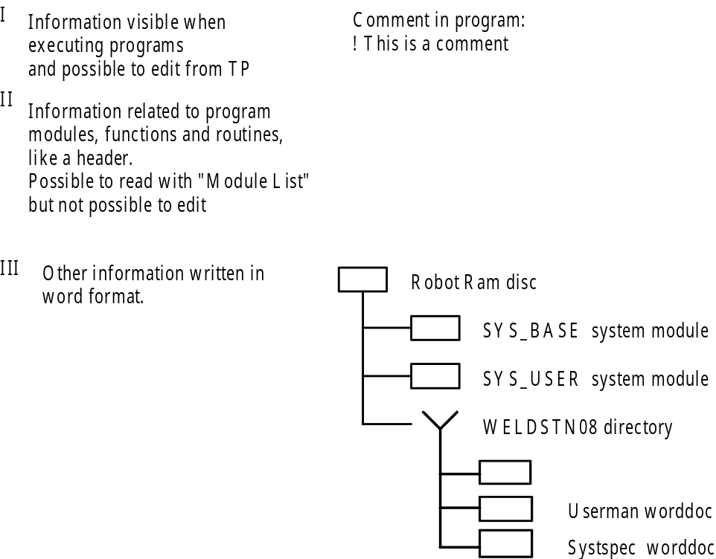

Alternatives to file information/documents

3.3 Document forms
The following forms are enclosed:
* System description - Robot controller addition
* System design specification - Robot controller addition
* Program specification
* Test & Review
The proposed information and data to be included is indicated within brackets
[Recommended information and data]
This is to be deleted by author when completing the form to obtain the final template document.

Hardware/Layout
[A principal layout and main hardware of the system if not already included]

The main task(s)
[List the main tasks the robot shall perform and when (condition) to perform each task.]

Operator interaction
[- Hardware
- Information to be exchanged]

How to handle errors
[- Which errors should be handled?
- What shall the operator do?
- What shall the robot system do?]

Which interfaces to other equipment
[- A list over other equipment to be interfaced with the robot.
- Type of information to exchanged
- I/O hardware if specified
- Protocols if specified]
System configuration
[Hardware configuration(Robot specification form)
Software configuration
- ApplicationWare
- Company standard modules(declarations, program structures etc) to be used
- Company standard instruction set to be used
- Communication software
- Customer standards
Co-ordinate systems
Tools/TCP]

Solution
[- Which tasks are to be performed by the robot, other equipment like PLC etc.
- Rough program philosophy.]

Existing software
[Which software already existing can be used.
- Internal and external Shareware
- Re-use of software solutions from similar solutions]

Communication contents and channels
[- I/O's
- Thumb wheels
- Push buttons/Lamps
- Teach pendant
- Soft panel
- Cell computer/PLC}

Program structure
[The purpose is to show the different routines and when/why they call another routine or is called.
It can be made in several layers or made for different cases depending what is needed in order to understand the program.]
Intended routines (procedures/functions)
[Identify all tasks to be made by the robot system based on requirements
and intended solution]

Routine documentation (Important Tasks/Routines including Main routine)
[* Task
* Data declarations (incl. names)
* Position names
* Headers and comments to be included in the program]

[List of Intended routines and Routine documentation are working documents, which later are replaced by the Program listing.]

Procedure description
[according to the S4 User's guide]

XXXX Title

[ Description]

Example

Arguments

Program execution

Syntax

Error handling

( ) | Review of document:
( ) | Review of code:
( ) | Test according to spec. :

PARTICIPANTS:
Name(s) | Signature

DECISION: ( ) OK ( ) OK after action ( ) New review/test

TOPIC | ACTION/COMMENTS | CLOSED  DATE/SIGN

Glossary of terms

Application | The manufacturing operation for which the S4 robot system is to be used, such as spot welding, machine tending, painting etc.
Application  Software | A user interface (and functions) developed for a specific application such as spot welding, arc welding, gluing, etc. In the S4, this is called ProcessWare -- ArcWare, SpotWare.
ARLA | Language used to program S2 and S3. (RAPIDis the language used in S4)
ARLA Program | A user defined robot program created in the ARLA language. (In the S4 this is a RAPID program)
Control program | The inherent set of control instructions which define the capabilities, actions and responses of a robot system. This type of program is fixed and is not modified by the user. Programs developed in ARLA and RAPID are not control programs.
Basic System | The basic system is an S4 robot system without options, accessories or application software.
Function | A routine that returns a value
Instruction | A program statement which constitutes an independent executing unit in RAPID.
Instruction  Development | The creation of RAPID instructions such as the development of a new move instruction. These new instructions can be defined either in RAPID or Real.
MMC | MMC or Man-Machine-Communications defines the method and interfacing with the robot controller -- how information is presented and programs are defined.
Operator | Competent person designated to start, monitor and stop the intended productive operation of a robot system.
Procedure | A sub-routine for specific part or task
Program | There are different types of programs:  (1) a user defined task program made in RAPID  (2) a robot control program made in C++ and/or Real
Program (RAPID) (xxxx.prg) | All existing program modules, which are handled as one unit when loading and saving the robot program. Programs do not, however, contain systen modules.
Program module  (yyyy.mod) | A set of routines, functions and data which define the task of the robot. Normally there is only one program module with the same name as the program. (Program modules can be loaded and saved separately)
Programmer | Programmers can also be classified at different levels: (1) a person who is qualified to write programs in RAPID, (2) a person or organisation that is allowed and qualified to write programs in Real.
RAPID | The user programming language for the S4 robot system.
Real | Robot elementary application language used by SEROP to develop RAPID instructions. Real consists of C and systems services which can be called from C. (Restricted availability)
Re-usable Modules | Routines consisting of task programs or user defined instruction program that are available within RAC/CoE for software development.
Routine | A sub-program written in the RAPID language, executed on the S4 robot system. There are three types of routines; Procedures, Functions and Trap routines.
Standard  Instructions | The RAPID instructions included in the basic S4 robot system
Standard  Language | Rapid, as it appears in a standard delivery of the S4 robot system.
Task Program | A set of motion and auxiliary functions which define the specific intended task of the robot system. This type of program is generated by the user in the RAPID language.
Trap routine | The routine that defines what is to be done when a specific interrupt occurs
User Developed  Instructions | Instructions not delivered by SEROP in the basic system. These include instructions developed in the RAPID language.
User Interface | The principle to exchange information between the user and the S4 system

Part B - Program design guidelines

Contents

1 Introduction
1.1 General
1.2 Summary

2 Main steps

3 Program components
3.1 Main Procedure
3.2 Modules
3.3 Routines
3.4 Data and parameters
3.5 Control structures
3.6 Comments

4 Naming
4.1 Modules
4.2 Routines (Procedures and functions)
4.3 Instructions
4.4 Data

5 Co-ordinate systems

6 User defined instructions

Enclosure: B-2.1 Naming data, I/O and labels

1 Introduction

1.1 General
The objectives of these guidelines are to promote:
- programs easy to understand and document
- efficient service and maintenance of robot systems
- future changs/development of the program by the customer
- efficient programming
For further hints, examples and information see the Lotus Notes database
”S4 ShareWare” category ShareWareForum/Documents.

1.2 Summary

* The programming should be based on a Program specification. It is highly recommended thet the JSP method has been used.

* Check if needed routines and modules, needed for the desired program structure, are included in the basic set-up. Otherwise declare additional.

* Check if needed data( TCPs, registers, counters, robot positions etc.) are included in the basic set-up. Otherwise declare additional data. At teach pendant programming this can be done when programming an instruction, which is using the data the first time.

* Think of information hiding. Use a hierarchical structure on level of details presented. No details on high level
* Structure the main routine corresponding to the main flow. The main routine should in principle just include calls to routines. Do the same with large sub-routines.

* Use Robtargets and give names to important positions
- Easy to understand where the position is located
- Makes hot editing possible
- Positions can be re-used (also with offsets)

* Limit routine length to 20 to 30 instructions.

2. Main steps
It is expected that the design and JSP-diagrams, as described in previous sections, has been fully worked through.

While it is highly recommended to work from top to bottom in the earlier design phases, it is more practical to work from bottom and up in the real coding and testing. A recommended scheme is outlined in the following:

- Declare the different modules if more than the main module is required.
- Declare, in each module, the required routines..
- Declare in each module, the required module data. Data in the main module should be global (default), while it is recommended to declare data as local in other modules, if they are only used inside that module.
Create a Module header
- Create the body of each routine. In some cases, local data might be created, e.g. for holding intermediate results in calculations etc.
- Test each routine, before going on with the next one. Then, when working with upper levels of routines, you are sure the lower levels are operating as required.

When all routines on lower levels are working correct, they are all connected on the uppermost level, i.e. in the main routine.

3. Program components

3.1 Main Procedure
Keep the main procedure in the main module rather short. This procedure should only include calls to other procedures. There also might be program elements like selections and iterations. All activities, such as movements, data handling, IO control etc., should be placed in procedures on lower levels.

3.2 Modules
Now the division into different modules should be decided. There are three general rules:
1. All programs include at least one module. holding the required ”main” procedure. This module is automatically created when opening a new program and receives the same name as the program.
2. Routines, which are of general character and which might be useful also in other programs, should be stored in a separate module. This will make it easy to store the routines separately and to load them into an other program. Remember to to have the data, used in the routine stored in the same module.
3. If a program will include a great number of data, e.g. robtarget constants, then it is reasonable to divide the program into a number of modules.
Then the maximum number of data of the same datatype, should be limited to approximately 200 per module. This limitation is however solved with release 2.0 revision 3.
4. Separate program modules are recommended for standard solutions like ShareWare (internal and external) and ProcessWare.
Standardised procedures and instructions are recommended to be located in separate system modules.

The system modules should be used for data and routines, which should be system resident and unchanged, when loading or creating new programs.

3.3 Routines
When the module design is outlined, the work with lower levels of routines should go on. Routines can be divided into procedures and functions.
- Procedures are the normal instrument for subprograms, used to get the program structure on different levels.
- Functions are used mainly for smaller calculations performed as a part of an expression in an assignment statement, i.e. as the right part of a "variable:=function()" statement.
It is quite possible to include all instructions into functions, also robot movements, which might be used, for instance, in a search function returning a robtarget for the search position. However, this kind of programming, with much code for functions, is not recommended.

Routines in the main module are normally global (default). In other modules, e.g. system modules, only routines, which are to be used from other modules, should be declared global. Others, which are to be used only within the module, should be declared as local
Should be limited to 60 - 80 lines of code, recommended is 20-30 lines. Large routines should be further broken down into smaller ones.

3.4 Data and parameters
General
Data and routines which are related to the customised solution shall be defined in the program module with the main routine.

Data and routines which are related to the physical installation shall be defined in the User system module.

Data.
By default, all data created in the system, are stored as global module data.
It is recommended to list, for each routine, the used global data separated in input data (only read) and inoutput data (both read and changed).

Data declared outside the routines, are module global within the module, i.e. they are accessible from each routine in the module. A module data may be declared as local, which means that it is not accessible from other modules.
All data in the main module should be global (default), while it is recommended to declare data as local in other modules, if they are only used inside that module.
In some cases, it is recommended to use local data in a routine. This is for occasional data, e.g. intermediate results in a calculation etc, where data must not be stored.

Parameters
Normally only functions are declared with parameters, while procedures often work with global data, i.e. have no parameters. However, if , as indicated above, a procedure should be reused in other programs, then it is most important to transfer the data via parameters.
Try to use parameters as much as possible, instead of global data, for transfering of data to and from procedures and functions. This will help avoiding “side effects”, i.e. a routine call will unexpectedly change data in other parts of the program.

Positions
Programming positions with a direct numeric value in the instruction, represented by a “*” on the teach pendant, might be useful to save memory.

If programming off-line, using Program Maker or line editor, all positions are programmed with a default value. This position value must be replaced with a real value, when the program has been loaded into the robot system. This is done by using the modpos function applied on each position.

3.5 Control structures
In Rapid the following control structures are possible:

- IF...THEN...ELSEIF...ELSE, where ELSEIF and ELSE branches are optional. Multiple ELSEIF branches may be used.
This statement should be used when the number of alternative branches is limited, or when the conditional expressions are different from branch to branch.
- Compact IF
This statement is used when only one condition is checked and if true, one statement should be executed.
- TEST...CASE, where multiple CASE branches may be used.
This statement is used when only one expression is evaluated, and depending of the result one branch of statements are executed.
- FOR... loops
This statement is used when a sequence of statements should be executed a certain number of times, controlled by a loop counter. It is very useful when working with arrays, where the different elements are addressed with the help of the loop counter.
- WHILE... loops
This statement is used when a sequence of statements should be repeated an indefinite number of times, as long as a condition is true.
All of the control statements listed above are so called structured control statements. This means that they fulfill the requirements from structured programming in the division of the code in separate blocks or sections. A block is a number of statements with one inport and one outport, and it is quite obvious what is what. In a FOR loop the block is the statements between DO and ENDFOR. There is no other way in than to the first statement and no other way out than from the last statement.
These control structures also directly reflect the structures in the JSP diagrams used in the design phases.
- GOTO statement
This statement should normally be avoided, since it doesn’t fulfill the structured programming requirements.
However, in some rare cases, the GOTO statement might be useful, e.g. when immediately leaving a loop or nested IF statements in case of error.
- Various statements like RETURN, RAISE, EXIT, RETRY, STOP etc.
For the use of these, see the Rapid Reference Manual.

3.6 Comments
Each block of module data should be preceded with comments describing the data. Such comments must be programmed off line with a line editor.

It is recommended that each block of statements is preceded with comments describing the block. The comments should focus on why rather than how. Try to keep the comments short and meaningful, the code itself should be written in a self-explanatory way, using describing names on data and routines. Do not comment every single line. Comment whole sequences.
When giving information to the operator, use the TPWrite instruction not Comment.
Headers not visible on normal program listing on the teach pendant is obtained by placing the comment ! Comment... outside PROC .... to ....ENDPROC in the program file (Can only be made off-line).
The following information is recommended to be included in the Program module head:
! Module name
! Version
! Description
! Module structure
! Date and programmer
! History
The following information is recommended to be included in the Program module before each routine:
! Description
! Global data used
! In parameters
! InOut parameters
! Return type if function
! Routine structure
! Date and programmer
! History

4 Naming

4.1 Modules
A module name is composed the following way:
MMMxxxx
MMM three upper case letters indicating the prefix used in naming of data and
procedures ( _ is omitted to save characters due to DOS limitations, Note: File manager in DOS systems will display only upper or lower case letters )
xxxx additional lower case letters to compose the name
Examples:
MAGazine module magazine
WDThick module welding thick material

4.2 Routines(procedures and functions)
A routine name is to be composed the following way
xxxZzzz
xxx three or more lower case letters, indicating the name of the routine
Zzzz one Uppercase letter followed by lowercase letters, additional name
Examples:
gripBox gripper procedure for Box
calcAverage (input) function to calculate the average of (input)
There are no rules for names except that already used names in the basic instruction and function repertoire should be avoided (these can be shadowed).

4.3 Instructions
An instruction name is to be composed the following way
XxxZzzz
Xxxx one Uppercase letter followed by lowercase letters, indicating the name
of the procedure
Zzzz one Uppercase letter followed by lowercase letters, additional name
Example:
GoCalib move robot to the Calib position
There are no rules for names except that already used names in the basic instruction and function repertoire should be avoided (these can be shadowed).

4.4 Data
The objectives of this sections is to make it easy for the user to understand the use of the data.

When there is an obvious name, which directly gives the needed associations, this name is recommended to be used.
Example:
partname string giving name of the part

I other cases, when there is a need to build a name, for example when data should be related to a specific part or machine, a data name, in case of variables and persistents, it is to be composed the following way
xxYyyyZzzz
xx one to two lower case letters, indicating the type of data. Defacto
standard like reg may however be used.
Yyyy one Uppercase letter followed by lowercase letters, the name of the
data
Zzzz one Uppercase letter followed by lowercase letters, additional name
Examples:
tGripPart1 TCP (tool) for Part1 gripper
reg1 Register 1
In case of constants the name is written with uppercase letters. Between two uppercase letters "_" is used.
Examples:
pSTART_FIRST Constant of type robtarget
Enclosure B-2.1 lists defined letters for data types

5 Co-ordinate systems
When doing processes on workpieces like welding, cutting etc. use a Work object co-ordinate system.
When doing machine tending relative to fixed objects in the cell, only the World co-ordinate system might be used if appropriate. (world co-ordinates are default unless a Workobject is included in the move-instructions)
For temporary displacements, use the program displacemnt coordinate system.
In many cases these three co-ordinate system can have the same position of origin and orientation.

6 User defined instructions
The definition of an instruction is that it is executed in one step at stepwise execution. This means that the "routine" behind should be located in a NOSTEPIN type of module, for example USER system module or if it shall be filed together with the program in a separate system module.
When creating instructions and also subroutines with parameters, keep the order of parameters used in similar basic instruction.
Example:
Circle ToPoint Speed Zone Tool Radius
The same order of parameters plus the desired radius. ToPoint is the centre of the circle.

Naming data, I/O and labels

Type | "Type" letters | Example
Data
bool | b | bMachReady
clock | ck | ckCycleTime
confdata | cf | cfConf15
dionum | i | iConveyor
errnum | er | erNum
extjoint | ej | ejAxpos10
intnum | ir | irIntno
iodev | de | deFile
loaddata | lo | loEmpty
mecunit | me | meUnit
motsetdata | mo | moC_Motset
num | n, reg | nTurns, reg1
orient | or | orIent1
pos | ps | psPos1
pose | pe | peFrame1
progdisp | pd | pdSearch
robtarget | p | pHOME
seamdata | sm | smStart1
signalxx |  | not used in programs
speeddata | v | v50
string | st | stVelcome
tooldata | t | tGripper
welddata | wd | weFillet10
weavedata | wv | wvVert
wobjdata | ob | obFixture2
zonedata | z | z100

Cont. Naming data, I/O and labels

Type | "Type" letters | Example
Label
Label | lb | lbStart
I/O
digital in | di | di1
digital group in | gi | giParttype
digital out | do | do4
digital group out | go | goProdunits
analog in | ai | aiTemp
analog out | ao | aoCurrent

