Using AND Gate
- Create the project in Vivado

- Start VIVADO 2022.1 (you may have different versions)

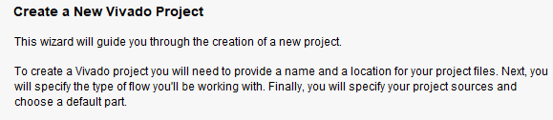

Then, click Next

- Add Project Name and Location
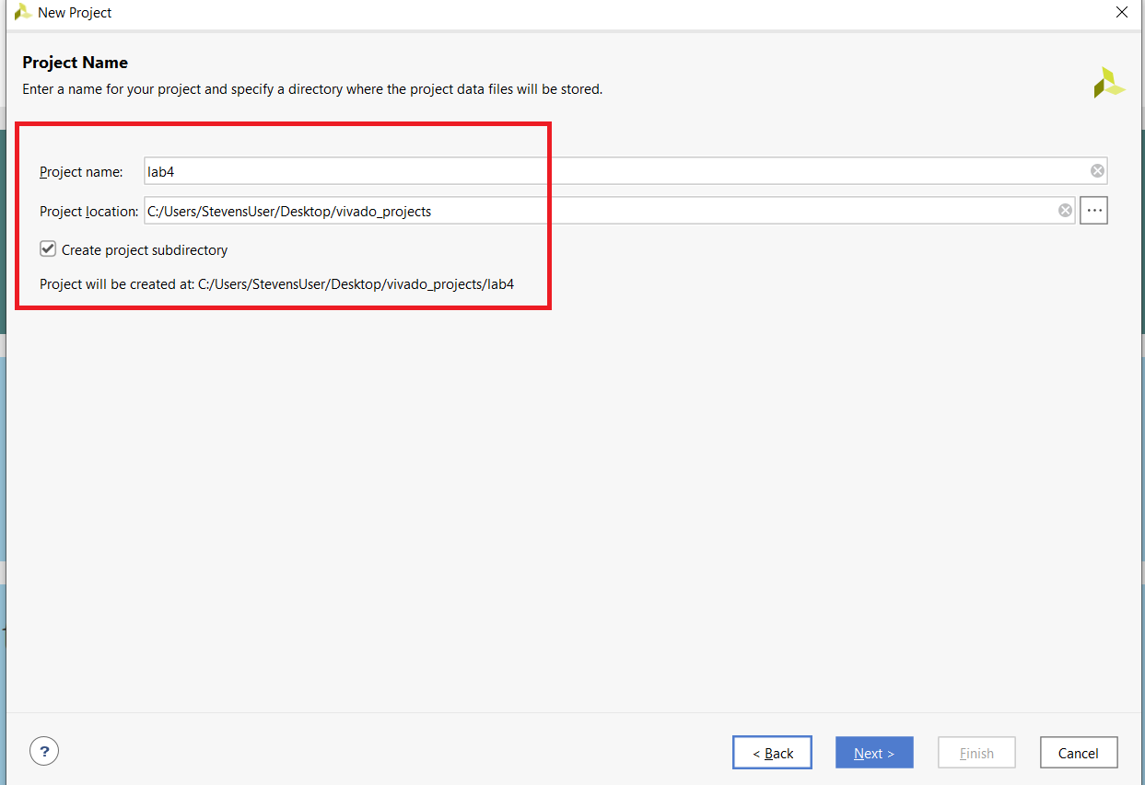
Then, click Next
- Select Project Type, select Register Transfer Level (RTL)

Select RTL Project and make sure to uncheck Do not specify sources at this time.
Then, click Next

- Create a new source file on disk and add it to your project. Make sure that you have selected “VHDL” from Target Language drop down menu.

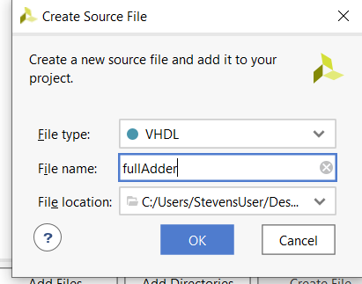
Then click Create Files
The following window displays. Make sure that File type is “VHDL”, Fine Name “Project Name”, in this case, it is “fullAdder”; specify your Project location.

Then, click OK

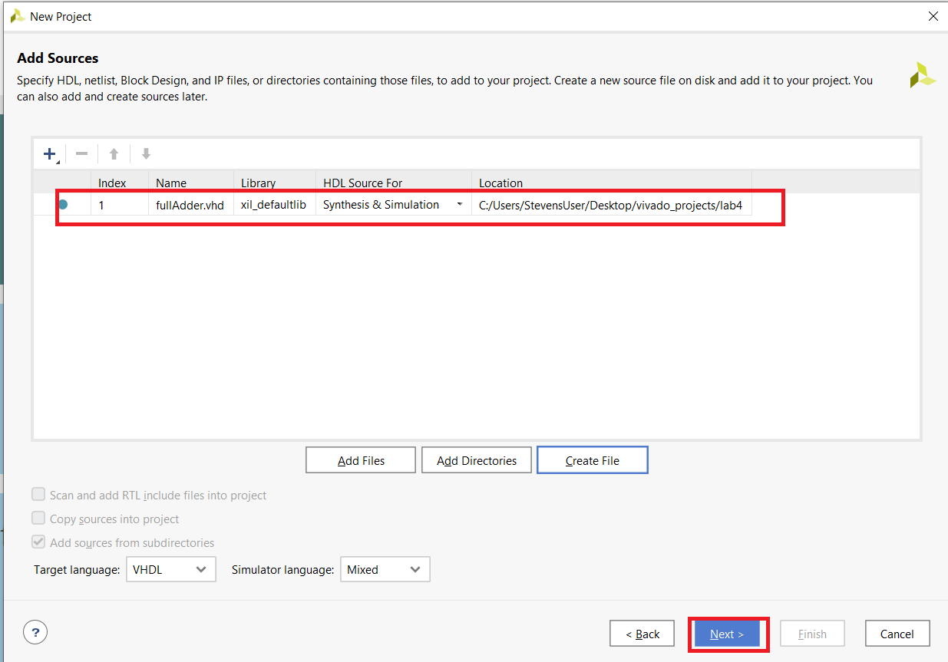

File source has been created, then click Next (twice).

- Choose a board for your project

Click Next
- Project Summary, verify to make sure that it is your board
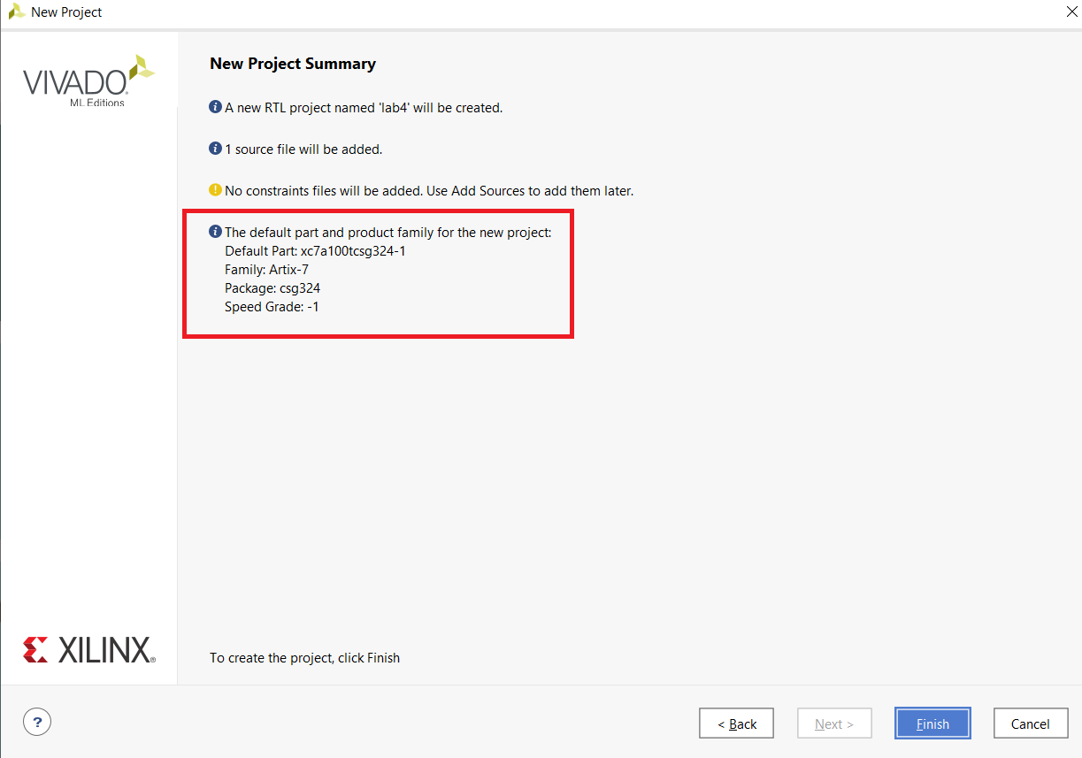
Finish

- Create Project Manager Window. This window will setup everything you will need for your project. Also, you will add port Name and Direction (input or output). Click inside spaces in Port Name

There are five fields to define for each of the module's I/O ports:

Port Name: This field defines the name of the port and needs to match one of the names used in the XDC file (will used later).
Direction: This drop-down menu can be set to input, output, or inout, defining the direction that signals propagate through the port, with respect to the VHDL module. Outputs are the signals that the module will control.
Bus: This box can be checked or not; when checked, the port will consist of multiple single bit signals, grouped into a single bus.
MSB: This field sets the index of the most significant bit of the port, if it is a bus. This option is grayed out for single-bit ports.
LSB: This field sets the index of the least significant bit of the port, if it is a bus. This option is grayed out for single-bit ports.

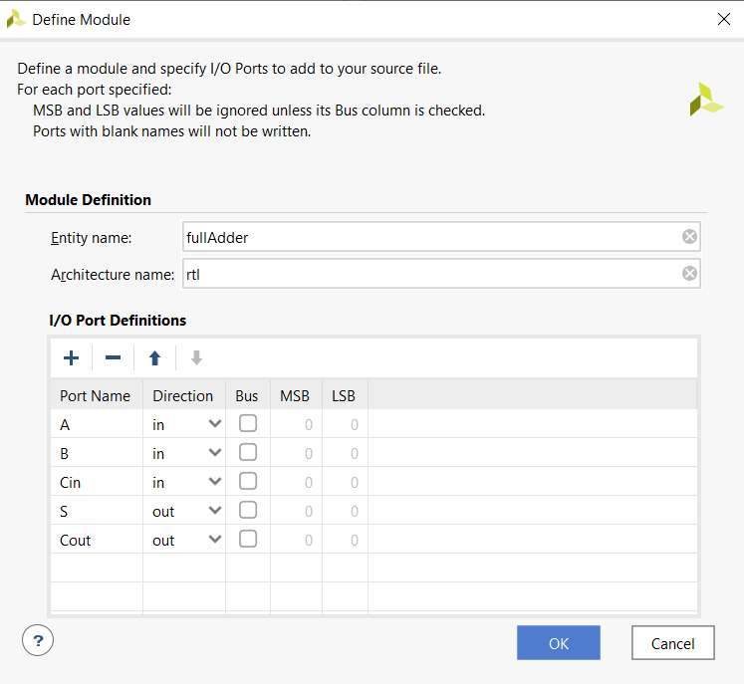

Then, click OK.

- The Flow Navigator
The Flow Navigator is the most important pane of the main Vivado window to know. It is how a user navigates between different Vivado tools.

The Navigator is broken into seven sections:

- Project Manager: Allows for quick access to project settings, adding sources, language templates, and the IP catalog.

- IP Integrator: Tools for creating complex designs in a graphical user interface, rather than by writing large source files.

- Simulation: Allows a developer to verify the output of their design prior to programming the target device.

- RTL Analysis: Lets the developer see how the tools are interpreting their code.

- Synthesis: Gives access to Synthesis settings and post-synthesis reports.

- Implementation: Gives access to Implementation settings and post-implementation reports.

- Program and Debug: Gives access to settings for bitstream generation and tools to program FPGAs.

- Project Manager Menu
This tool is where most development will occur and is the initial tool open after creating a new project.
The Project Manager consists of four panes, Sources, Properties, Results, and the Workspace, described below.

Sources Pane
The Sources pane contains the project hierarchy and is used for opening up files. The folder structure is organized such that the HDL files are kept under the Design Sources folder, constraints are kept under the Constraints folder, and simulation files are kept under the Simulation Sources folder. Files can be opened in the Workspace by double-clicking on the corresponding entry in the Sources pane. Sources can also be added by either right clicking the folder to add the file to and selecting Add Sources or by clicking the Add Sources button

Properties Pane
The Properties pane allows for viewing and editing of file properties. When a file is selected in the Sources pane its properties are shown in here. This pane can usually be ignored.

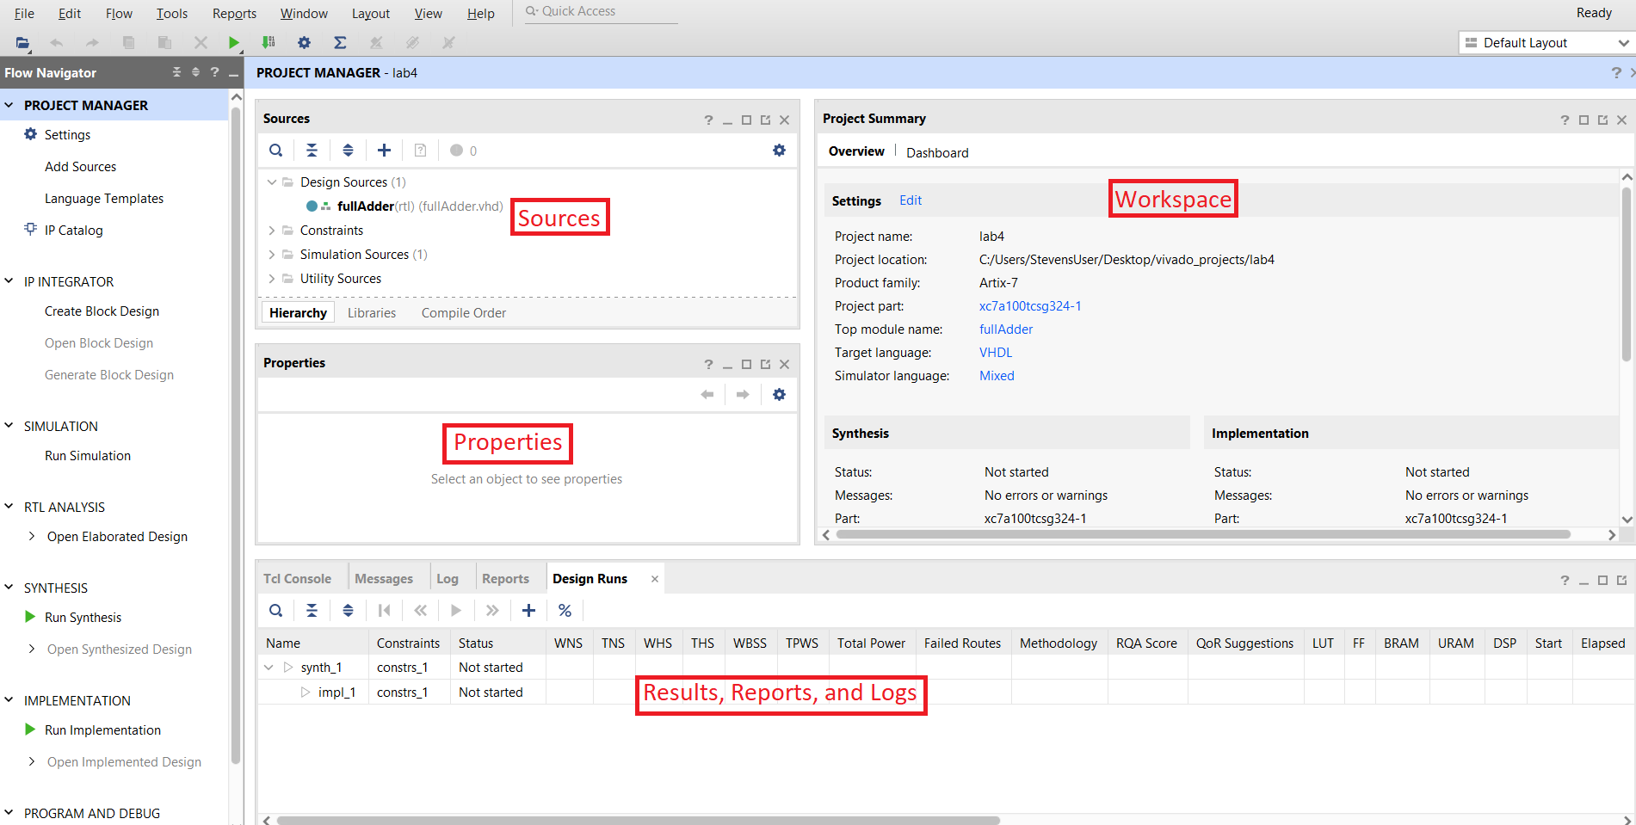

Results, Reports, and Logs
TCL Console Tab
The Tcl Console is a tool that allows running commands directly without the use of the main graphical user interface.

- Messages Tab
The Messages tab displays warnings (critical or otherwise) and errors that may occur during the process of building a project. If anything goes wrong while designing and building a project, check the Messages first. Solutions for many errors and warning can be found by right clicking on the message and selecting “Search for Answer Record”.
- Reports Tab
The Reports tool is useful for quickly jumping to any one of the many reports that Vivado generates on a design. These include power, timing, and utilization reports just to name a few.
- Log Tab
The Log displays the output from the latest Synthesis, Implementation, and Simulation runs. Digging into this is usually not necessary as the reports and message’s view store the information in the log in a more readable format.
- Design Runs Tab
The last tool is the Design Runs. Using this tool, run settings can be edited and new runs can be created. This tool is useful when targeting multiple devices with the same design.

Workspace Pane
The most important pane in the Project Manager is the Workspace. The Workspace is where reports are opened for viewing and source files are opened for editing. Initially the Workspace displays the Project Summary which show some basic information from some of the reports.

Maximized workspace is seen below
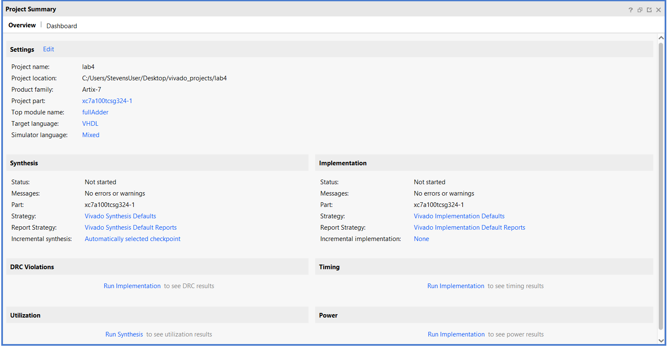

- At this point, the new source file will be added to the Design Sources folder in the Sources pane of the Project Manager. Expand this folder and double click on the file to open it.
Next, some VHDL code needs to be written to define how the design will actually behave.
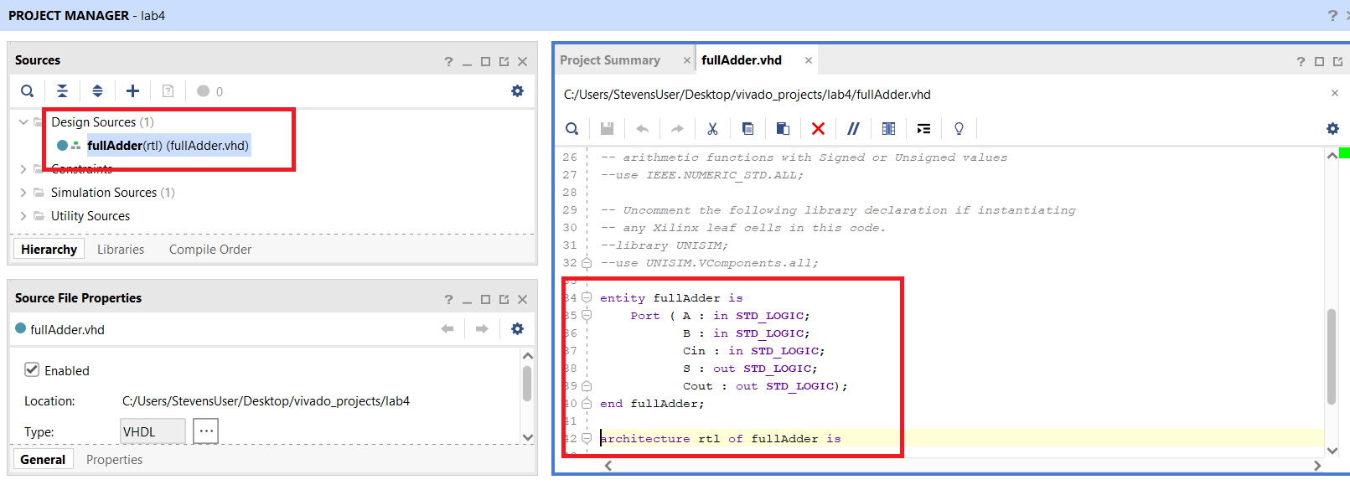
Add Full-Adder functions inside architecture module, as

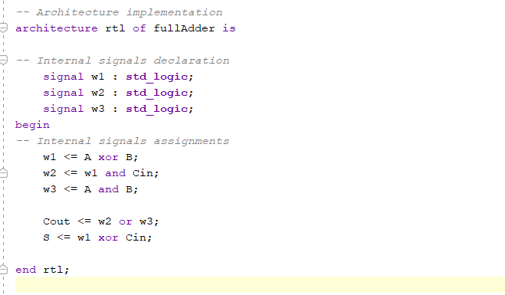

- Synthesis
In order to create a file that can be used to program the target board, each stage of the “compilation pipeline” needs to be run.

This starts with Synthesis. Synthesis turns HDL files into a transistor level description based on timing and I/O constraints. To run Synthesis, click either in the toolbar or in the Flow Navigator. The output of Synthesis is then passed to Implementation.
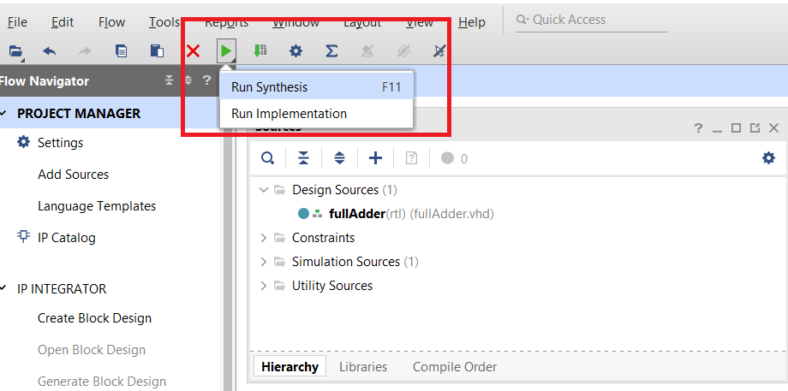

When a simulation is running, pay attention to the upper corner of toolbar.

At this point, you can check your circuit layout by opening Elaborated Design and clicking Schematic. Here our logic gate is generated as expected, AND gate
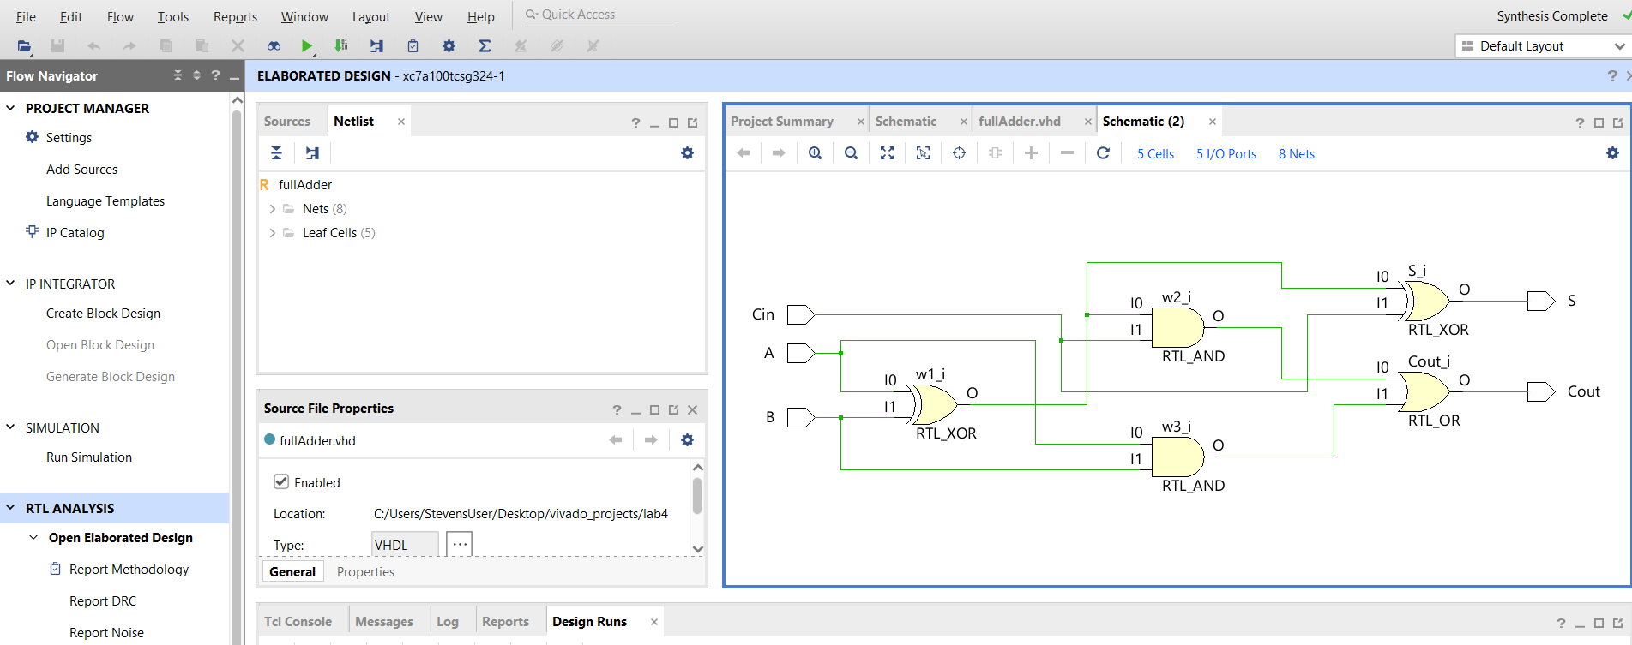

- Design Simulation
To simulate a design, you create a testbench file.
- Click the Simulation Source and
- Click Add Sources from Project Manager Window
- Click Creates Files and then Next

- The following box appears, add the name “tb_fullAdder” and make sure that you specify the file location. Then click OK.

- No inputs/outputs needed, Cancel

- Ok, then Finish.

- Click Yes

- At this point, the new source file will be added to the Design Sources folder in the Sources pane of the Project Manager. Expand this folder and double click on the file to open it.
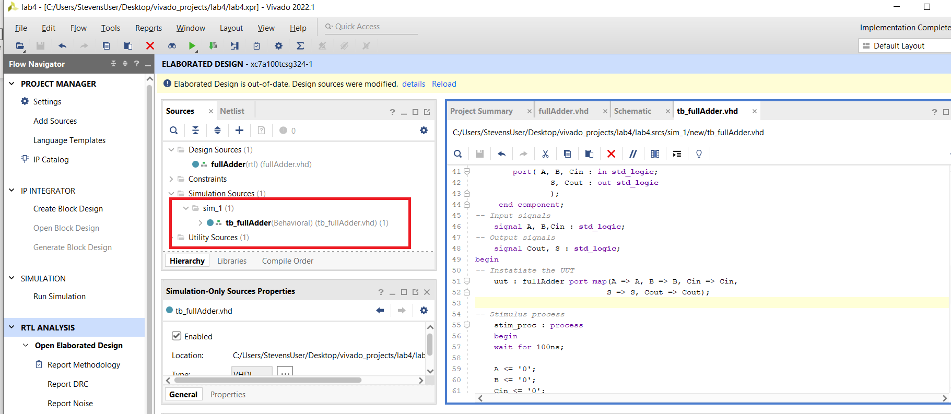
Next, some VHDL code needs to be written to define how the design will behave.

entity tb_fullAdder is
-- Port ( );
end tb_fullAdder;

architecture Behavioral of tb_fullAdder is
-- components declaration
component fullAdder
port( A, B, Cin : in std_logic;
S, Cout : out std_logic
);
end component;
-- Input signals
signal A, B,Cin : std_logic;
-- Output signals
signal Cout, S : std_logic;
begin
-- Instatiate the UUT
uut : fullAdder port map(A => A, B => B, Cin => Cin,
S => S, Cout => Cout);

-- Stimulus process
stim_proc : process
begin
wait for 100ns;

A <= '0';
B <= '0';
Cin <= '0';
wait for 20 ns;
A <= '0';
B <= '0';
Cin <= '1';
wait for 20 ns;
A <= '0';
B <= '1';
Cin <= '0';
wait for 20 ns;
A <= '0';
B <= '1';
Cin <= '1';
wait for 20 ns;
A <= '1';
B <= '0';
Cin <= '0';
wait for 20 ns;
A <= '1';
B <= '0';
Cin <= '1';
wait for 20 ns;
A <= '1';
B <= '1';
Cin <= '0';
wait for 20 ns;
A <= '1';
B <= '1';
Cin <= '1';
wait for 20 ns;

end process;

end Behavioral;

- Run Implementation
Implementation has several steps. The steps that are always run are Opt Design (Optimize the design to fit on the target FPGA), Place Design (Lay out the design in the target FPGA fabric), and Route Design (Route signals through the fabric). To run Implementation, click either in the toolbar or in the Flow Navigator. This output is then passed on to the Bitstream Generator.

After implementation is done running, the following window appears; click Cancel.

- Run Simulation
Selecting the “tb_fullAdder”, click Run Simulation and Run Behavioral Simulation

After running the simulation, the window below appears.

Right click and select Full View

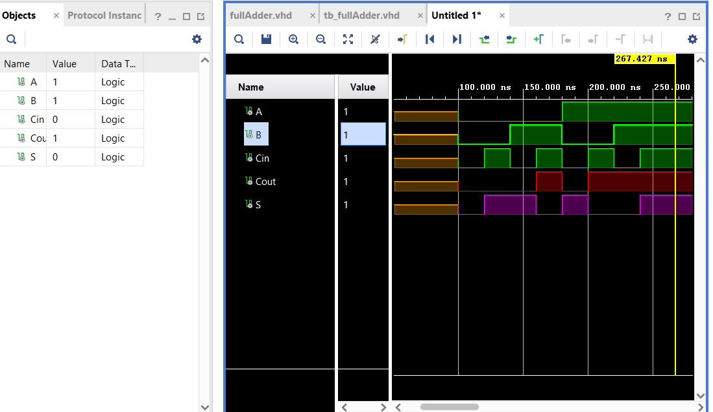
Test the logic

Next, we must download our VHDL to the board.

- Adding a Constraint File
In order to connect the inputs and outputs of an HDL design with the physical pins of the FPGA, a constraint file needs to be added or created. Digilent has produced a Xilinx Design Constraint (XDC) file for each board.

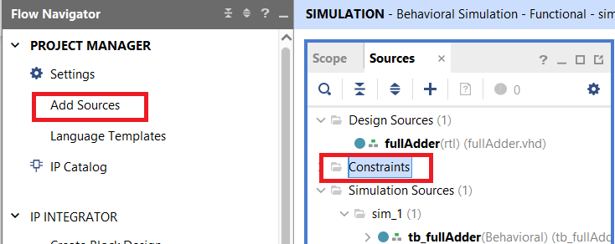
- Click “Constraints” in the Sources pane, then, in the Project Manager section of the Flow Navigator, click the Add Sources button.

- In the wizard that pops up, select Add or create constraints then click Next.
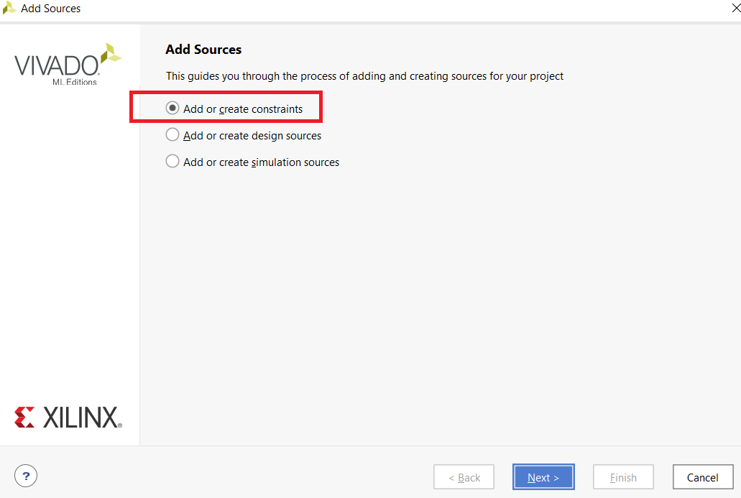

- At this stage, Vivado provides a list of all the constraint files that will be added or created when we click Finish. Currently this list is empty, this will change when files have been added or created. A constraint file will not be created from scratch in this guide, so click Add Files.
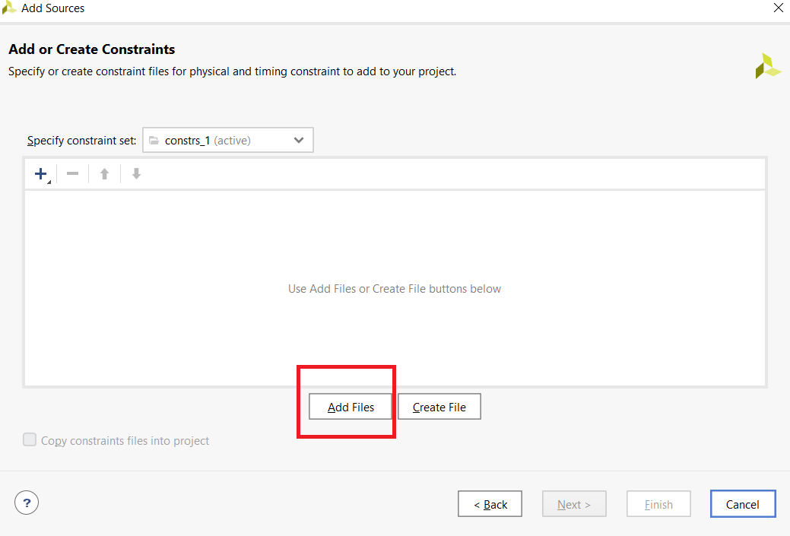

- Find the directory the “digilent-xdc-master.zip” archive was extracted into, then click on the file for the target FPGA system board. For our lab, we are using Nexys A7 - FPGA

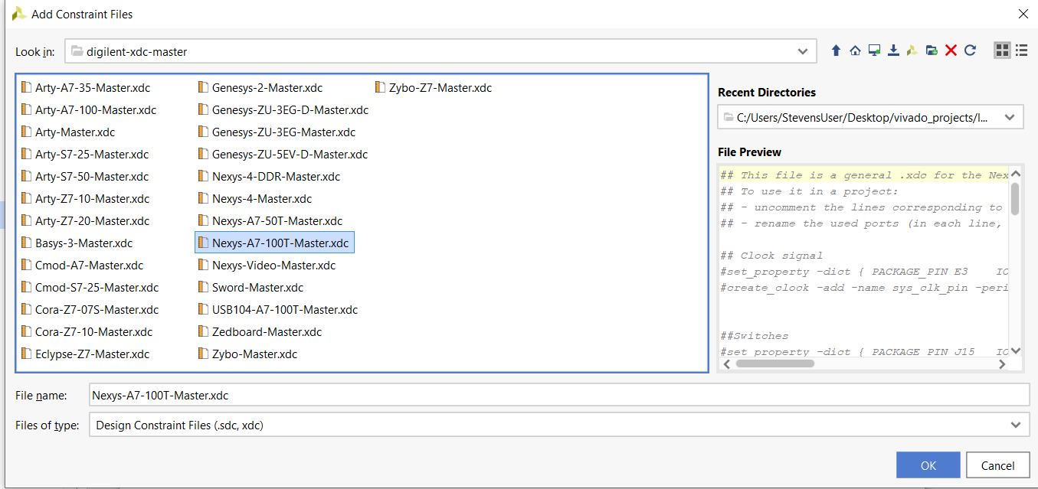
Click OK to continue.

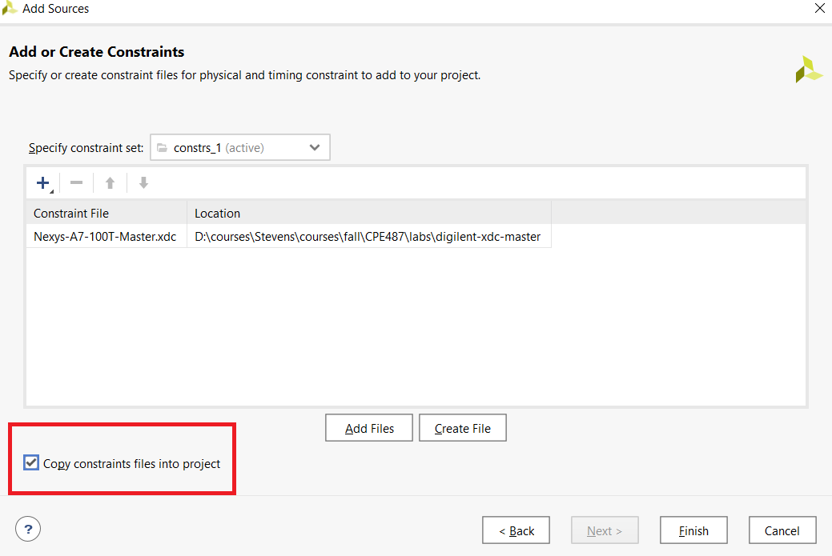
- Make sure that the selected XDC file has been added into the list of sources. Make sure that the “Copy constraint files into project” box is checked, so that the original file will be left alone so that it can be used in other projects. Click Finish.

- In the Sources pane of the Project Manager, expand the Constraints folder, then double click on the XDC file that was just added. Each of Digilent's XDC files contains constraints for each of the commonly used peripherals on their respective boards. For this demo, constraining the default system clock and a single led is required.

- In the ‘Switches’ files, find and uncomment the lines, as for example,
set_property -dict { PACKAGE_PIN J15 IOSTANDARD LVCMOS33 } [get_ports { SW[0] }];
IO_L24N_T3_RS0_15 Sch=sw[0], by removing the '#' symbol at the beginning of the line. Then,
replace SW [0] with ‘A’ for both lines. Do the same as follow for the rest input signals. We
are using switches as inputs.
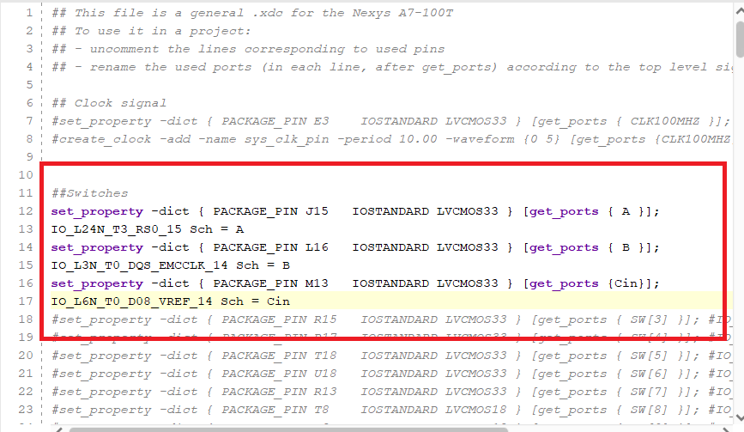

Do the same for the output signals, this time they are ‘LEDs’. Replace LED [0] with ‘Cout’
and LED [1] with ‘S’

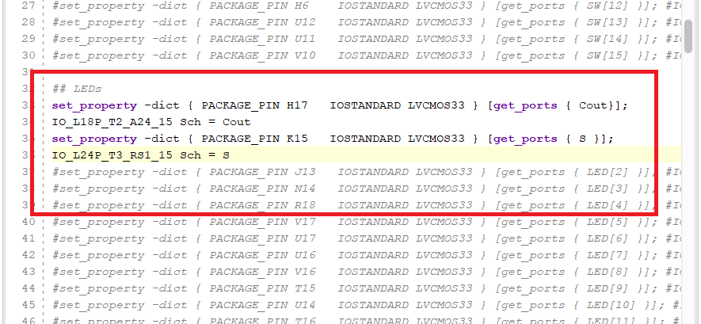

- Bitstream Generator
The Bitstream Generator generates the final outputs needed for programming the FPGA. To run Bitstream Generation click either in the toolbar or in the Flow Navigator. With no settings changed, the generator will create a '.bit' file, which can be used to program the design onto the target FPGA system board.

Bitstream Generation Completed Pop-Up
Once the bitstream has been generated, a pop-up will appear asking what Vivado should do next. The options in this pop-up allow the user to do several different things:

- Open Implemented Design takes the user to a tool where they can view how the project will be programmed into the fabric of the target FPGA chip.

- View Reports takes the user to a list of many different reports and statistics about how the project was laid out, including information about how fast the design can potentially be run, and how much of the FPGA will be used to run the design.

- Open Hardware Manager takes the user to a tool that can be used to program the generated bitstream onto a connected FPGA board.

- Generate Memory Configuration File lets the user create a file that can be used to program a non-volatile memory part on an FPGA system board, so that the FPGA can be automatically programmed each time that the board is powered on.

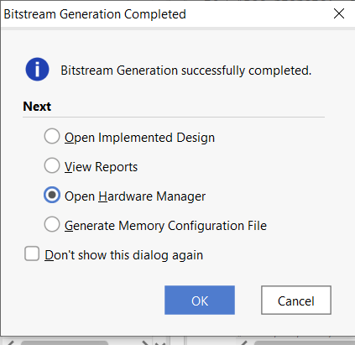

Select option ‘c)’ Open Hardware Manager, then click OK.

- The Hardware Manager
First, plug the target FPGA system board into the computer running Vivado using a MicroUSB cable capable of transferring data. With the board plugged in, it needs to be connected to the Vivado Hardware Server. There are two ways to do this through the Vivado Hardware Manager:

Programming
To program the device with the bit file generated earlier, either click the Program Device button in the Flow Navigator under PROGRAM AND DEBUG. From the drop-down that opens, select the device to program, then, click xc7a100t_0.

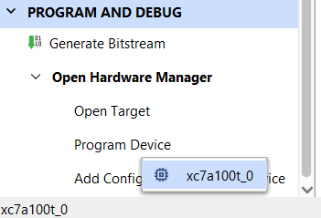

Then, the Program Device open, click the Program.
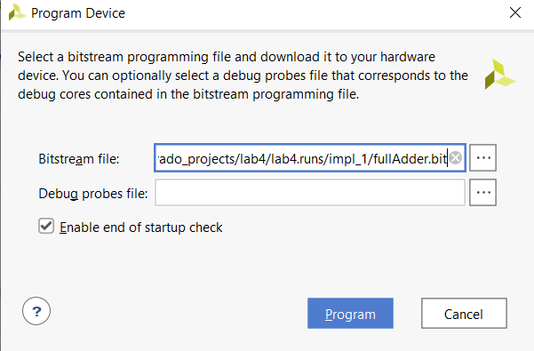

The Bitstream File field should be automatically filled in with the bit file generated earlier. If not, click the button at the right end of the field and navigate to <Project Directory>/<Project Name>.runs/impl_1/ and select the bit file (Example: fullAdder.bit). Now click Program. This will connect to the board, clear the current configuration, and program using the new bit file.

- Congratulation, you’re finished!

