**[PART 1] Import Dependencies & Create Engine**

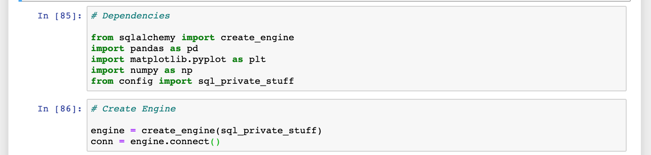

**[PART 2] Creating a histogram – (1) Needed DataFrames from PostgreSQL Tables**

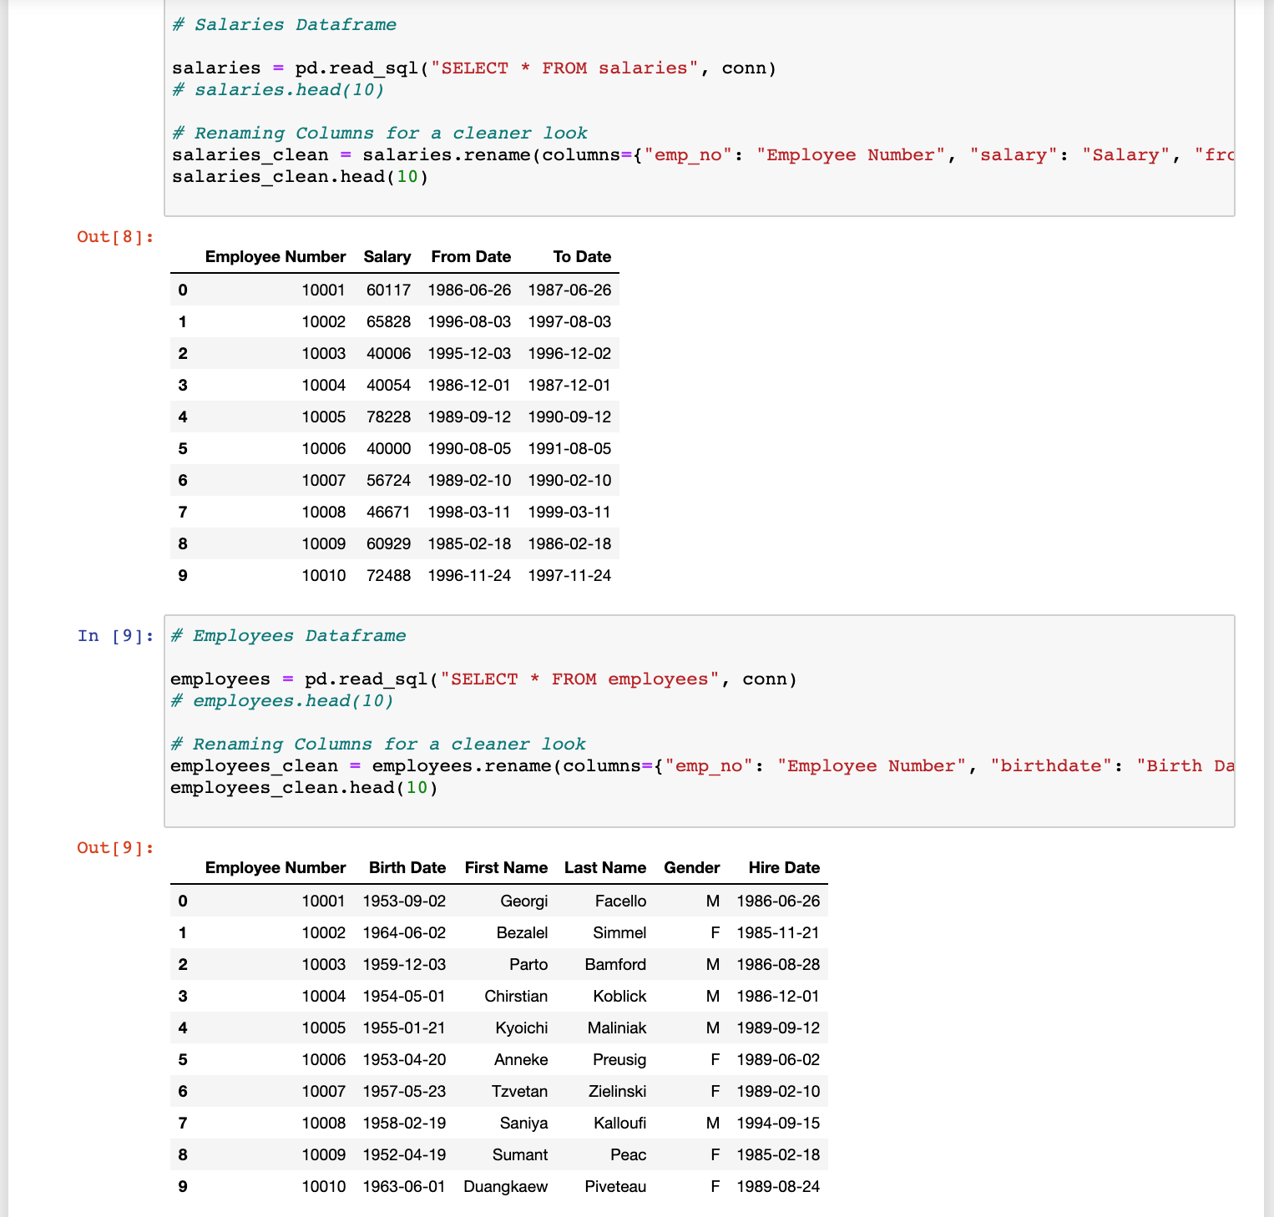

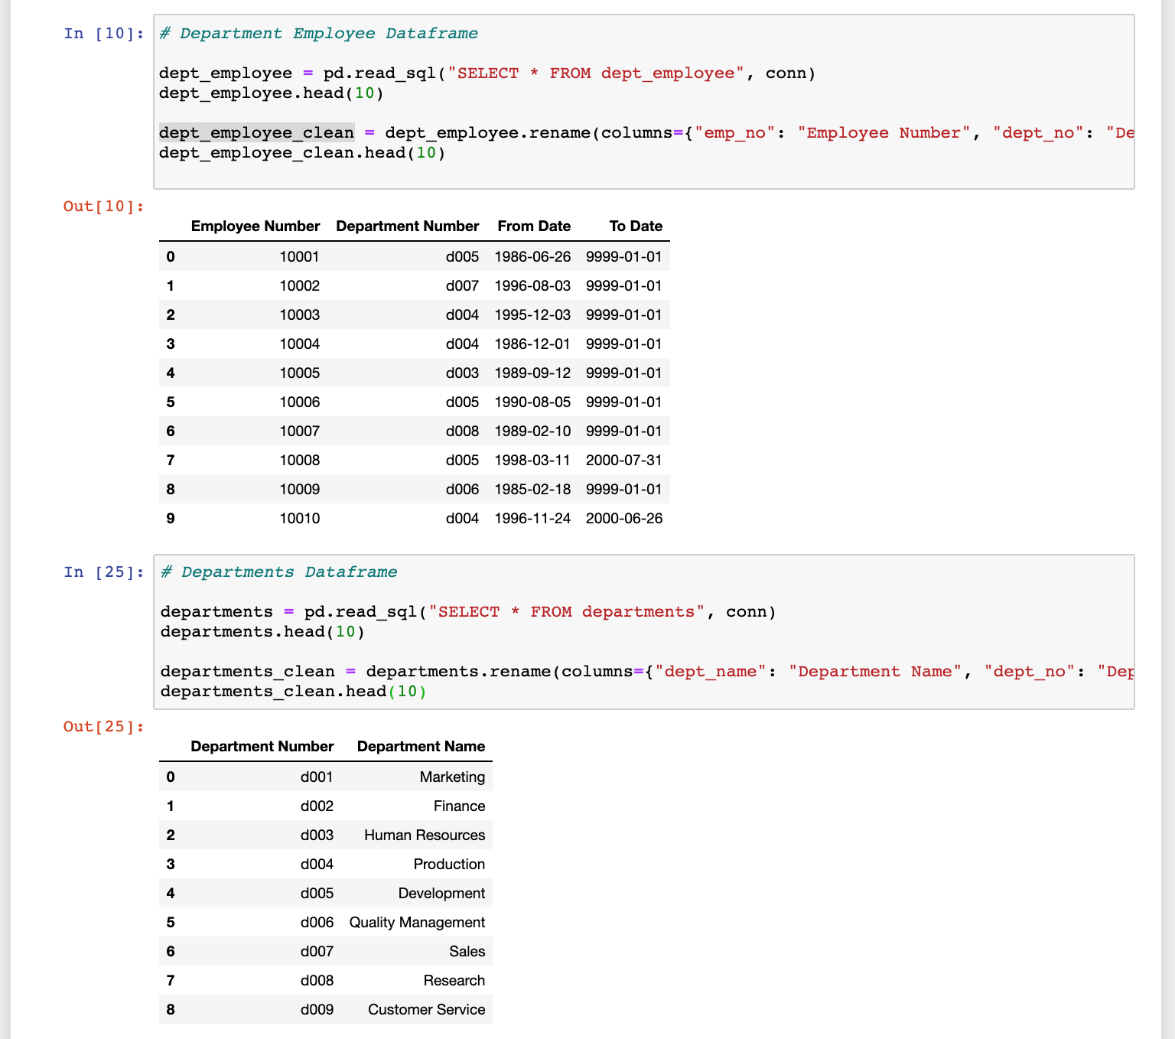

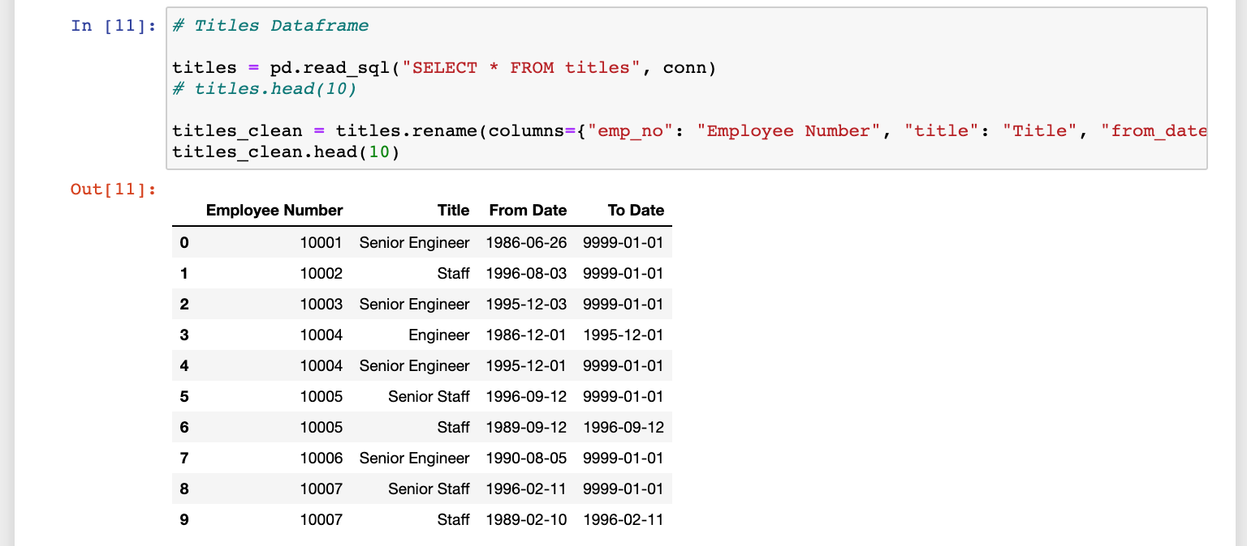

**[PART 3] Merging DataFrames**

**Salary and Titles:**

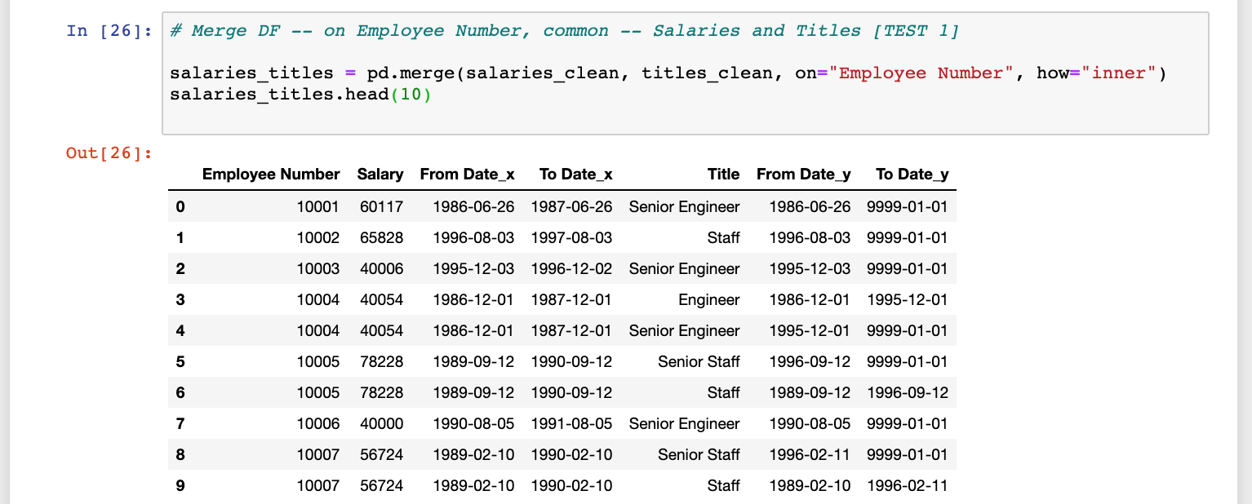

**Salary and Employees:**

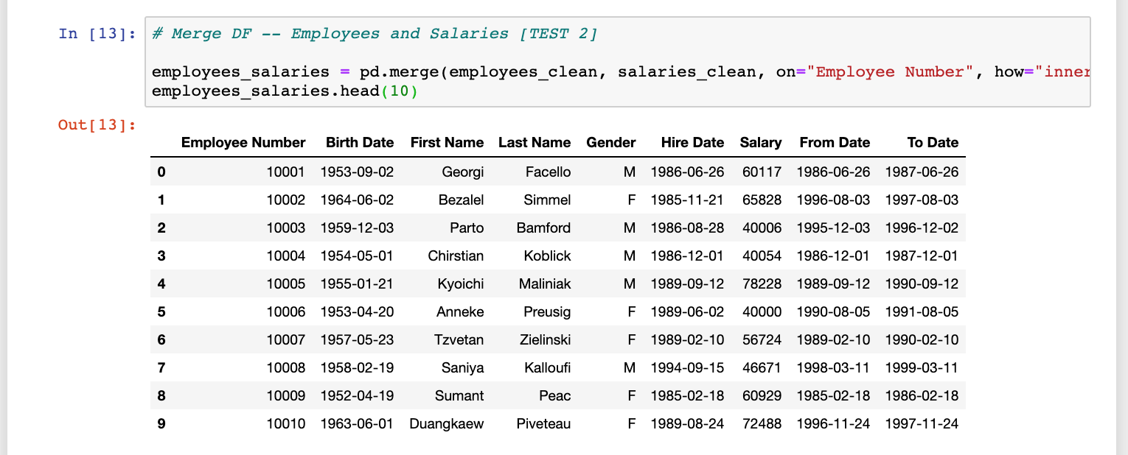

**Salary and Department Employee:**

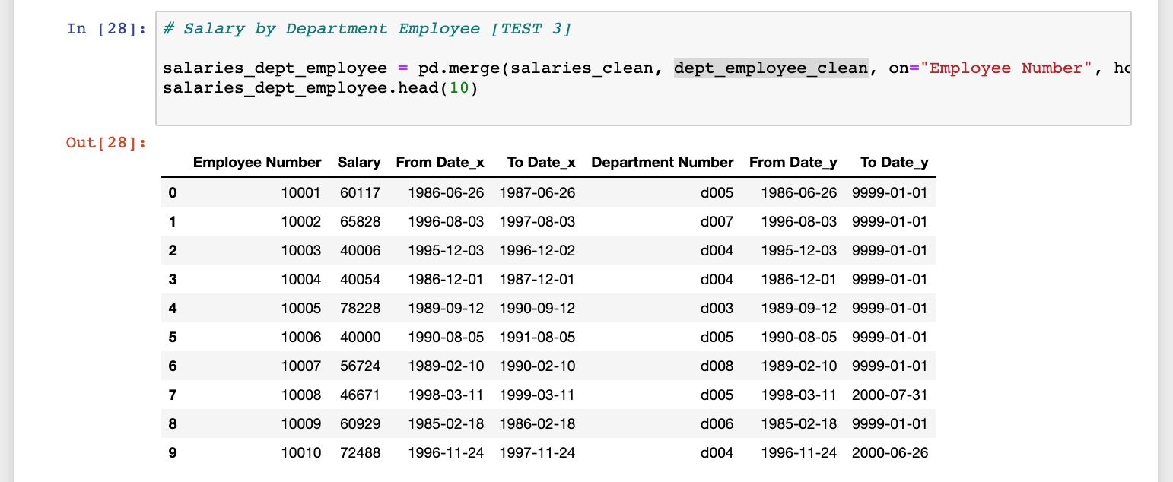

**Department and Department Employee:**

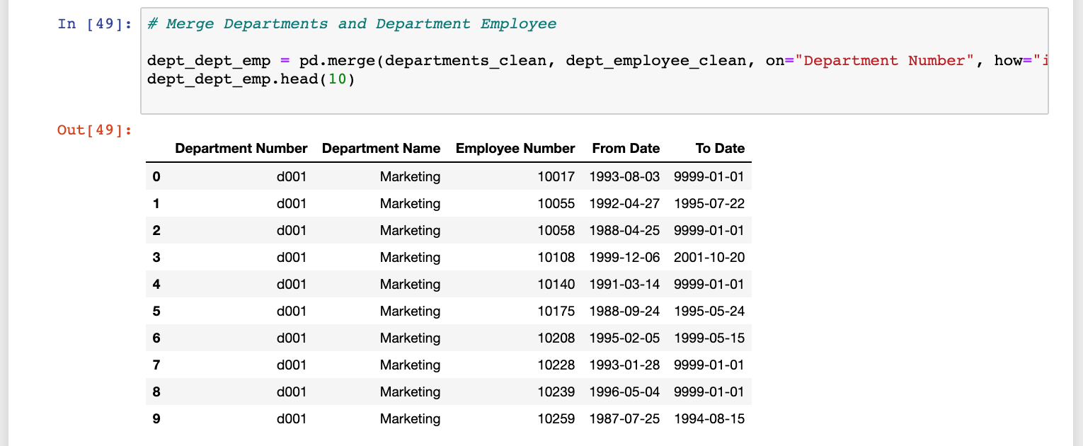

**[PART 4] Extra Merging – To Produce a mean of salary by department name**

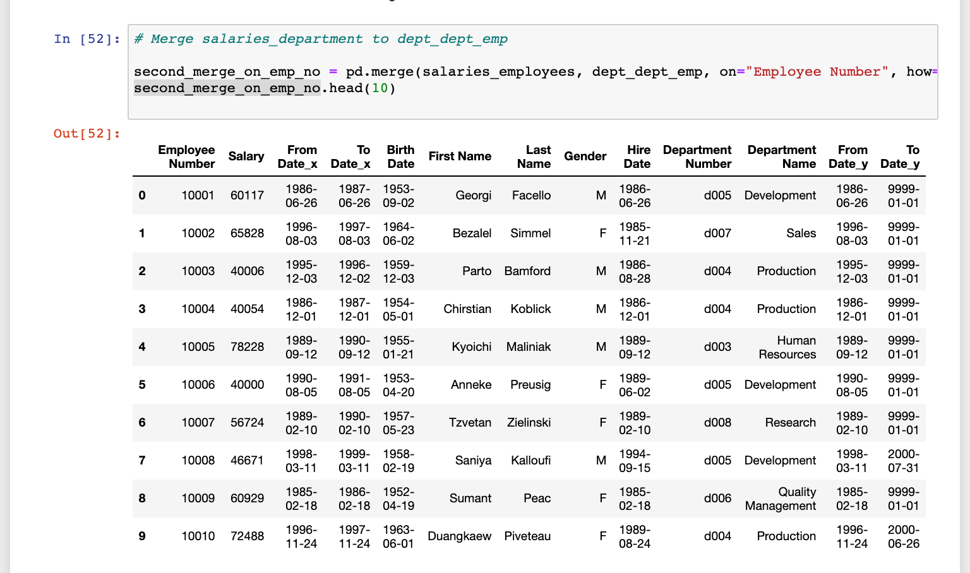

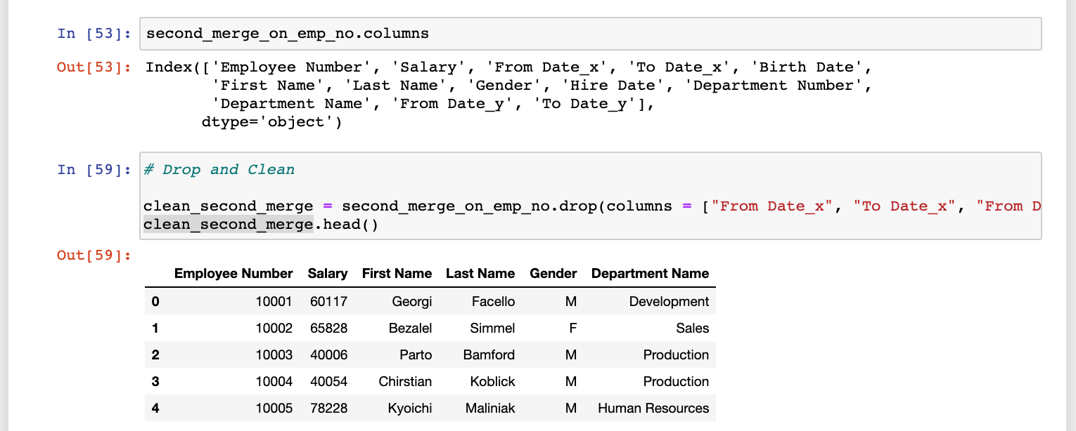

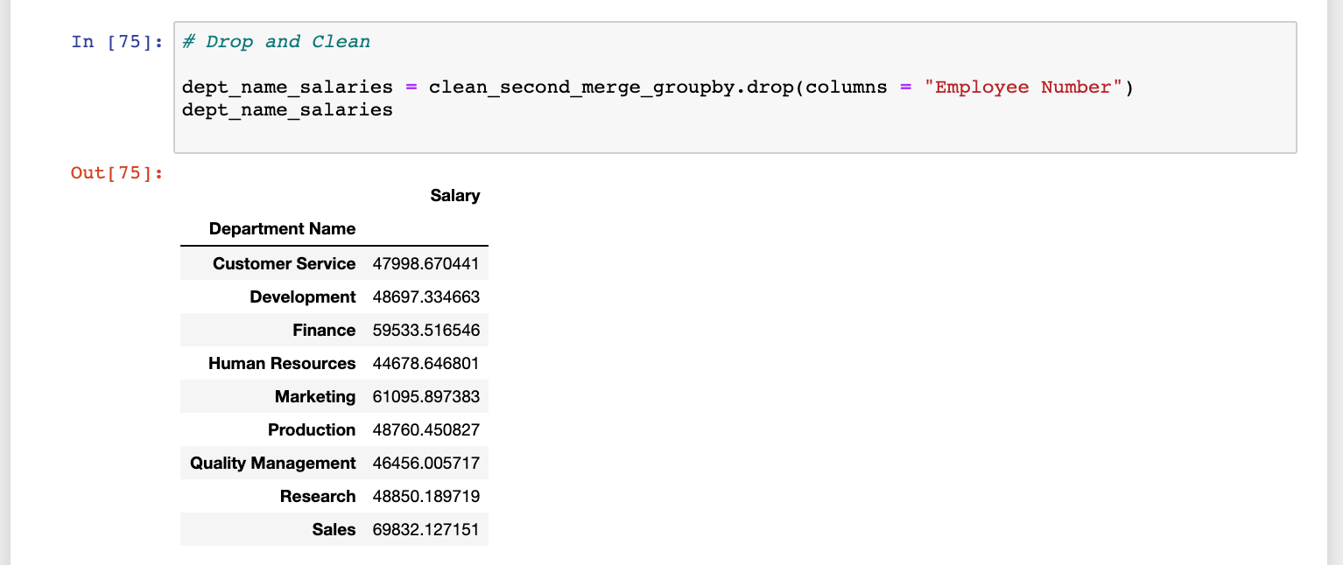

**[PART 5] Plot Hist – Range of Salary by Department Names**

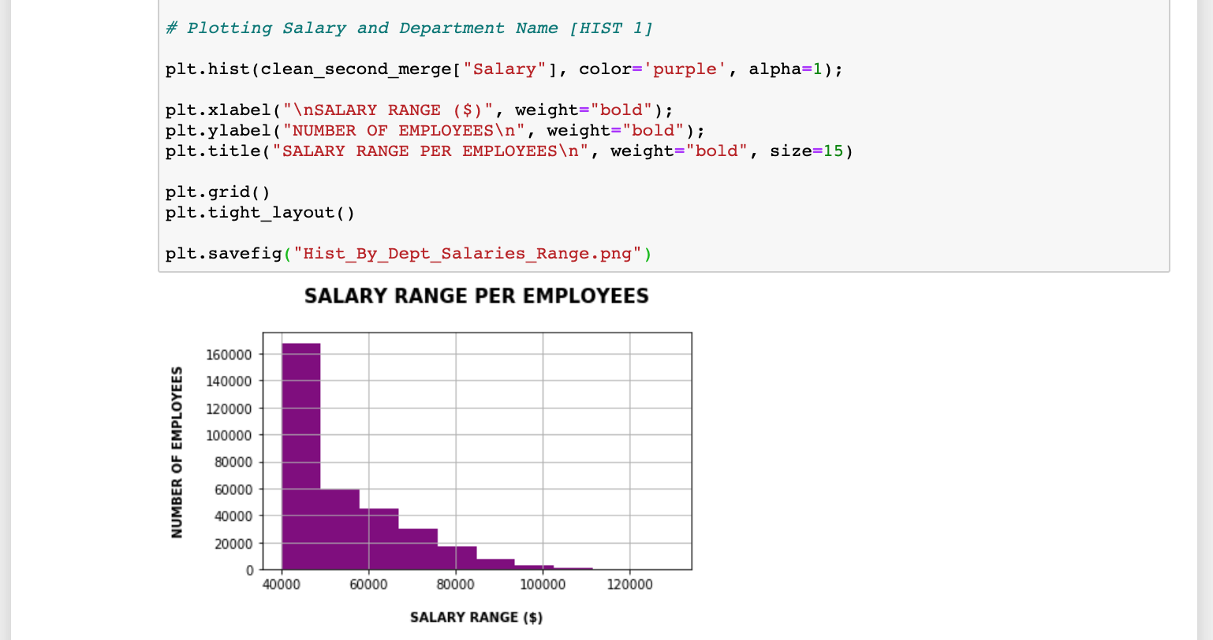

**[PART 6] Plotting Bar Graph – Produce a DataFrame of Salary Range and Title**

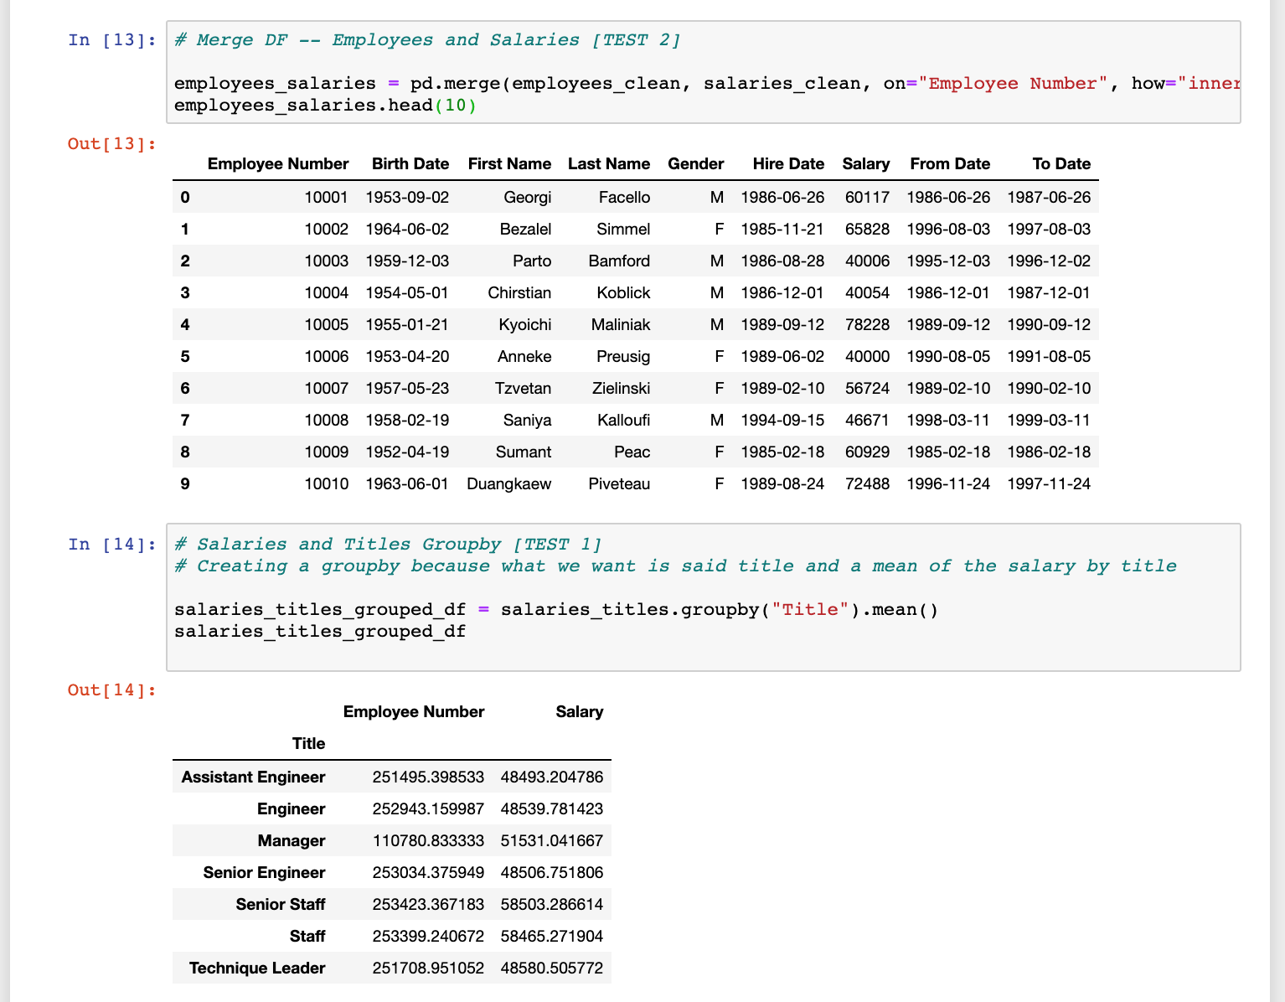

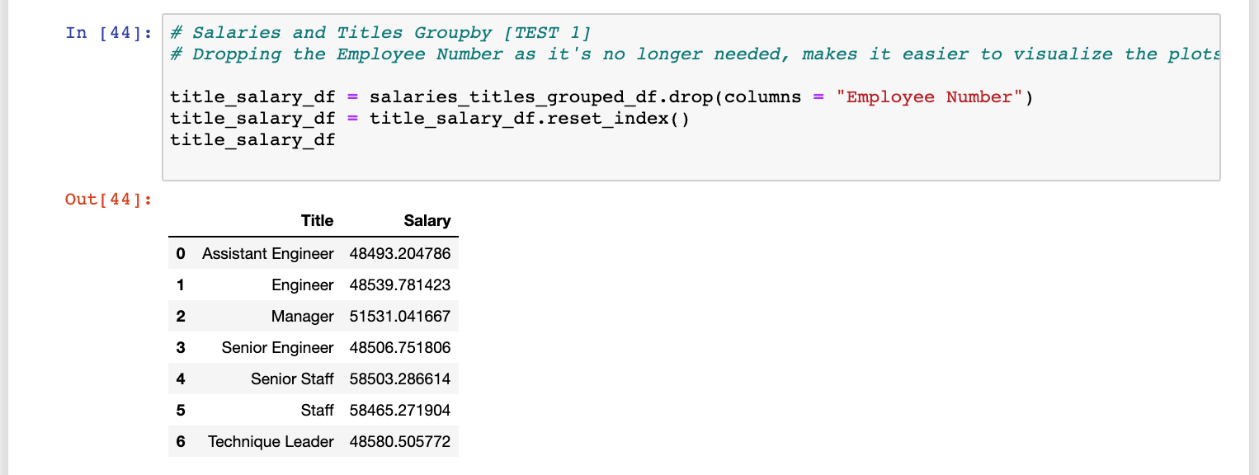

**[PART 7] Plot Bar Graph**

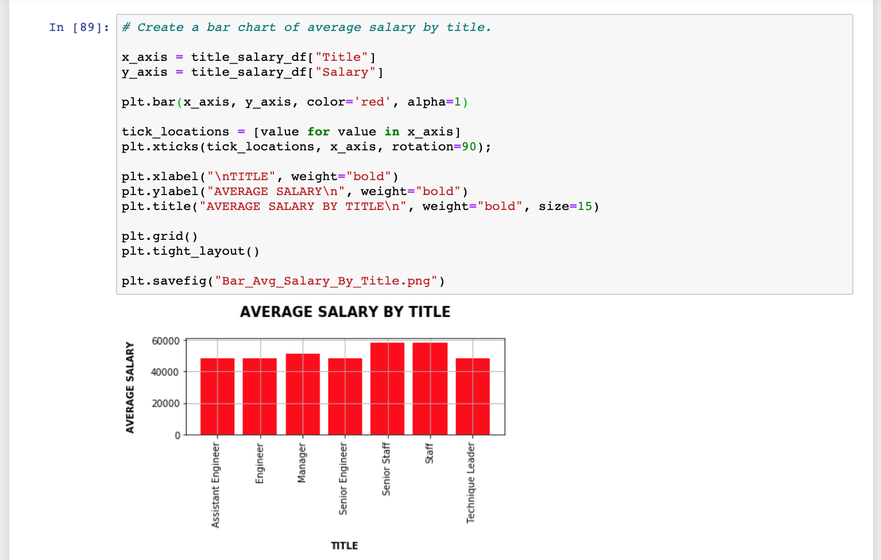

**[PART 8] Epilogue**

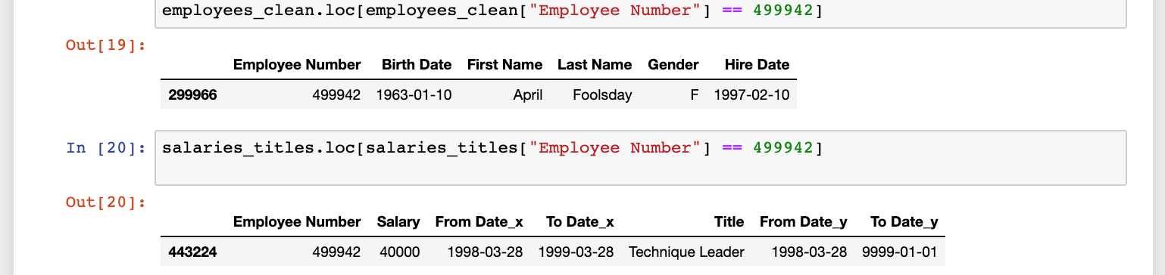

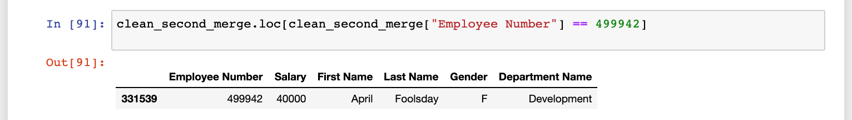

**[PART 9] Extra Hist – Salary Range and Title**

