

**AutomateYours**

Content Aggregation

Detailed Process Description

Version 1.0

Revision History

|  |  |  |  |
| --- | --- | --- | --- |
| Date Issued | Version | Description | Author |
| *22/06/2020* | *1.0* | *Draft* | *Mohammed* |

Contributors

The content of this document has been authored with the combined input of the following group of key individuals.

|  |  |  |
| --- | --- | --- |
| Name | Role | Area |
| *Mohammed Adam* | *RPA Consultant* | *QA Consulting* |
| *Chris Lucas* | *RPA Manager* | *QA Consulting* |
| *Roberto* | *Job Title* | *Torbor Inc* |

Business Sign-off

The following table contains the people required to sign-off and/or review this document and those that require the document for information only.

|  |  |  |
| --- | --- | --- |
| Name | Department | Responsibility |
| *Chris Lucas* | *RPA* | *Review* |
| *Roberto* | *Tobor* | *Review/Sign-off* |

Document Classification

|  |  |
| --- | --- |
| Classification | *Company Confidential* |
| Definition | *Information is company confidential and needs to be protected* |
| Context | *Where loss of information confidentiality would result in significant harm to the interests of the Organisation, financial loss, embarrassment or loss of information* |
|  |  |

Contents

1 Introduction 4

2 Manual Process 4

2.1 Overview 4

2.2 Detailed Process Flow 4

3 Automation Proposal 4

3.1 Overview 4

3.2 Automated Process Flow 4

3.3 Target Systems & User Requirements 4

3.4 Impacted Business Areas 5

3.5 Workload 5

3.6 Operational Constraints 5

3.7 Delivery 5

3.8 Contact List 5

4 Automation Details 6

4.1 Automation Walkthrough 6

4.1.1 *First robot action* 6

4.1.2 *second robot action* 6

4.1.3 *third robot action etc.* 6

4.2 Reporting 6

4.2.1 Business Exceptions 6

4.2.2 System Exceptions 6

4.2.3 Performance 7

4.2.4 Triggers 8

# 1 Introduction

To build a content delivery application that collects data from various websites depending on the users preferred content selection. This should be completed with efficiency and accuracy. This application should automate administration tasks and reduce the amount of manual back-end interaction.

**Objectives**

To reduce some of the capacity of the development department to allow them to concentrate on other projects to help facilitate growth.

The application should be efficient and accurate to help keep competitive edge.

Automate some administrations such as signups, aggregating content, the end delivery, and reporting.

# 2 Manual Process

## 2.1 Overview

Manual Current Process Steps

### User Registration

* Customer sends email with registration details.
* If any details are missing, would need to reply back for them to send through missing information.
* Company picks up email and manually stores this into the database.
* Registrations made before 11am to receive the days content.

### Content Aggregation

* Will go through database to see which user needs content sending.
* Select user and see preferred content.
* Manually visit website to select the content the user will receive.
* Continue on the process for the user from manipulation of content and sending off
* Moving on to the next user and follow the same process

### Content Manipulation

* The data copied from the website is manually cleaned removing any extra headers and ready to be sent off.

### Delivery of Content

* Once the content is ready it is pasted into the body of the email for the selected user and is sent.
* This information is then logged into the transmission databases with the users first name, last name, transmission date/time, content preference, part of the content.

### User Details / Removal Details

* Company will receive and email from customer with the subject ‘CHANGE’ or ‘DELETE.
* Customers are required to include all user details within the email. If the customer has requested to change details, they will present their current details and the details they would like to change. If they want details removed, they will just present their current details.
* These are then updated within the database and logged into the user request database.
* To receive content changes will need to made before 11am.

### Reports Created

* From the user requests database and the transmission database, things have been changed within the day will be manually aggregated into document.
* Document converted into a PDF.
* Document will be saved locally and sent to company email.

## 2.2 Detailed Process Flow

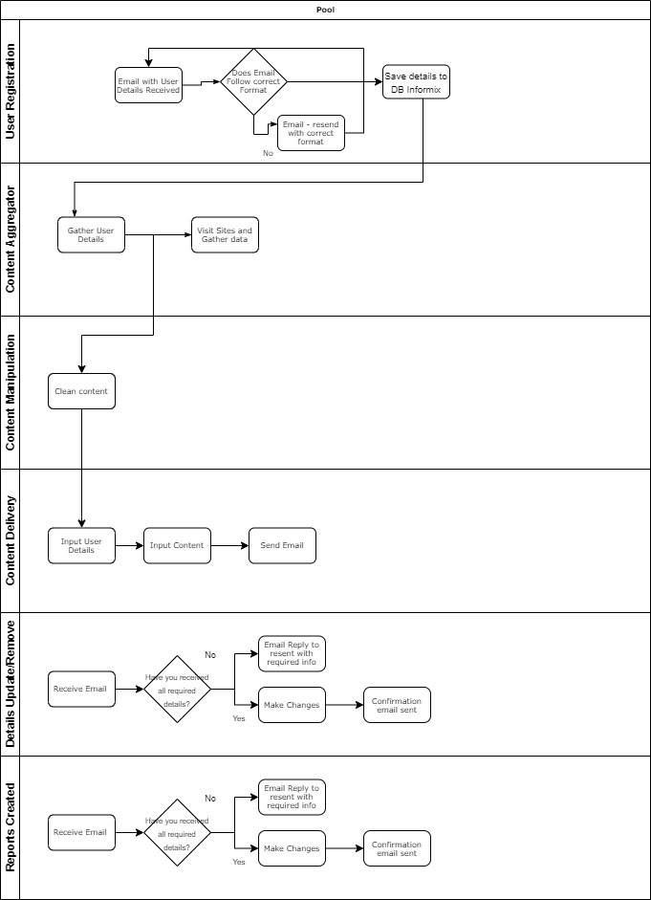

# 3 Automation Proposal

## 3.1 Overview

*The automation will be split into 3 processes.*

*The first process, will include emails sent from the user applying to registrations, user updates, and user deletions.*

*The second process will consist of the aggregation of the content, content manipulation, from sports, technology and books and these will be saved into a table for usage.*

*The third process will be for the reporting, to gather details of content transmission and user requests, collate these into a report and send off to company email.*

## 3.2 Automated Process Flow

*The process flow of the manual will be the same, but each of the steps will be automated.*

## 3.3 Target Systems & User Requirements

| Name | Description | User Permissions/Access |
| --- | --- | --- |
| MS Outlook | Email Inbox, simulates company email address. | No permission required |
| Excel Database | User Details, Content Details, Report Details. Used as replacement for company database. | No permission required |
|  |  |  |
| Gmail | User mailbox, content sent to, simulates a user, for development purposes | No permission required. |

## 3.4 Impacted Business Areas

* Backend application manager

## 3.5 Workload

*Metrics related to the automation, table example below*

|  |  |
| --- | --- |
| *Max. no. of Login Requests per week* | *30* |
| *Min. no. of Login Requests per week* | *4* |
| *Average no. of Login Requests per week* | *50* |
| *Current User Base* | *567* |
| *Average Content Send in a Day* | *500* |
| *How many people do this process per day?* | *1* |

***Need to Ask for the timings of Each process:***

***Registration,***

***Update/Remove Details,***

***Aggregating and distributing content***

***Collating reports***

***Automating the steps below will realise an average time saving of X minutes (X hrs) per day for <Process Name>:***

* *List of manual steps with manual execution time (Breakdown of all time saved)*

*Acronyms – detail the meanings of any acronyms used above e.g. systems, clients etc.*

## 3.6 Operational Constraints

* *Minimum of 3 websites used in development*
* *Content must not be repeated when sent to users*
* *Details must be saved securely*
* *Content is only sent if the registrations are made before the cut-off time off 11 am.*

## 3.7 Delivery

*The time-scale of the project, will be completed by 29th June 2020.*

## 3.8 Contact List

*List of key contacts for the project, both QA Ltd and Client e.g.*

*RPA Project Manager – Chris Lucas*

*RPA Consultant – Mohammed Adam*

*Department SMEs – Roberto (Customer Onboarding),*

# 4 Automation Details

## 4.1 Automation Walkthrough

### 4.1.1 *First robot action*

* *Description of first Robot step to complete action, include screenshots where necessary*
* *Description of second Robot step to complete action, include screenshots where necessary*
* *Etc.*

## 4.2 Reporting

### 4.2.1 Business Exceptions

|  |  |
| --- | --- |
| Exception | Solution |
| *List of expected or assumed exceptions* | *Details of method of handling exception* |
|  |  |
|  |  |
|  |  |
|  |  |
|  |  |

### 4.2.2 System Exceptions

|  |  |
| --- | --- |
| Exception | Solution |
| *List of expected or assumed exceptions* | *Details of method of handling exception* |

A performance report will be emailed to *<Client Contact>* each time the process runs (showing worked cases, exceptions and a cumulative processing log)

### 4.2.3 Performance

Once the processes have successfully completed a performance report and processing log will be emailed to *<Client Contact>* as an excel file.

**Performance Report**

This will contain all exceptions (business and system) and successes for the automated Process, based on the last automation execution completion (i.e. based on the last time the process ran)

EXAMPLE REPORT

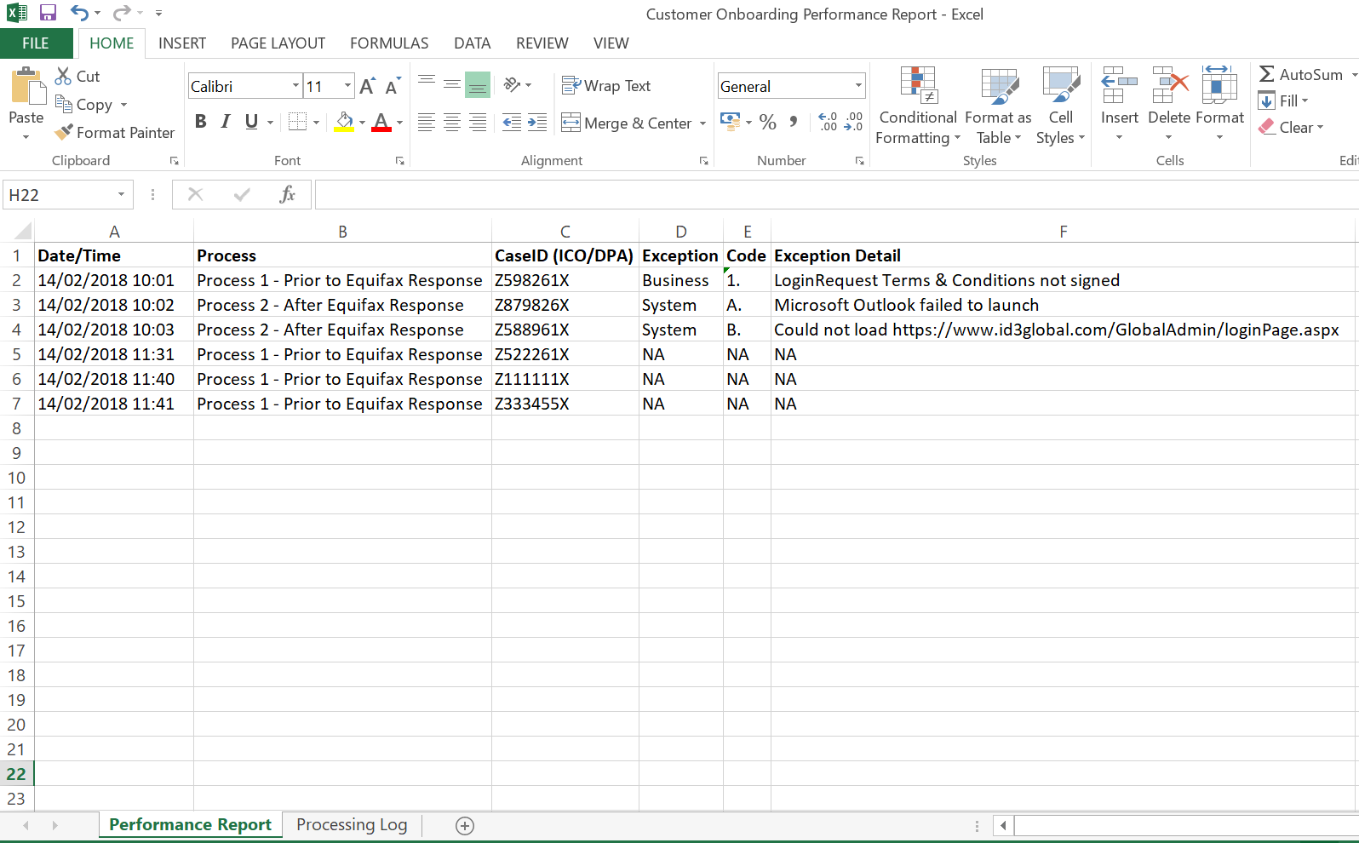

www.xip.com/Admin/loginPage.aspx

CredBest

CredBest

CredBest

CredBest

CredBest

CredBest

**Processing Log**

This will show cumulative successes from the automated Process:

EXAMPLE REPORT

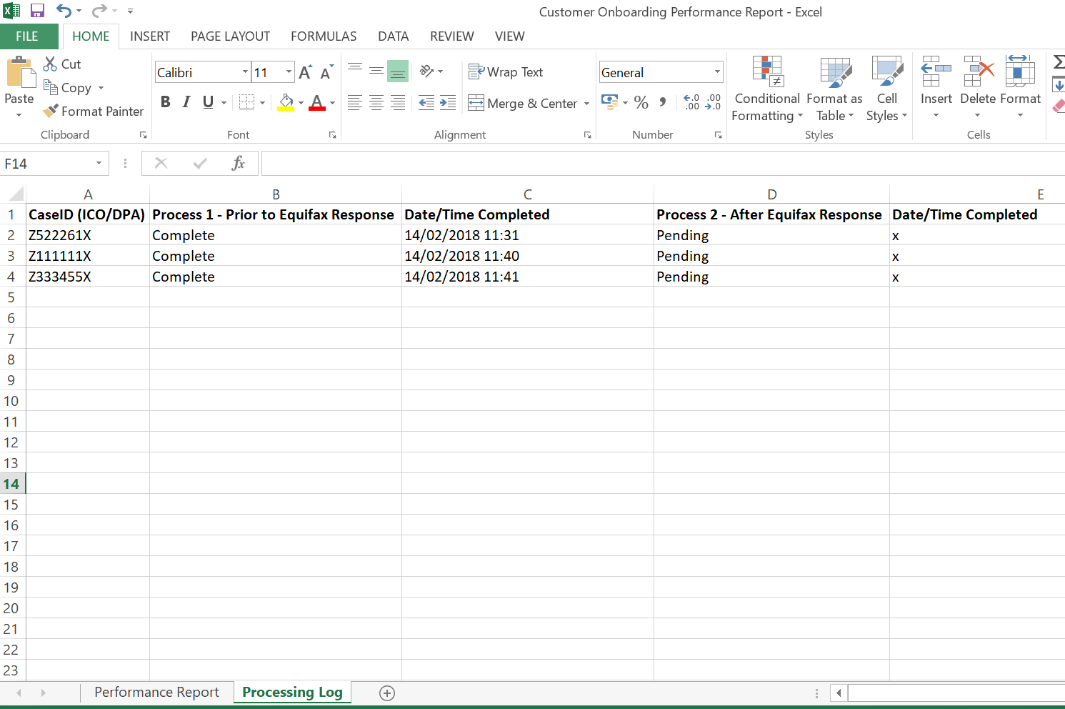

**CredBest**

**CredBest**

### 4.2.4 Triggers

*Definition of how the Robot will be triggered. This could simply define that this is a manual trigger i.e. an attended start, or could indicate more advanced triggers such as on a particular event or schedule.*

**UPDATE THE TABLE OF CONTENTS AND ENSURE ALL RED TEXT HAS BEEN UPDATED/REMOVED PRIOR TO DISTRIBUTION**