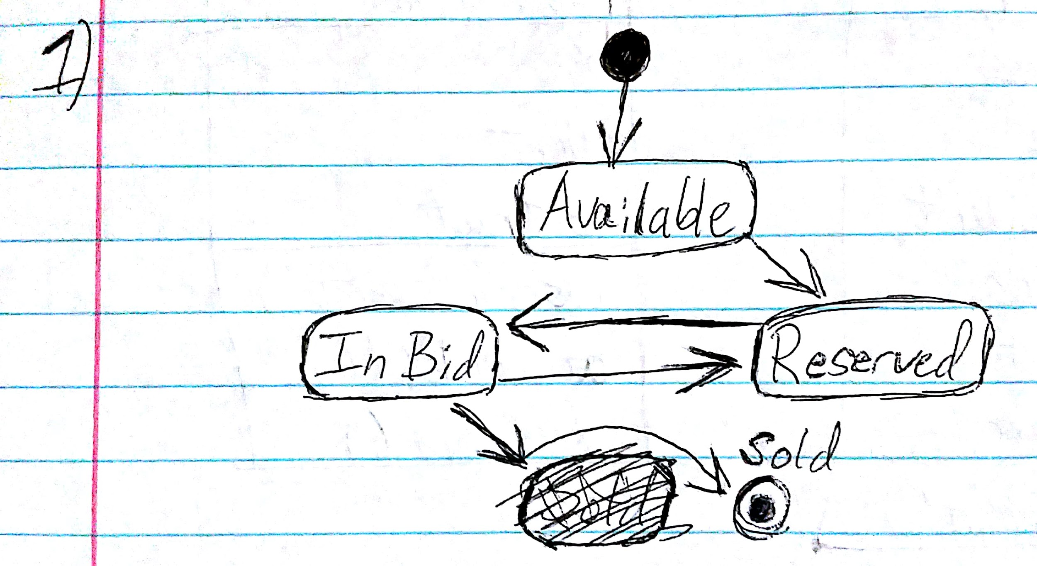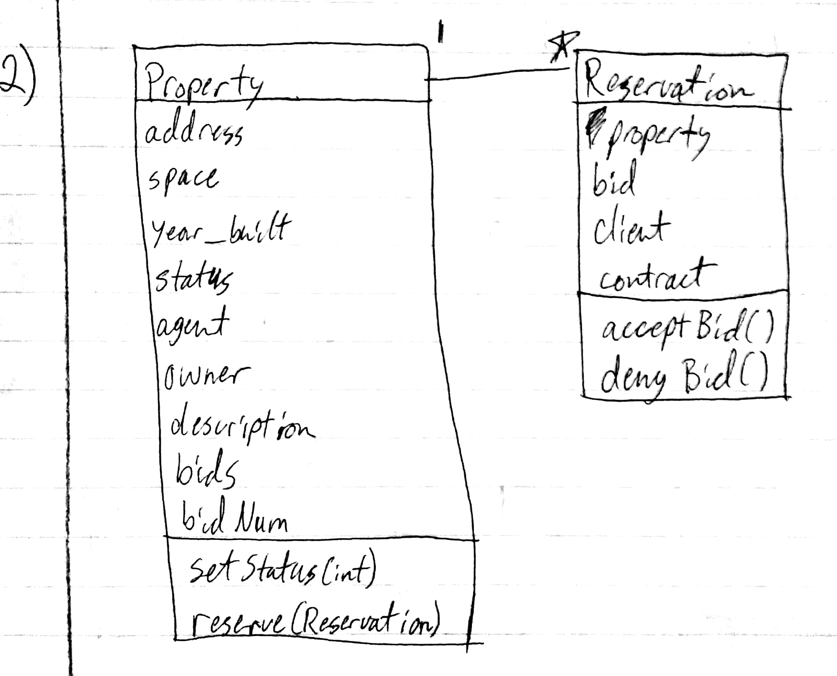//Michael Quach

//3.

#include <string>

class Property{

public:

Property(double space, string address, int year_built, int status, string owner, string agent, string description){

this->space = space; this->address = address; this->year_built = year_built;

this->status = status; this->owner = owner; this->agent = agent; this->description = description;}

~Property();

setStatus(int status){this->status = status;}

reserve(Reservation * bid){bids[bidNum] = bid; bidNum++;}

private:

Reservation * bids[10];

int bidNum = 0;

};

class Reservation{

public:

Reservation(Property * property, double bid, string client, string contract){

this->property = property; this->bid = bid; this->client = client; this->contract = contract;

property.reserve(this);

}

acceptBid(){property.setStatus(3) //3 refers to 'sold'}

denyBid(){delete this;}