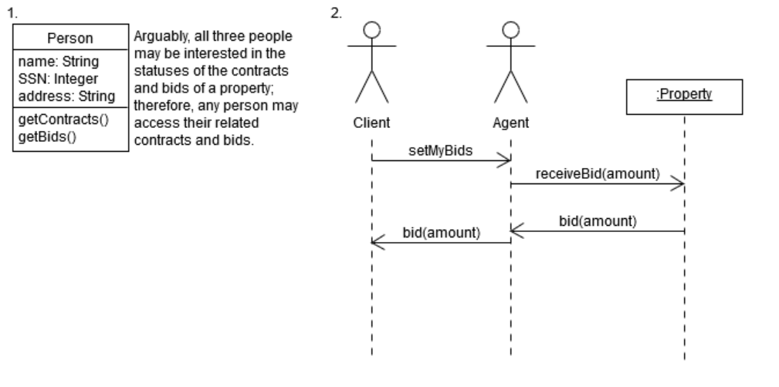

//Michael Quach

#include <string>

class Client{

public:

setMyBids(int amount){Agent.receiveBid(amount);}

}

class Agent{

public:

receiveBid(int amount){Property.bid(amount);}

}

class Property{

public:

bid(amount){this->Bid.offer = amount;}

}