EXPERIMENT-1

NAME: M Jyothi Kiran
REG.NO: 192424274
COURSE CODE: CSA1004
COURSE NAME: Software Engineering for Scalable Systems

STEP 1
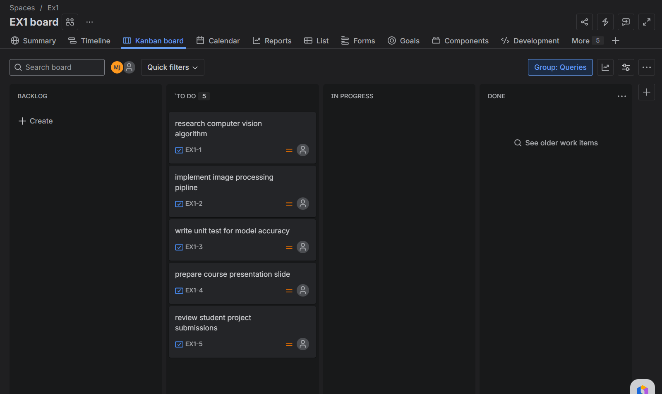

STEP 2
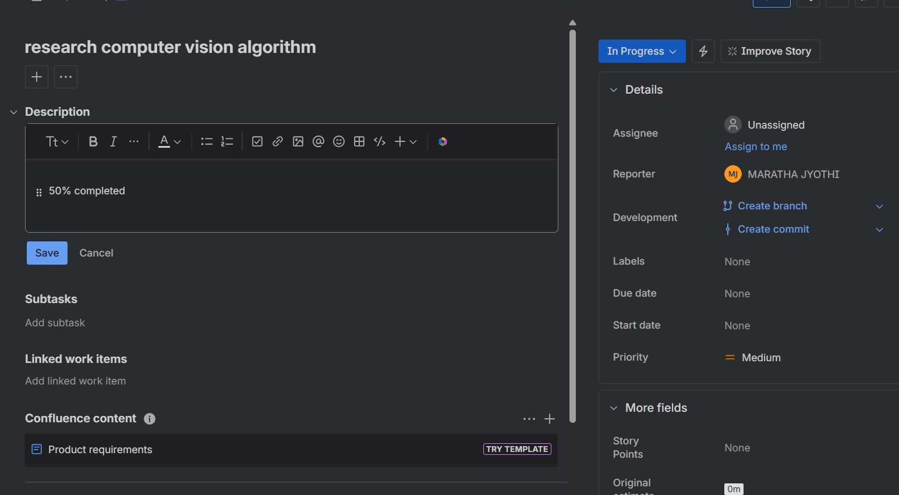
STEP 3
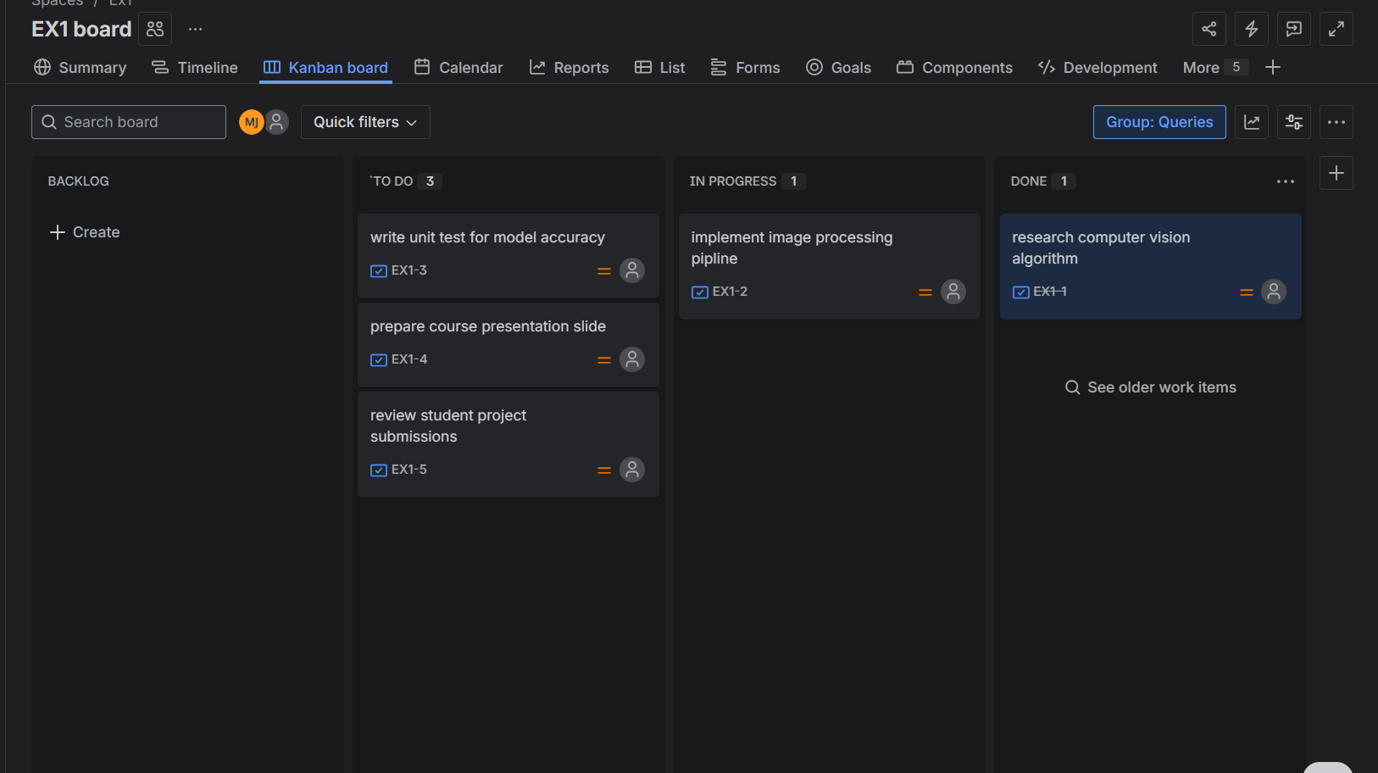

STEP 4
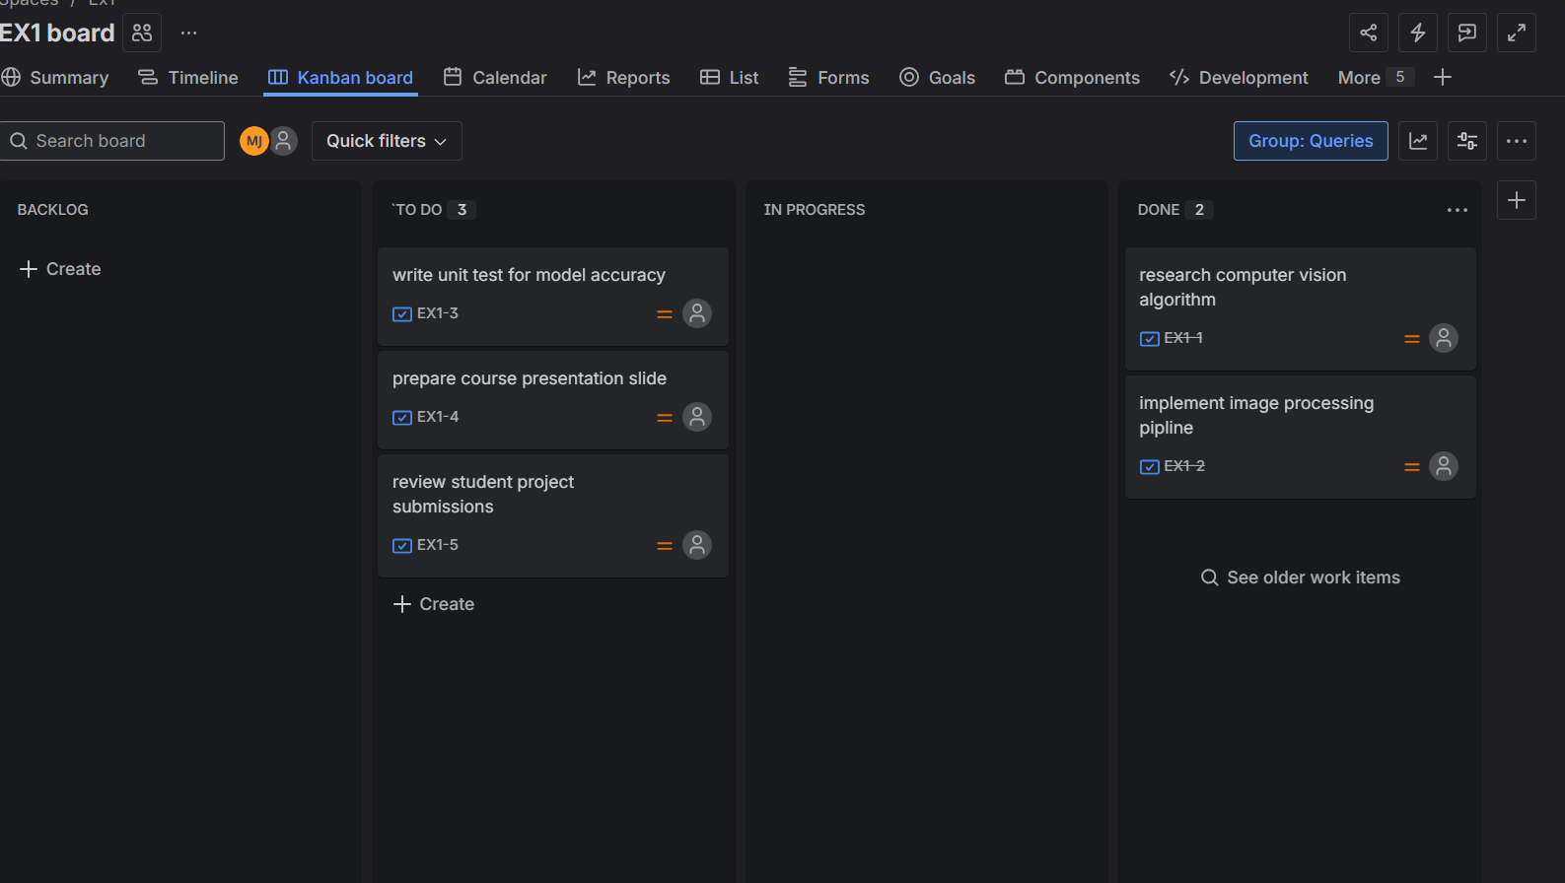
STEP 5
