**The "Battle" of Neighborhoods : Manhattan vs Staten Island**

**Task 1 : A description of the problem and a discussion of the background**

The world has faced a new challenge - to resist to new coronavirus COVID 19. The virus has penetrated all countries. The greatest threat of contamination to the inhabitants of megacities.

While scientists are looking for a vaccine, and doctors are fighting for people 's lives, our task is **KEEP CALM, STAY HOME** .

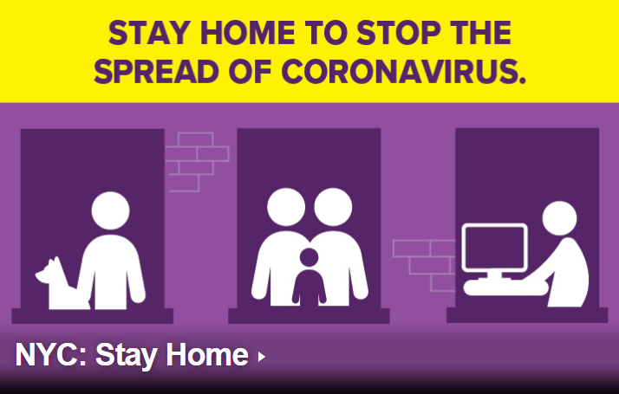

New York city is heroic against the virus. Unfortunately, it 's not stopped yet. You can find daily updates of information about people who have tested positive for COVID-19 in NYC:  <https://www1.nyc.gov/site/doh/covid/covid-19-data.page>

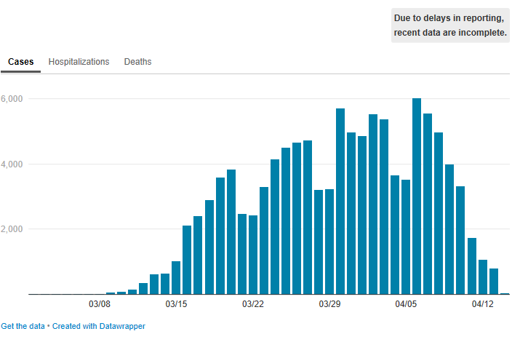

Due to the coronavirus outbreak, all of NYC’s nonessential businesses have been ordered to keep their workforces at home, and all nonessential gatherings are temporarily banned.

**Residents Manhattan** began to search for housing in other parts of the city. They no longer need restaurants and places of entertainment, they need places for privacy and relaxation.

NYC has 5 Boroughs :

<https://www.nycgo.com/neighborhoods-boroughs/about-nyc-five-boroughs/> .

* Bronx,
* Brooklyn,
* Manhattan,
* Queens
* Staten Island.

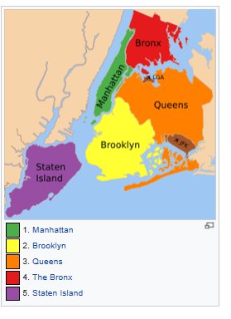

<https://en.wikipedia.org/wiki/Boroughs_of_New_York_City>

Bronx, Brooklyn and Queens have a high count of diseases.

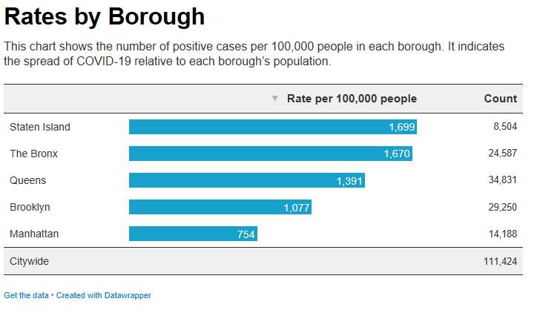

Let's have a look at **Staten Island**.

Easily accessible by a scenic ride on the Staten Island Ferry, the greenest borough feels like a getaway within the City. Beyond a charming North Shore rich with maritime history, Staten Island is best known for its beaches, vast parkland and even a fully preserved colonial village.

**Real Estate Agency** (hereinafter referred to as “REA”) would like to compare those two Boroughs (Manhattan vs Staten Island) and to focus on a list of places of Basic necessities: hospitals, pharmacies, food stores, repair workshops, veterinary clinics and so on. The full list of Basic necessities is provided here : <https://esd.ny.gov/guidance-executive-order-2026?cid=NYCEM_MEM_Coronavirus11_20200320>

**Can REA offer to rent housing with all Basic necessities in Staten Island?**