SEI Protected Leave Executive Report
Prepared for Executive Leadership

1. Example: Pregnancy Disability Leave (PDL)
Employee: Jane Doe
Role: Mid-level Environmental Consultant
Total Available Hours (Monthly): 160
Leave Taken: PDL (8 weeks / 320 hours over 2 months)
Billable Hours Worked: 100
Other Leaves: PTO – 8 hours

Chargeability Calculation
Adjusted Chargeability (%) = Chargeable Hours / (Total Available Hours – Protected Leave Hours) × 100
Adjusted Chargeability ≈ 32.1%

2. Payroll Code Matrix: PDL
Code | Description | KPI Denominator Inclusion | Category | Notes / Best Practice
PDL | Pregnancy Disability Leave | Exclude | Protected Leave | CA law: up to 4 months; job-protected; do not count in KPI denominator.
PDL-Partial | Partial PDL (Intermittent) | Exclude | Protected Leave | Track exact hours/days; adjust denominator for intermittent absences.
PDL-Return | Transition Back to Work | Include | Billable/Normal | Hours after leave counts normally; may include training/gradual ramp-up.
PDL-Overlap | PDL concurrent with FMLA/CFRA | Exclude | Protected Leave | Ensure no double-counting; both leaves excluded from KPI denominator.

3. Full Protected Leave Matrix
Code | Description | KPI Denominator | Category | Notes
FMLA | Family Medical Leave Act | Exclude | Protected Leave | Federal job-protected leave.
CFRA | California Family Rights Act | Exclude | Protected Leave | State job-protected leave.
PDL | Pregnancy Disability Leave | Exclude | Protected Leave | CA law, job-protected.
ADA/FEHA | Disability Accommodation Leave | Exclude | Protected Leave | State/federal disability protections.
Jury | Jury Duty | Exclude | Protected Leave | Statutory leave.
Bereavement | Bereavement Leave | Exclude | Protected Leave | Company leave.
Voting | Voting Leave | Exclude | Protected Leave | Statutory leave.
Military | Military Leave | Exclude | Protected Leave | Statutory leave.
Sick-Protected | Sick Leave – Job Protected | Exclude | Protected Leave | Sick leave covered under ADA/FMLA.
Sick-NonProtected | Sick Leave – Non-Protected | Include | Non-Protected Leave | Company policy sick PTO.

4. Billable vs Non-Billable
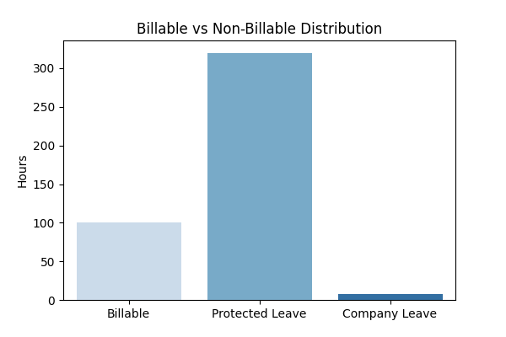

5. Leave Type Inclusion Heatmap
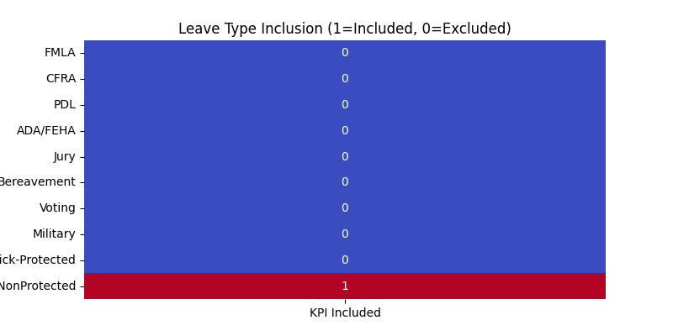

6. KPI Coverage Radar Chart
