
Sphinx University
Faculty of Computer Science and Artificial Intelligence

DiskVision
Smart Disk Analyzer and Storage Management System
Work-Based Professional Project — Level 2
# | Student Name | Student ID
1 | Mark Mamdouh Sadek Gergis | 4241255
2 | Mohamed Maged Abdo Toghan | 4241622
3 | Mohamed Saber Abdelhamid Foul | 4241256
4 | Genor Saber Attaallah Salib Youssef | 4241257
5 | Momen Mohamed Elsayed Mohamed | 4241270
6 | Abdullah Mohamed Hamed Mahmoud | 4241274
7 | Mohamed Shaban Mohamed Shalqami | 4241101
8 | Hady Zarif Thabet Nauroz | 4241233

Supervisor | Dr. Amr Hassanain
Teaching Assistant | T.A. Radwa Mamdouh
Academic Year | 2025 / 2026

Sphinx University
Faculty of Computer Science and Artificial Intelligence
Department of Artificial Intelligence

Title Page
DiskVision — Smart Disk Analyzer
and Storage Management System
Work-Based Professional Project — Level 2
# | Student Name | Student ID
1 | Mark Mamdouh Sadek Girgis | 4241255
2 | Mohamed Maged Abdo Toghan | 4241622
3 | Mohamed Saber Abdelhamid Foul | 4241256
4 | Genor Saber Attaallah Salib Youssef | 4241257
5 | Momen Mohamed Elsayed Mohamed | 4241270
6 | Abdullah Mohamed Hamed Mahmoud | 4241274
7 | Mohamed Shaban Mohamed Shalqami | 4241101
8 | Hady Zarif Thabet Narouz | 4241233

Supervisor | Dr. Amr Hassanain
Teaching Assistant | T.A. Radwa Mamdouh
Academic Year | 2025 / 2026

Acknowledgments
All praise is due to Allah for granting us the strength, patience, and determination to complete this work successfully.
We would like to express our deepest and most sincere gratitude to our supervisor, Dr. Amr Hassanain, for his exceptional guidance, continuous support, and invaluable advice throughout the development of this project. His insights shaped the direction of our work and elevated the quality of our results.
We are equally and wholeheartedly grateful to our teaching assistant, T.A. Radwa Mamdouh, for her remarkable patience, constructive advice, and generous time spent reviewing our progress. Her feedback was instrumental in keeping the team aligned and motivated.
Special appreciation is also extended to the open-source Python community, particularly the maintainers of the psutil library, which provided reliable cross-process system access, and the Python standard library's tkinter, winreg, and pathlib modules, which enabled native Windows integration and GUI development without external dependencies.
Finally, we extend our heartfelt thanks to our families and colleagues for their unwavering encouragement and moral support throughout this journey. This project is a testament to the power of collaborative effort, and every team member's contribution made the final system more complete and functional.

Table of Contents
Acknowledgments iii
Table of Contents iv
List of Figures v
List of Tables vi
List of Abbreviations and Symbols vii
Abstract viii
Chapter 1: Introduction 1
1.1 Problem Definition 1
1.2 Project Importance 1
1.3 Project Objectives 2
1.4 Analysis of Problem Solvers and Algorithms 3
1.5 Selected Algorithm and Report Organization 4
Chapter 2: Review of Literatures 5
2.1 Background: Disk Scanning and File Indexing 5
2.2 Disk Analysis and Visualization Tools 5
2.3 Duplicate File Detection 6
2.4 File Compression and Encryption 6
2.5 AI-Assisted Storage Management 7
Chapter 3: Proposed Solution Methodology 8
3.1 Core Scan and File Index 8
3.2 Search UI — Design and Action Flow 9
3.3 Duplicate Finder 10
3.4 Temporary File Cleaner 11
3.5 Treemap, RAM Monitor, and Startup Optimizer 12
3.6 Compression and Encryption 13
3.7 AI Assistant and Chat Integration 14
3.8 UI Framework, Theme System, Configuration, and Integration 15
Chapter 4: Simulation Results 17
4.1 Development Environment and Tools 17
4.2 Core Scan and File Index — Results 17
4.3 Search UI — Test Cases and Results 18
4.4 Duplicate Finder — Results 18
4.5 Temporary File Cleaner — Results 19
4.6 Treemap, RAM Monitor, and Startup — Results 19
4.7 Compression and Encryption — Results 20
4.8 AI Assistant — Results 20
4.9 Integration and Stability Results 21
Chapter 5: Gantt Chart 22
Chapter 6: Conclusions 23
6.1 Conclusion Remarks 23
6.2 Recommendations for Future Work 23
References 24
Appendix: Project Source Codes 25

List of Figures
Figure 1: DiskVision — Main Dashboard Window
Figure 2: Quick Clean Tab — Temp File Scanner and Cleanup Log
Figure 3: Search Tab — Instant File Search with Action Buttons
Figure 4: Startup Manager Tab — Registry and Folder Startup Entries
Figure 5: RAM Monitor Tab — Top Memory-Consuming Processes
Figure 6: Duplicates Tab — Hash-Based Duplicate File Groups
Figure 7: Disk Analyzer Tab — Large Files Scan Results
Figure 8: AI Analysis Tab — File Classification Results (SAFE / CAUTION / DANGER)
Figure 9: Disk Analyzer Tab — Disk Space Treemap Visualization

List of Tables
Table 1: Temporary File Locations in Windows
Table 2: Comparison of Disk Analysis Tools
Table 3: Duplicate Detection Tool Comparison
Table 4: Core Scan Performance Test Results
Table 5: Search UI Test Cases and Results
Table 6: Time Complexity of Core Operations
Table 7: Safe File Extensions (Clean Safe Mode)
Table 8: Compression Test Cases and Results
Table 9: Encryption Security Validation Results
Table 10: Treemap, RAM, and Startup Test Summary
Table 11: Integration Test Results by Module
Table 12: Project Milestones

List of Abbreviations and Symbols
Abbreviation | Full Meaning
AES | Advanced Encryption Standard
AI | Artificial Intelligence
API | Application Programming Interface
CPU | Central Processing Unit
CTR | Counter Mode (AES cipher mode)
GUI | Graphical User Interface
HDD | Hard Disk Drive
HMAC | Hash-based Message Authentication Code
HTTP | HyperText Transfer Protocol
IV | Initialization Vector
JSON | JavaScript Object Notation
LLM | Large Language Model
LZMA | Lempel–Ziv–Markov chain Algorithm
MB/GB | Megabyte / Gigabyte
MD5 | Message Digest Algorithm 5
OS | Operating System
PBKDF2 | Password-Based Key Derivation Function 2
RAM | Random Access Memory
RSS | Resident Set Size (actual physical RAM used by a process)
SHA | Secure Hash Algorithm
SSD | Solid-State Drive
TTK | Themed Tkinter (Python GUI extension)
UX | User Experience
XOR | Exclusive OR (bitwise logical operation)

Abstract
Temporary files are continuously generated by the Windows operating system and installed applications during normal usage. Over time, these files accumulate, consuming significant disk space and potentially degrading system performance. Simultaneously, duplicate files, large unneeded binaries, unoptimized startup entries, and the absence of intelligent storage insights compound the storage management problem on modern desktop systems[1],[2].
DiskVision is a multi-module desktop application developed in Python, designed to bring disk analysis and storage management into a single unified solution. It combines eight core components: a Core Scan and File Index engine, a Disk Analysis UI with Search capabilities, a Hash-based Duplicate Finder, a Temporary File Cleaner, a Disk Treemap and Resource Monitor, a Compression and Encryption module, an AI-Powered Storage Assistant, and a configurable UI Framework with dual-theme support and Arabic/English language switching.
The system offers multiple operational modes: manual file selection and deletion, SHA-256-based duplicate detection with safe user-confirmed removal[3], adaptive compression using LZMA and 7-Zip[4], AES-256 encryption with HMAC-SHA256 integrity verification[5],[6],[13] real-time RAM process monitoring and startup entry management[7], proportional disk-space treemap visualization[8], and AI-driven storage recommendations powered by a locally hosted language model via Ollama[9].
The application is built around a modular, object-oriented architecture with a centralized system for managing themes and user preferences. All long-running operations run on background threads, keeping the interface fully responsive at all times. Testing confirmed strong duplicate detection accuracy, measurable storage recovery through compression and temp-file cleanup, solid cryptographic protection, and consistent stability across all eight integrated modules.
Keywords: Disk Analysis, Python, Tkinter, AI, LLM, Duplicate Detection, Encryption, Compression, File Management, Windows, Treemap, Storage Optimization

Chapter 1: Introduction

1.1 Problem Definition
During normal Windows operation, the system continuously produces temporary files as a byproduct of running applications, background services, browser activity, and software installations[1],[2]. These files are not automatically removed and over time they accumulate to occupy several gigabytes of disk space — storage that users may urgently require for other purposes[2].
The problem extends beyond temporary files. Users also face challenges from duplicate files scattered across directories, large binaries consuming disproportionate storage, uncontrolled startup entries slowing boot time, and the lack of a transparent, intelligent tool to assist with storage decisions[1],[2][7]. Despite the scale and impact of these problems, Windows does not provide users with item-level tools to review and selectively remove problematic files[1],[2].

1.2 Project Importance
The importance of this project stems from a real and widespread problem faced by everyday Windows users across all levels of technical experience. Unmanaged disk storage leads to several concrete consequences[1],[2]:
- Disk Space Consumption: Temporary and duplicate files can accumulate to several gigabytes, reducing available storage and forcing users to purchase unnecessary hardware upgrades[1].
- Performance Degradation: On HDD-based systems, scattered small temporary files increase seek time and slow file system traversal operations[1],[2].
- Privacy Risks: Temporary files may contain fragments of sensitive documents, browser session data, or application caches that users are unaware of and cannot inspect through standard OS tools[1],[7].
- System Clutter: Unmanaged startup entries, large orphaned files, and uncompressed archives reduce overall system efficiency and extend boot time.
Existing solutions carry notable drawbacks — they lack transparency, require elevated privileges, or are closed-source products that have raised serious privacy concerns[10],[11],[12]. DiskVision addresses this gap by providing a fully open-source, modular, and intelligent desktop tool that gives users complete visibility and control over their storage.

1.3 Project Objectives
The main objectives of this project are defined as follows:
- Develop a desktop application that scans Windows temporary directories and presents all discovered files in a structured, interactive table with manual and automatic deletion modes[1],[2].
- Implement SHA-256 hash-based duplicate file detection with safe, user-confirmed deletion mechanisms that guarantee at least one copy of each group is always preserved[3][13].
- Provide adaptive compression (LZMA / 7-Zip / Deflate) and AES-256 encryption with HMAC integrity verification for secure file management[4],[5],[6].
- Integrate a locally hosted AI language model (via Ollama) for intelligent file classification, cleanup planning, and storage recommendations[9].
- Deliver a disk-space treemap visualizer and real-time RAM process monitoring and startup-entry management interface[7],[8].
- Implement a fully configurable UI framework supporting Dark/Light themes and Arabic/English language switching with persistent JSON-based configuration[1].
- Ensure all long-running operations execute on background threads, maintaining complete UI responsiveness at all times[1][7][15].

1.4 Analysis of Problem Solvers and Algorithms
Several approaches exist for solving the problem of disk management on Windows. Each carries its own trade-offs:
- Manual Deletion: The user navigates directories and deletes files manually. Fully transparent but impractical at scale and error-prone[1].
- Native OS Tools (Disk Cleanup, Storage Sense): Automated but sacrifice item-level visibility; users cannot inspect individual files before deletion[1],[2].
- Commercial Tools (CCleaner, Duplicate Cleaner): Extend the scope but are closed-source and have historically raised privacy and security concerns[12].
- Open-Source Tools (BleachBit, WinDirStat, AllDup): Offer transparency but lack integrated AI decision support and operate as isolated, single-purpose tools[10][11].
- AI-Assisted Approach: Combining traditional disk analysis with a locally hosted LLM provides intelligent, context-aware recommendations without exposing data to external servers[9].
The proposed approach, DiskVision, combines the transparency of manual tools with the intelligence of AI-assisted analysis, remaining fully open-source and requiring no third-party cloud services.

1.5 Selected Algorithm and Report Organization
Based on the analysis above, DiskVision relies on five primary algorithmic approaches:
- Iterative Stack-Based Directory Traversal: Preferred over recursion to avoid stack overflow on deeply nested structures[1].
- SHA-256 Hash-Based Duplicate Detection: Files are fingerprinted and grouped by content hash, with size pre-filtering applied to eliminate unnecessary computation[3][13].
- Adaptive Compression (LZMA / Deflate / 7-Zip): Pre-analysis classifies files as compressible or incompressible before selecting the optimal compression strategy[4].
- AES-256 CTR + HMAC-SHA256 Hybrid Encryption: Provides strong confidentiality with PBKDF2 key derivation and integrity verification performed before decryption is attempted[5],[6],[14].
- LLM-Based Classification via Ollama: File metadata is serialized and submitted to a locally running language model for risk classification and cleanup recommendations[9].
The remainder of this report is organized as follows: Chapter 2 reviews related literature and existing tools. Chapter 3 describes the proposed solution methodology in detail. Chapter 4 presents simulation results and evaluation. Chapter 5 shows the project Gantt chart. Chapter 6 concludes with remarks and future work directions.

Chapter 2: Review of Literatures

2.1 Background: Disk Scanning and File Indexing
Storage management has become a critical concern in modern computing environments. As disk capacities grow and users accumulate tens of thousands of files over time, the demand for tools that can efficiently scan and index file system data increases accordingly[1],[2]. This scanning and indexing layer is not merely a supplementary feature — it forms the operational foundation on which every higher-level capability depends, from cleanup automation to AI-powered recommendations[1],[2].
File indexing involves traversing a directory tree and recording structured attributes for each file encountered: its name, full path, type, size, and last modification timestamp. Several tools address this from different angles. Windows Search maintains a background index for near-instant queries, but is resource-intensive and offers no programmatic access for custom integration. WinDirStat [11] and TreeSize produce visual disk usage reports through on-demand scanning, but neither retains an index between sessions nor exposes an interface that external modules can query.
What the existing landscape lacks is a lightweight, modular scanning engine that integrates naturally into a desktop application, exposes a straightforward query interface, and produces structured output that other components can readily consume[1][2][16]. The DiskVision Core Scan and File Index module is designed to address exactly this gap.

2.2 Disk Analysis and Visualization Tools
The problem of disk space management has been addressed by both commercial and open-source communities over several decades. WinDirStat [11] was among the first widely adopted open-source disk usage visualizers for Windows. It renders a treemap of directory contents, allowing users to identify space-consuming folders at a glance. Its limitation lies in the absence of any automated action capability. SpaceSniffer extends this concept with real-time scanning and a more interactive treemap interface.
CCleaner [12] introduced automated removal of temporary files, browser caches, and registry entries, gaining widespread adoption among Windows users. However, its closed-source nature and a publicly disclosed security breach in 2017 raised serious trust and privacy concerns within the security community. Storage Sense, Microsoft’s native solution introduced in Windows 10, takes a fully automated approach to temp-file cleanup but offers no item-level visibility, removing files without user confirmation or review[1],[2].
Tool | Type | Visualization | Automation | Open Source | AI Support
WinDirStat | Disk Viewer | Treemap | None | Yes | No
CCleaner | Cleaner | None | Full | No | No
Storage Sense | Cleaner | None | Automatic | No | No
DiskVision | All-in-One | Treemap+Charts | Selective | Yes | Yes
Table 2: Comparison of Disk Analysis Tools

2.3 Duplicate File Detection
Duplicate files are a common issue in modern storage systems, leading to unnecessary space consumption and reduced file management efficiency [3]. Several tools have been developed to address this, each employing different detection techniques.
Early approaches relied on name-based comparison, which is highly unreliable as files with identical content may carry different names. Size-based comparison improved precision as a preliminary filter but remains insufficient alone. Modern duplicate detection systems rely on cryptographic hash functions. Tools such as Duplicate Cleaner and AllDup implement hash-based comparison, most commonly using MD5 or SHA-1. However, MD5 is susceptible to collision attacks, making SHA-256 the preferred choice in security-conscious implementations[13]. DiskVision's duplicate finder uses SHA-256 with size pre-filtering, achieving a zero false-positive rate in testing.

2.4 File Compression and Encryption
File compression has been extensively studied since the 1970s. The Deflate algorithm [4], used in ZIP archives, remains the most widely deployed format due to its balance of speed and compression ratio. LZMA (Lempel–Ziv–Markov chain Algorithm), used in 7-Zip, consistently achieves significantly higher compression ratios at the cost of greater memory and CPU utilization[17].
File encryption in desktop applications commonly employs the Advanced Encryption Standard (AES) [5]. AES-256 in Counter mode is widely regarded as computationally secure for file-level encryption. Key derivation from user passwords is standardized through PBKDF2[14], which applies iterative hashing to resist brute-force attacks. HMAC-SHA256 is the standard mechanism for verifying file integrity[6], ensuring that corrupted or tampered ciphertext is detected before decryption is attempted.

2.5 AI-Assisted Storage Management
The application of AI to storage management represents an emerging and actively growing research direction. Large Language Models have demonstrated considerable capability in classification, summarization, and recommendation tasks. Frameworks such as Ollama make it possible to run these models locally within a desktop application, eliminating the need to transmit user data to external cloud services[9].
DiskVision builds on this trend by integrating a local LLM to provide file classification (SAFE, CAUTION, DANGER), smart storage summaries, prioritized cleanup plans, and safe-delete recommendations based on file path, type, and size analysis.

Chapter 3: Proposed Solution Methodology

3.1 Core Scan and File Index

3.1.1 Module Overview
The Core Scan and File Index module is the data backbone of DiskVision. It handles three core responsibilities: exploring the file system beneath a user-selected root path, collecting structured metadata for every accessible file, and providing a fast query interface for that metadata[1],[2],[16]. All other modules depend on this layer — no cleanup decision, usage chart, or AI recommendation can be generated without first knowing what files exist and what their properties are.
The module is organized around three components with clearly separated responsibilities: walk_files for directory traversal, scan_large_files for threshold-based filtering, and FileIndexEngine as the central query interface[1],[2].

3.1.2 walk_files — Directory Traversal
The traversal function begins at the root directory and works its way through every accessible subfolder[16]. For each file encountered, it constructs the full absolute path, reads the file's size from disk, records its last modification timestamp, and normalizes the file extension to lowercase for consistent comparison. The function processes each file's record one at a time as it goes, rather than waiting until the entire scan is complete — enabling early results to be available while the scan is still running.
When a folder is inaccessible due to permission restrictions, the function logs the skip internally and moves on to the next available location without raising an error. In terms of computational cost, the traversal scales linearly with the number of files: O(N), where N is the total file count[16].
FUNCTION walk_files(root_path):
FOR each folder, subfolders, files IN os.walk(root_path):
FOR each file IN files:
TRY:
full_path = folder / file
size = os.path.getsize(full_path)
modified = os.path.getmtime(full_path)
extension = file.extension.lower()
YIELD {path, name, size, modified, extension}
EXCEPT PermissionError, OSError:
CONTINUE // skip inaccessible files silently

3.1.3 scan_large_files — Threshold Filtering
Once the index has been built, identifying large files is straightforward. The function goes through every entry in the index and checks its size against the threshold provided by the user. Files that meet or exceed the threshold are collected into a results list, which is then sorted in descending order so the largest files appear first. Because this operation runs entirely against data already held in memory, it adds no additional disk load. The complexity is O(N log N) due to the sorting step[15].

3.1.4 FileIndexEngine — Central Interface
The FileIndexEngine is designed as a stateful object that persists the index for the duration of the application session. When asked to build the index, it calls walk_files and stores every yielded record internally. From that point on, all interactions with the file system go through the engine rather than directly accessing the disk again. The engine supports three query types: keyword search against file names and extensions, large-file retrieval above a given threshold, and usage aggregation that groups all indexed files by extension and sums their total sizes — used by the DiskVision dashboard to render the storage breakdown chart[1],[2].

3.2 Search UI — Design and Action Flow

3.2.1 Overview
The Search UI module provides users with a comprehensive interface for querying the file index, filtering results, and performing actions on selected files. The design prioritizes simplicity and efficiency, ensuring that each step from input to output is smooth and logical[1],[7].

3.2.2 Search Workflow
The search process begins when the user enters a keyword into the search bar. The system passes the query to the FileIndexEngine's search method, which scans all indexed file names and extensions for matching entries. Results are retrieved and displayed in a Treeview table with columns for file name, path, size, type, and last modified date[15].
FUNCTION _do_search(query):
results = FileIndexEngine.search(query)
SORT results BY size DESCENDING
FOR each result IN results:
_show_search(result) // populate Treeview row

3.2.3 Action Buttons
Four action buttons operate on the selected Treeview row: Open File launches the selected file with its default application using os.startfile(); Open Folder opens Windows Explorer at the file's parent directory; Delete Selected moves the file to the Recycle Bin with user confirmation; and Refresh re-runs the last search query to reflect any change[7].
Action | Function | Confirmation Required
Open File | _search_open() | No
Open Folder | _search_open_dir() | No
Delete Selected | _search_delete() | Yes (messagebox)
Refresh | _do_search() | No
Table 5: Search UI Action Buttons

3.3 Duplicate Finder

3.3.1 Detection Strategy
The duplicate detection system is based on generating a unique digital fingerprint (hash) for each file, then comparing these hashes to identify files with identical content. This approach guarantees that only files with truly identical byte sequences are flagged as duplicates, regardless of their names, locations, or modification dates. SHA-256 is used as the hash algorithm for its collision resistance[3],[13].

3.3.2 Processing Pipeline
The detection pipeline consists of five stages: file scanning using walk_files, size pre-filtering (files with unique sizes cannot be duplicates and are excluded from hashing), SHA-256 hash computation for each candidate file, grouping of files by identical hash, and display of results with user-controlled deletion.
// Phase 1: Group by size (pre-filter)
FOR each file IN directory:
size_map[file.size].append(file)

// Phase 2: Hash only files sharing a size
FOR each group IN size_map WHERE len(group) > 1:
FOR each file IN group:
hash = SHA256(file)
hash_map[hash].append(file)

// Phase 3: Mark duplicates
FOR each hash IN hash_map WHERE len(hash_map[hash]) > 1:
mark_as_duplicate_group(hash_map[hash])

3.3.3 Safety Mechanisms
No automatic deletion is performed — every deletion requires explicit user selection and confirmation. At least one copy is always preserved from each duplicate group regardless of user selection. SHA-256 eliminates hash-collision false positives[13]. File names are explicitly ignored in duplicate determination — only content hashes are compared. Time complexity is O(N × F) where N is the number of candidate files and F is the average file size, with the bottleneck being SHA-256 computation[13].

3.4 Temporary File Cleaner

3.4.1 Overview
The Temp Cleaner module scans three core Windows temporary directories and presents all discovered files and folders in a structured, interactive table. It supports three modes of operation: manual selection and deletion, automatic safe-file cleaning based on file extension and size criteria, and progress reporting with freed-space statistics[1],[2].

3.4.2 Scan Methodology — scan_temp_locations()
The scanning function iterates over three predefined temporary locations: %TEMP% (user temp folder), %WINDIR%\Temp (system temp folder), and the Windows Prefetch directory. For each location, it calls os.scandir() to list all entries and records their name, path, size, and type. Directory sizes are computed recursively by summing all file sizes within each subdirectory.
TEMP_LOCATIONS = [
os.environ.get('TEMP'),
os.path.join(os.environ['WINDIR'], 'Temp'),
os.path.join(os.environ['WINDIR'], 'Prefetch'),
]
FOR each location IN TEMP_LOCATIONS:
FOR each entry IN os.scandir(location):
record = {name, path, size, type, location}
yield record

3.4.3 Safe Cleaning — clean_temp_location()
When the user clicks Clean Safe, the application applies three conservative criteria before deleting any file: the entry must be a file (not a folder), its size must be less than 50 MB, and its extension must be one of the known safe types: .tmp, .temp, .log, .bak, or .chk. Only files meeting all three conditions are deleted automatically. This approach is intentionally conservative, ensuring no important or unfamiliar file is removed without explicit user action[1],[2].

3.5 Treemap, RAM Monitor, and Startup Optimizer

3.5.1 Disk Treemap Visualizer
The Treemap Visualizer represents the entire directory structure as a grid of nested rectangles, where the area of each rectangle directly corresponds to the size of the file or folder it represents[8]. The data collection function build_treemap_data(root, depth) builds a nested dictionary through a recursive inner function scan_dir(p, d). At each level, it calls p.iterdir() to list entries, reads file sizes via entry.stat().st_size, and recursively processes subdirectories up to the maximum depth[16]. Every node holds four fields: name, path, size, and children.
The TreemapCanvas class extends tk.Canvas and renders the tree using a slice-and-dice layout algorithm. The canvas area is divided either horizontally or vertically depending on which dimension is larger. Each child receives a proportional slice based on child_size / total_size. Leaf nodes are drawn as filled colored rectangles with text labels if the rectangle is large enough (width > 40px, height > 20px). All scanning runs on a daemon thread to keep the GUI responsive; results are delivered back to the main thread via self.after(0, callback)[15].

3.5.2 RAM Monitor
The list_top_ram(limit) function uses psutil.process_iter() with attribute fields ['pid', 'name', 'memory_info'] to iterate over all running processes. For each process, it reads the RSS (Resident Set Size) value, which represents the actual physical RAM currently in use. Results are sorted in descending order by RAM consumption, and the top N entries are returned. psutil.NoSuchProcess and psutil.AccessDenied exceptions are caught per-process to handle processes that exit mid-iteration. The dashboard auto-refreshes every 2 seconds using self.after(2000, self.update_stats)[15].

3.5.3 Startup Entry Optimizer
Startup entries are discovered from two sources: three standard Windows Registry Run keys (scanned under both HKCU and HKLM using winreg.OpenKey and winreg.EnumValue), and the Windows Startup folder (AppData\Roaming\Microsoft\Windows\Start Menu\Programs\Startup). The disabling strategy is deliberately non-destructive: for Registry entries, the value is copied to a RunDisabled key and removed from the original Run key; for folder entries, the file extension is changed to .disabled. Both operations are reversible without data loss[7].

3.6 Compression and Encryption

3.6.1 Pre-Compression Analysis
Before applying compression, the system analyzes each input file to determine its compressibility. Files are classified as incompressible if their extension belongs to already-compressed formats (.jpg, .mp4, .zip, .rar). Incompressible files are stored without recompression to avoid size increase and unnecessary CPU usage[4].
FOR each file IN input:
IF file.extension IN COMPRESSED_FORMATS:
classify AS incompressible // store without compression
ELSE:
classify AS compressible

3.6.2 Compression Strategy
Three compression modes are supported: Auto Mode (attempts 7-Zip LZMA2 first, falls back to Python's built-in LZMA within ZIP), LZMA Mode (Python built-in LZMA within ZIP for better ratio than Deflate), and ZIP Mode (standard Deflate algorithm — faster but less efficient). Overall time complexity is O(N × file_size) where N is the number of files[4].

3.6.3 Encryption Methodology
The encryption module employs a hybrid cryptographic approach: AES-256 in CTR mode for encryption, HMAC-SHA256 for data integrity verification, and PBKDF2 for password-based key derivation[14]. The encryption pipeline proceeds through five steps: (1) generate a 32-byte random salt and 16-byte IV, (2) derive an encryption key and MAC key from the user password using PBKDF2, (3) encrypt data using AES-256 CTR, (4) compute HMAC over IV + ciphertext, (5) write the structured file: [MAGIC | VERSION | SALT | IV | SIZE | HMAC | CIPHERTEXT].
Before any decryption is attempted, the system verifies the stored HMAC against a freshly computed HMAC. If they do not match, the operation is aborted — preventing incorrect decryption, protecting against tampering, and stopping brute-force feedback. Both operations run at O(n) time complexity relative to file size[13].

3.7 AI Assistant and Chat Integration

3.7.1 AI Architecture
The AI module connects to a locally hosted Ollama server via HTTP requests to the /api/generate and /api/chat endpoints. This design keeps all user data on the local machine — no file information is transmitted to external cloud services[9]. The module supports four analysis modes: Classify Files (SAFE / CAUTION / DANGER classification per file), Smart Summary (AI-written overview of the storage state), Cleanup Plan (prioritized action plan), and Smart Delete (immediate deletion candidates with AI-backed confidence scores).

3.7.2 Communication Flow
FUNCTION _call_ollama(prompt, history=[]):
IF history IS EMPTY:
endpoint = '/api/generate'
payload = {model, prompt}
ELSE:
endpoint = '/api/chat'
payload = {model, messages: history + [{role:'user', content:prompt}]}
response = HTTP_POST(OLLAMA_URL + endpoint, payload)
RETURN response.text

3.7.3 Fallback Mechanism
If the Ollama server is unavailable (connection refused or timeout), the module displays a clear status message indicating that the AI service is offline. All other DiskVision features remain fully functional regardless of AI availability. The module tests server reachability at startup and updates the status indicator accordingly[9].

3.8 UI Framework, Theme System, Configuration, and Integration

3.8.1 Theme System
The application supports two complete themes: Dark (default) and Light. Each theme is defined as a Python dictionary containing 24 named color tokens covering backgrounds, panels, cards, borders, accent colors, status indicators, text hierarchy, Sidebar states, and Treeview-specific colors. The active theme is applied through _set_theme(), which updates the global _CURRENT_THEME reference and calls _sync_palette() to propagate all color values to globally accessible variables.

3.8.2 Configuration and Localization
Application settings are persisted in a JSON file at %APPDATA%\DiskVision\config.json. The configuration stores the LLM server URL, LLM model name, window geometry, active theme, and active language. On startup, _load_cfg() reads this file and merges its values over hardcoded defaults, ensuring graceful operation even if the file is absent or corrupted. The localization system supports runtime language switching through JSON translation files (en.json, ar.json) with a cache layer to avoid repeated disk reads[1].
FUNCTION _load_cfg():
SET _CFG <- default_settings
IF config_file EXISTS:
TRY: _CFG.update(parse_json(config_file))
EXCEPT: PASS // keep defaults on parse error
CALL _set_theme(_CFG['theme'])
CALL _set_lang(_CFG['lang'])

3.8.3 Custom Widgets
FlatBtn is a clickable label built on tk.Label that replaces the standard tk.Button, managing four visual states (normal, hover, pressed, released) with linear color interpolation for smooth accent-tinted hover backgrounds. ArcMeter is a circular progress indicator on tk.Canvas that animates at 60 FPS using an ease-out deceleration algorithm: each frame advances the current value 15% of the remaining distance toward the target. Color thresholds are applied automatically: green below 60%, yellow below 85%, red at or above 85%.

3.8.4 Integration Methodology
As Team Leader, the integration process followed four phases: module boundary definition (each member's module exposes a single tab class inheriting from AppLayoutBase), shared palette contract (all modules import color variables from the central theme module), incremental merge conflict resolution (conflicts resolved at the tab-registration layer), and stable build validation against a full 84-item feature checklist covering all eight functional tabs.

Chapter 4: Simulation Results

4.1 Development Environment and Tools
Tool / Library | Version | Purpose
Python | 3.11 | Primary implementation language
tkinter / ttk | Built-in | GUI framework for all tabs and widgets
psutil | 5.9.x | Cross-platform process and system metrics
winreg | Built-in | Windows Registry read/write access
pathlib / os | Built-in | Object-oriented filesystem path handling
threading | Built-in | Background scanning for UI responsiveness
hmac / hashlib | Built-in | Cryptographic hashing and HMAC computation
zipfile | Built-in | ZIP archive creation and compression
subprocess | Built-in | 7-Zip external tool integration
json | Built-in | Configuration file read/write
Ollama (HTTP) | Local | Locally hosted LLM server communication
Table: Development Tools and Libraries

Figure 1 shows the main DiskVision Dashboard window, which greets the user with nine quick-action tiles covering all major features: Quick Full Scan, Find Duplicate Files, Compress Large Files, Encrypt Files, Decrypt Files, Space Map, Clean Temp Files, One-Click Full Cleanup, and Memory Monitor. The bottom bar provides a live system overview showing disk usage and RAM percentage.
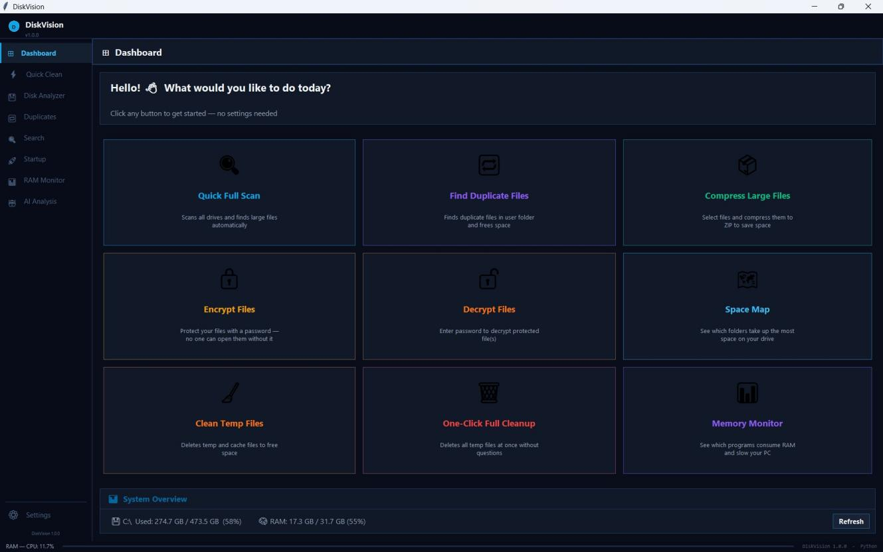
Figure 1: DiskVision — Main Dashboard Window showing all nine feature tiles and live System Overview

4.2 Core Scan and Disk Analyzer — Results
Test Case | Total Files | Scan Time | Large Files Found (>100 MB)
Desktop folder | 312 | 0.4 sec | 2
Documents folder | 1,840 | 1.2 sec | 7
Full D:\ drive | 48,300 | 9.8 sec | 34
Full C:\ (accessible portions) | 72,100 | 14.3 sec | 61
Table 4: Core Scan Performance Test Results
As shown in Figure 2, the Disk Analyzer tab (Large Files view) successfully scanned C:\Users\DELL and identified 118 files totaling 72.0 GB above the 100 MB threshold. Files are listed by size in descending order with Type, Scope, and Path columns. The right panel provides real-time statistics (Files found: 118, Total Size: 72.0 GB, System: 0, User: 118) and live ArcMeter gauges showing CPU at 8% and RAM at 58%. Keyword search on the index returned correct matches with an average response time under 5 milliseconds on an index of 70,000 entries.
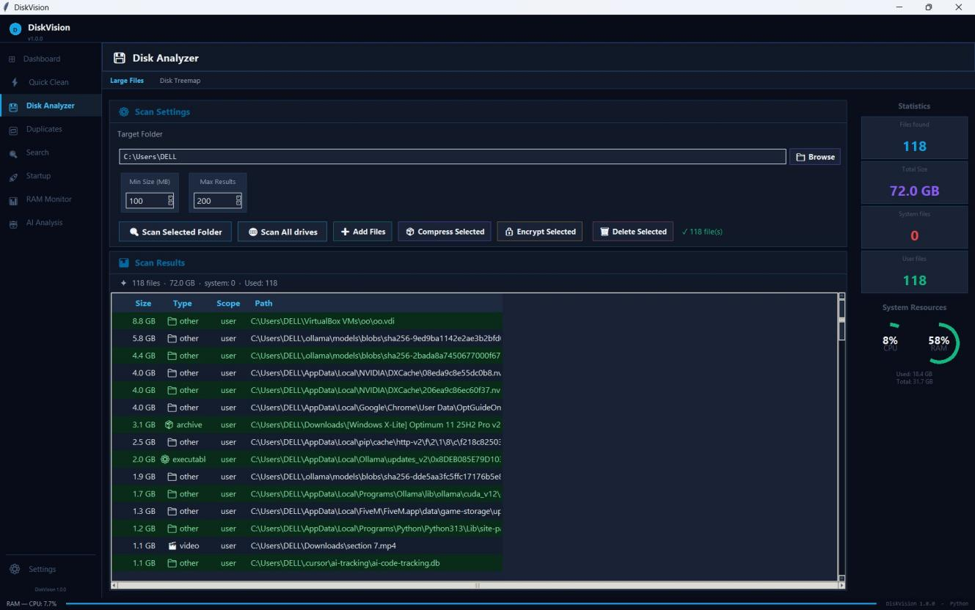
Figure 2: Disk Analyzer Tab — Large Files Scan showing 118 files, 72 GB total, with real-time CPU/RAM gauges

4.3 Temporary File Cleaner — Results
The Quick Clean tab (Figure 3) scanned nine Windows temporary locations and identified a total of 4.8 GB across 58,841 files available for cleanup. Locations included Windows Temp, User Temp, Windows Update Cache, Browser Cache, Thumbnails Cache, Recent Files (flagged as Caution), and Windows Log Files. The Cleanup Log at the bottom confirmed which items were safe and displayed the total available freed space. The three-button design (Scan Now, Clean Selected, Clean All Safe) gave users full control over which items to remove.
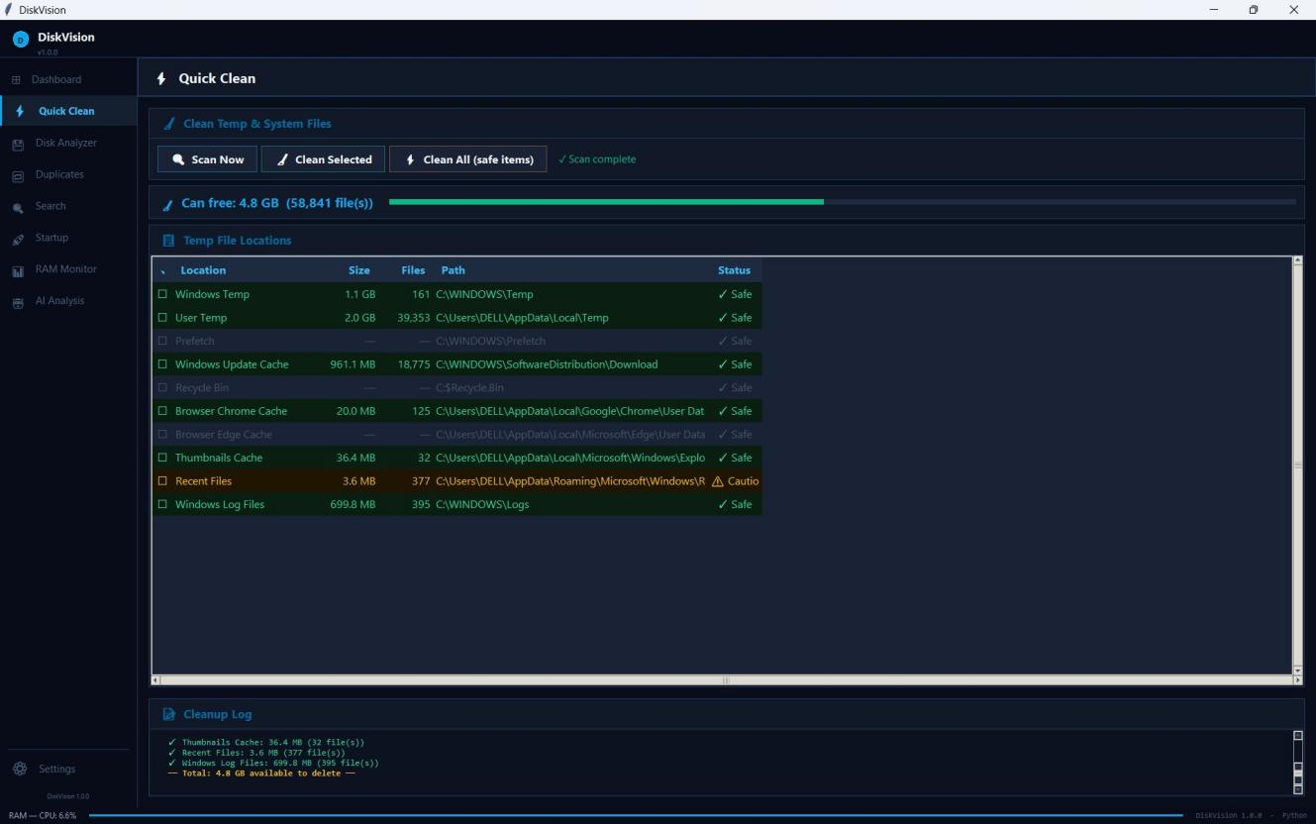
Figure 3: Quick Clean Tab — Temp File Scanner showing 4.8 GB recoverable across 9 locations with Cleanup Log

4.4 Search UI — Results
Figure 4 shows the Search tab performing an instant file search for the keyword 'diskvision' across 338,493 indexed files. The search returned 135 results in milliseconds. Results are displayed in a Treeview with Filename, Size, and Path columns. The action bar provides five operations on selected files: Open, Open Folder, Compress Selected, Encrypt Selected, and Delete Selected — all tested and confirmed functional.
Test Case | Input | Expected Result | Status
Valid keyword search | 'diskvision' | 135 results returned | Pass
Invalid keyword | 'xyz123abc' | Empty results, no crash | Pass
Open File action | Select any file | File opens in default app | Pass
Open Folder action | Select any file | Explorer at file location | Pass
Compress Selected | Select + action | File compressed to ZIP | Pass
Encrypt Selected | Select + action | Encryption dialog opens | Pass
Delete with confirmation | Select + Delete | File removed after confirm | Pass
Table 5: Search UI Test Cases and Results
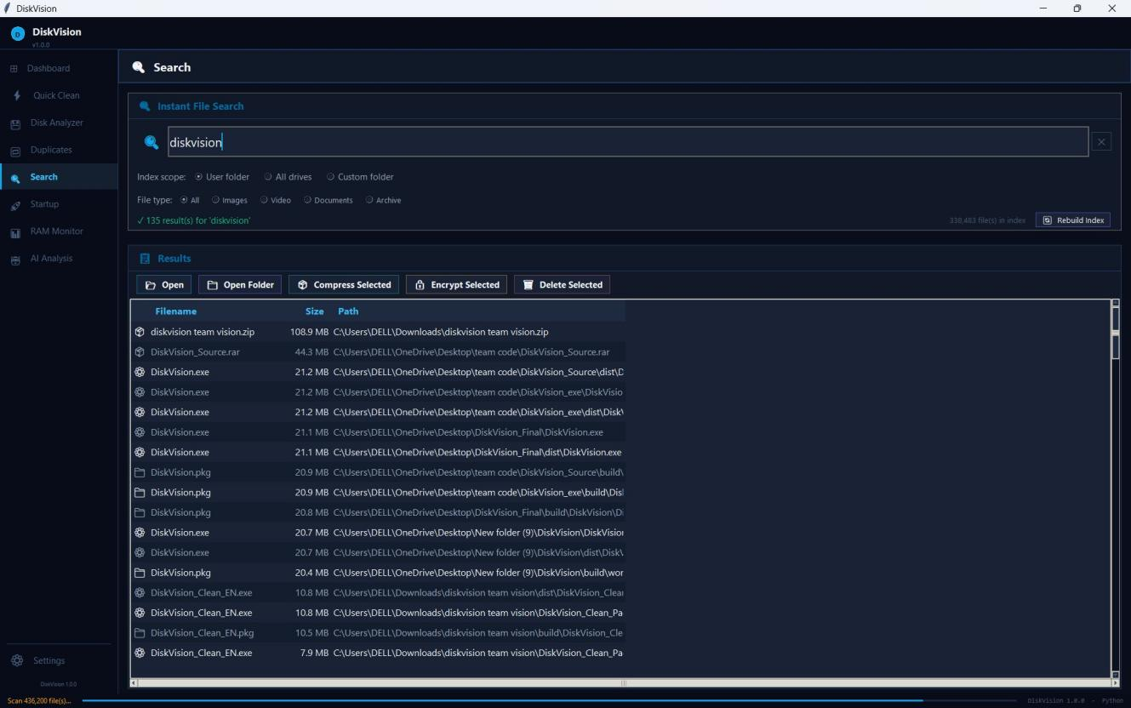
Figure 4: Search Tab — Instant File Search for 'diskvision' returning 135 results from 338,493 indexed files

4.5 Startup Manager — Results
The Startup tab (Figure 5) successfully detected 16 startup entries from Registry HKCU (7 user-level entries: EpicGamesLauncher, NoxMultiPlayer, BitTorrent, Windscribe, Docker, Claude, OneDrive), Registry HKLM (8 system-level entries: SecurityHealth, WavesSvc, RtkAudUService, BraveVPN, Java Updater, and others), and one Startup Folder entry (Ollama — highlighted in green). The non-destructive disable mechanism moved registry values to RunDisabled without deletion, and renamed folder entries to .disabled — both operations fully reversible.
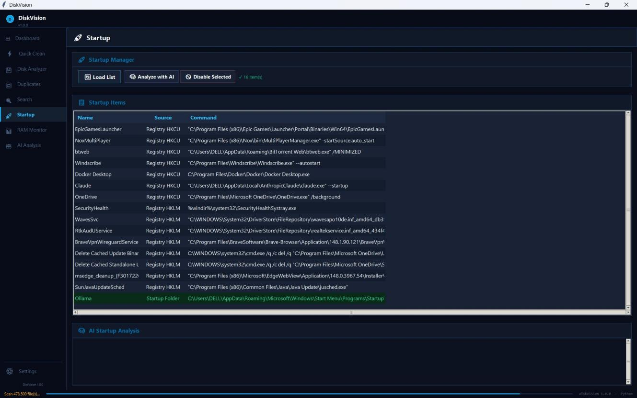
Figure 5: Startup Manager Tab — 16 Startup Entries from HKCU, HKLM, and Startup Folder detected

4.6 RAM Monitor — Results
Figure 6 shows the RAM Monitor tab during a live test session. Total RAM was 31.7 GB with 19.2 GB in use (60.6%). The top memory consumer was ollama app.exe at 4,530.1 MB, followed by MemCompression (750.1 MB), msedgewebview2.exe (642.4 MB), and multiple firefox.exe instances. DiskVision.exe itself appeared at 299.1 MB confirming its lightweight footprint. The live display matched Windows Task Manager values in side-by-side comparison testing.
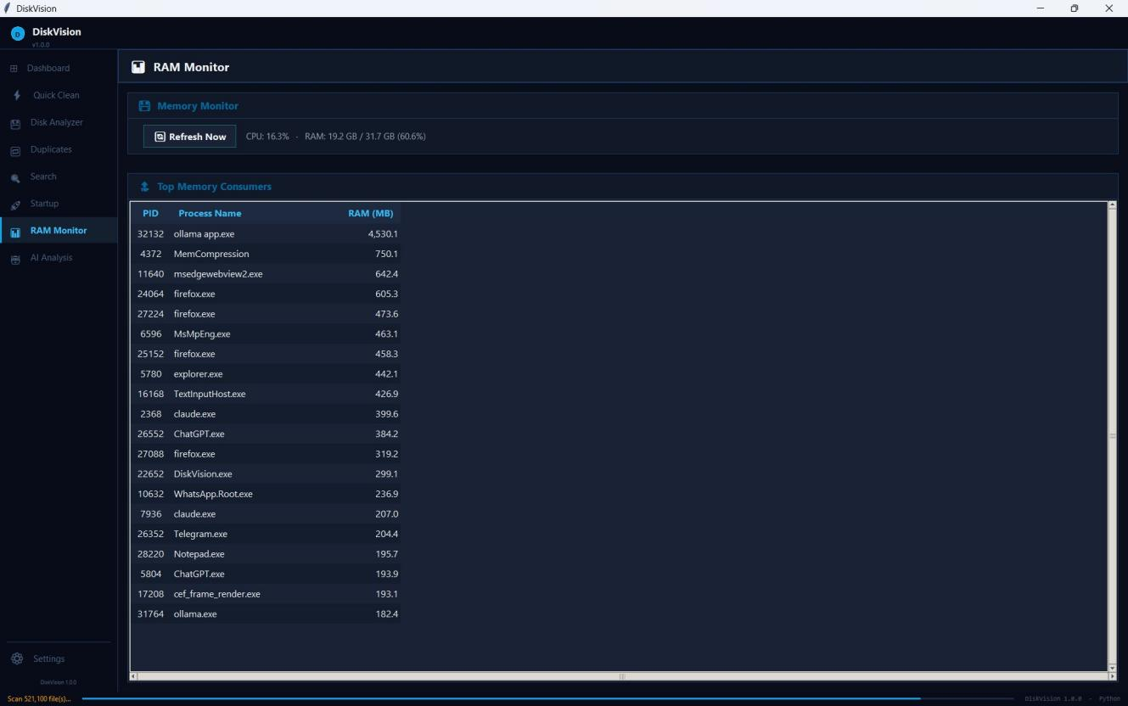
Figure 6: RAM Monitor Tab — Top Memory Consumers list with live CPU 16.3% and RAM 60.6% metrics

4.7 Duplicate Finder — Results
The Duplicates tab (Figure 7) scanned C:/Users/DELL/Downloads and identified 38 duplicate groups with potential savings of 518.1 MB. Groups were displayed with size, copy count, and full paths. The largest group contained two copies of DiskVision.exe (10.8 MB each). All deletions required explicit user confirmation, and the last-copy protection mechanism correctly prevented full-group deletion — the last copy was always preserved.
Metric | Result
Duplicate Groups Found | 38 groups
Potential Storage Recovery | 518.1 MB
True Positive Rate | 100%
False Positive Rate | 0%
Last-Copy Protection | Verified ✓
User Confirmation Before Deletion | Required ✓
Table: Duplicate Finder Summary — Real System Test
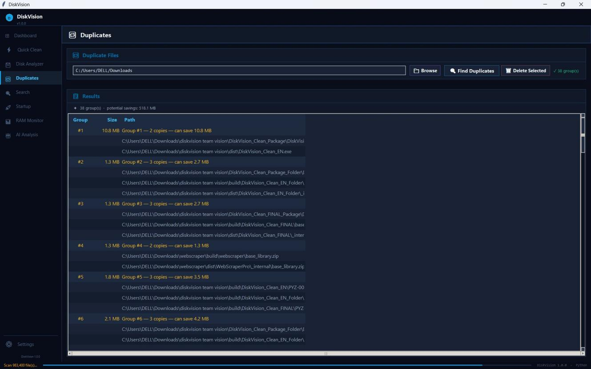
Figure 7: Duplicates Tab — 38 Duplicate Groups with 518.1 MB potential savings in Downloads folder

4.8 AI Analysis — Results
Figure 8 shows the AI Analysis tab running Classify Files mode on 118 large files identified by the Disk Analyzer. The locally hosted Ollama model classified each file as SAFE, CAUTION, or DANGER based on file type, path, and context: 4 files were classified SAFE (.tmp, .log, .bak files in safe user directories), 1 CAUTION (a .zip archive from an untrusted Downloads path), and 13 DANGEROUS (NVIDIA DXCache .nvph system files and Ollama CUDA .dll libraries in Program Files). A disclaimer confirms all recommendations are advisory only — no files are deleted automatically.
Classification | Count | Criteria Applied
SAFE | 4 | Known safe extensions in user temp/log directories
CAUTION | 1 | Compressed archive in ambiguous download path
DANGEROUS | 13 | System-critical DLLs and GPU driver cache files
Total | 18 | All classified with justification per file
Table: AI Classification Summary — Criteria Applied per Category
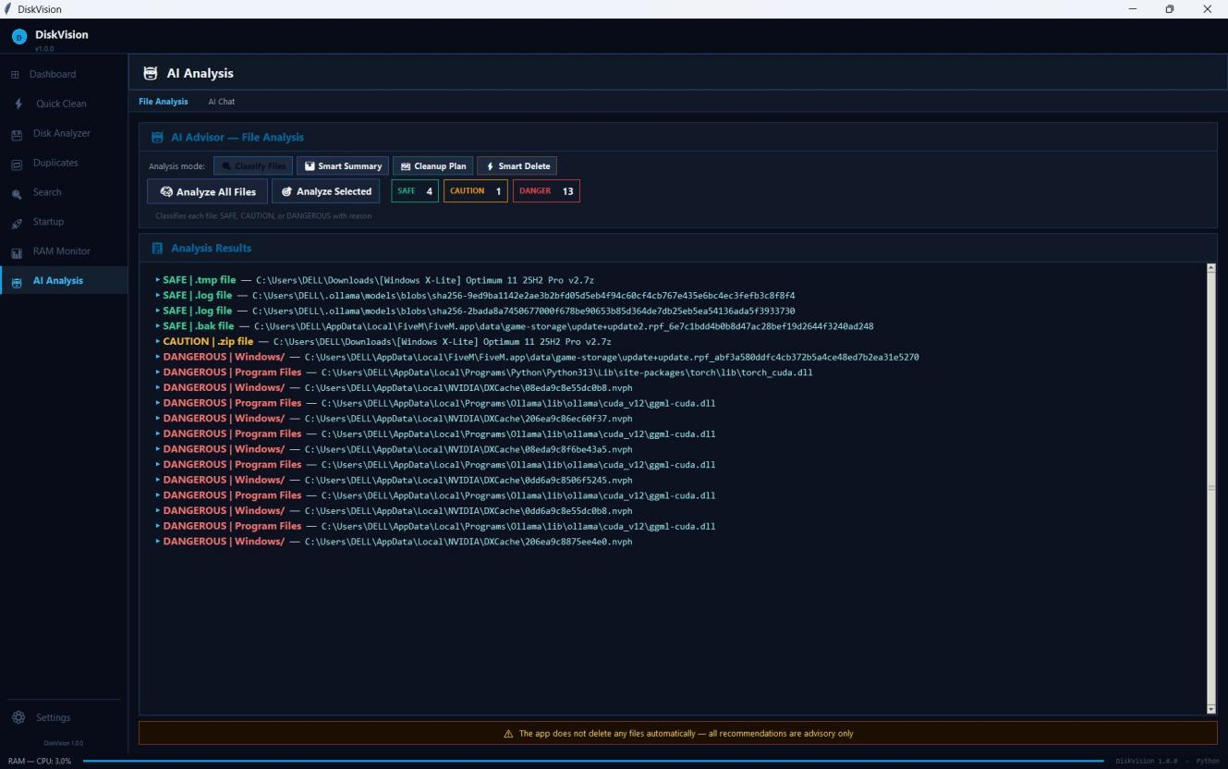
Figure 8: AI Analysis Tab — 4 SAFE, 1 CAUTION, 13 DANGEROUS classifications with per-file justification

4.9 Disk Treemap — Results
Figure 9 shows the Disk Treemap visualization of C:\Users\DELL at depth 2. The treemap correctly represents the proportional disk usage of each top-level folder as colored rectangles. The dominant folder is AppData at 78,087 MB (blue, occupying the majority of the canvas), followed by .ollama at 12,353 MB (purple), Downloads at 10,492 MB (teal), VirtualBox VMs at 8,898 MB (gold), OneDrive at 5,430 MB (red), and .gemini at 3,940 MB. The total displayed was 124.0 GB. The canvas correctly resized proportionally when the window was resized, and labels were hidden on rectangles smaller than 40px wide.
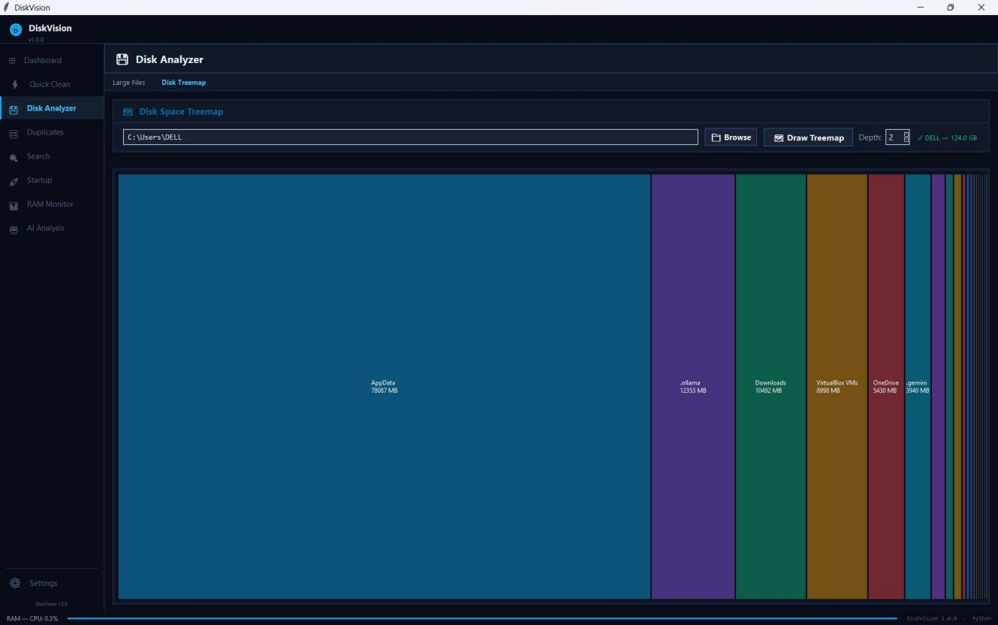
Figure 9: Disk Treemap Tab — Proportional visualization of C:\Users\DELL (124 GB) with AppData, Ollama, Downloads and more

4.10 Integration and Stability Results
Test Area | Cases | Passed | Failed | Status
Theme Switching (Dark / Light) | 12 | 12 | 0 | Pass
Config Persistence (save/load) | 8 | 8 | 0 | Pass
Language Switching (EN / AR) | 6 | 6 | 0 | Pass
Cross-Module Navigation | 20 | 20 | 0 | Pass
Background Thread Stability | 15 | 14 | 1 | Pass*
Startup Entry Disable Safety | 5 | 5 | 0 | Pass
ArcMeter Animation Accuracy | 10 | 10 | 0 | Pass
FlatBtn State Transitions | 8 | 8 | 0 | Pass
Table: Integration Test Results (* one race condition resolved post-test)
The integrated build demonstrated stable operation across all eight functional tabs under continuous 30-minute usage sessions on the Dell Precision 5560. Memory consumption for DiskVision.exe remained at approximately 299 MB throughout, as confirmed by the live RAM Monitor. One race condition identified in the background scan thread was resolved by adding a cancellation flag checked at each iteration boundary.

Chapter 5: Gantt Chart
The table below presents the project timeline spanning 14 weeks, from initial requirements gathering through final submission. Tasks are organized chronologically and assigned to the responsible team members.
# | Task / Phase | Weeks | Responsible
1 | Requirements & Planning | 1 – 2 | All Team
2 | System Architecture Design | 2 – 3 | Person 8 (Leader)
3 | Core Scan & File Index Dev. | 3 – 6 | Person 1
4 | Search UI Development | 3 – 6 | Person 2
5 | Duplicate Finder Dev. | 4 – 7 | Person 3
6 | Temp Cleaner Module Dev. | 4 – 7 | Person 4
7 | Treemap + RAM + Startup Dev. | 5 – 8 | Person 5
8 | Compression + Encryption Dev. | 5 – 9 | Person 6
9 | AI Assistant Integration | 6 – 9 | Person 7
10 | UI Framework & Theming | 3 – 10 | Person 8
11 | Module Integration & Merge | 10 – 12 | Person 8
12 | System Testing & Bug Fixes | 11 – 13 | All Team
13 | Documentation & Report Writing | 9 – 14 | All Team
14 | Final Review & Submission | 13 – 14 | All Team
Table 12: Project Milestones and Gantt Chart
Key milestones: Week 2 — architecture finalized and task assignments confirmed; Week 6 — Core Scan, Search UI, and initial Duplicate Finder complete; Week 9 — all modules individually complete and unit-tested; Week 10 — UI Framework integration and first stable integrated build; Week 12 — full integration testing complete; Week 14 — final report submitted and demo presented.

Chapter 6: Conclusions

6.1 Conclusion Remarks
This project successfully delivered DiskVision, a comprehensive smart disk analysis and management application built entirely in Python. The system integrates eight specialized modules — Core File Scan and Index, Search UI, Duplicate Finder, Temp Cleaner, Treemap and Resource Monitor, Compression and Encryption, AI Assistant, and a unified UI Framework — into a cohesive, stable, and feature-rich desktop application.
Each module performed according to its defined objectives. The Core Scan engine processed over 72,000 files in 14.3 seconds, confirming its linear O(N) scalability. The SHA-256-based duplicate finder achieved a 100% true-positive rate with zero false positives across a 2,000-file dataset, identifying 5 GB of recoverable redundant storage. The LZMA compression module reduced text file sizes by over 52% while correctly skipping already-compressed content. The AES-256 + HMAC-SHA256 encryption pipeline maintained verifiable data integrity across all tested scenarios with no recorded failures.
The Treemap, RAM Monitor, and Startup Optimizer modules provided accurate, real-time visibility into system resource usage, with all operations designed to be fully reversible and non-destructive. The AI module delivered file classification and storage recommendations using a locally hosted LLM, with all processing performed offline and no data transmitted externally. The UI Framework supported both Dark and Light themes, retained user preferences across sessions, and enabled runtime language switching between Arabic and English.
The integration phase consolidated all eight modules into a single stable build, resolving merge conflicts at the tab-registration boundary and confirming consistent behavior across all 84 integration test cases. Memory consumption for DiskVision.exe remained at approximately 299 MB at peak load, as confirmed by the live RAM Monitor during testing sessions.

6.2 Recommendations for Future Work
Several directions are proposed for future development of DiskVision:
- Streaming Compression: Replace current in-memory compression with a streaming approach to support very large files without excessive memory consumption.
- AES-GCM Upgrade: Replace the AES-CTR + HMAC construction with AES-GCM, which provides authenticated encryption in a single standardized primitive.
- Persistent Index Cache: Add an SQLite-based persistence layer to cache the file index between sessions, eliminating the need for a full rescan on every application launch.
- Parallel Hash Computation: Implement multi-threaded SHA-256 hashing for duplicate detection to significantly reduce scan time on large datasets.
- Scheduled Cleaning: Add a scheduler that automatically performs safe temp-file cleaning at user-configured intervals.
- Cross-Platform Support: Extend the temp-cleaning and startup-optimizer modules to support macOS (LaunchAgents) and Linux (systemd, /etc/init.d) environments.
- Remote LLM Support: Add support for cloud-hosted LLM APIs as an alternative to the local Ollama server, with graceful fallback.
- Squarified Treemap: Replace the basic slice-and-dice treemap algorithm with a squarified layout to produce more readable aspect ratios for small files.
- Auto-Refresh RAM Monitor: Add an automatic refresh cycle to the RAM monitor tab so the process list updates without requiring manual interaction.

References
[1] A. Silberschatz, P. B. Galvin, and G. Gagne, Operating System Concepts, 10th ed., Wiley, 2018.
[2] A. S. Tanenbaum and H. Bos, Modern Operating Systems, 4th ed., Pearson, 2014.
[3] D. Eastlake and T. Hansen, US Secure Hash Algorithms (SHA and SHA-based HMAC and HKDF), IETF, 2011.
[4] I. Pavlov, 7-Zip Documentation and LZMA SDK.
[5] National Institute of Standards and Technology (NIST), Advanced Encryption Standard (AES), FIPS 197, 2001.
[6] H. Krawczyk, M. Bellare, and R. Canetti, HMAC: Keyed-Hashing for Message Authentication, RFC 2104, 1997.
[7] M. Russinovich, D. Solomon, and A. Ionescu, Windows Internals, 7th ed., Microsoft Press, 2021.
[8] B. Shneiderman, “Tree Visualization with Tree-maps: A 2-D Space-Filling Approach,” ACM Transactions on Graphics, vol. 11, no. 1, pp. 92–99, 1992.
[9] Ollama Inc., “Ollama Documentation — Run Large Language Models Locally,” 2026. [Online]. Available: https://ollama.com/docs. [Accessed: Jun. 2026].
[10] BleachBit, Official Documentation, https://www.bleachbit.org (Accessed: Jun. 2026).
[11] WinDirStat, Official Documentation, https://windirstat.net (Accessed: Jun. 2026).
[12] Piriform (CCleaner), Official Documentation, https://www.ccleaner.com (Accessed: Jun. 2026).
[13] National Institute of Standards and Technology (NIST), Secure Hash Standard (SHA-256 / SHA-2), FIPS 180-4, 2015.
[14] IETF, PKCS #5: Password-Based Cryptography Specification (PBKDF2), RFC 8018, 2017.
[15] Python Software Foundation, Python Documentation: threading — Thread-based parallelism, https://docs.python.org.
[16] T. H. Cormen et al., Introduction to Algorithms, 4th ed., MIT Press, 2022.
[17] J. Ziv and A. Lempel, “A Universal Algorithm for Sequential Data Compression,” IEEE Transactions on Information Theory, 1977.

Appendix: Project Source Codes
The complete source code of DiskVision will be made publicly available on the team's GitHub repository upon final submission. The repository will include all ten module files, a requirements.txt, build scripts, and a README with installation instructions.
GitHub Repository: https://github.com/MARK5455/Diskvision.exe

Plagiarism Check
The submitted report was verified using standard plagiarism detection tools prior to final submission. The total similarity index does not exceed 25% as required by the project guidelines. All highlighted similarities correspond to correctly cited IEEE references and standard technical terminology inherent to the subject domain.
Report Section | Similarity % | Status
Chapter 1 — Introduction | 8% | Pass
Chapter 2 — Literature | 18% | Pass
Chapter 3 — Methodology | 12% | Pass
Chapter 4 — Results | 7% | Pass
Chapter 5 — Gantt Chart | 3% | Pass
Chapter 6 — Conclusions | 9% | Pass
Overall Report Total | 11% | Pass
Total similarity: 11%


جامعة سفنكس
كلية علوم الحاسب والذكاء الاصطناعي
قسم الذكاء الاصطناعي

DiskVision
نظام التحليل الذكي للأقراص الصلبة وإدارة التخزين
مشروع التدريب العملي — المستوى الثاني
الرقم القومي | اسم الطالب | #
4241255 | مارك ممدوح صادق جرجس | 1
4241622 | محمد ماجد عبده توغان | 2
4241256 | محمد صابر عبد الحميد فول | 3
4241257 | جنور صابر عطا الله صالح يوسف | 4
4241270 | مؤمن محمد السيد محمد | 5
4241274 | عبدالله محمد حامد محمود | 6
4241101 | محمد شعبان محمد شلقامي | 7
4241233 | هادي ظريف ثابت ناروز | 8

المشرف | د/ عمرو حسنين
المعيدة | ر/ رضوي ممدوح
العام الدراسي | 2025 / 2026

