ComboBug: Obstacle Avoidance Algorithm for Mobile Robots in Unknown Environment
Izabella Valero June 13, 2025

Introduction
Autonomous navigation in unknown environments presents a significant challenge in obstacle-avoidance robotics. Bug algorithms have been a fundamental approach to path planning, offering minimal mem- ory requirements, localization, and deterministic decision making. Their deterministic behavior enables clear, rule-based navigation strategies, such as goal directed movement and wall-following behavior.
This paper focuses on two key deterministic behaviors: common-sense and m-line. The common- sense behavior refers to goal-directed movement, where the robot navigates toward the goal when no obstacle obstructs its path. When an object is encountered, the robot follows the boundary of the obstacle—also known as wall-following—until a clear path to the goal is reestablished. The secondary behavior, m-line, establishes a straight-line path from the starting position to the goal. When wall- following the obstacle’s boundary, the robot seeks to rejoin the m-line to the goal when it is accessible, creating a structured path-planning approach to the goal.
Many traditional existing algorithms incorporate common-sense or m-line behaviors within their algorithm. However, these methods may exhibit limitations while operating in more complex environ- ments. In these scenarios the path may become prolonged or contain excessive detours. This research paper introduces ComboBug, a new bug algorithm designed to enhance existing approaches by inte- grating their distinct decision-making techniques. ComboBug aims to offer a more effective solution for localized autonomous navigation in environments with unknown obstacles.

Research Problem
For this paper, we define the inefficiencies of the m-line and common-sense techniques. While both are well-established obstacle avoidance strategies, they may exhibit excessive detours and prolonged time when navigating environments.
One of the well-known algorithms utilizing the common-sense approach is Bug0, the simplest and oldest bug algorithm based on this principle. While the approach is highly effective in minimally obstructed environments, Bug0 struggles to generate an efficient trajectory when navigating more complex scenarios (see Fig. 1).
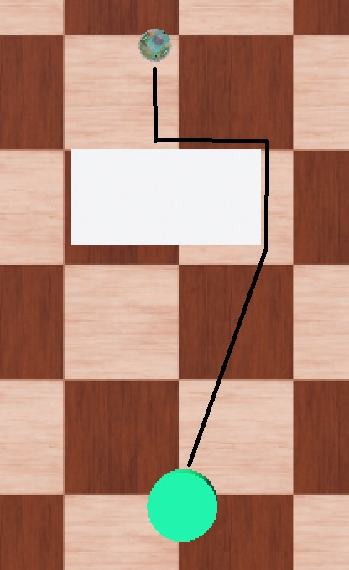
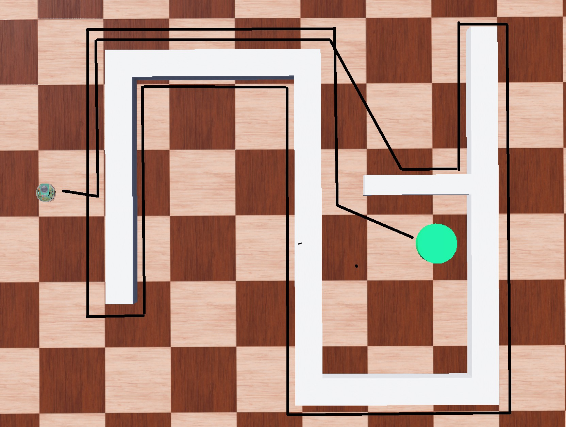
(a) Efficient (b) Inefficient
Figure 1: The effectiveness of Bug0 navigating a simple and complex scenario.

To illustrate the inefficiencies of the m-line algorithms, we consider Bug2, the most basic imple- mentation of an m-line approach. The technique aims to reduce the excessive path deviations seen

in common-sense strategies by enforcing a structured path-following behavior. Fig. 2b displays an effective use of the m-line behavior, proving to be more effective than Bug0 in Fig. 1b. Although this method appears advantageous for minimizing detours, it can result in longer navigation paths in simpler environments. Fig. 2a displays a longer path compared to Fig. 1a, which uses common sense. This inefficiency presents a challenge, as an ideal algorithm should maintain efficiency in both simple and complex environments. Ultimately, these limitations highlight the shortcomings of traditional bug algorithms in unpredictable environments. This displays a need for an algorithm that remains effective where both common-sense and m-line fail.
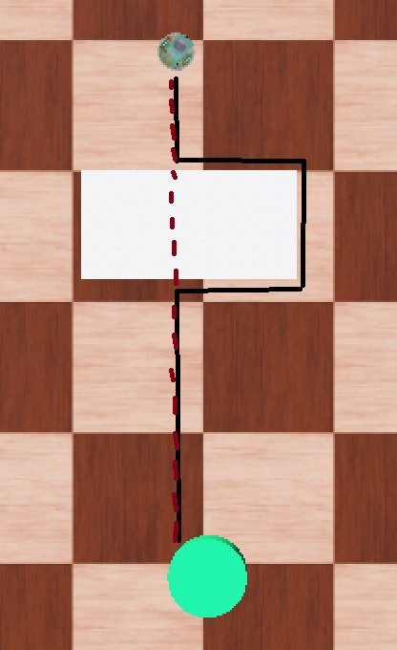
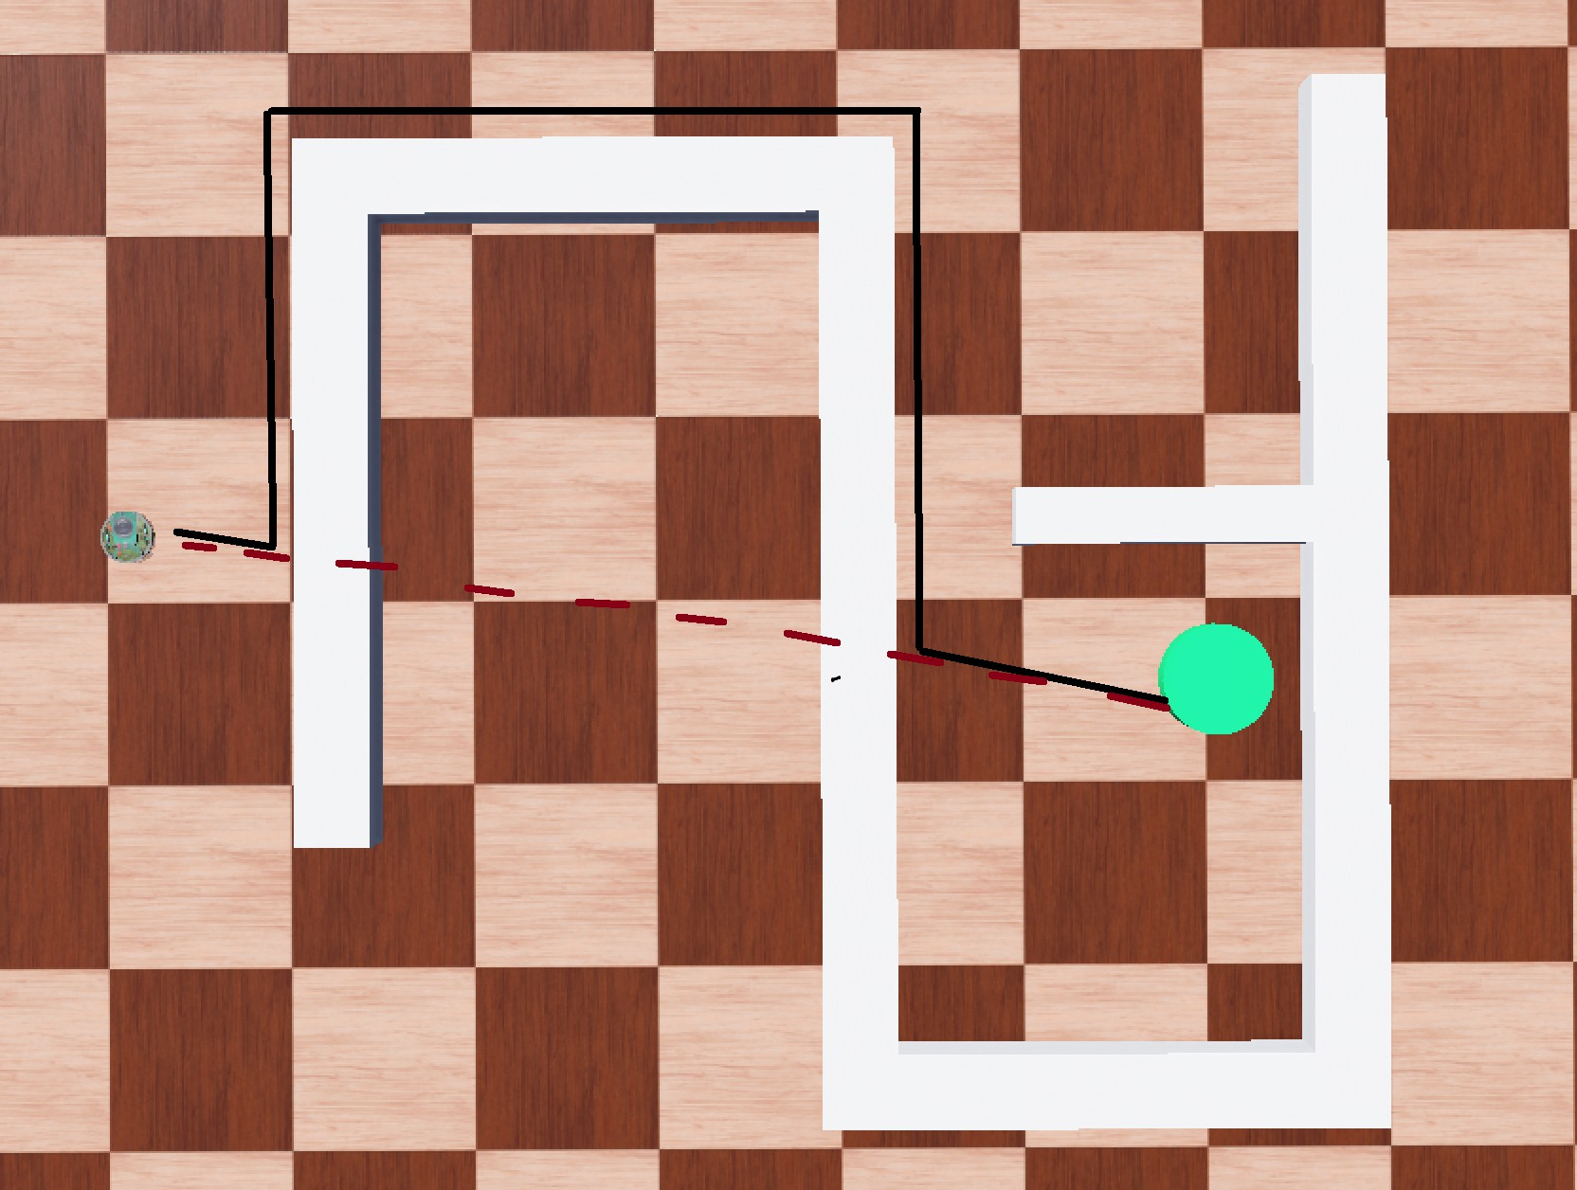
(a) Inefficient (b) Efficient
Figure 2: The effectiveness of Bug2 navigating a simple and complex scenario.

Proposed idea
The ComboBug algorithm proposes a hybrid approach that integrates the strengths of both m-line and common-sense techniques. The fundamental idea is to prioritize the common-sense approach for obtaining the most intuitive and direct path to the goal while switching to m-line logic in cases where common-sense navigation is prone to failure.
Since m-line navigation was originally developed to enhance efficiency over common-sense naviga- tion, ComboBug employs this concept to correct the robot’s trajectory when an inefficient path from common-sense navigation occurs. The robot will prioritize m-line navigation if it encounters the m-line directly or if it detects that common-sense behavior has previously failed in the same area.
To further enhance and merge these algorithm techniques, a temporary m-line is established when- ever the robot attempts to use common-sense navigation to leave the object. The temporary m-line acts as a predetermined reference path that the robot can follow whenever common sense proves in- effective and the original m-line is inaccessible. The state transition diagram in Figure 3 illustrates the decision-making process, displaying how ComboBug provides the use of common-sense and m-line strategies.
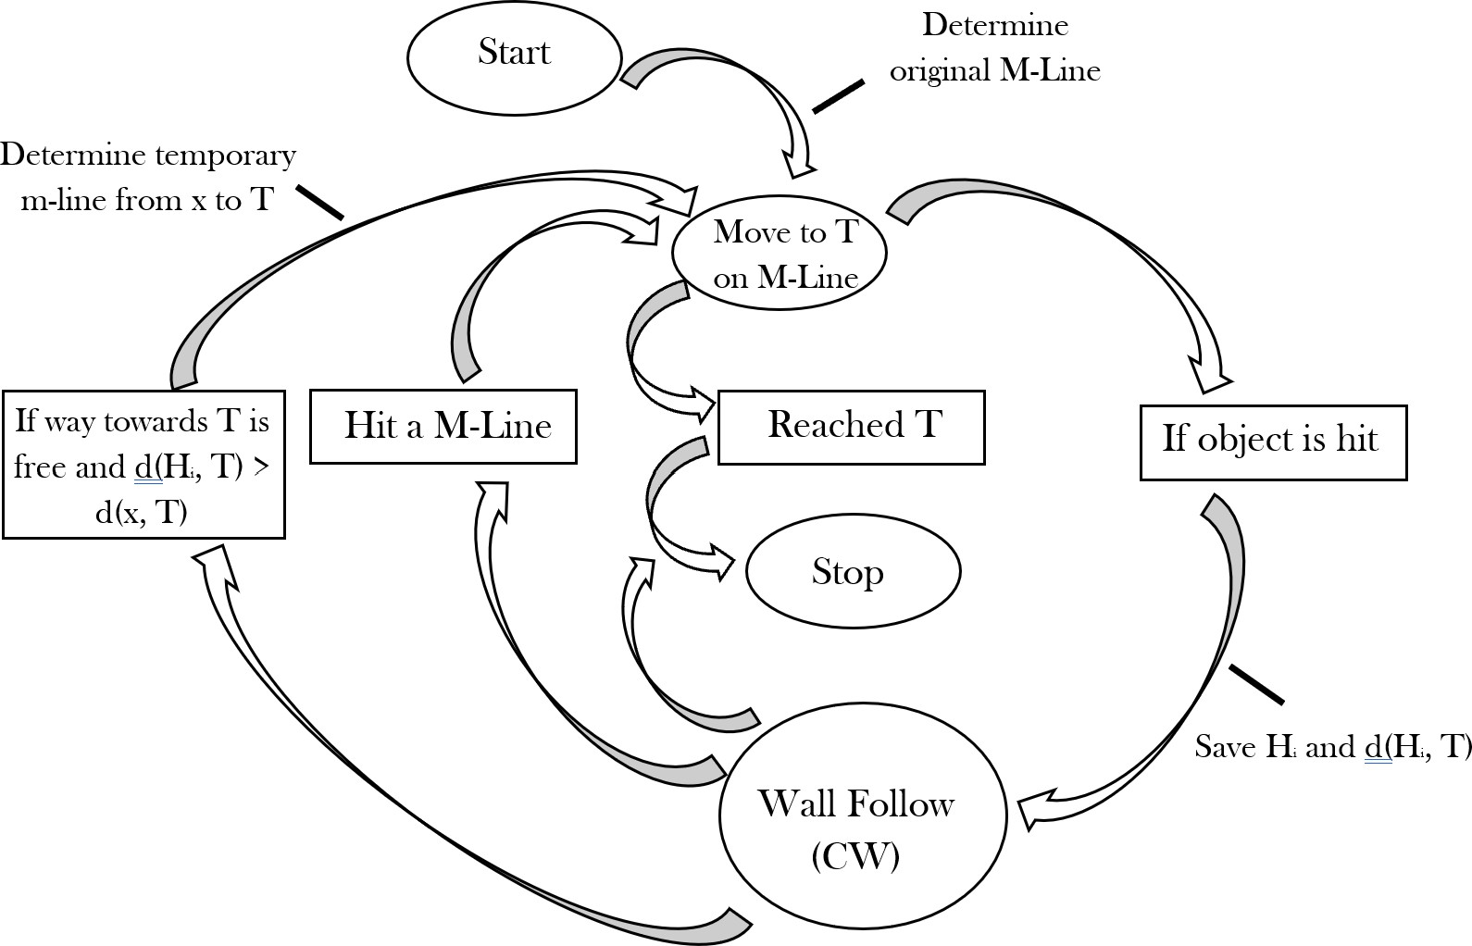

Figure 3: The diagram displays the state transitions that defines the behavior of the ComboBug algorithm.

By combining the strengths of both methodologies to mitigate their individual weaknesses, Com- boBug offers a more balanced solution compared to the existing algorithms. Compared to the tradi- tional Bug algorithms, this technique provides a flexible solution that is able to adapt to the object while remaining deterministic and using only localized information.

Related work
While the basic bug algorithms such as Bug0 and Bug1 utilize m-line and common-sense techniques, other extensions have been developed to enhance their efficiency. These modifications incorporate more memory, allowing the robot to track key locations where it has encountered an obstacle—referred to as hit points—and where it has successfully moved away from an obstacle—known as leave points. Among these advanced approaches, the Alg series and Rev series introduce systematic improvements to the basic common-sense and m-line techniques.
The Alg series, consisting of Alg1 and Alg2, builds upon the foundation of Bug0 and Bug2 by integrating memory of previously encountered obstacles. Alg1 follows the m-line approach, while Alg2 utilizes the common-sense technique. Both algorithms function similarly to their traditional counterparts but introduce the following improvement: the robot records hit points to detect if it is retracting its path. If the robot identifies a previously visited hit point while wall-following, it alters its direction to wall-follow in the opposing direction to avoid redundant detours and build an alternative route. Figure 4a and Figure 4b display the behavior of Alg1 and Alg2 respectively. The adjustment mitigates inefficiencies in environments where the robot would otherwise become trapped in unnecessary loops.
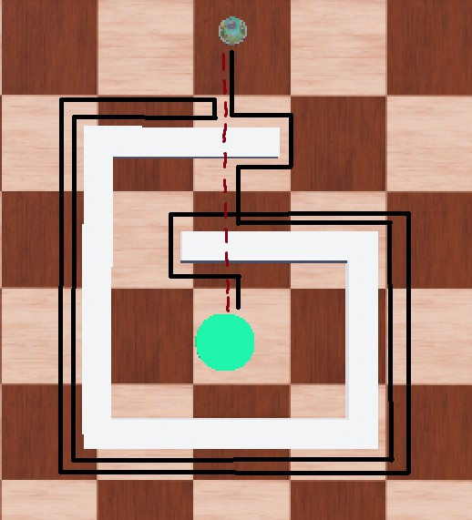
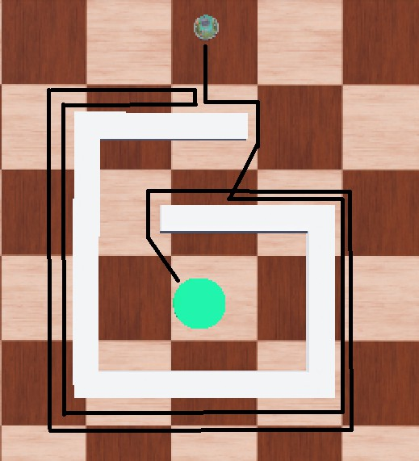
(a) Alg1 (b) Alg2
Figure 4: The effectiveness of Bug2 navigating a simple and complex scenario.

The Rev series, including Rev1 and Rev2, also builds upon Bug 0 and Bug2 by shifting focus from precise memory storage to adaptive wall-following behavior. Rev1 follows the m-line technique, while Rev2 adopts the common-sense approach. Unlike the Alg series, which tracks the locations of hit and leave points, the Rev series instead remembers only the occurrence of these events to establish the next move. When the robot encounters an obstacle, it initially follows the boundary in the default clockwise direction. However, upon leaving the obstacle and encountering a new one, the robot reverses the wall-following direction to counter-clockwise and displayed in Figures 5a and 5b. This strategy removes the predictability of the robot and introduces a changing variable that prevents the robot from becoming trapped.
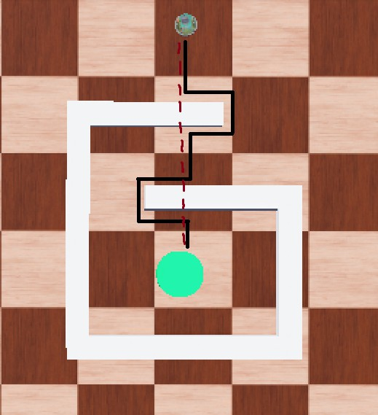
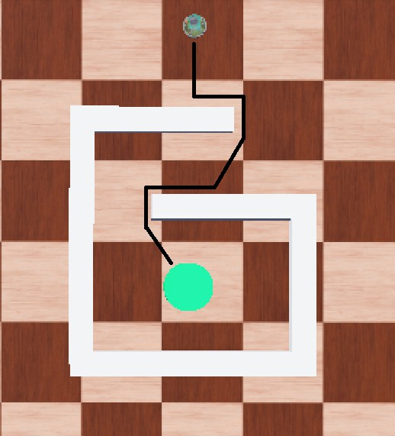
(a) Rev1 (b) Rev2
Figure 5: The effectiveness of Bug2 navigating a simple and complex scenario.

Additional Bug Algorithms, such as Bug1 and TangentBug, employ alternative path-planning.

However, these methods do not rely on either common-sense or m-they fall outside the primary scope of this study. Bug1 prioritizes completeness over efficiency by requiring the robot to traverse the entire perimeter of an obstacle before proceeding toward the goal. While this guarantees that the shortest possible path is found, it often results in impractical detours, making it suboptimal for practical navi- gation. In contrast, TangentBug utilizes range-base sensing to identify tangent lines around obstacles, enabling more efficient path planning. However, this technique at the cost of increased computational complexity, making it less favorable for resource-constrained robotic applications.
For the purpose of this study, Figure 6 from the paper reference **classifies these algorithms based on their reliance of range-based, m-line, and common-sense navigation. While some algorithms, such as Bug1, do not fit neatly into any of these categories, the figure highlights existing overlaps between range-based sensing and common-sense techniques, as well as range-based sensing and m-line strategies. Notably, there is no existing overlap between the m-line and common-sense approaches, demonstrating a gap in current methodologies. The ComboBug algorithm seeks to bridge this gap, offering a hybrid solution that maintains the computational simplicity of deterministic Bug Algorithms while improving path efficiency for complex environments.
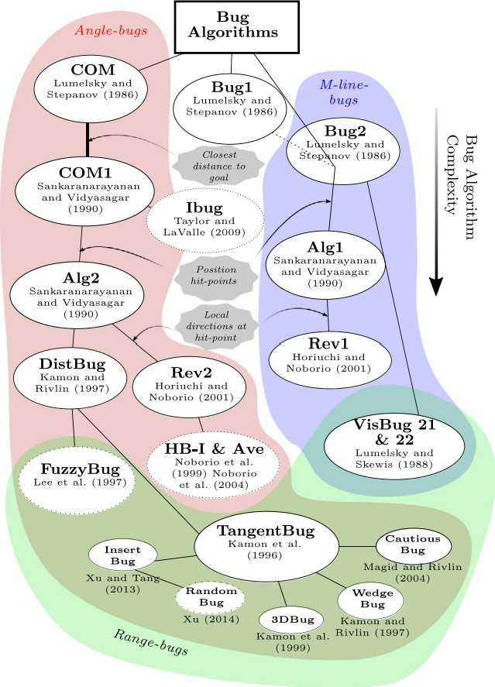

Figure 6: The referenced diagram is displayed to show the relationships between the algorithms that currently exist. Bug0 is interchangebly described as Com.

Methods and Design
Include pseudo code and state diagram in this section of ComboBug ONLY. Reference inspiration from the comparative analysis and the breakdown of their state diagram.
T o effectively merge the strategies, an understanding of the algorithms state diagram was eval- uated. These algorithms, inclusive to: Alg1, Alg2, Rev1, and Rev2, can be examined in reference
** where a state diagram of each algorithm is provided with examples of how they operate in some example environments. From these diagrams, a new state diagram was created to display the expected behavior of the ComboBug algorithm, proposed in Figure 3. The diagram displays a merge of the algorithms that will produce behavior states inclusive for both strategies.
The inclusion of both m-line and common-sense strategies is simple, both states needed to be included in the diagram, and they kept their own transitions. For common-sense this was determining if the path was open and closer to the goal than the previous hit point, and for m-line the transition was determined by the robots proximity to a m-line. This meant that common-sense would take precedence in most situations, and would be backed by the m-line strategy. To improve upon this, the m-line was incorporated into the behavior of the common-sense, producing a temporary m-line when leaving the object. The state for m-line can be triggered by this temporary line, only if the robot is wall following and has not happened across the original m-line. This provided a solution incase common-sense failed and the temporary m-line was a closer solution than the original m-line.
This displayed the ability to merge the algorithms and include additional adaptations like recorded hit and leave points and a temporary m-line, to ensure the strategies can be used effectively in the simulation.

Experimental setup
To evaluate the efficiency of the proposed ComboBug algorithm, a series of simulations was conducted to measure the primary performance metric, travel time to the goal, upon various obstacle configura- tions. The experiments were performed using the Webots simulation platform, with the E-puck robot model. The environment consisted of static obstacles of varying size and shape to simulate navigation challenges. To navigate, the E-puck is equipped with infrared sensors for proximity detection and GPS sensors to determine the orientation of the robots own position and the location of the goal. A total of seven distinct maps were designed, each allowing various starting positions and goal locations. Since various start and goal locations can be used, thirteen unique test scenarios were created to test all the maps for differing paths to the goal, ensuring a diverse evaluation of the algorithms.
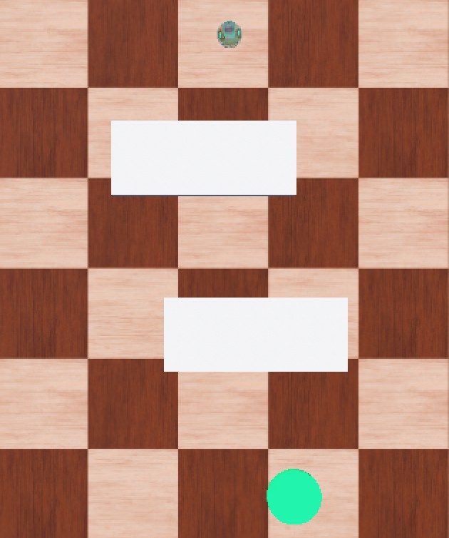
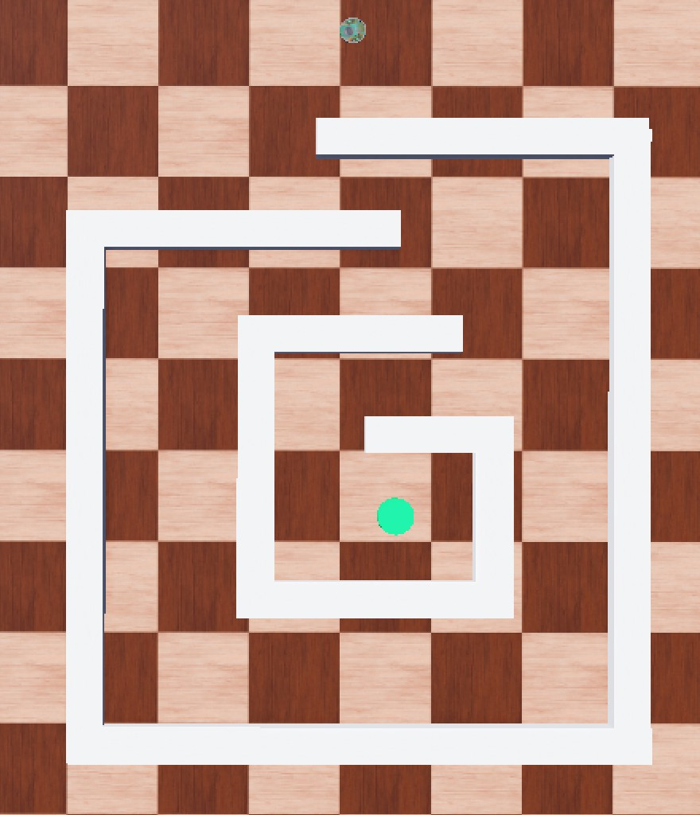
(a) Simple (b) Complex
Figure 7: A display of a map that is simple enough to require only one run, and a complex map that could require multiple runs for varying results.

The following Bug Algorithms were implemented based on their state diagram and pseudocode from
**reference**: Bug0, Bug2, Alg1, Alg2, Rev1, and Rev2. ComboBug was also developed according to the state diagram proposed in this paper. Each algorithms was executed under identical initial start positions and goal placements across all test runs. To ensure consistency and reliability, each algorithm was executed twice per environment to verify reproducibility. Additionally, the travel times of each algorithm in each scenario were recorded for all test cases to assess navigation efficiency, with longer path times indicating a longer route taken.

Results
All obstacles were tested with each algorithm, to record the time it took the robot to reach the goal from the starting point. Some of the algorithms only ran on the map once due to the simplicity of the obstacle or the constraints of the obstacle on the direction of the robots path to the goal(Fig. 8). Other maps produced varying results, and for this reason could be used for multiple scenarios, resulting in data like Figure 9.
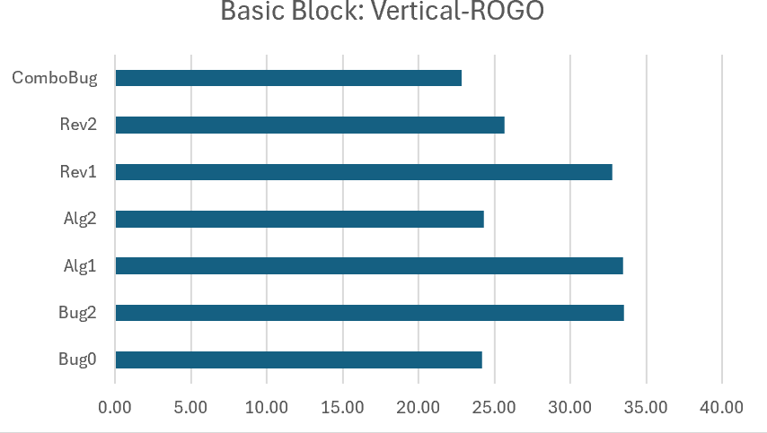
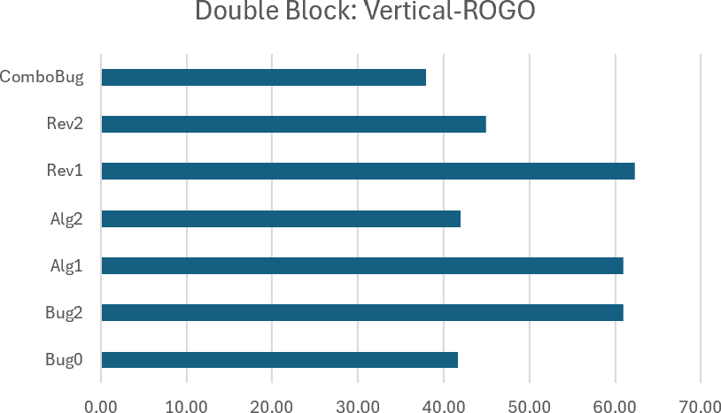
(a) (b)
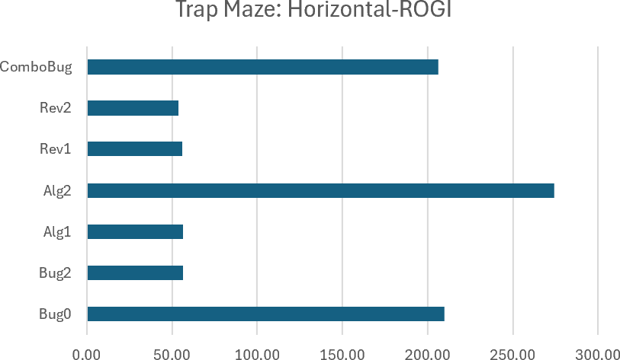
(c)
Figure 8: Run time of algorithms on maps that ran the algorithm only once, due to the simplicity or the constraints of the map.

Each of the graphs in Figures 8 and 9 include the recorded time for each algorithm and the path the robot took, indicating the start and end points. Horizontal, Vertical, and Diagonal indicated the robots position relative to the goal. If it was vertical, it would start above or below the goal, while horizontal indicated the robot began to the left or right side of the goal. Diagonal was set up to be between the vertical and horizontal positions and tested only when there was a resulting path that was different than both the vertical and horizontal paths. Each graph also has an indicator of where the robot and goal are located relative to the obstacle. Robot-Out-Goal-Out (ROGO) and Robot- Out-Goal-In (ROGI) are distinctions for whether the goal was located within the goal or outside of the goal. For example, in a maze scenario (Fig. 7b) the goal could be located within the obstacle, or outside of the obstacle, but for a simple solid obstacle (Fig. 7a) the object can only be located on the outside.
After collecting all data, we could compare all the algorithm run times from each scenario. Figure 10 helps display how often the recorded time for ComboBug aligned with the recorded time for Bug0 or the other common-sense algorithms. During the simulation being ran, it was also observed that the ComboBug algorithm would occasionally take the m-line path after common-sense failed. This indicates the ComboBug can dynamically switch between the strategies, allowing the algorithm to use new behavior. However, these maps did not display the behavior to the best of its ability, as it remained similar to the common-sense algorithms for most tests.
The behavior was placed into categories to determine if every runtime was the same as Bug0 if the variance caused the algorithm to be worse than the common-sense strategies. The categorized behavior is displayed in 11
NEEDS ELABORATION THIS IS FROM POWERPOINT

Conclusions
from powerpoint draft The ComboBug successfully merges the M-Line and Common-Sense strategies Provides an algorithm that deterministically changes between strategies Is not an algorithm that

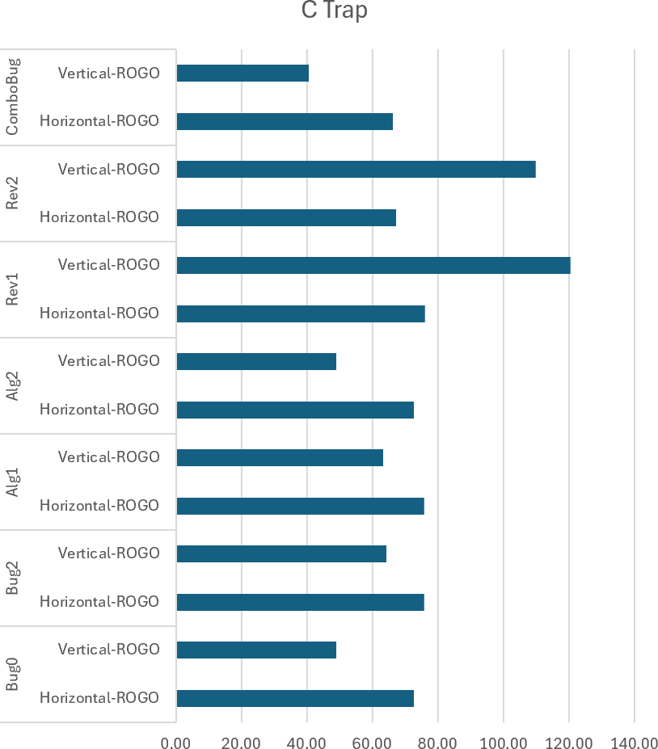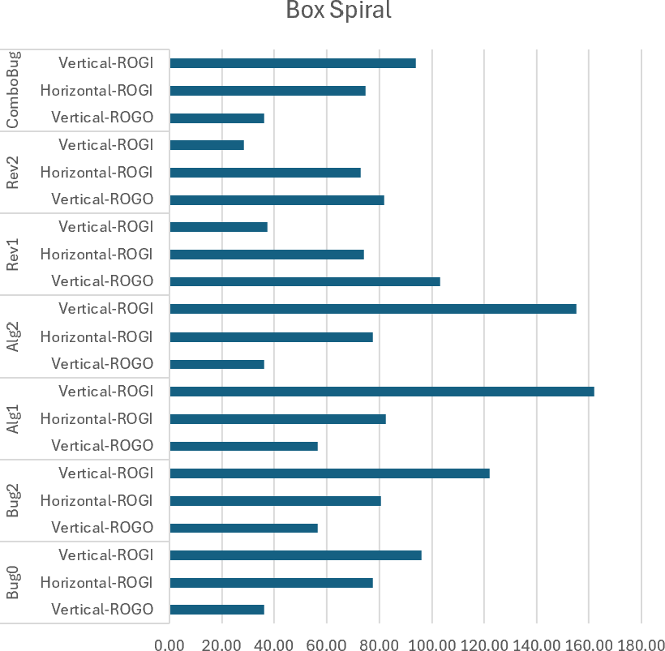
(a) (b)
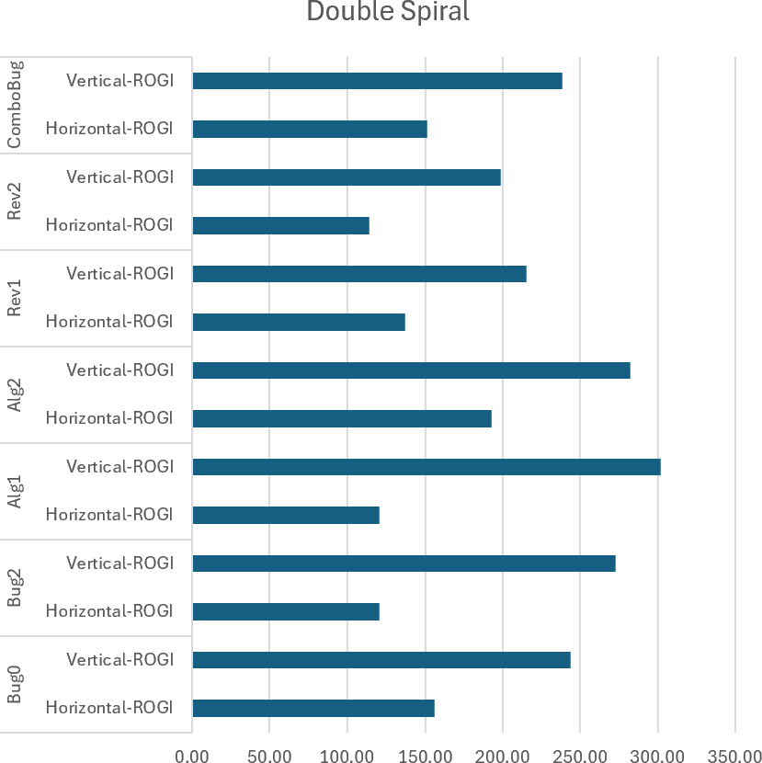
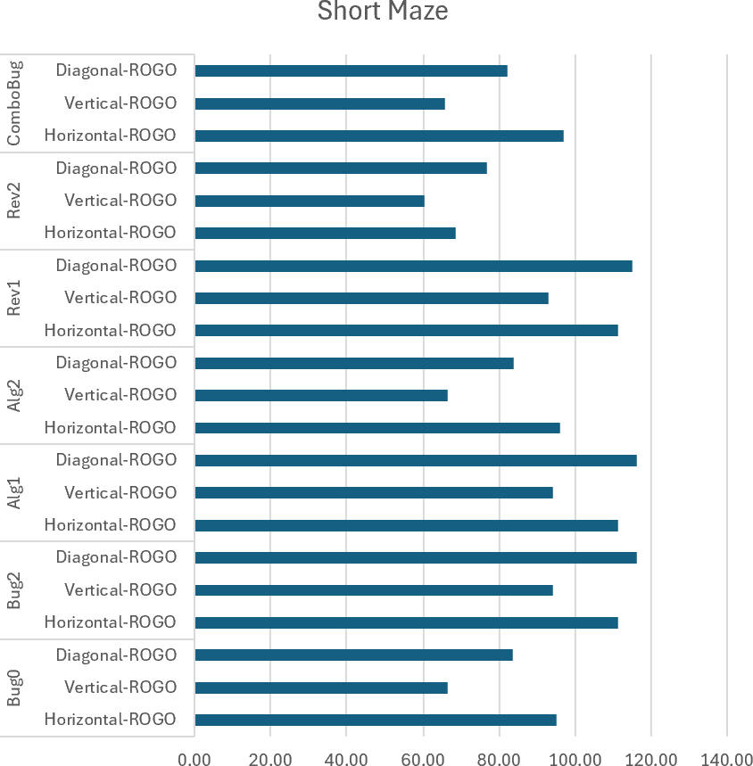
(c) (d)
Figure 9: Run time of algorithms on maps that ran the algorithm more than once in varying direction, due to the complexity of the map.

produces shorter times but instead provides a ‘back up’ path.

References
NEEDS CITATION IN THE PARAGRAPHS
- McGuire, K.N., G.C.H.E. de Croon, and K. Tuyls. ”A Comparative Study of Bug Algorithms for Robot Navigation.” Robotics and Autonomous Systems 121. 2019.
- Yufka, Alpaslan, and Osman Parlaktuna. ”Performance Comparison of the BUG’s Algorithms for Mobile Robots.“ 2009.
- J. Antich, A. Ortiz, and J. M´ınguez, ”A Bug-inspired algorithm for efficient anytime path planning,” 2009 IEEE/RSJ International Conference on Intelligent Robots and Systems. 2009.
- Y. Zhu, T. Zhang, J. Song, and X. Li, “A New Bug-type Navigation Algorithm Considering Practical Implementation Issues for Mobile Robots.
THIS IS HOW THE BIB SHOULD BE ORGANIZED. see pigar’s bib in order to reorganize own. his is great.
Qi Lu and Ryan Luna. Adaptive Multiple Distributed Bidirectional Spiral Path Planning for Foraging Robot Swarms. In 2023 20th Conference on Robots and Vision (CRV), pages 225–232, 2023. https:
//api.semanticscholar.org/CorpusID:261388579

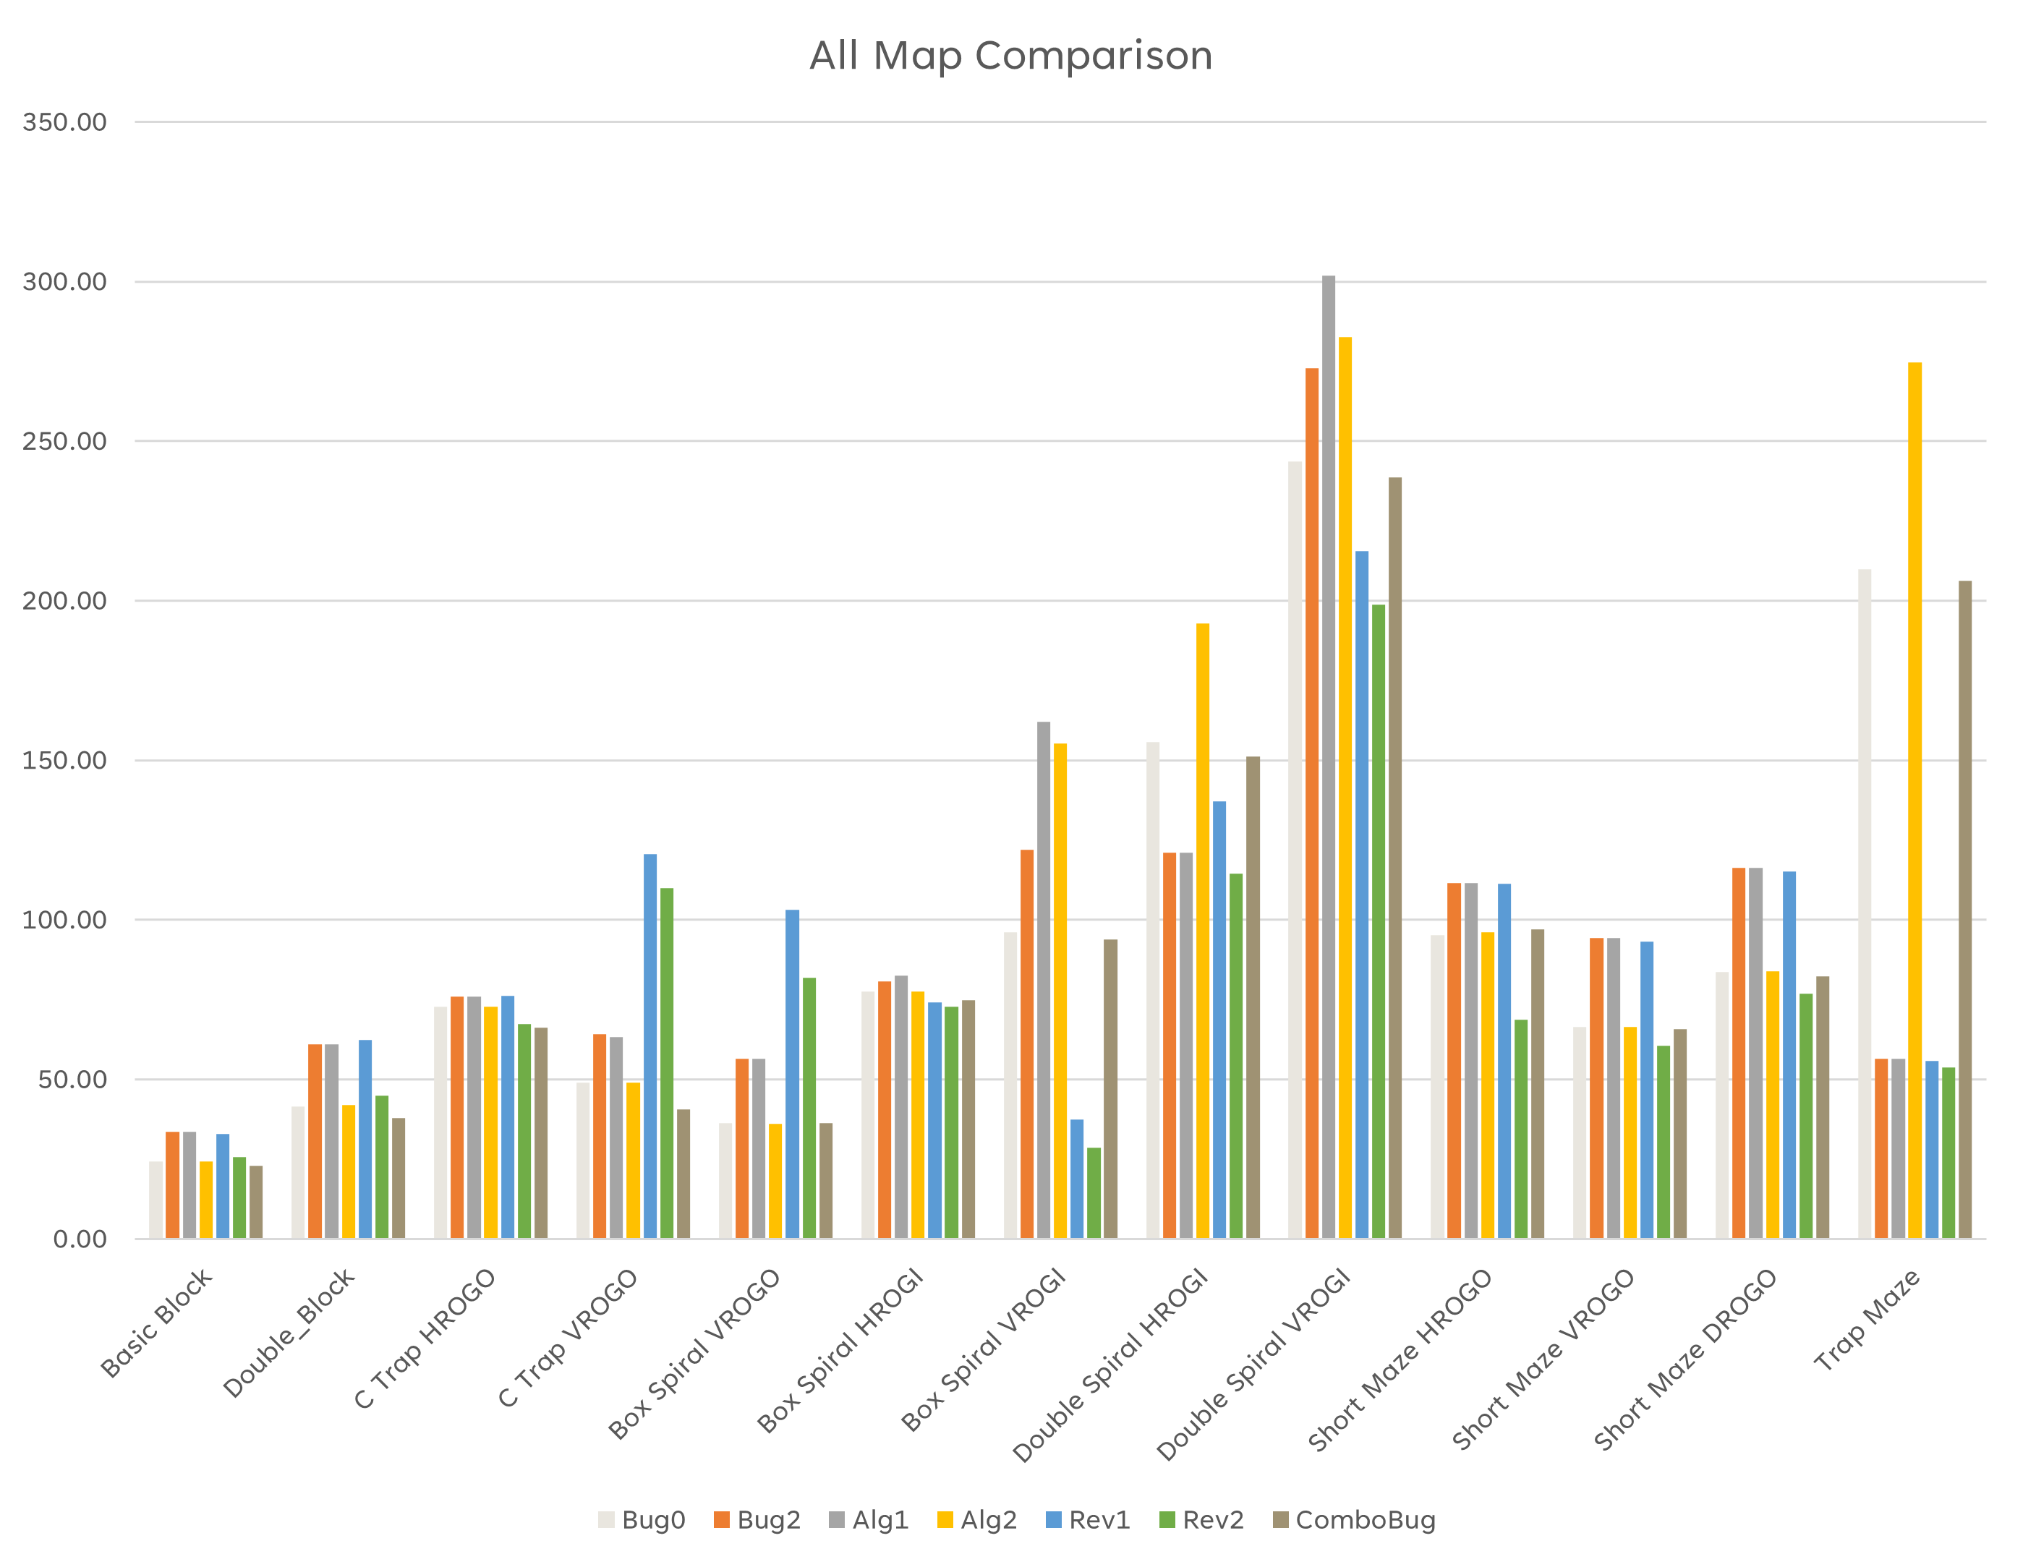

Figure 10: Display of each algorithm and the run-time each map.

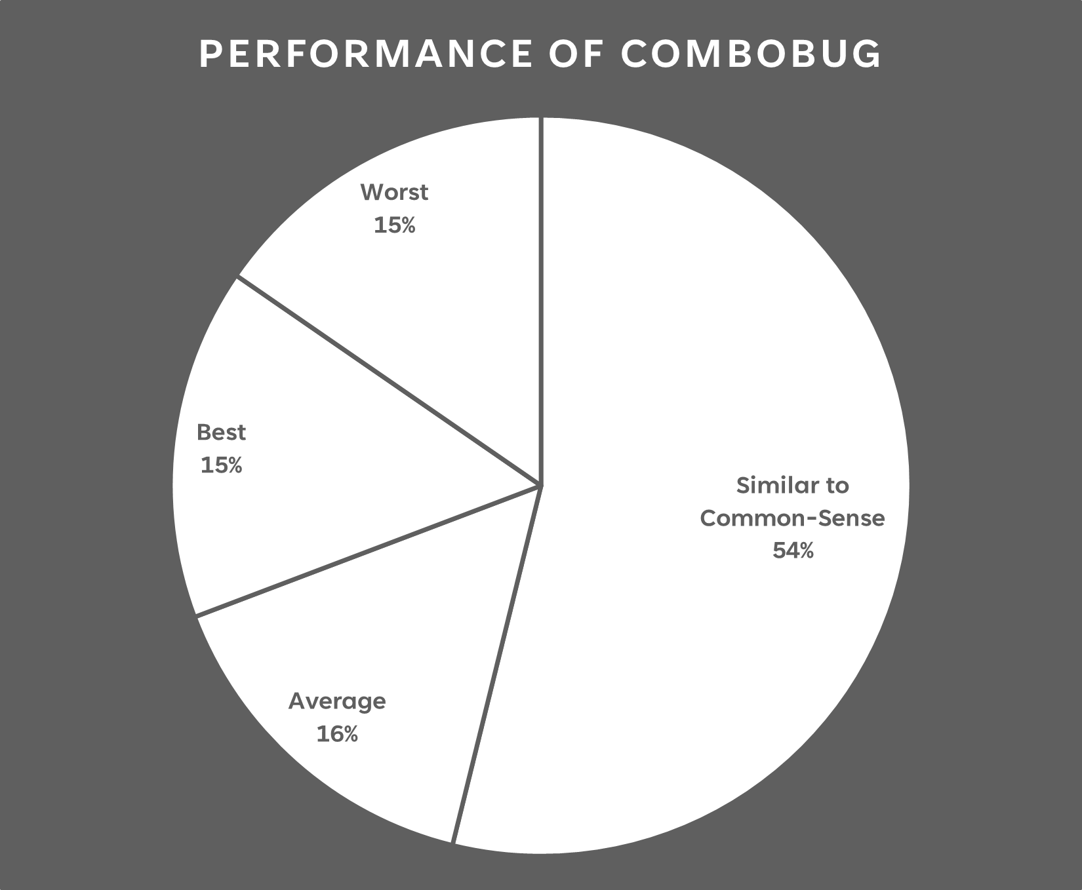
Figure 11: Pie chart displaying how ComboBug was closely related to Bug0 performance and rarely performed better or worse.

