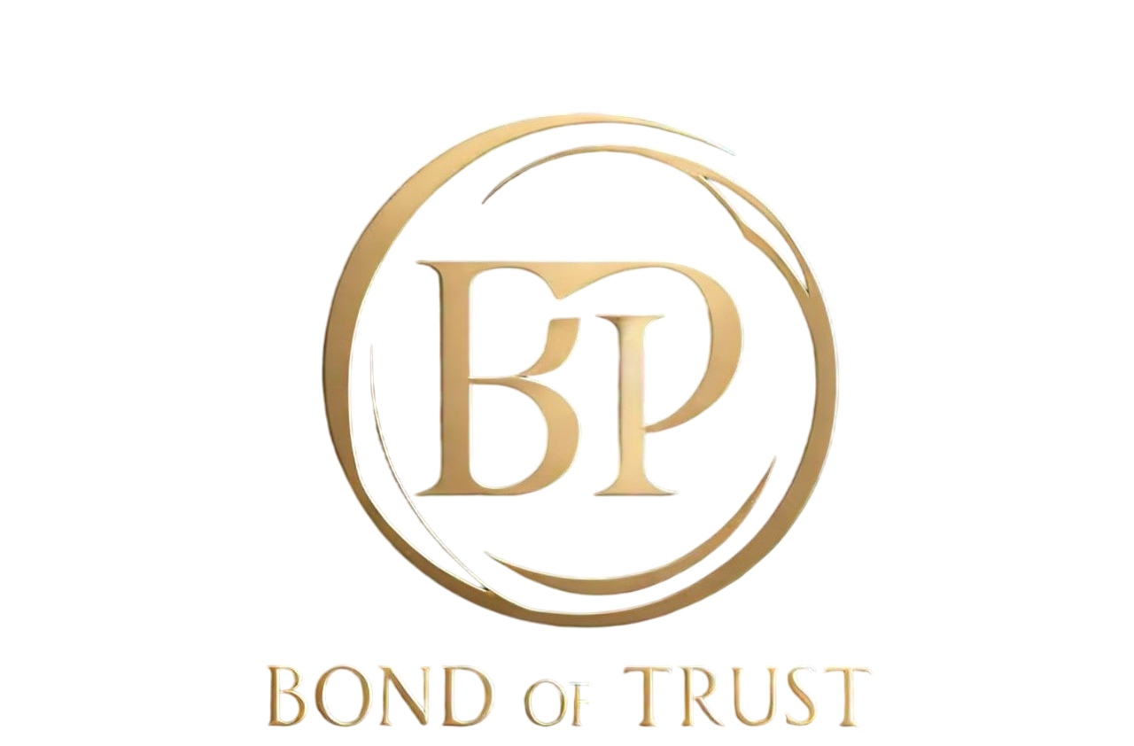

Non-Disclosure and Confidentiality Agreement

Relationship Commitment Agreement

This agreement is made between ________ and ________ on 27th October,2024.

The Parties are committed to building a relationship based on patience, loyalty, and exclusivity. To avoid disappointment and foster trust, the Parties agree as follows:

1. Patience and Waiting

We agree to wait for the right time to advance our relationship.

1. Promise of Exclusivity

We commit to being loyal and choosing each other above all others.

1. Open Communication

We promise to communicate openly to prevent misunderstandings.

Confidentiality:

By signing this Agreement, each Party agrees not to share its contents or terms with anyone else.

Name:_____________

Signed:________________________

Date: 27thOctober ,2024

Name:_______________________________

Signed:______________________________

Date:_____________________________