Baleen Whale Analysis Summary

G. Macklin

Date created: 2024-05-24

This report summarizes the acoustic analysis results for Blue whale (tonal calls), Blue whale (audible calls). This includes recording stations COC, CS1, CS3, CSE, DAC, EFC, EMBS, FCH, FCM, GLD, GMB, JOBW, LOC, MBK, MGL, ROB, SAB, SABV, SABW, SCAT from 2017 to 2023.

## Data Collection and Analysis

Deployments from 2017 to 2023 were analysed, comprising of 27 deployments across 20 recording stations (Figure 1, Table 1).

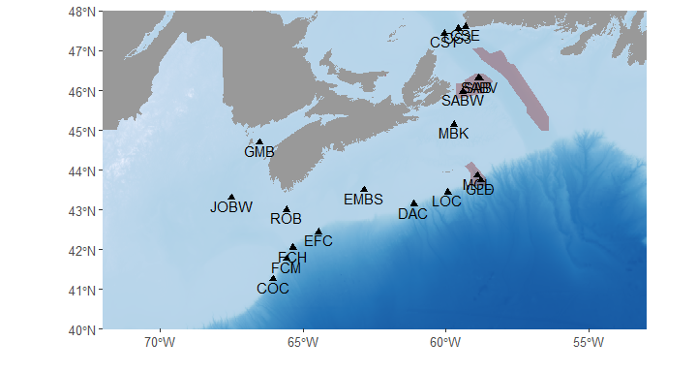  
**Figure 1.** Map of DFO Maritimes Region’s 2017-2023 passive acoustic monitoring (PAM) efforts included in this study (black triangles). Red polygons indicate important marine zones (MPAs, AOIs, etc.)

**Table 1.** Summary of PAM deployments included in this study. Depth indicates the seafloor depth at each station. Recording dates and number of days represent complete recording days, excluding days the recorder was deployed and recovered, or shut off for other reasons. Recorder type indicates the make and model of the acoustic recording system used in the deployment.

| Station | Latitude (decimal degrees) | Longitude (decimal degrees) | Depth (m) | Recording Dates | # Days | Recorder Type |
| --- | --- | --- | --- | --- | --- | --- |
| JOBW | 43.3001 | -67.4999 | 195 | 2019-04-10 - 2019-10-06 | 180 | JASCO AMAR G4-UD |
| 189 | 2020-09-02 - 2021-08-21 | 354 |
| GMB | 44.6910 | -66.5300 | 180 | 2018-09-22 - 2019-04-07 | 198 | JASCO AMAR G4-PVC-2X-6.5 |
| 179 | 2019-04-02 - 2019-10-18 | 200 | JASCO AMAR G3-PVC-2X |
| 170 | 2020-09-02 - 2021-04-10 | 221 | JASCO AMAR G4-PVC-2X-6.5 |
| 192 | 2021-04-12 - 2021-08-22 | 133 | JASCO AMAR G3-PVC-2X |
| 172 | 2021-08-24 - 2022-09-14 | 387 | JASCO AMAR G4-PVC-2X-6.5 |
| 183 | 2022-10-04 - 2023-08-25 | 326 | JASCO AMAR G3-PVC-2X |
| COC | 41.2570 | -66.0430 | 1,500 | 2020-09-03 - 2021-08-20 | 352 | JASCO AMAR G4-UD |
| 1,346 | 2021-08-22 - 2022-09-01 | 376 |
| FCM | 41.7696 | -65.5756 | 1,432 | 2021-08-22 - 2022-09-11 | 386 | JASCO G4-UD-2channel |
| FCH | 42.0430 | -65.3618 | 1,456 | 2018-09-18 - 2019-10-07 | 385 | JASCO AMAR G3A-AL-4X |
| 1,452 | 2019-10-09 - 2020-09-01 | 329 | JASCO AMAR G4-UD |
| 1,475 | 2020-09-03 - 2021-08-20 | 352 | JASCO G4-UD-2channel |
| EFC | 42.4420 | -64.4547 | 1,487 | 2021-08-21 - 2022-08-12 | 357 | JASCO AMAR G4A-AL-4X |
| ROB | 43.0000 | -65.5680 | 121 | 2018-05-01 - 2018-09-15 | 138 | JASCO AMAR G3-PVC-2X |
| 122 | 2018-09-17 - 2019-08-14 | 332 | JASCO AMAR G4-UD |
| 121 | 2019-10-08 - 2020-02-02 | 118 | JASCO AMAR G4-PVC-2X-6.5 |
| 114 | 2020-09-01 - 2021-08-18 | 352 | JASCO AMAR G3A-AL-4X |
| EMBS | 43.5000 | -62.8690 | 118 | 2018-05-02 - 2018-09-22 | 144 | JASCO AMAR G3-PVC-2X |
| 123 | 2018-09-24 - 2019-06-27 | 277 | JASCO AMAR G4-UD |
| 112 | 2019-10-07 - 2020-09-06 | 336 | JASCO AMAR G3A-AL-4X |
| 114 | 2020-09-08 - 2021-08-25 | 352 |
| DAC | 43.1438 | -61.1170 | 1,407 | 2017-11-30 - 2018-09-25 | 300 |
| 1,374 | 2018-09-25 - 2019-09-10 | 351 | JASCO AMAR G4-UD |
| LOC | 43.4424 | -59.9443 | 1,392 | 2017-11-30 - 2018-09-25 | 300 | JASCO AMAR G3A-AL-4X |
| 1,548 | 2018-09-27 - 2019-08-25 | 333 | JASCO AMAR G4-UD |
| GLD | 43.7417 | -58.7953 | 2,663 | 2017-12-01 - 2018-01-06 | 37 |
| MGL | 43.8600 | -58.9100 | 1,650 | 2017-12-02 - 2018-09-26 | 299 | JASCO AMAR G3A-AL-4X |
| 1,625 | 2018-09-28 - 2019-10-12 | 380 |
| 1,350 | 2019-10-14 - 2020-09-04 | 327 | JASCO AMAR G4A-AL-4X |
| 1,585 | 2021-08-30 - 2022-09-30 | 397 | JASCO AMAR G3A-AL-4X |
| MBK | 45.1432 | -59.7151 | 114 | 2021-09-03 - 2022-09-13 | 376 | JASCO AMAR G4-UD |
| SABW | 45.9753 | -59.4224 | 71 | 2022-10-17 - 2023-08-16 | 304 | JASCO AMAR G3A-AL-4X |
| SABV | 46.2946 | -58.8171 | 333 | 2019-06-03 - 2019-08-14 | 73 | JASCO AMAR G3-4.3 VLA |
| SAB | 46.3048 | -58.8746 | 320 | 2017-12-05 - 2018-01-08 | 35 | JASCO AMAR G4-UD |
| 2018-09-30 - 2019-10-02 | 368 | JASCO AMAR G3A-AL-4X |
| 336 | 2021-09-02 - 2022-10-02 | 396 |
| CS1 | 47.4344 | -60.0532 | 490 | 2022-10-16 - 2023-08-17 | 306 | JASCO AMAR G4-UD |
| CS3 | 47.5452 | -59.5609 | 469 | 2022-10-16 - 2023-08-19 | 308 |
| CSE | 47.6000 | -59.3220 | 130 | 2020-09-05 - 2021-01-23 | 141 | JASCO AMAR G4-PVC-2X-6.5 |
| 139 | 2021-05-31 - 2021-11-28 | 182 |
| 192 | 2022-10-16 - 2023-08-19 | 308 | Ocean Instruments SoundTrap ST600-STD |
| SCAT |  |  | 52 | 2019-06-12 - 2019-06-27 | 16 | Turbulent Research Porpoise |
| 2019-11-16 - 2020-03-27 | 133 |

Our analysis targeted 1 baleen whale species, and their detectable call types.

**Table 2**. Species, detectable call type and reference specified in these results.

| Species | Call Type(s) | Reference |
| --- | --- | --- |
| Blue whale | Infrasonic/tonal call (A/B/AB) | Berchok et al. 2006 |
| Audible calls |
| NOTE: If blue whale audible calls or minke whale pulse trains are presented, results are a mix of opportunistic and detected calls | | |

Datasets were analyzed for whale calls using the Low Frequency Detection and Classification System (LFDCS; Baumgartner and Mussoline 2011). LFDCS processed audio files to create spectrograms and identify whale calls by tracing their fundamental frequency. Signal characteristics were compared to a call library, and matches within a specified Mahalanobis distance were classified as target species calls. A two-tiered validation approach verified LFDCS detections of blue, fin, sei and humpback whales to minimize false positives. The first tier used a lower M-dist threshold, prioritizing accuracy, while the second tier used a higher threshold to ensure no calls were missed. Days with validated detections from the target species’ detector and days where the target species was found using another species’ detector are included. All North Atlantic right whale upcalls detected within an M-dist threshold of < 3.0 were manually reviewed due to their rarity and conservation importance. Manual review involved a two-step process to confirm detections and exclude false positives. For minke whale pulse trains, datasets were visually reviewed using Long-Term Spectral Averages (LTSA) in Triton software (Scripps Institution of Oceanography, UC San Diego), as no reliable automated detector was available. LTSA reviews created a record of daily minke whale occurrence by identifying and annotating pulse trains each day. This comprehensive analysis approach aimed to accurately document the presence and distribution of various whale species.

## Results

Blue whale (audible calls) were found on a total of 592 (5%) days, ranging from 0.3% to 20.2% (Table 2). Blue whale (tonal calls) were found on a total of 1745 (15%) days, ranging from 0.4% to 83.8% (Table 2).

**Table 3.** Recording effort (number of recording days), and number and percentage of recording days with confirmed Blue whale (audible calls) overall and by season for each station. For a given season, the percent of recording days with calls present was calculated based on the available recording effort within that season, which varied across station.

| Station | Number recording days | Overall | WINTER | SPRING | SUMMER | FALL |
| --- | --- | --- | --- | --- | --- | --- |
| A | | | | |
| GMB | 1,465 | 4 (0.3%) | 1 (0.1%) | 3 (0.2%) | 0 (0%) | 0 (0%) |
| COC | 728 | 8 (1.1%) | 5 (0.7%) | 0 (0%) | 1 (0.1%) | 2 (0.3%) |
| FCM | 386 | 5 (1.3%) | 3 (0.8%) | 2 (0.5%) | 0 (0%) | 0 (0%) |
| FCH | 1,066 | 23 (2.2%) | 10 (0.9%) | 7 (0.7%) | 0 (0%) | 6 (0.6%) |
| EFC | 357 | 14 (3.9%) | 5 (1.4%) | 0 (0%) | 1 (0.3%) | 8 (2.2%) |
| ROB | 940 | 14 (1.5%) | 2 (0.2%) | 4 (0.4%) | 1 (0.1%) | 7 (0.7%) |
| EMBS | 1,109 | 59 (5.3%) | 26 (2.3%) | 10 (0.9%) | 2 (0.2%) | 21 (1.9%) |
| DAC | 651 | 24 (3.7%) | 5 (0.8%) | 3 (0.5%) | 15 (2.3%) | 1 (0.2%) |
| LOC | 633 | 29 (4.6%) | 5 (0.8%) | 2 (0.3%) | 22 (3.5%) | 0 (0%) |
| GLD | 37 | 2 (5.4%) | 2 (5.4%) | 0 (0%) | 0 (0%) | 0 (0%) |
| MGL | 1,397 | 24 (1.7%) | 2 (0.1%) | 3 (0.2%) | 17 (1.2%) | 2 (0.1%) |
| MBK | 376 | 68 (18.1%) | 14 (3.7%) | 9 (2.4%) | 16 (4.3%) | 29 (7.7%) |
| SABW | 304 | 7 (2.3%) | 1 (0.3%) | 4 (1.3%) | 1 (0.3%) | 1 (0.3%) |
| SAB | 799 | 161 (20.2%) | 33 (4.1%) | 58 (7.3%) | 43 (5.4%) | 27 (3.4%) |
| CS1 | 306 | 50 (16.3%) | 12 (3.9%) | 20 (6.5%) | 10 (3.3%) | 8 (2.6%) |
| CS3 | 308 | 49 (15.9%) | 7 (2.3%) | 9 (2.9%) | 22 (7.1%) | 11 (3.6%) |
| CSE | 631 | 42 (6.7%) | 16 (2.5%) | 7 (1.1%) | 6 (1%) | 13 (2.1%) |
| SCAT | 149 | 9 (6%) | 3 (2%) | 6 (4%) | 0 (0%) | 0 (0%) |

**Table 4.** Recording effort (number of recording days), and number and percentage of recording days with confirmed Blue whale (tonal calls) overall and by season for each station. For a given season, the percent of recording days with calls present was calculated based on the available recording effort within that season, which varied across station.

| Station | Number recording days | Overall | WINTER | SPRING | SUMMER | FALL |
| --- | --- | --- | --- | --- | --- | --- |
| IF | | | | |
| GMB | 1,465 | 6 (0.4%) | 6 (0.4%) | 0 (0%) | 0 (0%) | 0 (0%) |
| COC | 728 | 78 (10.7%) | 44 (6%) | 5 (0.7%) | 1 (0.1%) | 28 (3.8%) |
| FCM | 386 | 47 (12.2%) | 33 (8.5%) | 1 (0.3%) | 2 (0.5%) | 11 (2.8%) |
| FCH | 1,066 | 197 (18.5%) | 104 (9.8%) | 17 (1.6%) | 8 (0.8%) | 68 (6.4%) |
| EFC | 357 | 76 (21.3%) | 36 (10.1%) | 2 (0.6%) | 1 (0.3%) | 37 (10.4%) |
| ROB | 940 | 39 (4.1%) | 34 (3.6%) | 2 (0.2%) | 0 (0%) | 3 (0.3%) |
| EMBS | 1,109 | 130 (11.7%) | 82 (7.4%) | 12 (1.1%) | 0 (0%) | 36 (3.2%) |
| DAC | 651 | 104 (16%) | 68 (10.4%) | 10 (1.5%) | 5 (0.8%) | 21 (3.2%) |
| LOC | 633 | 85 (13.4%) | 63 (10%) | 9 (1.4%) | 6 (0.9%) | 7 (1.1%) |
| GLD | 37 | 31 (83.8%) | 31 (83.8%) | 0 (0%) | 0 (0%) | 0 (0%) |
| MGL | 1,397 | 89 (6.4%) | 36 (2.6%) | 8 (0.6%) | 7 (0.5%) | 38 (2.7%) |
| MBK | 376 | 151 (40.2%) | 56 (14.9%) | 10 (2.7%) | 7 (1.9%) | 78 (20.7%) |
| SABW | 304 | 4 (1.3%) | 1 (0.3%) | 0 (0%) | 1 (0.3%) | 2 (0.7%) |
| SAB | 799 | 434 (54.3%) | 157 (19.6%) | 66 (8.3%) | 51 (6.4%) | 160 (20%) |
| CS1 | 306 | 120 (39.2%) | 63 (20.6%) | 10 (3.3%) | 2 (0.7%) | 45 (14.7%) |
| CS3 | 308 | 123 (39.9%) | 59 (19.2%) | 10 (3.2%) | 10 (3.2%) | 44 (14.3%) |
| CSE | 631 | 20 (3.2%) | 4 (0.6%) | 2 (0.3%) | 0 (0%) | 14 (2.2%) |
| SCAT | 149 | 11 (7.4%) | 8 (5.4%) | 2 (1.3%) | 0 (0%) | 1 (0.7%) |

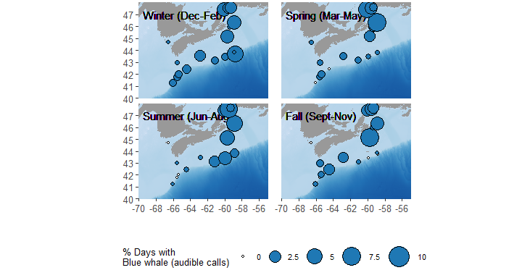

**Figure 2.** Percentage of recording days with confirmed Blue whale (audible calls) present at each of the 20 recording stations (indicated by circles) for each season (Winter = December-February, Spring = March-May, Summer = June-August and Fall = September-November), all years combined.

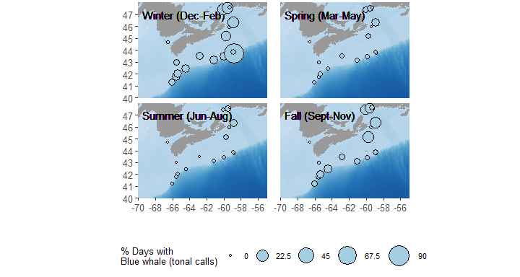

**Figure 3.** Percentage of recording days with confirmed Blue whale (tonal calls) present at each of the 20 recording stations (indicated by circles) for each season (Winter = December-February, Spring = March-May, Summer = June-August and Fall = September-November), all years combined.

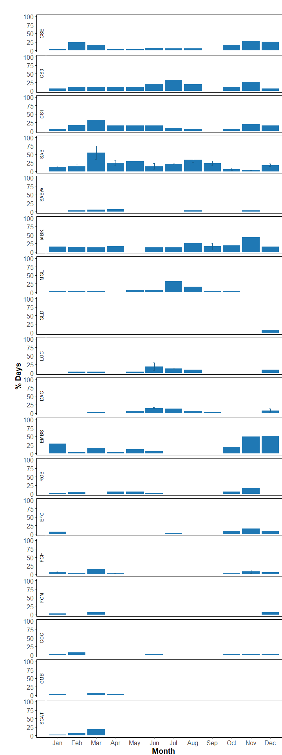

**Figure 4.** Percentage of recording days with confirmed Blue whale (audible calls) present for each month at each station. In cases where multiple years of data were collected the average percentage of days/month with Blue whale (audible calls) present were calculated (error bars = standard error).

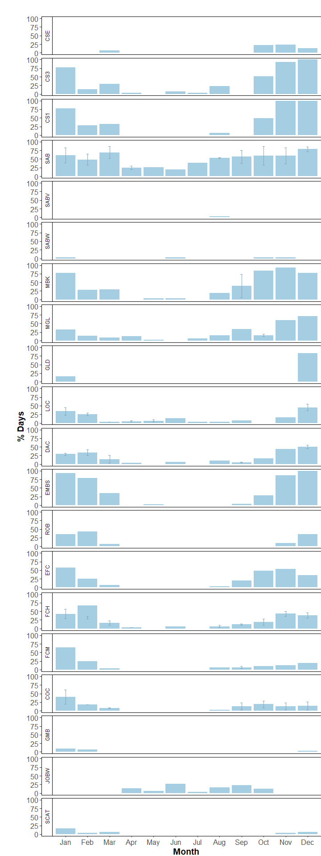

**Figure 5.** Percentage of recording days with confirmed Blue whale (tonal calls) present for each month at each station. In cases where multiple years of data were collected the average percentage of days/month with Blue whale (tonal calls) present were calculated (error bars = standard error).

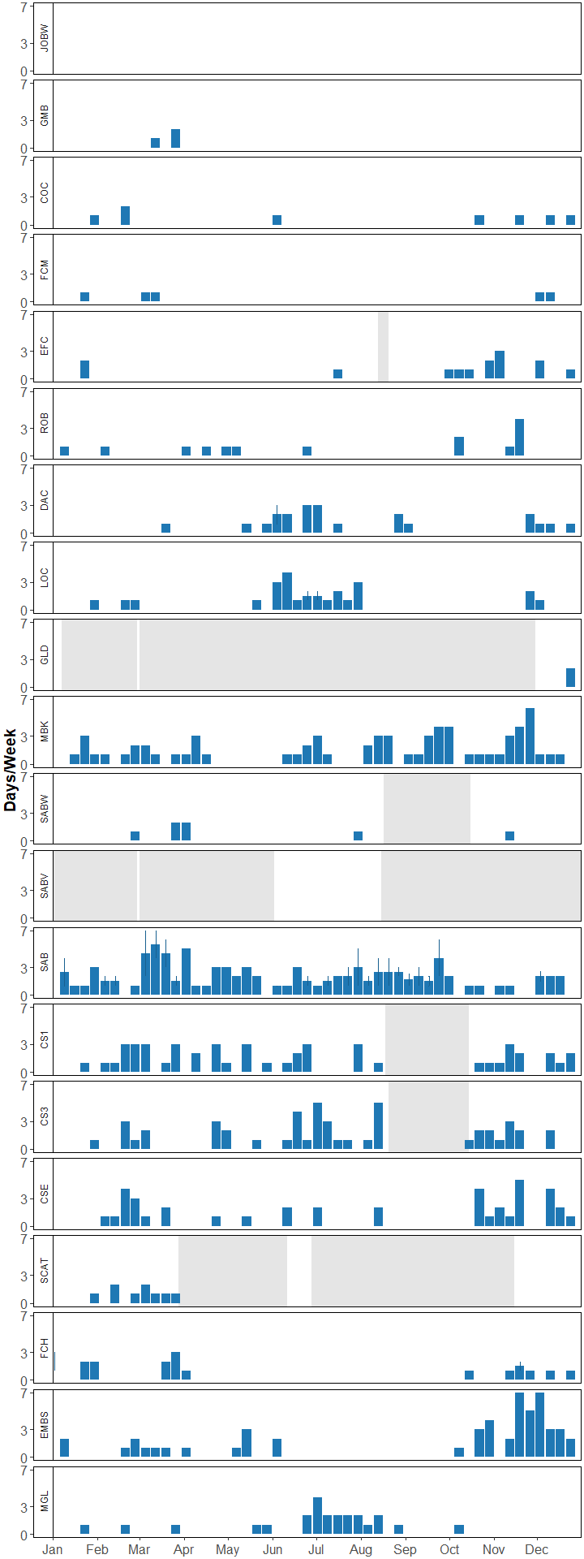

**Figure 6.** Seasonal occurrence of Blue whale (audible calls). Number of days per week with Blue whale (audible calls) calls present at each recording station in specified area throughout the year. In cases where multiple years of data were available, the mean number of days per week with Blue whale (audible calls) present is shown, with error bars indicating standard error. Grey shaded areas represent periods with no recording effort.

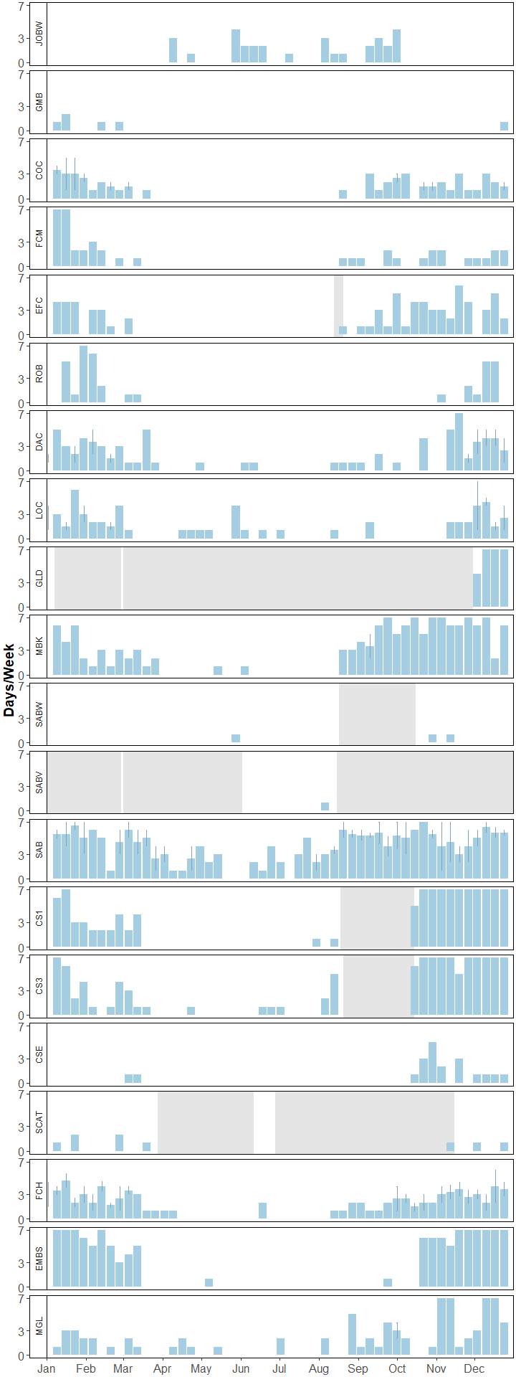

**Figure 7.** Seasonal occurrence of Blue whale (tonal calls). Number of days per week with Blue whale (tonal calls) calls present at each recording station in specified area throughout the year. In cases where multiple years of data were available, the mean number of days per week with Blue whale (tonal calls) present is shown, with error bars indicating standard error. Grey shaded areas represent periods with no recording effort.

## Appendix A

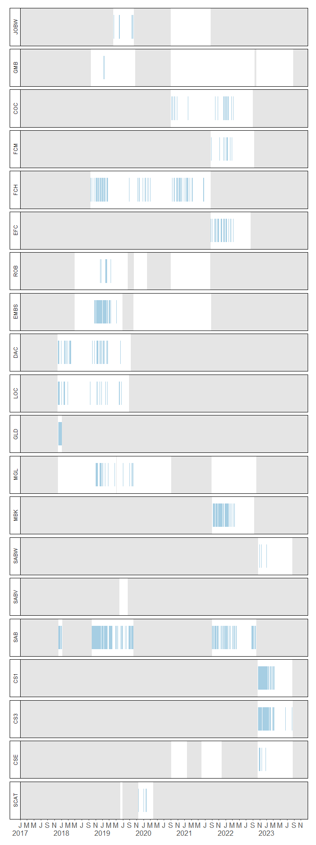

**Figure A-1.** Daily occurrence of confirmed Blue whale (tonal calls) at each recording station. Grey shading represents periods with no recording effort throughout the study period 2017 - 2023

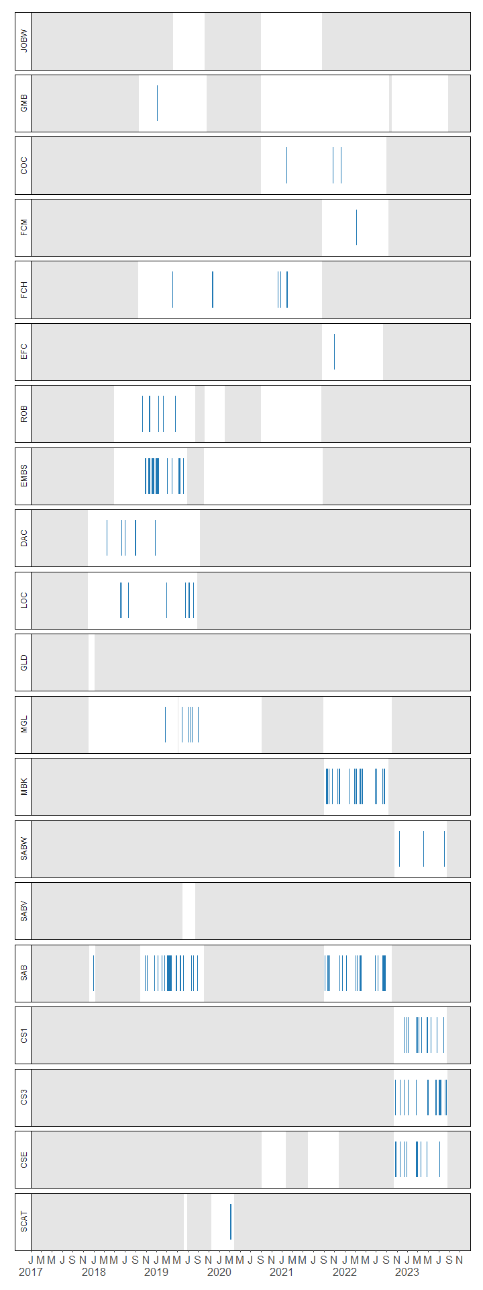

**Figure A-2.** Daily occurrence of confirmed Blue whale (audible calls) at each recording station. Grey shading represents periods with no recording effort throughout the study period 2017 - 2023

## References

Baumgartner, M. F., & Mussoline, S. E. (2011). A generalized baleen whale call detection and classification system. The Journal of the Acoustical Society of America, 129(5), 2889–2902.

Berchok, C. L., Bradley, D. L., & Gabrielson, T. B. (2006). St. Lawrence blue whale vocalizations revisited: Characterization of calls detected from 1998 to 2001. The Journal of the Acoustical Society of America, 120(4), 2340.