Baleen Whale Analysis Summary

G. Macklin

Date created: 2024-05-24

This report summarizes the acoustic analysis results for . This includes recording stations COC, CS1, DAC from 2017 to 2023.

## Data Collection and Analysis

Deployments from 2017 to 2023 were analysed, comprising of 5 deployments across 3 recording stations (Figure 1, Table 1).

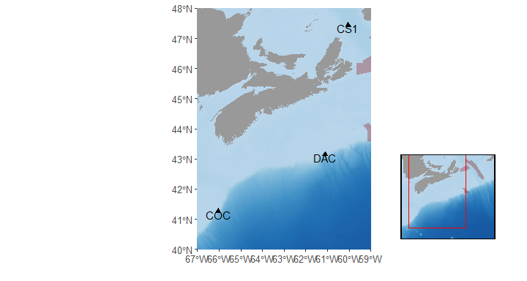  
**Figure 1.** Map of DFO Maritimes Region’s 2017-2023 passive acoustic monitoring (PAM) efforts included in this study (black triangles). Red polygons indicate important marine zones (MPAs, AOIs, etc.)

**Table 1.** Summary of PAM deployments included in this study. Depth indicates the seafloor depth at each station. Recording dates and number of days represent complete recording days, excluding days the recorder was deployed and recovered, or shut off for other reasons. Recorder type indicates the make and model of the acoustic recording system used in the deployment.

| Station | Latitude (decimal degrees) | Longitude (decimal degrees) | Depth (m) | Recording Dates | # Days | Recorder Type |
| --- | --- | --- | --- | --- | --- | --- |
| COC | 41.2570 | -66.0430 | 1,500 | 2020-09-03 - 2021-08-20 | 352 | JASCO AMAR G4-UD |
| 1,346 | 2021-08-22 - 2022-09-01 | 376 |
| DAC | 43.1438 | -61.1170 | 1,407 | 2017-11-30 - 2018-09-25 | 300 | JASCO AMAR G3A-AL-4X |
| 1,374 | 2018-09-25 - 2019-09-10 | 351 | JASCO AMAR G4-UD |
| CS1 | 47.4344 | -60.0532 | 490 | 2022-10-16 - 2023-08-17 | 306 |

Our analysis targeted 6 baleen whale species, and their detectable call types.

**Table 2**. Species, detectable call type and reference specified in these results.

| Species | Call Type(s) | Reference |
| --- | --- | --- |
| Blue whale | Infrasonic/tonal call (A/B/AB) | Berchok et al. 2006 |
| Audible calls |
| Fin whale | 20 Hz pulse | Watkins et al. 1987 |
| Sei whale | Full-frequency downsweep | Baumgartner et al. 2008 |
| Humpback whale | Song and non-song | Au et al. 2006 |
| North Atlantic right whale | Upcall | Parks 2003 |
| Minke whale | Pulse trains | Risch et al. 2013 |
| NOTE: If blue whale audible calls or minke whale pulse trains are presented, results are a mix of opportunistic and detected calls | | |

Datasets were analyzed for whale calls using the Low Frequency Detection and Classification System (LFDCS; Baumgartner and Mussoline 2011). LFDCS processed audio files to create spectrograms and identify whale calls by tracing their fundamental frequency. Signal characteristics were compared to a call library, and matches within a specified Mahalanobis distance were classified as target species calls. A two-tiered validation approach verified LFDCS detections of blue, fin, sei and humpback whales to minimize false positives. The first tier used a lower M-dist threshold, prioritizing accuracy, while the second tier used a higher threshold to ensure no calls were missed. Days with validated detections from the target species’ detector and days where the target species was found using another species’ detector are included. All North Atlantic right whale upcalls detected within an M-dist threshold of < 3.0 were manually reviewed due to their rarity and conservation importance. Manual review involved a two-step process to confirm detections and exclude false positives. For minke whale pulse trains, datasets were visually reviewed using Long-Term Spectral Averages (LTSA) in Triton software (Scripps Institution of Oceanography, UC San Diego), as no reliable automated detector was available. LTSA reviews created a record of daily minke whale occurrence by identifying and annotating pulse trains each day. This comprehensive analysis approach aimed to accurately document the presence and distribution of various whale species.

## Results

Blue whale (audible calls) were most prevalent at CS1 (16.3%) and least at COC (1.1%). Blue whale (tonal calls) were most prevalent at CS1 (39.2%) and least at COC (10.7%). Fin whale were most prevalent at COC (78.2%) and least at CS1 (57.8%). Humpback whale were most prevalent at DAC (15.4%) and least at CS1 (2%). Minke whale were most prevalent at COC (0.4%) and least at DAC (0.3%). North Atlantic right whale were most prevalent at DAC (0.2%) and least at CS1 (0%). Sei whale were most prevalent at COC (19.2%) and least at CS1 (3.6%).

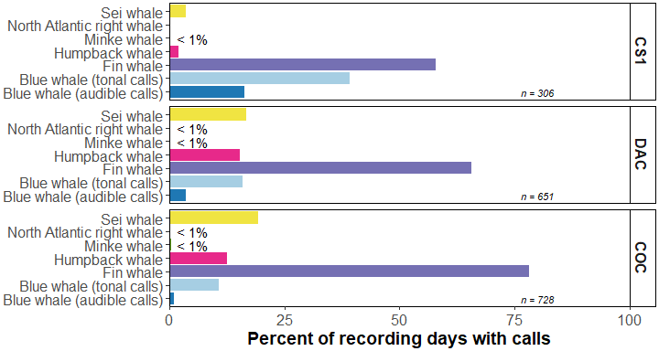

**Figure 2.** Prevalence of specified baleen whale species calls recorded within the specified area. Percentage of total recording days (n) with confirmed calls of each baleen whale species at each recording station, shown from east (top) to west (bottom).

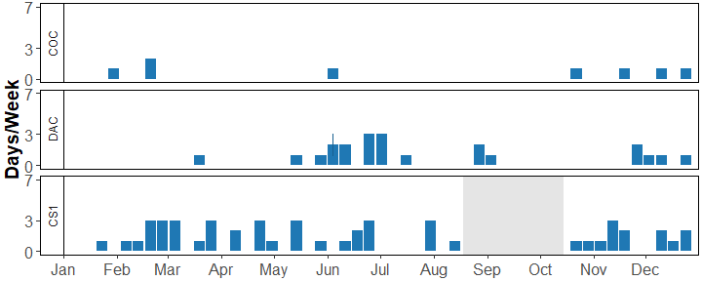

**Figure 3.** Seasonal occurrence of Blue whale (audible calls). Number of days per week with Blue whale (audible calls) calls present at each recording station in specified area throughout the year. In cases where multiple years of data were available, the mean number of days per week with Blue whale (audible calls) present is shown, with error bars indicating standard error. Grey shaded areas represent periods with no recording effort.

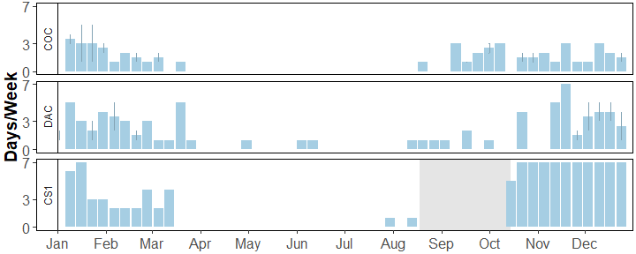

**Figure 4.** Seasonal occurrence of Blue whale (tonal calls). Number of days per week with Blue whale (tonal calls) calls present at each recording station in specified area throughout the year. In cases where multiple years of data were available, the mean number of days per week with Blue whale (tonal calls) present is shown, with error bars indicating standard error. Grey shaded areas represent periods with no recording effort.

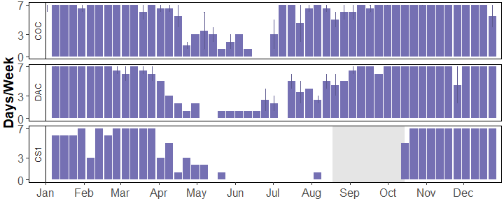

**Figure 5.** Seasonal occurrence of Fin whale. Number of days per week with Fin whale calls present at each recording station in specified area throughout the year. In cases where multiple years of data were available, the mean number of days per week with Fin whale present is shown, with error bars indicating standard error. Grey shaded areas represent periods with no recording effort.

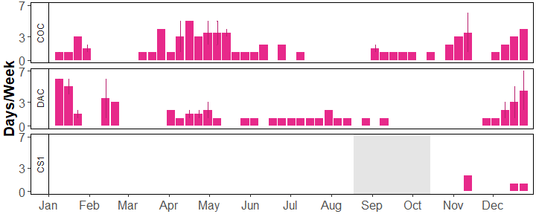

**Figure 6.** Seasonal occurrence of Humpback whale. Number of days per week with Humpback whale calls present at each recording station in specified area throughout the year. In cases where multiple years of data were available, the mean number of days per week with Humpback whale present is shown, with error bars indicating standard error. Grey shaded areas represent periods with no recording effort.

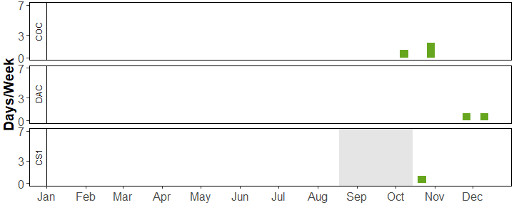

**Figure 7.** Seasonal occurrence of Minke whale. Number of days per week with Minke whale calls present at each recording station in specified area throughout the year. In cases where multiple years of data were available, the mean number of days per week with Minke whale present is shown, with error bars indicating standard error. Grey shaded areas represent periods with no recording effort.

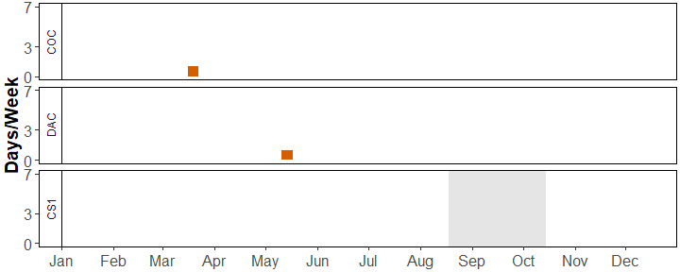

**Figure 8.** Seasonal occurrence of North Atlantic right whale. Number of days per week with North Atlantic right whale calls present at each recording station in specified area throughout the year. In cases where multiple years of data were available, the mean number of days per week with North Atlantic right whale present is shown, with error bars indicating standard error. Grey shaded areas represent periods with no recording effort.

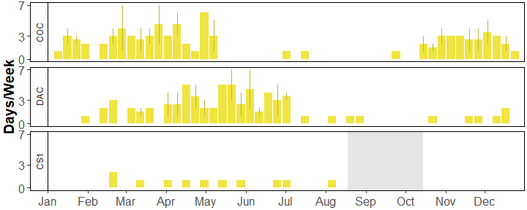

**Figure 9.** Seasonal occurrence of Sei whale. Number of days per week with Sei whale calls present at each recording station in specified area throughout the year. In cases where multiple years of data were available, the mean number of days per week with Sei whale present is shown, with error bars indicating standard error. Grey shaded areas represent periods with no recording effort.

## Appendix A

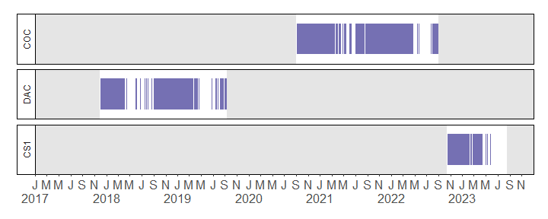

**Figure A-1.** Daily occurrence of confirmed Fin whale at each recording station. Grey shading represents periods with no recording effort throughout the study period 2017 - 2023

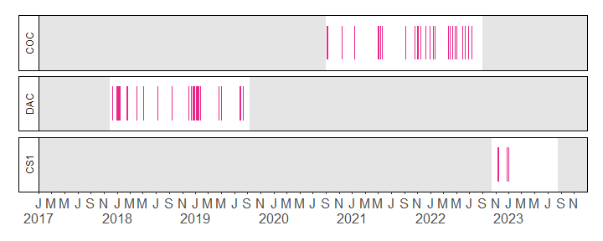

**Figure A-2.** Daily occurrence of confirmed Humpback whale at each recording station. Grey shading represents periods with no recording effort throughout the study period 2017 - 2023

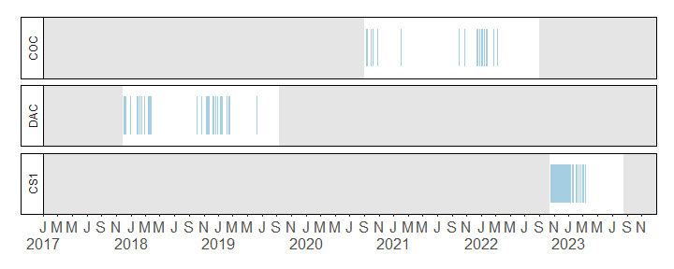

**Figure A-3.** Daily occurrence of confirmed Blue whale (tonal calls) at each recording station. Grey shading represents periods with no recording effort throughout the study period 2017 - 2023

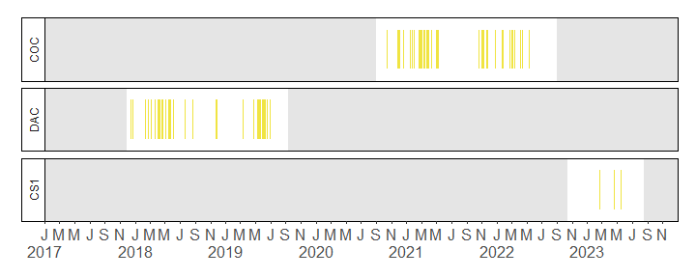

**Figure A-4.** Daily occurrence of confirmed Sei whale at each recording station. Grey shading represents periods with no recording effort throughout the study period 2017 - 2023

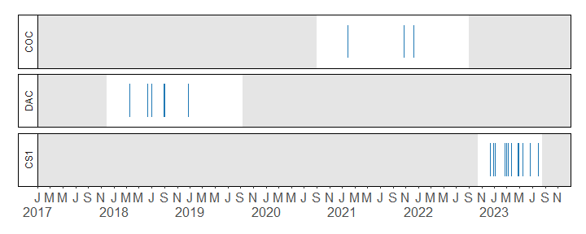

**Figure A-5.** Daily occurrence of confirmed Blue whale (audible calls) at each recording station. Grey shading represents periods with no recording effort throughout the study period 2017 - 2023

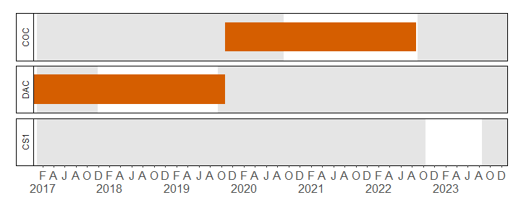

**Figure A-6.** Daily occurrence of confirmed North Atlantic right whale at each recording station. Grey shading represents periods with no recording effort throughout the study period 2017 - 2023

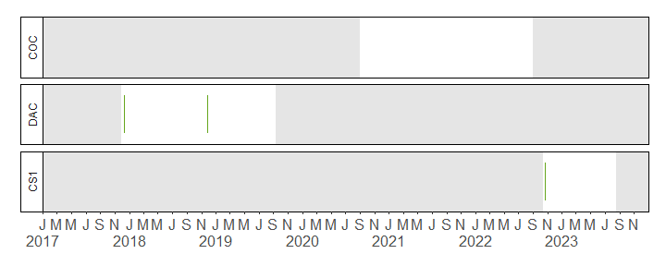

**Figure A-7.** Daily occurrence of confirmed Minke whale at each recording station. Grey shading represents periods with no recording effort throughout the study period 2017 - 2023

## References

Au, W. W. L., Pack, A. A., Lammers, M. O., Herman, L. M., Deakos, M. H., & Andrews, K. (2006). Acoustic properties of humpback whale songs. The Journal of the Acoustical Society of America, 120(2), 1103–1110.

Baumgartner, M. F., & Mussoline, S. E. (2011). A generalized baleen whale call detection and classification system. The Journal of the Acoustical Society of America, 129(5), 2889–2902.

Baumgartner, M. F., Van Parijs, S. M., Wenzel, F. W., Tremblay, C. J., Carter Esch, H., & Warde, A. M. (2008). Low frequency vocalizations attributed to sei whales (Balaenoptera borealis). The Journal of the Acoustical Society of America, 124(2), 1339–1349.

Berchok, C. L., Bradley, D. L., & Gabrielson, T. B. (2006). St. Lawrence blue whale vocalizations revisited: Characterization of calls detected from 1998 to 2001. The Journal of the Acoustical Society of America, 120(4), 2340.

Parks, S. E. (2003). Acoustic Communication in the North Atlantic Right Whales (Eubalaena glacialis) (pp.270). Massachusetts Institute of Technology.

Risch, D., Clark, C. W., Dugan, P. J., Popescu, M., Siebert, U., & Van Parijs, S. M. (2013). Minke whale acoustic behavior and multi-year seasonal and diel vocalization patterns in Massachusetts Bay, USA. Marine Ecology Progress Series, 489, 279–295.

Watkins, W. A., Tyack, P., Moore, K. E., & Bird, J. E. (1987). The 20-Hz signals of finback whales (Balaenoptera physalus). Journal of the Acoustical Society of America, 82(6), 1901–1912.