**Create Batch LTSAs**

1. **Requirements**

The following GitHub repos must be cloned or downloaded/unzipped and added to the MATLAB path:

* Triton-TeamWhale (<https://github.com/MARTeamWhale/Triton-TeamWhale>)
* Misc-PAM-data-scripts (<https://github.com/MARTeamWhale/Misc-PAM-data-scripts>)
* MATLAB-Utilities-for-Cetacean-Acoustics (<https://github.com/MARTeamWhale/MATLAB-Utilities-for-Cetacean-Acoustics>)

1. **Organize .wav files into monthly subfolders**

First, check that dataset folder contains only .wav files from full days to be included in the analysis. In MATLAB, open the script “organize_monthly.m” and edit line 21 with the full path to the dataset folder:

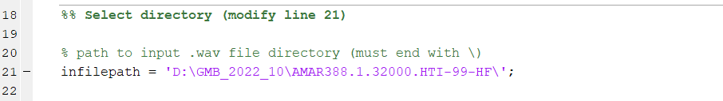

Under the Editor tab, click “Run” (large green arrow). This creates monthly subfolders based on the .wav file dates, and moves all files into the appropriate subfolder. It may take at least 30 minutes to complete, depending on the number of files.

1. **Create batch LTSAs in Triton**

Open Triton. If the “BatchLTSAs” Remora isn’t listed in the “Remoras” menu, choose “Add Remora” and select the following folder:

Triton-TeamWhale-main > Remoras > BatchLTSA

Once the BatchLTSAs Remora is added, go to the “Remoras” menu and choose “Batch LTSAs” > “Batch create LTSAs”.

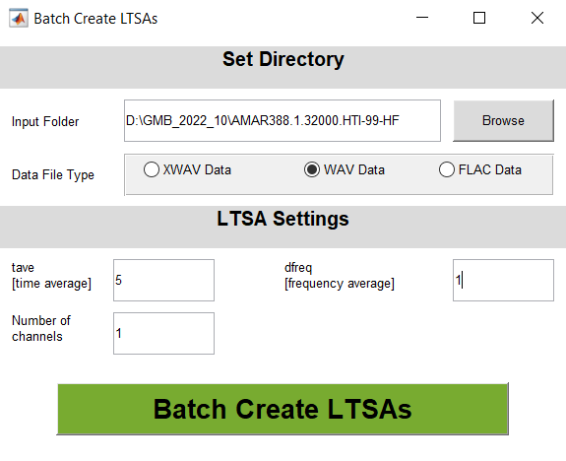

To select the input folder, browse to the dataset folder containing the monthly subfolders created in step 1. Select “WAV Data”, and enter the desired LTSA settings, where “tave” is the time bin in seconds, and “dfreq” is the frequency bin in Hz. Click “Batch Create LTSAs”.

Check LTSA settings chosen for all subfolders, and click “Okay”.

Check/edit LTSA filenames for all subfolders, and click “Okay”. An LTSA will be created within each folder. This could take several hours to complete depending on the size of the dataset.

1. **Move .wav and .ltsa files back to main dataset folder & remove monthly subfolders**

In MATLAB, open the script “remove_monthly_subdirectories.m” and edit line 18 with the full path to the dataset folder (which currently contains the monthly subfolders):

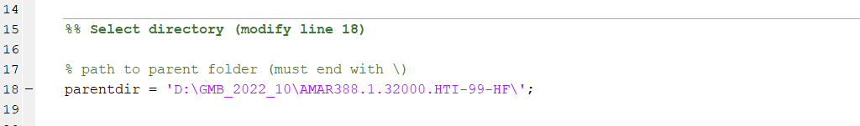

Under the Editor tab, click “Run” (large green arrow). This moves all .wav and .ltsa files out of subfolders and into the main folder. It may take at least 30 minutes to complete, depending on number of files. Empty subfolders will then be deleted.

**FINAL NOTE:** when finished working with the LTSAs, please move the .ltsa files to a separate folder on the hard drive outside of the dataset folder before returning the hard drive to the cabinet for general use.