Documentation
Cute of Curse

Our Java Game Project concluded with the addition of more entities, their characteristics, their interactions with each other, and other components related to them. For instance, we added skills to our main character Felis, which is a key part of his character. We created the skills on a different sprite and overlayed them with our combat frame background. Felis was given three (3) skills. In essence, our combat style or mechanics were similar to that of Pokemon. Our character was intended to face backwards and each turn launches an attack on the NPC enemy. In theory, the player was given the ability to choose between the 3 aforementioned skills through clicking, which unfortunately didn’t come through. Our programmers also added the menu interface which is what appears on start up and the “Play” button redirects to the main game interface. A shortcut for the inventory was also added as an additional function. All in all, certain plans for the game went as planned and some didn’t.

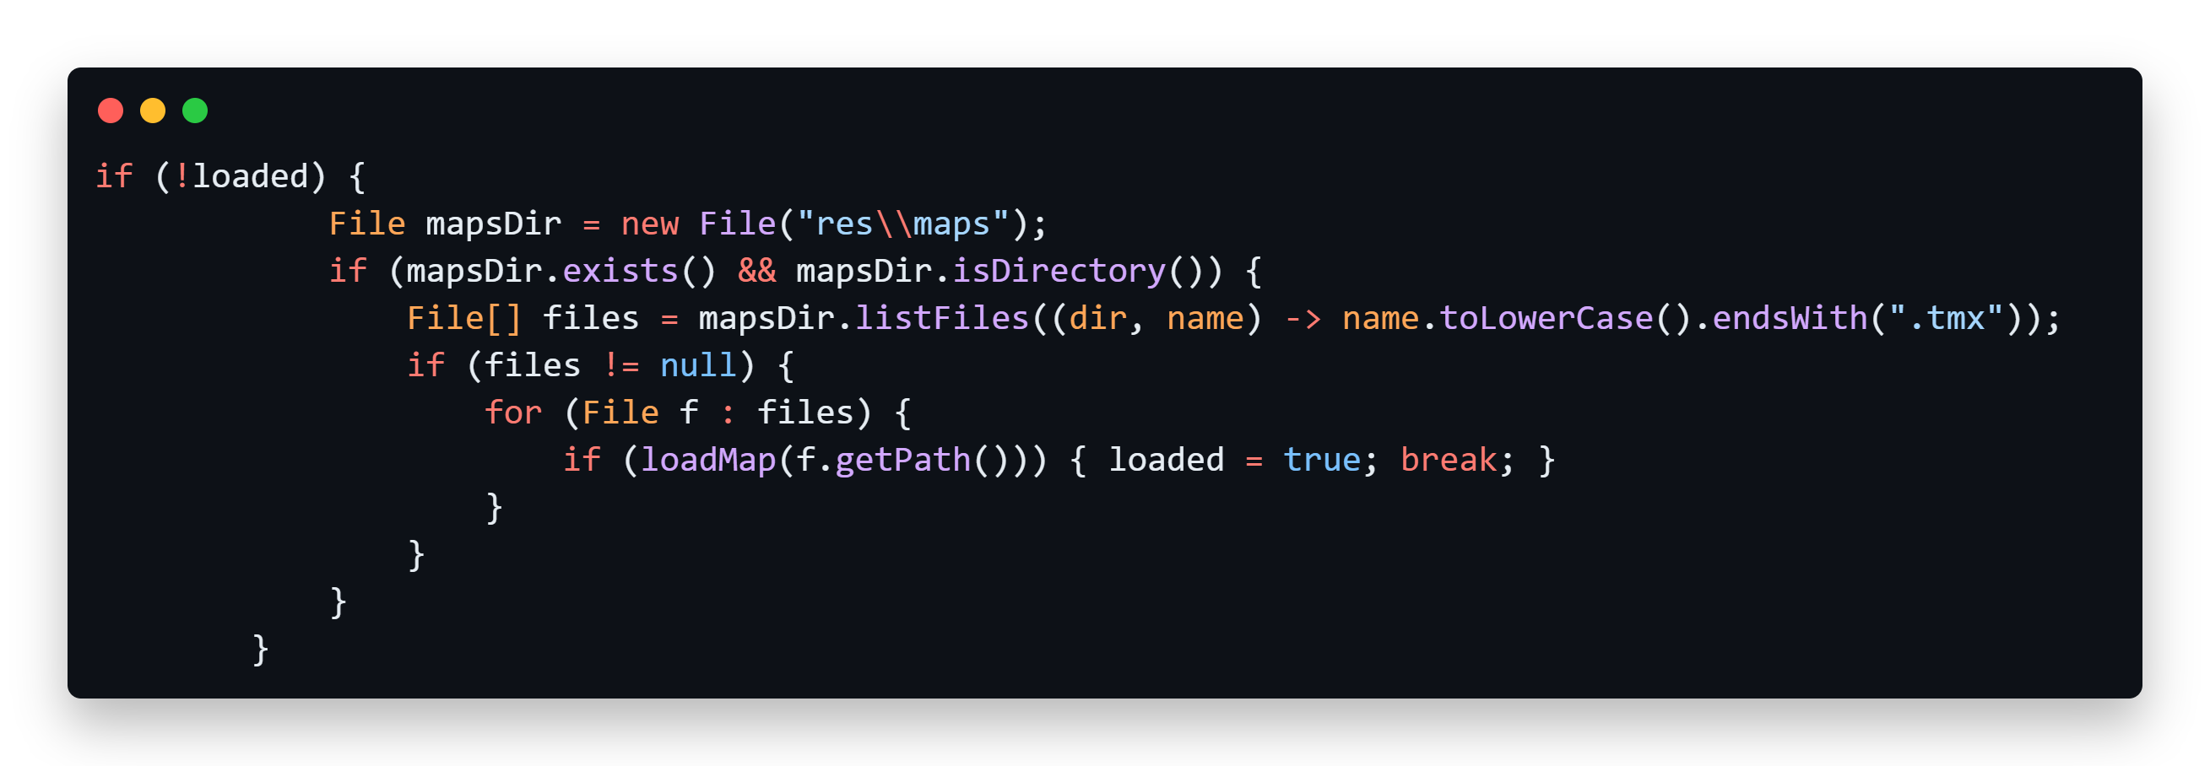

Here is an example code when we coded the rendering logic from manually drawing per sprites by using for loops but now it uses a tmx file which wa created in Tiled Map Editor.

