CSE6214 Software Engineering Fundamentals

Tutor’s Guide 12
Part A: Discussion
Topic (Lecture 12): Software Project Management

Allocate about 5 - 10 minutes for each question. Let the students work in groups of 3 or 4 to discuss with each other their answers. They can refer to the textbook if they want, or search for their answers. They can submit their answers in Google classroom assignment.

- Briefly describe the four P’s in software project management.

Solution:
- People — the most important element of a successful project
- Product — the software to be built
- Process — the set of framework activities and software engineering tasks to get the job done
- Project — all work required to make the product a reality

- List a few examples of project metrics.

Solution:
- Effort/time per software engineering task
- Errors uncovered per review hour
- Scheduled vs. actual milestone dates
- Changes (number) and their characteristics
- Distribution of effort on software engineering tasks

- Explain the use of size-oriented and function-oriented metrics.

Solution:
- assess the status of an ongoing project
- track potential risks
- uncover problem areas before they go “critical,”
- adjust work flow or tasks,
  - evaluate the project team’s ability to control quality of software work products

- What is required to produce a good estimation for a software project?

Solution:
- Project scope must be understood
- Elaboration (decomposition) is necessary
- Historical metrics are very helpful
- At least two different techniques should be used

- What is software scope?

Solution:
- Software scope describes
  - the functions and features that are to be delivered to end-users
  - the data that are input and output
  - the “content” that is presented to users as a consequence of using the software
  - the performance, constraints, interfaces, and reliability that bound the system.

Part B: Tutorial Activity
Learn to draw network diagram in finding a critical path (AOA)
Calculate path possibility and estimated path.

Allocate about 30 minutes to complete the activities. Demonstrate how to draw the AOA diagram with the first table, and ask them to draw the second one. They can submit their answers in Google classroom assignment.

Activity 1 – Read and understand the meaning of Critical Path Method at the following URL: http://en.wikipedia.org/wiki/Critical_path_method

- What is the importance of drawing an (Activity on Arrow) AOA diagram in finding a critical path?

Solution:
By drawing a network diagram, you can figure out the critical path of your project. In project management, a critical path is the sequence of project network activities which add up to the longest overall duration. This determines the shortest time possible to complete the project. Any delay of an activity on the critical path directly impacts the planned project completion date (i.e. there is no float on the critical path).
It means:
- Path - is a connected sequence of activities leading from the starting event to the ending event
- Critical path - is the longest path (time) which determines the project duration. These are the activities that must be completed in as little time as possible, in order that the duration of the project can be minimized. The critical path can be found by identifying the activities that have no float time. These activities must be closely supervised, since any delay will delay the completion of the project.
- Critical activities - refer to all of the activities that make up the critical path. This is an activity which is on the critical path. If this activity is delayed, then the project will not be able to be completed on time.
- Critical path analysis - is the way of showing how a lengthy and complex project (e.g. a building project) can be completed in the shortest possible time. The project is broken down into a number of separate activities, and each activity is then placed in the correct sequence, so to minimize the duration of the project

- Search the Internet on the characteristics of an AOA Diagram.

Solution:
- Construct from left to right
- Any activity can have only one start node
- No two activities can have the same start and end node
- Dummy activities are used in AOA
- Start the network by finding those activities that have no predecessors
- Calculate activity times using probabilistic or deterministic means

- Find out the meaning and the symbols that represent Activity, Event and Dummy Activities in AOA diagram.

Solution:
- Activity - A task or job which takes time & use up resources
Represented by labeled arrow
- Event - An instantaneous point representing the start or finish of an activity
Represented by node
- Dummy activity - Represented by dotted arrow
Used when relationships between activities require no work
Applied when:
- Two activities start and end similarly
- Succeeding activities have partial dependencies on predecessor
activities

Activity 2 – Draw an AOA diagram based on Table 1

Table 1
Activity | Immediate Predecessor | Duration (month)
A | - | 4
B | - | 3
C | A | 2
D | A | 4
E | B | 2
F | C | 3

Solution:

Start by drawing the initial node, and the arrows for A and B (no predecessors). Then draw C and D from the end of A, followed by E from the end of B. Next draw F from the end of C. Merge all the end nodes into a single final node. See the following diagram. Ask the students what is the critical path. There are 3 paths: A-C-F, A-D, B-E. A-C-F is the longest path (4+2+3=9) so it is the critical path.
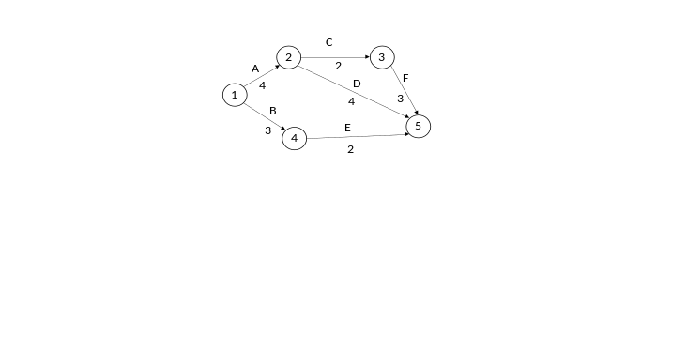

Activity 3 – Draw an AOA Diagram and calculate the longest path using Table 2

Table 2
Activity | Immediate Predecessor | Duration (week)
A | - | 2
B | - | 1
C | - | 3
D | A | 2
E | B, C | 4
F | C | 4
G | D, E | 3

Solution:

Start by drawing the initial node, and the arrows for A, B and C (no predecessors). Then draw D from the end of A, followed by F from the end of C. For E, because the predecessors are B + C, meaning E has to start from the end of both, a dummy arrow (dotted line) is added from C to B and then draw E from the end of B. Merge the ends of D and E, and draw G from the merged node. Merge all the end nodes into a single final node. See the following diagram.
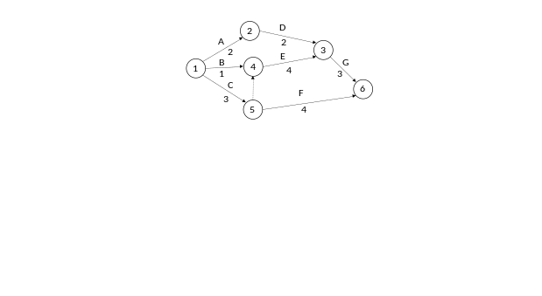

There are 4 paths: A-D-G, B-E-G. C-(dummy)-E-G, C-F. The longest path is C-(dummy) –E-G (3+4+3=10). Explain that it is the critical path since these activities cannot be delayed without impacting the project.

Part C: Project
Task: Verification & Validation

Students to continue the project work in Project III. They should completed the software and review the work against the requirements and design.

- Review the prototype with the software design, and ensure that the prototype is developed according to the software design.

- Review the functions of the prototype with the software requirements, and ensure that the required functions are processing as required by the customers / users. You should use the acceptance test as a checklist for this purpose.

