**Software Requirements and Design Document**

***for***

**GYM Management System**

***Prepared by***

* **Muhammad Abdur Rafey – I210705**
* **Ayra Alamdar – I212968**

***Date: 3rd December 2023, Sunday***

**Table of Contents**

|  |  |  |  |
| --- | --- | --- | --- |
| Serial Number | Contents | Page Number | |
| 1. Introduction | 1.1 Purpose | | 4 |
|  | 1.2 Product Scope | | 4 |
|  | 1.3 Title | | 5 |
|  | 1.4 Objectives | | 5 |
|  | 1.5 Problem Statement | | 6 |
| 1. Overall Description | 2.1 Product Perspective | | 7 |
|  | 2.2 Product Functions | | 7-9 |
|  | 2.3 List of Use Cases | | 10 |
|  | 2.4 Extended Use Cases | | 11-22 |
|  | 2.5 Use Case Diagram | | 23 |
| 1. Other Nonfunctional Requirements | 3.1 Performance Requirements | | 24-25 |
|  | 3.2 Safety Requirements | | 26-27 |
|  | 3.3 Security Requirements | | 28-29 |
|  | 3.4 Software Quality Attributes | | 30-31 |
|  | 3.5 Business Rules | | 32-33 |
|  | 3.6 Operating Environment | | 34-35 |
|  | 3.7 User Interface | | 36-38 |
|  | Domain Model | | 39 |
|  | System Sequence Diagram | | 40-51 |
|  | Sequence Diagram | | 52-63 |
|  | Class Diagram | | 64 |
|  | Package Diagram | | 65 |
|  | Deployment Diagram | | 66 |

* **Introduction**
  + **Purpose:**
* The primary motivation for selecting this project stems from the observed absence of fitness applications in Pakistan that offer direct user-to-trainer online interactions. Currently, many individuals in Pakistan embark on fitness journeys without proper guidance, often relying on trends found on the internet, which can lead to health issues and ineffective results.
* The project aims to bridge this gap by offering a web-based fitness application that provides users with access to certified fitness trainers, personalized workout plans, and nutritional guidance. This approach not only addresses the problem of limited guidance but also mitigates the potential health risks associated with uninformed fitness practices. It is a feasible solution to empower individuals in Pakistan to achieve their fitness goals safely and with expert support.
* **Product Scope:**
* The scope of the project encompasses the development of a web-based fitness application. This application will cater to fitness enthusiasts across various demographics, making it accessible to a wide user base. The primary focus of the application is to provide personalized workout plans, real-time communication with fitness trainers, messaging features, progress tracking tools, and computer vision technology for exercise form assessment. Unlike previous tools in this domain, which may have been limited in functionality or user reach, this web-based fitness application aims to offer a comprehensive and inclusive fitness solution, making it available to a broader audience beyond specific institutions or groups.
* **Title:**
  + **System Aim:** Mobile/Desktop Physical Fitness Assistance Application
  + **Immediate Solution:** The fitness application will go above and beyond by incorporating a cutting-edge feature that uses the application's webcam and computer vision technology to assess and ensure correct exercise form. This innovative tool will provide real-time feedback to clients, helping them perform exercises accurately and reduce the risk of injury. With this added feature, clients can be confident that they are getting the most out of their workouts while maintaining safe and effective form, further enhancing their overall fitness experience.
* **Objectives:**
* **Development of a Comprehensive Fitness Platform:** Create a web-based fitness application that offers a wide range of features, including personalized workout plans, real-time communication, messaging, progress tracking, and exercise form assessment.
* **Enhanced User Engagement:** Foster user engagement by providing a dynamic and interactive fitness community where users can connect with trainers and peers, participate in challenges, and share their fitness achievements.
* **Personalization and Effectiveness:** Tailor fitness plans and recommendations to individual user goals and abilities, thereby maximizing the effectiveness of their fitness routines.
* **Safety and Correct Form:** Implement computer vision technology to ensure that users perform exercises with proper form, reducing the risk of injury and enhancing the quality of workouts.
* **Accessibility:** Make the application accessible to a wide demographic, ensuring that individuals of all fitness levels and backgrounds can benefit from its features.
* **User Progress Tracking:** Develop tools for users to easily track and visualize their fitness progress over time, motivating them to stay committed to their fitness goals.
* **Quality Assurance and User Satisfaction:** Continuously gather user feedback, ratings, and reviews to improve the application's quality, ensuring high user satisfaction and loyalty.
* **Problem Statement:**
* **Facilitating Direct User-Trainer Interaction:** Develop a platform that allows users in Pakistan to have direct online interactions with fitness trainers, addressing the existing gap in the market where such solutions are limited.
* **Mitigating Health Risks:** Address the significant health issues that arise when individuals engage in fitness training and dieting without proper guidance. The project aims to provide users with expert advice and personalized fitness plans to ensure they pursue their fitness goals safely and effectively.
* **Overall Description**
  + **Product Perspective:**
* The web-based fitness application, as specified in this Software Requirements System, is envisioned as a standalone product aimed at addressing the specific fitness needs of users in Pakistan. It is not a replacement for existing systems but rather a novel solution filling a gap in the market by offering a comprehensive and inclusive fitness platform. While the application is self-contained, it is designed to interact seamlessly with external components, particularly certified fitness trainers who will provide real-time guidance and support. The product is part of the broader context of the fitness technology landscape, emphasizing innovation through the integration of computer vision technology for exercise form assessment. A conceptual diagram depicting the major components of the overall system, including user interfaces, communication channels, and external trainer interactions, will be beneficial to visualize the interconnected elements of this fitness application.
* **Product Functions:**
* **User Registration and Authentication:**
  + Allow users to register accounts with the application.
  + Implement secure authentication mechanisms to safeguard user data.
* **Personalized Workout Plans:**
  + Provide users with the ability to create and customize personalized workout plans based on their fitness goals and abilities.
* **Real-time Communication:**
  + Facilitate direct online interactions between users and certified fitness trainers in real-time.
  + Enable messaging features for seamless communication between users and trainers.
* **Progress Tracking Tools:**
  + Develop tools for users to monitor and visualize their fitness progress over time.
  + Implement features for setting and tracking fitness milestones.
* **Exercise Form Assessment:**
  + Integrate computer vision technology to assess and ensure correct exercise form in real-time.
  + Provide immediate feedback to users, helping them perform exercises accurately and reduce the risk of injury.
* **Community Engagement Features:**
  + Foster a dynamic and interactive fitness community.
  + Enable users to connect with peers, participate in challenges, and share their fitness achievements.
* **Accessibility and User Personalization:**
  + Ensure the application is accessible to a wide demographic, catering to users of varying fitness levels and backgrounds.
  + Tailor fitness plans and recommendations to individual user goals and abilities.
* **Quality Assurance and User Feedback:**
  + Gather user feedback, ratings, and reviews continuously to improve the application's quality.
  + Implement features for users to provide input on their experience, ensuring high user satisfaction and loyalty.

This high-level summary outlines the core functions of the web-based fitness application, ranging from user registration and personalized workout plans to real-time communication with trainers, progress tracking, and innovative exercise form assessment through computer vision technology.

* **List of Use Cases**
  + Manager Client Account
  + Register Clients
  + Schedule Sessions
  + Client-Trainer Sessions
  + Workout services
  + Dietary Guidance Issues
  + Client Trainer Interaction OR Client-Client Interaction
  + Payment Control
  + Feedback and Rating System
  + Report Generation from Logs
  + Advertisement Management
* **Extended Use Cases**

**Manager Client Account**

|  |  |
| --- | --- |
| Component | Details |
| Use case name | Manage Client Account |
| Scope | GYM Management System |
| Level | User goal |
| Primary actor | Admin |
| Stakeholders and interests | * Admin: Manages client accounts efficiently. * Database: Stores and retrieves client account data. |
| Preconditions | Admin is logged in. |
| Postcondition | Client account information is updated. |
| Main success scenario | * Admin selects "Manage Client Account." * System retrieves a list of client accounts. * Admin selects a specific client. * Admin updates client details. * System stores the changes. |
| Extensions | * If the admin encounters an error while updating, an error message is displayed. * If the admin cancels the update, the system retains the original client account information. |

**Register Clients**

|  |  |
| --- | --- |
| Component | Details |
| Use case name | Register Clients |
| Scope | GYM Management System |
| Level | User goal |
| Primary actor | Admin |
| Stakeholders and interests | * Admin: Adds new clients to the system. * Database: Stores new client information. |
| Preconditions | Admin is logged in. |
| Postcondition | New client is registered in the system. |
| Main success scenario | * Admin selects "Register Clients." * Admin enters new client information. * System validates information. * System stores new client data. * Confirmation of successful registration is displayed. |
| Extensions | * If the entered information is invalid, the system prompts the admin to correct the details. * If the admin cancels the registration, no new client is added. |

**Schedule Sessions**

|  |  |
| --- | --- |
| Component | Details |
| Use case name | Schedule Sessions |
| Scope | GYM Management System |
| Level | User goal |
| Primary actor | Admin |
| Stakeholders and interests | * Admin: Manages scheduling efficiently * Database: Stores session schedules |
| Preconditions | Admin is logged in. |
| Postcondition | Session is scheduled in the system. |
| Main success scenario | * Admin selects "Schedule Sessions." * System displays available slots. * Admin selects a slot and assigns it to a client. * System updates the session schedule. * Confirmation of successful scheduling is displayed. |
| Extensions | * If the selected slot is already booked, the system prompts the admin to choose another slot. * If the admin cancels the scheduling, no session is scheduled. |

**Client-Trainer Matching**

|  |  |
| --- | --- |
| Component | Details |
| Use case name | Client-Trainer Matching |
| Scope | GYM Management System |
| Level | User goal |
| Primary actor | Admin |
| Stakeholders and interests | * Admin: Matches clients with suitable trainers * Database: Stores client-trainer relationships |
| Preconditions | Admin is logged in. Clients and trainers are registered. |
| Postcondition | Client is matched with a suitable trainer. |
| Main success scenario | * Admin selects "Client-Trainer Matching." * System displays available trainers. * Admin selects a trainer for a specific client. * System updates the client-trainer relationship. * Confirmation of successful matching is displayed. |
| Extensions | * If no suitable trainer is available, the system suggests alternative options. * If the admin cancels the matching process, no client-trainer relationship is established. |

**Workout Services**

|  |  |
| --- | --- |
| Component | Details |
| Use case name | Workout Services |
| Scope | GYM Management System |
| Level | User goal |
| Primary actor | Admin |
| Stakeholders and interests | * Admin: Configures workout services * Database: Stores configured services |
| Preconditions | Admin is logged in. |
| Postcondition | Workout services are configured in the system. |
| Main success scenario | * Admin selects "Workout Services". * System displays available workout options. * Admin configures workout services for a specific client. * System stores the configured services. * Confirmation of successful configuration is displayed. |
| Extensions | * If the selected workout options are incompatible, the system prompts the admin to adjust the selection. * If the admin cancels the configuration, no workout services are configured. |

**Dietary Guidance Services**

|  |  |
| --- | --- |
| Component | Details |
| Use case name | Dietary Guidance Services |
| Scope | GYM Management System |
| Level | User goal |
| Primary actor | Admin |
| Stakeholders and interests | * Admin: Configures dietary guidance services * Database: Stores configured services |
| Preconditions | Admin is logged in. |
| Postcondition | Dietary guidance services are configured in the system. |
| Main success scenario | * Admin selects "Dietary Guidance Services”. * System displays available dietary guidance options. * Admin configures dietary guidance services for a specific client. * System stores the configured services. * Confirmation of successful configuration is displayed. |
| Extensions | * If the selected dietary guidance options conflict with the client's preferences, the system suggests alternatives. * If the admin cancels the configuration, no dietary guidance services are configured. |

**Client-Trainer Interaction OR Client-Client Interaction**

|  |  |
| --- | --- |
| Component | Details |
| Use case name | Client-Trainer Interaction OR Client-Client Interaction |
| Scope | GYM Management System |
| Level | User goal |
| Primary actor | Customer (registered OR Trainer) |
| Stakeholders and interests | * Customer: Interacts with the assigned trainer or other clients * Database: Stores interaction history |
| Preconditions | Customer is logged in and assigned to a trainer or is part of a group interaction. |
| Postcondition | Interaction history is recorded in the system. |
| Main success scenario | * Customer selects "Client-Trainer Interaction" or "Client-Client Interaction." * System displays available interaction options. * Customer interacts with the assigned trainer or other clients. * System records the interaction history. * Confirmation of successful interaction is displayed. |
| Extensions | * If the interaction involves a dispute, the system initiates a conflict resolution process. * If the customer cancels the interaction, no interaction history is recorded. |

**Payment Control**

|  |  |
| --- | --- |
| Component | Details |
| Use case name | Payment Control |
| Scope | GYM Management System |
| Level | User goal |
| Primary actor | Admin |
| Stakeholders and interests | * Admin: Manages client payments and subscriptions * Database: Stores payment and subscription information |
| Preconditions | Admin is logged in. Clients have active subscriptions. |
| Postcondition | Payment is processed successfully. |
| Main success scenario | * Admin selects "Payment Control." * System displays a list of clients with active subscriptions. * Admin selects a client for payment processing. * System processes the payment. * Confirmation of successful payment is displayed. |
| Extensions | * If the payment fails, the system provides an error message and prompts the admin to retry. * If the admin cancels the payment, no payment is processed. |

**Feedback and Rating System**

|  |  |
| --- | --- |
| Component | Details |
| Use case name | Feedback and Rating System |
| Scope the system under design | GYM Management System |
| Level | User goal |
| Primary actor | Customer (registered) |
| Stakeholders and interests | * Customer: Provides feedback and ratings for services * Database: Stores feedback and rating information |
| Preconditions | Customer is logged in and has completed a session or received a service. |
| Postcondition | Feedback and rating are recorded in the system. |
| Main success scenario | * Customer selects "Feedback and Rating." * System prompts for feedback and rating. * Customer provides feedback and rates the service. * System records the feedback and rating. * Confirmation of successful submission is displayed. |
| Extensions | * If the customer provides a low rating, the system initiates a feedback resolution process. * If the customer cancels the feedback submission, no feedback or rating is recorded. |

**Service Customization**

|  |  |
| --- | --- |
| Component | Details |
| Use case name | Service Customization |
| Scope | GYM Management System |
| Level | User goal |
| Primary actor | Admin |
| Stakeholders and interests | * Admin: Configures personalized services for clients * Database: Stores configured services |
| Preconditions | Admin is logged in. |
| Postcondition | Personalized services are configured in the system. |
| Main success scenario | * Admin selects "Service Customization." * System displays options for configuring services. * Admin configures personalized services for a specific client. * System stores the configured services. * Confirmation of successful configuration is displayed. |
| Extensions | * If the admin configures conflicting services, the system prompts for clarification. * If the admin cancels the customization, no personalized services are configured. |

**Report Generation from Logs**

|  |  |
| --- | --- |
| Component | Details |
| Use case name | Report Generation from Logs |
| Scope | GYM Management System |
| Level | User goal |
| Primary actor | Admin |
| Stakeholders and interests | * Admin: Generates reports for system activities * Database: Stores system logs |
| Preconditions | Admin and Customers are logged in. System logs are available. |
| Postcondition | Report is generated based on system logs. |
| Main success scenario | * Admin selects "Report Generation from Logs." * Customer is able to see their progress based on their log reports. * System provides options for report parameters. * Admin configures report parameters. * System generates and displays the report. * Confirmation of successful report generation is displayed. |
| Extensions | * If the selected report parameters are invalid, the system prompts the admin to adjust them. * If the admin cancels the report generation, no report is generated. |

**Advertisement Management**

|  |  |
| --- | --- |
| Component | Details |
| Use case name | Advertisement Management |
| Scope | GYM Management System |
| Level | User goal |
| Primary actor | Admin |
| Stakeholders and interests | * Admin: Manages advertisements within the system * Database: Stores advertisement information * Customer: Relevant advertisements |
| Preconditions | Admin is logged in. Advertisements are available in the system. |
| Postcondition | Advertisements are managed within the system. |
| Main success scenario | * Admin selects "Advertisement Management." * System displays options for managing advertisements. * Admin adds, edits, or removes advertisements. * System updates the advertisement information. * Confirmation of successful management is displayed. |
| Extensions | * If the admin encounters issues while managing advertisements, the system provides error messages and guidance. * If the admin cancels the management process, no changes are made to advertisements. |

* **Use Case Diagram**

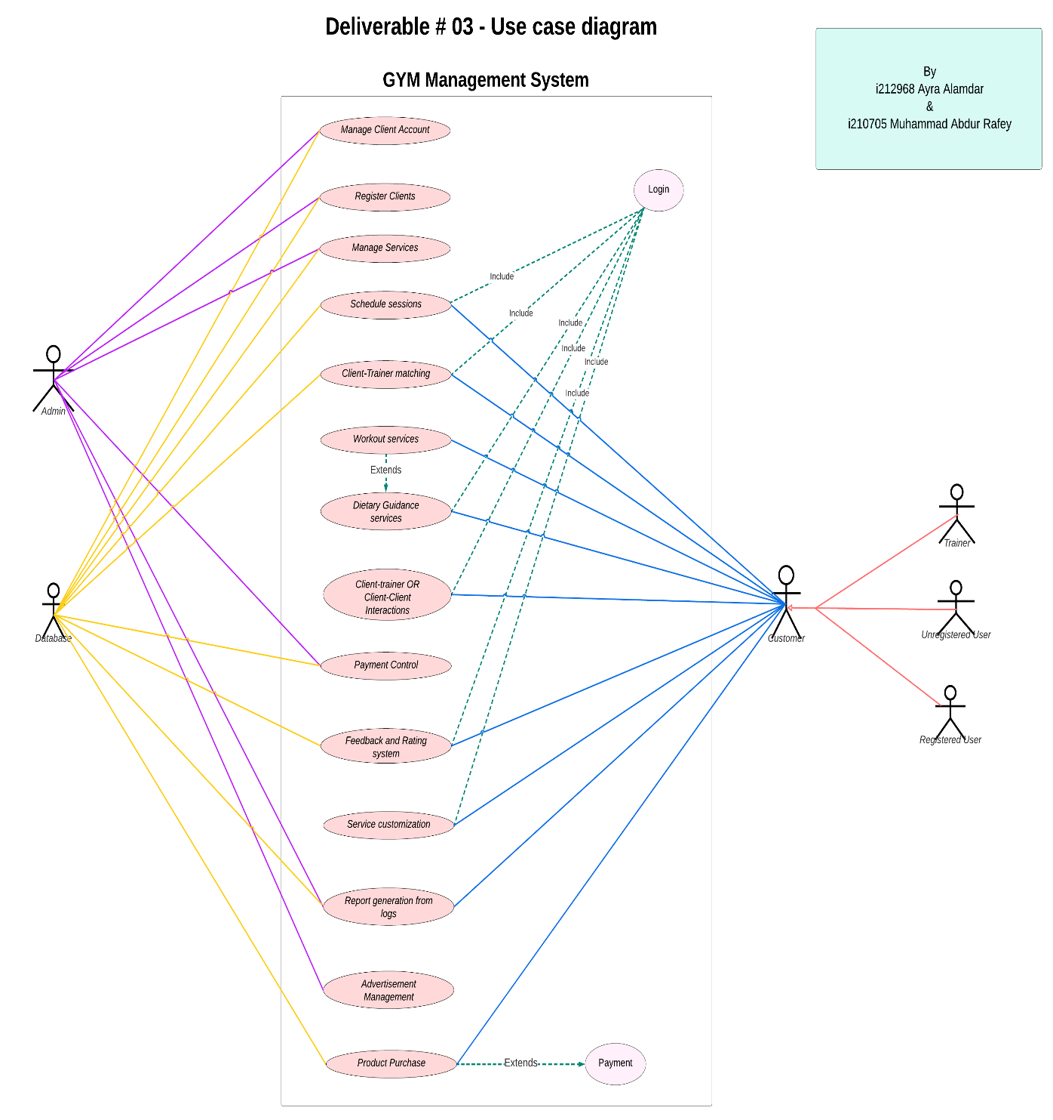

* **Other Nonfunctional Requirements**
  + **Performance Requirements**

**Performance Standards:**

* **Reaction Time:**
  + To provide a smooth and responsive user experience, the application should react to user engagements (such as clicks and inputs) in less than two seconds.
* **Communication Latency in Real Time:** 
  + For real-time communication features involving consumers and professional fitness coaches, keep latency under 500 milliseconds.
* **Processing Time for Computer Vision:** 
  + To provide prompt and precise assistance during workouts, the computer vision technology exercise form assessment should offer real-time feedback with a processing time of no more than one second per frame.
* **Scalability:** 
  + It should be possible for the system to sustain at least 10,000 concurrent users without experiencing appreciable performance reduction, allowing it to grow with the user base*.*
* **Retrieval Time of Data:** 
  + Make sure that the database is accessed quickly; strive for an average query execution time of less than 200 milliseconds.
* **Updates on Progress Tracking:**
  + Real-time updates to user progress tracking tools, like charts and statistics, are necessary to give users current and accurate information about their fitness journey.
* **Responsiveness in Community Engagement Features:** 
  + In order to provide a dynamic and captivating user experience, community engagement features such as achievements sharing, peer interactions, and challenges should function without any discernible lag.

**Justification:**

* **User Engagement:** 
  + A positive user experience promotes engagement and satisfaction. Fast reaction times for user interactions and low latency in real-time communication are two factors that support this.
* **Real-time Feedback:** 
  + In order to improve workout effectiveness and lower the risk of injury, users must receive prompt feedback on proper form using computer vision data processing.
* **Scalability:** 
  + As the number of users increases, scalability makes sure that the program stays responsive and performant, giving all users a top-notch experience.
* **Data Accuracy:** 
  + Users are motivated and have a better overall fitness experience thanks to real-time updates for progress tracking and community features, which also contribute to accurate and trustworthy information.
* **Safety Requirements**

**Requirements for Safety:**

* **Safety of Exercise Form Assessment:**
  + When assessing exercise form, computer vision technology must put user safety first. This means that it must give precise feedback to stop users from performing exercises incorrectly, which could cause injury.
* **Privacy and Data Security:**
  + Put strong security measures in place to protect user data, make sure that applicable data protection laws are followed, and stop illegal access or data breaches.
* **User Verification:** 
  + Employ secure authentication techniques to shield user accounts from illegal access, avert any abuse, and guarantee the confidentiality of personal data.
* **Fitness Trainer Certification:**
  + It is imperative to verify that fitness instructors engaging in live chat sessions with clients are licensed experts who follow industry safety regulations.
* **Information in Case of Emergency:**
  + Give users rapid access to contacts or emergency information within the app so they can seek help quickly in the event of a medical emergency while working out.
* **Unambiguous Usage Instructions:**
  + In order to inform users about the significance of adhering to recommended practices during their exercise regimens, the application should clearly express safety standards and proper usage instructions.
* **Observance of Health Regulations:**
  + Respect applicable health and fitness laws and guidelines to make sure the program follows industry best practices and puts user safety first.
* **Frequent evaluations of security:** 
  + To detect and resolve such vulnerabilities and maintain continuous compliance with safety and privacy regulations, conduct routine security audits and assessments.
* **Alerts and User Education:**
  + Use the program to include instructive pop-ups or alerts that warn users about possible risks related to specific exercises and offer safety advice to reduce those risks.
* **Constant Tracking and Reporting**:
  + Provide systems that allow for the ongoing observation of user behaviour and application usage. This will allow for the prompt identification and reporting of any abnormalities or safety concerns.

**Justification:**

* **User Safety:**
  + The main goal is to make sure that users are safe while engaging in fitness activities. This is especially true when computer vision technology and real-time contact with fitness trainers are employed.
* **Data security:**
  + Preserving user privacy, preventing unwanted access, adhering to legal obligations, and preserving user confidence all depend on protecting user data.
* **Trainer Certification:**
  + By guaranteeing that knowledgeable advice is given during in-person contacts, confirming the certification of fitness trainers enhances user safety.
* **Emergency Preparedness:**
  + Giving users access to emergency contacts and information promotes their safety in the event that they have unanticipated medical problems while exercising.
* **User Education:**
  + When safety instructions and instructional alerts are communicated clearly, users' awareness is increased, and they are more equipped to choose their exercise regimens.
* **Security Requirements**

**Security prerequisites:**

* **User Verification:**
  + To guarantee that only authorized users have access to the program, implement secure user authentication techniques like multi-factor authentication.
* **Encryption of Data:**
  + To prevent unwanted access, utilize robust encryption protocols when transmitting and storing sensitive user data, such as contact logs and personal information.
* **Control of Access:**
  + To limit system access based on user roles and stop unauthorized users from accessing sensitive features or data, define and implement role-based access control.
* **Channels for Secure Communication:**
  + To preserve user privacy, make sure that all channels of communication—particularly those used for in-the-moment interactions with fitness trainers—are safe and secured.
* **Frequent audits of security:**
  + To maintain the application's ongoing security, do frequent security audits and vulnerability assessments to find and fix any possible security flaws.
* **Data Accuracy:**
  + Put safeguards in place to ensure the accuracy of user data, guarding against illegal access to or alteration of data that is stored within the program.
* **Configuring Privacy:**
  + Give users the ability to manage the visibility of their accomplishments, exercise records, and personal information within the program using detailed privacy options.
* **Adherence to Regulations:**
  + Respect applicable privacy laws and data protection rules, making sure that industry norms are followed, and that user data is protected as required by law.
  + The plan for responding to incidents. To minimize the possible impact on users and the application, develop and maintain an incident response plan that outlines how to address and mitigate security events quickly.
* **Safe Integrations with Third Parties:**
  + Make sure that any integrations the application has with other services or APIs follow security best practices and don't jeopardize user data.
* **Staff Security Training:**
  + To promote a security-conscious culture and reduce the likelihood of human-related security concerns, provide security training to employees involved in the application's development and maintenance.
* **Certifications in Security:**
  + Acquire industry-relevant security certifications, such as ISO 27001 or others, to show that you are dedicated to upholding the strictest security guidelines.

**Justification**

* **User Data Protection:**
  + To preserve the integrity and confidentiality of sensitive data, security measures are designed to safeguard user data both during transmission and storage.
  + Role-based access control minimizes the possibility of unwanted access by guaranteeing that users can only access the information and functionality required for their responsibilities.
* **Regulatory Compliance:**
  + Respecting data protection laws is essential to using user data in a way that is morally and legally acceptable, building confidence, and preserving the app's good name.
* **Incident Response:**
  + To reduce the impact of security incidents and quickly fix any potential vulnerabilities, a clearly defined incident response plan is necessary.
* **Software Quality Attributes**
* **Usability:**
  + **Goal**: The goal is to receive at least 90% of the possible points in usability feedback questionnaires from users.
  + **Justification**: To improve the application's overall usability, give top priority to user-friendly interactions, easy navigation, and intuitive user interfaces.
* **Dependability:**
  + **Goal**: Preserve a 99.9% system uptime while reducing downtime for planned maintenance and unforeseen problems.
  + **Justification**: Since reliability guarantees that the program is constantly responsive and available, it is essential for user confidence and happiness.
* **Efficiency of Performance:**
  + **Goal**: Confirm that the application can support a minimum of 10,000 concurrent users without experiencing a notable reduction in response time.
  + **Justification**: In order to support an expanding user base and maintain a fluid and responsive experience, performance efficiency is essential.
* **Sustainability:**
  + **Goal**: Using static code analysis methods, obtain a code maintainability index of at least 80%.
  + **Justification**: Give priority to clear, modular code to make it easier for developers to maintain and improve it in the future.
* **Safety:**
  + **Goal**: In regular security audits, find and fix possible vulnerabilities with a minimum score of 95%.
  + **Justification**: Security needs to be proactive and always being evaluated in order to preserve user confidence and safeguard user data.
* **Scalability:**
  + **Goal**: The goal is to effectively manage a load test with a 50% increase in simulated users over the anticipated peak load in order to validate the application's scalability.
  + **Justification**: The capacity to scale a program without sacrificing speed allows it to support an increasing user base.
* **Compatibility and Interoperability:** 
  + **Goal**: Verify compatibility with popular operating systems (Windows, macOS, Linux) and ensure compatibility with major web browsers (Chrome, Firefox, Safari).
  + **Justification**: By accommodating a variety of user preferences and environments, compatibility and interoperability support a larger user base.
* **Testability:** 
  + **Goal**: Achieve a test coverage of at least 80% for critical application functionalities. Rationale: High testability enables efficient identification and resolution of bugs, ensuring the reliability and correctness of the application.
* **Adaptability:** 
  + **Goal**: Apply adaptive design principles to ensure a seamless user experience across multiple devices, earning a user satisfaction rating of at least 85% on mobile devices.
* **Accuracy:**
  + **Goal**: Keep user-reported major issues resolved in fewer than 48 hours for bug fixes.
  + **Justification**: Accuracy is essential to provide a reliable and error-free user experience, requiring early problem detection and fixing.

The purpose of these particular, measurable quality qualities is to guarantee that the web-based fitness program satisfies user requirements and development standards while offering a dependable, safe, and easy-to-use fitness experience.

* **Business Rules**
* **Sign-up for an account and access to it:**
  + The fitness application only permits accounts to be registered by people who are at least eighteen years old.
  + When registering, users must enter valid personal information, and multiple accounts are not allowed.
* **Fitness Trainer Certification:**
  + The management of the program verifies that only certified fitness trainers are permitted to engage in real-time communication with users.
* **Exercise Form Evaluation:**
  + For exercise form evaluation to be enabled using computer vision technology, users need to use a device that has a working webcam.
  + In the event that the webcam is broken, the application will prevent users from continuing with the workouts.
* **User Behaviour in Features for Community Engagement:**
  + When using community features, users are required to interact with peers and fitness trainers in a courteous and upbeat manner.
  + Depending on the seriousness of the transgression, community guidelines violations may result in warnings, temporary suspensions, or permanent account revocation.
* **Accuracy of Emergency Information:**
  + It is the user's responsibility to maintain current emergency information in the application.
  + The application assumes no liability for users' outdated or erroneous emergency information.
* **Preferences for Data Sharing:**
  + Granular privacy options allow users to manage who can see their achievements, workout statistics, and personal information.
  + User control over these parameters allows for the safety of user data to be prioritized in default privacy configurations.
* **Observance of Regulations:**
  + The application will abide by all applicable health and fitness laws, guaranteeing that the advice and information offered are in line with industry standards.
* **Support and Feedback Accessible:**
  + It is advised for users to use the application's appropriate channels to report bugs, offer comments, and request assistance.
  + For ongoing development, the application will give top priority to resolving issues that have been identified and obtaining user input.
* **User Adherence to Safety Protocols:**
  + It is expected of users to follow the safety instructions in the program, particularly when engaging in physical activity.
  + Applications that cause harm due to users disobeying safety instructions are not the responsibility of the program.
* **Renewal of Certification and Accreditation:**
  + Fitness trainers with certifications need to periodically recertify to make sure they still satisfy the most recent industry standards.
  + They risk having their access to real-time communication services suspended if they don't renew their credentials in the allotted time.

The expectations for user behaviour and operational procedures are set forth in these business rules for the fitness application. They offer the structure needed to guarantee that every user is in a courteous, safe, and productive workout environment.

* **Operating Environment**

To provide broad accessibility, the web-based fitness program will function in a heterogeneous technical environment that supports a range of hardware platforms, operating systems, and software components. The target user population uses a variety of operating systems and major web browsers; hence the program is meant to be platform-agnostic.

Among the main factors affecting the operational environment are:

* **Platforms for Hardware:**
  + It is anticipated that the program will function flawlessly across various hardware platforms, such as tablets, smartphones, laptops, and desktop computers.
  + The elements of the application—particularly the computer vision exercise form assessment—should work with gadgets that have working cameras.
* **Internet browsers:**
  + The program will work with the most recent iterations of widely used web browsers, such as
    - Google Chrome
    - Firefox on Mozilla
    - Safari on Apple
* **Internet connection using Microsoft Edge:**
  + For seamless data transmission and real-time communication functionality, the application needs a steady internet connection.
  + Users are encouraged to have a minimum recommended bandwidth for an optimal experience during video interactions and data synchronization.
* **Web host:**
  + To guarantee continuous availability and responsive performance, the application will be hosted on a scalable and dependable web server architecture.
  + It is important to configure the web server to withstand sudden increases in traffic, particularly during periods of high usage.
* **System for Managing Databases:**
  + A strong database management system will be used by the application to store, retrieve, and manage data effectively.
  + Throughout the development process, compatibility with popular systems like MySQL, PostgreSQL, or MongoDB will be taken into account.
* **Integrities with Third Parties:**
  + For certain functionality, the application may integrate with third-party services or APIs.
  + Third-party service compatibility will be guaranteed, and integration points will be built to coexist harmoniously with outside elements.
* **Components of Security:**
  + To safeguard user data during transmission and storage, the application will use security features such encryption techniques and secure sockets layer (SSL) certifications.

The web-based fitness program strives to offer an inclusive and adaptable user experience by remaining compatible with a wide variety of hardware, operating systems, and web browsers, thereby catering to a wide range of users with different technological preferences.

* **User Interfaces**

The web-based fitness application will have an easy-to-use interface that is intuitive, making it more enjoyable for users to use on a variety of devices. Among the elements of the user interface are:

* **Sign-up and Access:**
  + Users will be presented with a simple registration screen where they can fill out the required information to open an account.
  + Standard fields for password and username/email will be present on the login screen, along with a password recovery option.
* **Dashboard:**
  + Users will be taken to a dashboard featuring recent activity, progress tracking, and customized workout routines after logging in.
  + An application's different components can be easily navigated with the help of a clear and visually appealing layout.
* **Creator of Workout Plans:**
  + Users will be able to personalize their training regimens according to their tastes, fitness objectives, and the equipment that is accessible using the workout plan design interface.
  + There will be an easy-to-use drag-and-drop feature for seamless customisation.
* **Instantaneous Communication:**
  + The interface for chatting, screen-sharing, and video chat with fitness experts in real-time will be available.
  + Within the program, users may effortlessly start and maintain conversation sessions.
* **Exercise Form Evaluation:**
  + A customized interface will show the user's live video stream and provide real-time form feedback while they work out.
  + Guidance prompts and corrections will be integrated into the UI to help users retain proper form.
* **Monitoring Progress:**
  + A graphical depiction of the users' fitness development, complete with achievements, data, and charts, will be available to them.
  + Fitness objectives can be defined and tracked by users through the progress monitoring interface.
* **Participation in the Community:**
  + Users will be able to engage with peers and fitness trainers through a social feed, achievements, and challenges all integrated into a community hub experience.
  + In addition to sharing accomplishments and taking part in group challenges, users can submit updates.
* **Configurations and Security Measures:**
  + Users will be able to alter notification preferences, privacy restrictions, and application preferences through a settings interface.
  + Users will be able to control how visible their data is within the program through privacy settings.
* **Assistance and backing:**
  + There will be a specific help and support section with tutorials, FAQs, and a contact form for user questions.
  + There will be standard buttons on various panels that allow you to access help and assistance.
* **Designing with responsiveness:**
  + Reactivity will be taken into consideration while designing the user interface, guaranteeing the best possible experience across a range of screen sizes on PCs, tablets, and smartphones.
* **Uniform Design Language:**
  + The user interface shall follow a unified and aesthetically acceptable design language that incorporates font, colour palettes, and iconography.
* **Error Resolution:**
  + Error messages will be presented in an understandable and user-friendly style, offering support when there are mistakes or offering advice on how to fix problems.

To assist the development team in creating a unified and aesthetically pleasing user interface that complements the overall design concept of the web-based fitness application, user interface specifications, comprising comprehensive screen layouts, style guides, and interactive prototypes, will be documented separately.

**Domain Model**

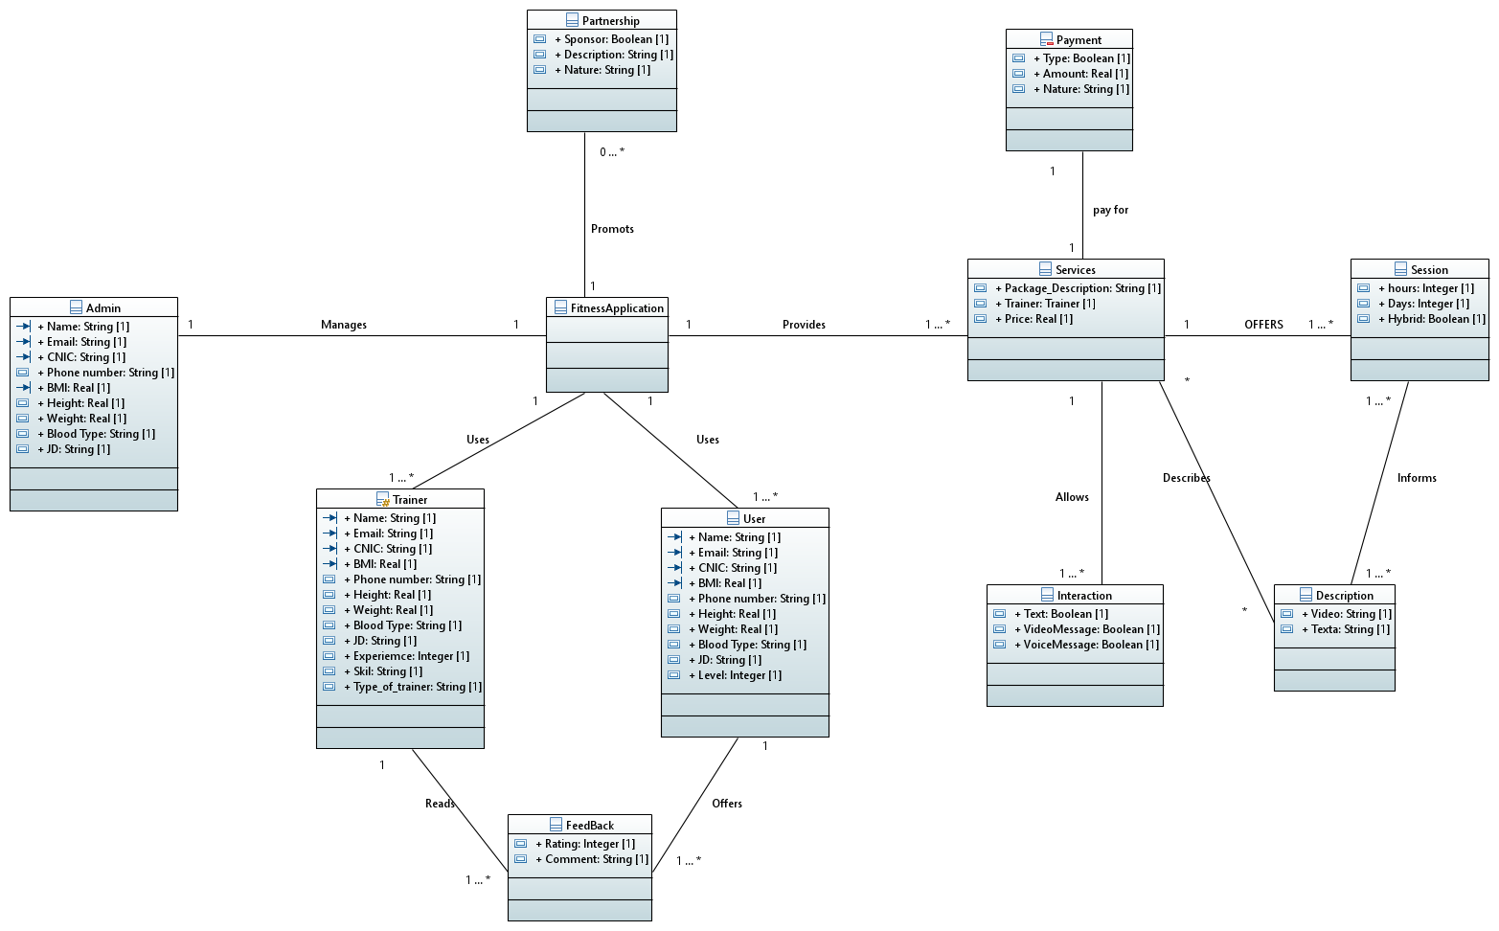

* **System Sequence Diagrams**

* **Sequence Diagrams**

**Class Diagram**

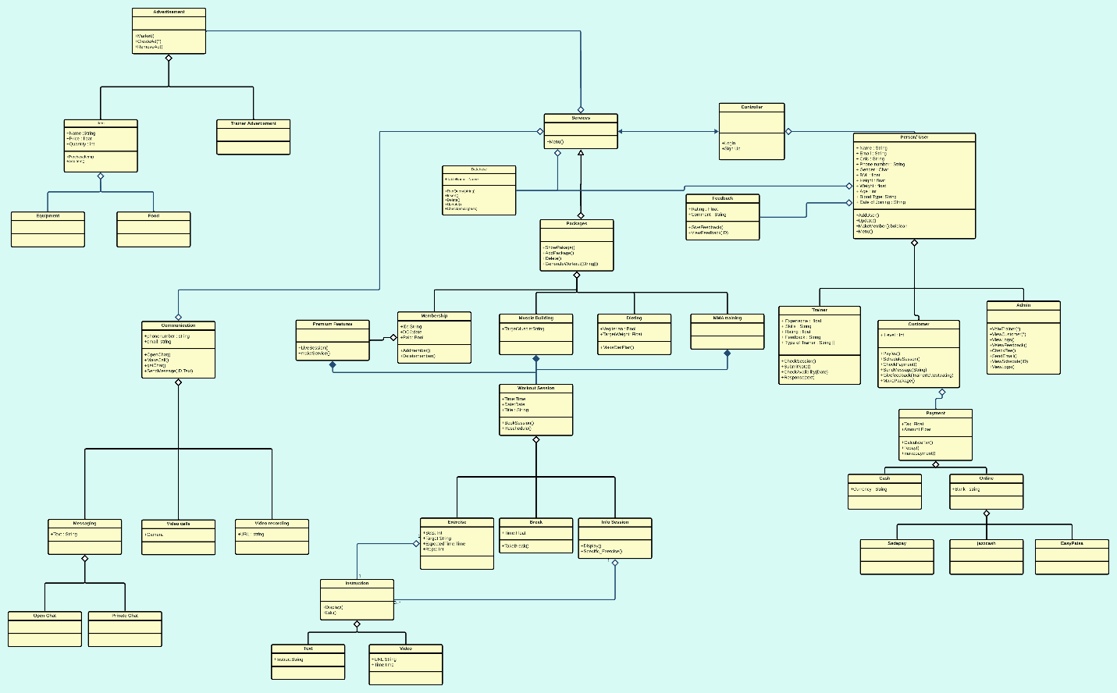

## Package Diagram

## 

## Deployment Diagram

## 