Quantum-Assisted Evacuation Routing
RAPTOR transit routing + QAOA congestion-aware assignment for cyclone storm-surge evacuation in Karachi
Qiskit Quantum Optimization Challenge · Domain 2: Disaster Response · Repository: https://github.com/MARafey/Quantum-Routing

1. Problem statement
Motivation. When a cyclone storm surge threatens Karachi's coastal belt (Keamari, Clifton, DHA, Korangi, Lyari, Saddar/Tower), thousands of people must be moved inland on a bus network that is itself partly flooded. A journey planner such as RAPTOR gives each group its individually fastest route, but if every group follows its own best route the same buses and the same shelters overload, which costs time and safety.
Intended users. Disaster-management authorities and transit operators who coordinate evacuation transport and need an assignment of evacuee groups to journeys that balances travel time against bus crowding and shelter capacity.
Optimisation problem. Choose one public-transport journey for every evacuee group so that total person-minutes of travel, bus overcrowding and shelter overload are jointly minimised. These objectives compete: the fastest journeys share the same trunk lines and shelters.

2. Formulation
Decision variables. x[g,r] ∈ {0,1}: group g (size n_g) takes journey option r ∈ {1..K}. Options are the K most attractive Pareto-optimal journeys found by RAPTOR (diverse destination shelters, several departures).
Objective. minimise Σ_g Σ_r n_g·(T[g,r] + 5·transfers[g,r])·x[g,r] + w_c·Σ_s (Σ_{g,r∋s} n_g x[g,r])² / cap_s + w_h·Σ_h (Σ_{g,r→h} n_g x[g,r])² / cap_h
Here s ranges over individual bus-trip segments (capacity 40–60), h over shelters (capacity 160–250), and w_c = w_h = 3. The squared loads are convex congestion costs; they create the quadratic coupling between groups, so the problem is naturally a QUBO rather than a linear problem with penalty terms added on.
Constraint. Σ_r x[g,r] = 1 for every group g (each group takes exactly one journey).
Test instances. Network: 69 stops, 8 bus lines (18 directed RAPTOR routes), 338 timetabled trips, 2 flood-closed segments, 6 shelters. Small instance: 4 groups (60–90 people) × K=3 options = 12 binary variables / qubits, 81 feasible assignments. City-scale instance: 12 groups in two departure waves × 3 options = 36 variables (531,441 feasible assignments).

3. Architecture
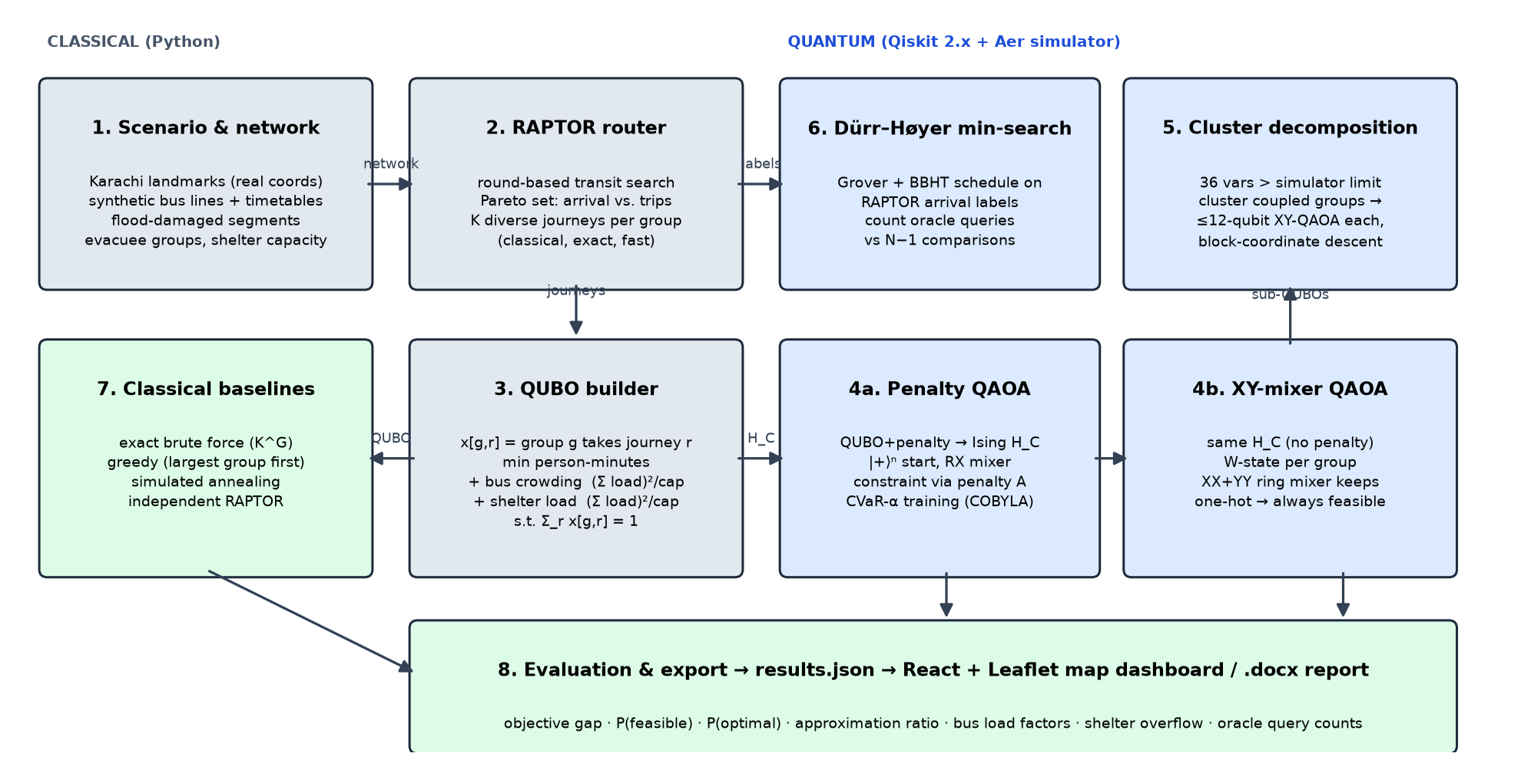
RAPTOR (classical, exact and fast) turns the large transit graph into a small set of candidate journeys. The combinatorial, coupled part (who takes which journey under shared capacity) is mapped to an Ising Hamiltonian and solved with QAOA on the Qiskit Aer simulator. Everything is checked against exact brute force.

4. Quantum approach and justification
- Mapping. The QUBO is converted to an Ising Hamiltonian with x_i = (1 − Z_i)/2, giving a SparsePauliOp with Z and ZZ terms (one qubit per decision variable). The cost unitary exp(−iγH_C) is exact because all terms commute.
- Why QAOA. QAOA is the standard variational algorithm for QUBO/Ising problems on near-term devices; it works directly on our quadratic congestion objective and has a natural constraint-preserving variant.
- Two variants. Variant A (textbook): |+⟩ⁿ, RX mixer, one-hot constraint via penalty A·(Σ_r x − 1)². Variant B (Hadfield et al. 2019, Quantum Alternating Operator Ansatz): each group's 3 qubits start in a W state and the mixer is a ring of XX+YY gates, which conserves Hamming weight. The state never leaves the feasible subspace, so the penalty and its tuning disappear.
- Training. Angles are trained with COBYLA (3 random restarts) on exact statevector probabilities using a CVaR-α loss (α = 0.2, Barkoutsos et al. 2020); the final circuit is sampled with 4096 shots on AerSimulator.
- Scaling. For 36 variables (2³⁶ amplitudes) we split groups into clusters of ≤4 by coupling strength and re-optimise one cluster at a time with XY-QAOA (block-coordinate descent; other clusters enter as linear terms).
- Second quantum component. Dürr–Høyer minimum finding (Grover search with the BBHT schedule) applied to RAPTOR's final label-selection step, comparing oracle queries with classical comparisons.

5. Results

5.1 12-qubit instance: QAOA vs. exact and classical baselines
Method | Objective | Gap to exact | Avg travel | Max bus load | Overloaded segs | Shelter overflow
Independent RAPTOR (no coordination) | 27458 | 1.44% | 45.8 | 225% | 30 | 0
Greedy | 27068 | 0.00% | 47.0 | 225% | 30 | 0
Simulated annealing | 27068 | 0.00% | 47.0 | 225% | 30 | 0
Exact (brute force) | 27068 | 0.00% | 47.0 | 225% | 30 | 0
QAOA penalty p=1 | 27068 | 0.00% | 47.0 | 225% | 30 | 0
QAOA penalty p=2 | 27068 | 0.00% | 47.0 | 225% | 30 | 0
QAOA penalty p=3 | 27068 | 0.00% | 47.0 | 225% | 30 | 0
QAOA XY-mixer p=1 | 27068 | 0.00% | 47.0 | 225% | 30 | 0
QAOA XY-mixer p=2 | 27068 | 0.00% | 47.0 | 225% | 30 | 0
QAOA XY-mixer p=3 | 27068 | 0.00% | 47.0 | 225% | 30 | 0

QAOA run | P(feasible) | P(optimal) | Approx. ratio | Found opt. | Depth | CNOTs | Sim time (s)
Penalty p=1 | 0.392 | 0.56% | 0.524 | yes | 48 | 46 | 37.7
Penalty p=2 | 0.583 | 0.73% | 0.525 | yes | 68 | 92 | 98.0
Penalty p=3 | 0.979 | 1.34% | 0.522 | yes | 97 | 138 | 80.2
XY-mixer p=1 | 1.000 | 15.11% | 0.787 | yes | 75 | 86 | 49.2
XY-mixer p=2 | 1.000 | 6.69% | 0.863 | yes | 109 | 156 | 80.4
XY-mixer p=3 | 1.000 | 16.77% | 0.828 | yes | 155 | 226 | 54.6
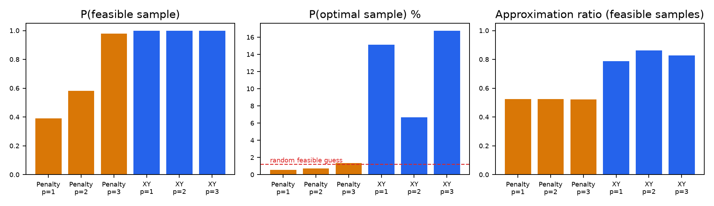
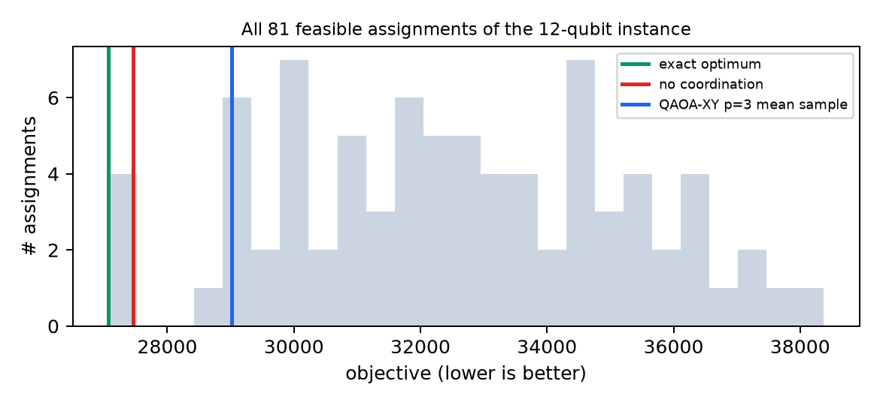
Findings. Coordination matters: the exact optimum reroutes groups away from their individually fastest RAPTOR journey, lowering the objective by 1.44% relative to uncoordinated routing (max bus load 225% → 225%). XY-mixer QAOA returned a feasible sample 100.0% of the time at every depth, against at most 97.9% for penalty QAOA. Its best probability of sampling the exact optimum was 16.8% (p=3), versus 1.23% for a random feasible guess and at most 1.34% for penalty QAOA. Every QAOA run had the optimum among its 4096 samples.

5.2 City-scale instance: clustered QAOA (36 variables)
Method | Objective | Gap to exact | Avg travel | Max bus load | Overloaded segs | Shelter overflow
Independent RAPTOR (no coordination) | 69918 | 1.03% | 43.7 | 225% | 72 | 120
Greedy | 70317 | 1.61% | 46.2 | 225% | 72 | 15
Simulated annealing | 69205 | 0.00% | 44.8 | 225% | 72 | 15
Exact (brute force) | 69205 | 0.00% | 44.8 | 225% | 72 | 15
Clustered XY-QAOA | 69205 | 0.00% | 44.8 | 225% | 72 | 15
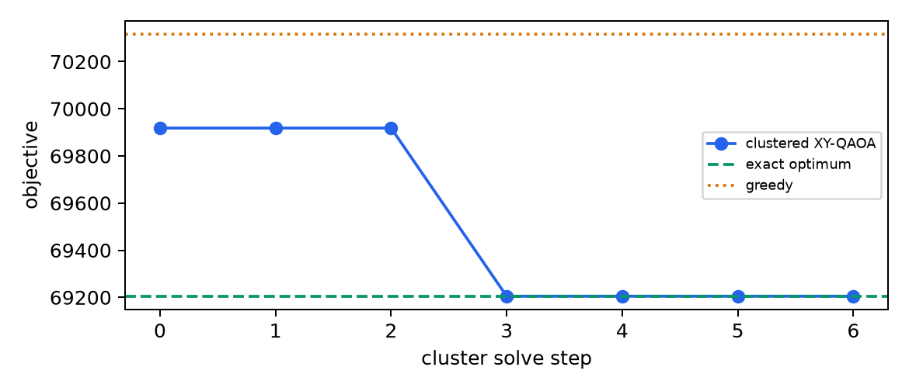
Clustered XY-QAOA (clusters [[3, 4, 5, 11], [0, 6, 9, 10], [1, 2, 7, 8]]) reached an objective 0.00% from the exact optimum in 6 cluster solves. Greedy was 1.61% from optimal, which is worse than no coordination at all (1.03%), and simulated annealing reached 0.00%.

5.3 Dürr–Høyer minimum search over RAPTOR labels
N labels | Qubits | Classical comparisons | Quantum queries to min (mean) | √N | Success
8 | 3 | 7 | 4.9 | 2.8 | 100%
16 | 4 | 15 | 10.0 | 4.0 | 100%
32 | 5 | 31 | 15.6 | 5.7 | 100%
64 | 6 | 63 | 24.6 | 8.0 | 100%
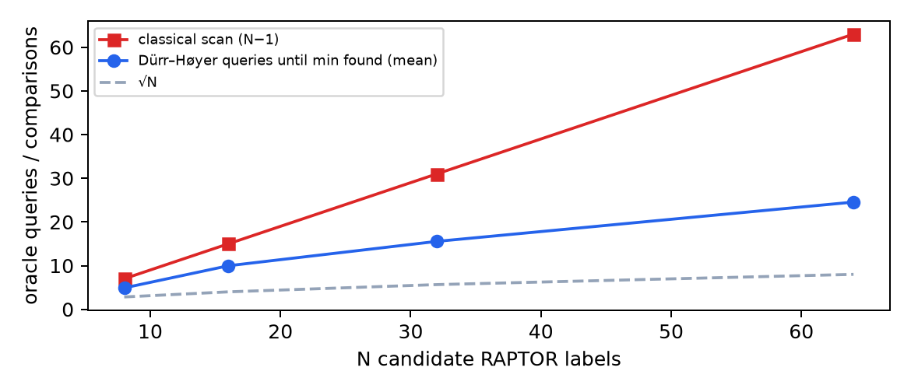
Queries until the true minimum is first held grow roughly like √N, while the classical scan grows like N. This is a query-count comparison, not a timing comparison (see limitations).

6. Limitations and honest discussion
- No speedup. Every quantum result comes from classical simulation. Simulation time grows as 2ⁿ, so the quantum runs take seconds to minutes (37.7–98.0 s) while brute force over 81 assignments takes milliseconds. We claim no speedup.
- Small instances are classically easy. At 4 groups, greedy and simulated annealing also find the optimum, and SA does so on the 36-variable instance too. QAOA's contribution here is shown by solution quality and feasibility, not by beating classical solvers. Instances this small are easy classically.
- Low P(optimal). The XY-QAOA probability of sampling the optimum is modest (16.8%) because many assignments have nearly equal objectives (see the landscape plot). Deeper circuits help only a little, and the classical optimiser cost grows with depth.
- Circuit cost. The XY mixer needs more two-qubit gates (CNOTs 226 vs 138 at p=3). On noisy hardware that would reduce fidelity, and we did not run a noise model.
- Penalty tuning. The penalty strength A was set by a heuristic (1.5× max variable influence). Penalty QAOA's feasibility depended strongly on depth (39–98% feasible), but even when feasible its samples were spread across poor assignments (approximation ratio ≈0.52): the large penalty dominates the energy scale and flattens the real objective.
- Query accounting. The Dürr–Høyer figures count queries until the true minimum is first held. The algorithm itself cannot detect that moment and runs to its O(√N) budget (22.5√N + 1.4 log²N), which at these small N exceeds N. The asymptotic advantage only becomes practical at much larger N.
- Oracle construction. The Grover oracle is a diagonal phase gate built from labels already known classically. A real advantage would need quantum-accessible memory (QRAM) and a reversible comparator, which we did not build. The √N result is about query complexity only.
- Decomposition. The cluster decomposition is a heuristic. It is only guaranteed to be locally optimal, and it uses brute force for reporting sub-problem quality, which would not scale.
- Synthetic data. Landmark coordinates are real, but the bus lines, timetables, capacities, damage and group sizes are synthetic. A real deployment would use GTFS feeds and live road-damage data.

7. Reproducibility
cd backend && uv sync && uv run qroute-demo (all seeds fixed; writes results.json)
uv run pytest · uv run qroute-report · cd frontend && npm install && npm run dev
Generated 2026-11-12 21:17:21; full experiment runtime 448 s on a laptop CPU.

8. References and credits
- D. Delling, T. Pajor, R. F. Werneck. Round-Based Public Transit Routing. Transportation Science 49(3), 2015. (RAPTOR; implemented from the paper.)
- E. Farhi, J. Goldstone, S. Gutmann. A Quantum Approximate Optimization Algorithm. arXiv:1411.4028, 2014.
- S. Hadfield et al. From the QAOA to a Quantum Alternating Operator Ansatz. Algorithms 12(2):34, 2019. (XY mixer.)
- P. Kl. Barkoutsos et al. Improving Variational Quantum Optimization using CVaR. Quantum 4, 256, 2020.
- C. Dürr, P. Høyer. A Quantum Algorithm for Finding the Minimum. arXiv:quant-ph/9607014, 1996.
- M. Boyer, G. Brassard, P. Høyer, A. Tapp. Tight bounds on quantum searching. Fortschr. Phys. 46, 1998.
- F. Neukart et al. Traffic Flow Optimization Using a Quantum Annealer. Front. ICT 4:29, 2017. (Inspiration for route-choice QUBOs.)
- Qiskit, Qiskit Aer (IBM). Map tiles © OpenStreetMap contributors, © CARTO. Code written by the team; no tutorial code copied.

