**!!!!TODO: Change threshold**

September 2022 Nidelva plans

# Objective:

As part of the [MASCOT project](https://wiki.math.ntnu.no/mascot). The adaptive ocean sampling will be conducted in September, Trondheim, 2022. The goal of their trials will be to validate the performance of such algorithms in the actual setting based on the given assumptions. Multi-agent adaptive sampling will be conducted: [TAICHI](https://mascot-ntnu.github.io/TAICHI/).

The goal of TAICHI is to achieve the multi-agent autonomous sampling. Why multi-agent sampling matters is that even though one can achieve a good sampling with one agent, it is often limited by its capacity for large-scale fully autonomous ocean sampling with only one agent. By expanding the capability of sampling arrays, one can either validate the result from each agent by another independent agent, or one can obtain a large-scale in-situ measurements with collective power.

What needs to be tested:

* Comparison between one adaptive and one non-adaptive.
* Data sharing capability through WIFI, IRIDIUM, BLUETOOTH or other methods.
* Two-way communication.
* Collision avoidance system.

TODO:

* Martin updates prior model.
* Check path.

# Logistics:

### People:

* **Yaolin Ge** will be onboard, taking notes & checking AUV behaviors and take actions when it is dangerous in situation such as collision avoidance etc.
* **André Olaisen** will be onboard, observing, photographer.
* **Tore** will be onboard, in charge of LAUV-Thor & USBL beacons and so on.
* **Jens** will be onboard, in charge of USV.
* Martin maybe onboard depending on the TAICHI feedback from more HITL. (videotaper).

### SINMOD:

* **Ingrid** needs to provide SINMOD ocean data as soon as possible.
* **Martin OB** is responsible for following up with SINMOD.
  + Ingrid says SINMOD will provide the forecast data 2 days ahead.

### Systems and sensors:

* **Tore** is responsible for checking equipment and sensors.
* [LAUV Harald](https://www.ntnu.edu/aur-lab/lauv-harald)
  + **CTD**
  + Jetson TX2
* [LAUV Roald](https://www.ntnu.edu/aur-lab/lauv-roald)
  + **CTD**
  + Jetson TX2
* AURLab Flyer boat
  + MBR
  + Manta GW
  + USBL

### Boat traffic:

There is some regular boat traffic in the mission area. This traffic will mainly interfere with the Mascot mission. Here is a [document](https://docs.google.com/spreadsheets/d/1H-Iy321Pr8vWqALSPWlyYzuHvziTNbx8hm_Ss5FICew/edit?usp=sharing) that shows the planned traffic.

#### Boats from the Hurtigbåtterminal:

These boats will not interfere with the MAFIA mission, but will disrupt the GOOGLE mission. These ferries run on a fixed schedule, but there are delays.

#### Larger ships:

Larger boats have to announce their arrival and departure beforehand. These boats arrive in, and it can find the arrival of larger boats [here](https://trondheimhavn.no/anlop/#anlop-table).

#### Hobby boat:

There is also some hobby boat traffic in the area, this is not predictable, and we need to react in the moment. We can see some on marine traffic websites like [this](https://www.marinetraffic.com/en/ais/home/centerx:10.405/centery:63.439/zoom:13). But this is slow to update and does not include every boat.

# Assumptions & schedule restrictions:

* In summer conditions, the best temporal window to perform the missions is after High-tide, when estuarine water starts to flow into the coastal ocean.
* Each operation should take one day to fully utilise the mission window to explore the region.
* Ideally, two day is enough, multiple days is reserved for redundancy.

# Satellite image

Sentinel 2 images are taken around ~11:30 am, one sample image from Sentinel-2 on June 2nd 2021 is shown as follows.

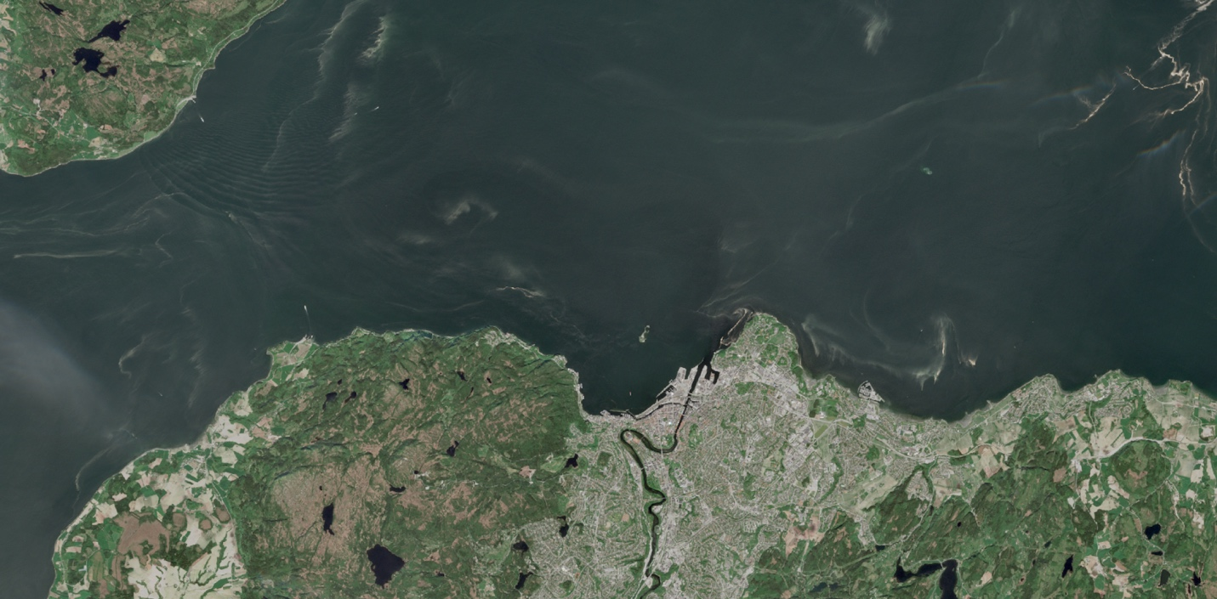

# Schedule

Mission dates are not yet decided, but preferably it will be in August.

Checklist

* Equipment
  + Boat at Nidelva.
  + LAUV-Thor from AURLab at TBS, charging one day before mission day.
  + Manta from AURLab at TBS, charging one day before mission day.
  + WorkPC from AURLab at TBS, charging one day before mission day.
* Algorithm
  + HITL needs to be done before launching the mission.
  + SINMOD forecast data needs to be ready by mission day.
* Miscs
  + Maybe check with AtB for the boat time schedule etc. To select the best time window.
  + Check yr.no for latest weather forecast. Select best time window.
* People
  + Yaolin needs to be onboard.
  + Tore needs to be onboard.
  + André needs to be onboard.
  + Martin needs to be onboard.
* Mission manual
  + Check crane.
  + Load AUV & accessaries (Mantas, PC, cables, USBL) onboard the workboat.
  + Check USBL cable capabilities, change it if it is worn. It happened last time.
  + Check buoyancy & trim of the AUV, so it is balanced.
  + Check fuel level of the workboat, so it is sufficient for the mission day.
  + Check HSE onboard. Helmet, jacket, gloves etc.
  + Apply sunscreen!!! Very important on a sunny day out in the sea.
  + Reach mission desired starting location.
  + Deploy AUV in the water.
  + Check controllability using Bluetooth App.
    - Flap
    - Rudder
    - Propeller
    - Navigation
  + Launch mission.
  + Check acoustic report during the mission
    - Take action(abort, pause, resume) depending on situations.
    - Retrieve AUV after mission complete, aborted, paused.
  + Retrieve AUV onboard.
  + Reach TBS.
  + Unload AUV & accessaries (Mantas, PC, cables, USBL) offboard the workboat.
  + Clean AUV and tide up the workboat.
  + Mission-brief broadcasting.
  + Data sharing.

Mission log

* Mission date will be updated to everyone included.