Lost in (parameter) space: quantifying parameter-dependent recovery and morphometric variability of infant white matter pathways in the HBCD cohort
Gabriella C. Taylorª, Elyssa M. McMaster^{b}, Gaurav Rudravaram^{b}, Jongyeon Yoon^{c}, Kurt G. Schilling^{deg}, Daniel Moyer^{c}, Laurie E. Cutting^{bdef}, Kathryn L. Humphreys^{ah}, Bennett A. Landman^{bcdef}
ªVanderbilt Brain Institute, Vanderbilt University, Nashville, TN, USA; ^{b}Department of Electrical and Computer Engineering, Vanderbilt University, Nashville, TN, USA; ^{c}Department of Computer Science, Vanderbilt University, Nashville, TN, USA; ^{d}Vanderbilt University Medical Center, Nashville, TN, USA; ^{e}Department of Radiology and Radiological Sciences, Vanderbilt University Medical Center, Nashville, TN, USA; ^{f}Vanderbilt Kennedy Center, Nashville, TN, USA;
^{g}Vanderbilt University Institute of Imaging Science, Vanderbilt University Medical Center, Nashville, TN, USA; ^{h}Department of Psychology and Human Development, Vanderbilt University, Nashville, TN, USA

Abstract
Characterizing large-scale trends in infant white matter development requires a reliable automated tractography method, but current methods often fail to capture infant anatomy. This is due in part to the dynamic nature of the infant brain, as rapid changes in volume and myelination inhibit establishment of accurate anatomical priors; as such, automated methods tend to rely on adult priors, producing broad mismatches in tract morphology. Less discussed, however, is the possibility of lost anatomical detail as a consequence of inadequate parameter tuning, as prior infant tractography studies commonly use fixed or default parameters. In the present study, we extract a series of tracts in a subset of the HEALthy Brain and Child Development (HBCD) cohort (N = 12 infants; 6 males) over a broad parameter space with the aim of quantifying the extent to which shifting parameter sensitivity drives recovery, morphological variability, and anatomical fidelity of tracts. Diffusion weighted images (DWI) at paired Visit 2 (V02; 0–1 month) and Visit 3 (V03; 3–9 months) time points were run through DSI Studio’s AutoTrack tool over a set of 5 parameters with 5 step values each. Shape similarity scores assessed variation in morphometry among recovered tracts, and Hausdorff Distance (HD) measured anatomical similarity of tracts relative to those extracted by an expert rater. A HD-derived signed information-divergence metric was used to fit a RBF-kernel support vector machine (SVM), which isolated tract-level subsets of high-information parameter combinations. Every tract was recovered under a subset of parameter combinations, suggesting that missingness reflected methodological instability rather than genuine anatomy. Shape and anatomical fidelity varied substantially by tract and parameter level, with clusters of high-information combinations exhibiting distinct profiles of relevant parameters and dependent value ranges. We conclude that anatomical plausibility in automated infant tractography is driven by coordinated, tract-specific tuning across multiple parameters.

Keywords: Tractography, pediatric, neuroimaging, diffusion imaging, white matter

INTRODUCTION
Diffusion magnetic resonance imaging (MRI) tractography is particularly challenging during early infancy, as the tissue properties and anatomical geometry that support pathway reconstruction change rapidly and asynchronously. Across the first postnatal years, white matter pathways expand and reorient themselves at different rates, producing trends in axonal packing and myelination that differ between projection, association, limbic, and commissural pathways^{1–3}. As such, early-maturing projection pathways may exhibit relatively coherent diffusion contrast at an age when later-maturing association pathways remain weakly anisotropic⁴. This developmental heterogeneity directly affects tractography, as weak diffusion signal may cause streamline propagation to terminate prematurely, cause streamlines to follow a spurious dominant orientation, or fail to generate a candidate pathway altogether⁵. Rapid developmental changes in tract position, curvature, and brain volume also serve as a source of error for automated tractography methods that depend on adult templates or adult anatomical priors, as a single adult-derived prior can be mismatched to both the geometry and diffusion characteristics of an infant pathway⁶ – to this end, even age-specific infant priors⁷ provide only a static approximation of a continuously changing system. Expert-guided manual tractography can match subject-specific anatomy by iteratively adjusting region-of-interest constraints, but it can only select among streamlines produced by the underlying diffusion data. If an immature pathway produces insufficient directional signal in said data, this method cannot recover those streamlines⁸.
Prior infant tractography work has attempted to address these limitations through age-specific templates^{7,9}, probabilistic tracking⁸, and expert-guided protocols^{10,11}. These approaches improve anatomical localization and can increase robustness to weak diffusion contrast, but they leave a separate source of variability unresolved: the tracking parameters that govern streamline propagation, smoothing, pruning, and assignment to reference or template tracts. These settings determine the balance between sensitivity to anatomy and specificity against false-positive trajectories, and their effects are likely to depend on a given tract's developmental stage, location, and geometry^{12,13}. Nevertheless, a methodological review of diffusion MRI tractography in infants aged 0-2 years found that only a small subset of studies systematically varied or tuned tracking parameters⁵. As a result, an expected tract that is absent under a default or fixed parameter set is difficult to interpret, as apparent missingness may reflect genuinely inadequate local diffusion information, a mismatch between pathway and anatomical prior, or tracking settings that are overly restrictive for the observed tract or for the developmental stage of the infant. More permissive settings may restore missing anatomy, but they may also produce anatomically implausible or “false-positive” streamlines in the resulting tractogram. Distinguishing these possibilities requires evaluating recovery and anatomical plausibility across different parameter-value combinations in joint parameter space.
The present study addresses this problem by evaluating infant tract extraction via DSI Studio’s AutoTrack tool¹⁴ across the complete Cartesian product of five user-controlled tracking parameters sampled at five ordered levels. We first ask whether a pathway that is missing under one combination of values can be recovered elsewhere in parameter space, thereby testing cases of true anatomical missingness against those caused by methodological divergence. We then test the parameter sensitivity of recovered pathways by evaluating trends in morphometry and anatomical fidelity against reference tracts extracted by an expert rater. Finally, we isolate favorable parameter combinations to restrictive, tract-specific regions and test whether those regions depend on coordinated constraints across multiple parameters. This framework requires an experimental design that defines how movement along each tracking parameter relates to the relative “strictness” of extraction - hence, each manipulated parameter is assigned a tuning direction according to its expected effect (Table 1). Increasing turning angle, step size, and tolerance moves tracking from relatively strict to relatively “loose” or permissive conditions; conversely, increasing smoothing and topology-informed pruning (TIP) iterations moves tracking from loose to strict conditions. Selecting values closer to the “loose” extreme of a given parameter’s value range may increase tract size and variance at the risk of generating false-positive streamlines, whereas selecting values toward the “strict” extreme may prevent tract recovery altogether (Fig. 1; A). In the context of the present study, “optimal” parameter tuning maximizes a tract’s recovery, variance, and anatomical fidelity while minimizing false-positive trajectories. Anatomical fidelity is evaluated per tract relative to a corresponding subject-session-specific reference pathway (Figure 1B). Here, “false-negative” anatomy comprises reference portions absent from the AutoTrack tractogram, and false-positive regions extend beyond the reference morphology or into anatomically implausible regions. The theoretical optimum is a tract that preserves the anatomy of the reference pathway while limiting losses and spurious additions. We hypothesize that tract recovery, morphometric variability, and anatomical fidelity of infant white matter pathways are driven by coordinated, tract-specific tuning across multiple parameters.
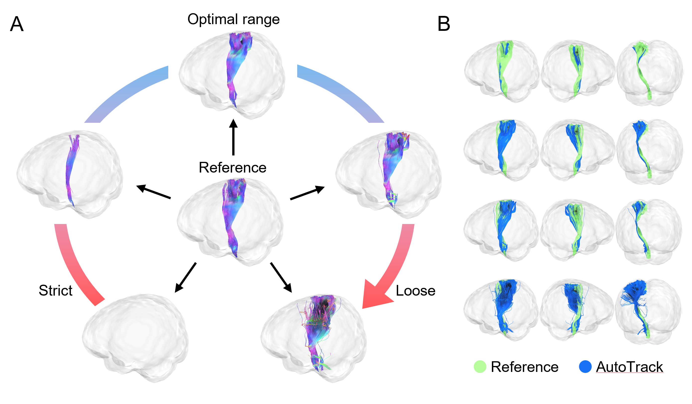
Figure 1. (A) Each white matter pathway extracted with the AutoTrack method has a theoretical “optimal range” of parameter values over which the resultant pathway contains the maximum number of true positive streamlines while minimizing both false negative (missing) and false positive streamlines. These latter conditions emerge as a result of overly “strict” or overly “loose” parameter tuning, respectively, with relative “strictness” dictated by the tuning direction of each parameter as outlined in Table 1. (B) In this study, true-positive tract morphometry in extracted AutoTrack pathways is measured relative to a set of ROI-based reference pathways extracted by an expert rater in DSI Studio.
Table 1. A summary of major AutoTrack parameters, including tuning directions and selected step-values for analysis.
Parameter | Selected step-values | Units | Default setting | Description | Tuning direction
Turning angle | 30, 45, 60, 75, 90 | Degrees (°) | Random value between 15°- 90° | Maximum allowable turning angle for fiber tracking. | strict → loose
Step size | 0.5, 0.75. 1.0, 1.25, 1.5 | Millimeters (mm) | Random value between 1–3 voxel/mm | Propagation distance for fiber tracking. | strict → loose
Smoothing | 0.0, 0.2, 0.4, 0.6, 0.8 | Percent (%) | 0 | Fraction of previous fiber direction to incorporate in tracking. | loose → strict
TIP iterations | 0, 4, 8, 16, 32 | Number of iterations | 16 | Topology-informed pruning (TIP) iterations; uses voxel-wise density to eliminate noisy fibers. | loose → strict
Tolerance | 22, 24, 26 ,28, 30 | Millimeters (mm) | Search over  22, 26, 30 mm | AutoTrack-only parameter; maximum allowable distance from template tract for recognition. | strict → loose

methodology

Data acquisition and processing
Our study sample comprised 12 infants from the HEALthy Brain and Child Development (HBCD) cohort (6 males, 6 females). The HBCD Study is the largest longitudinal study of early brain and child development in the United States, consisting of 27 data acquisition sites and collecting - among other developmental assessments - multimodal neuroimaging data acquired at regular intervals over the first 2 years of life¹⁵. For the present study, each subject contributed diffusion-weighted MRI (DWI) data from paired Visit 2 (V02; 0-1 months) and Visit 3 (V03; 3-9 months) sessions, yielding 24 subject-session datasets in total.
DWI scans were preprocessed with the PreQual pipeline¹⁶, which performed denoising, intensity normalization, eddy-current- and motion-induced artifact correction, and signal drop-out imputation. PreQual DWI, bval, and bvec outputs were subsequently reconstructed in DSI Studio using a generalized q-sampling imaging (GQI) fit, which generated fiber information (FIB) files for tractography. The FIB file for each unique subject-session pair was used for both AutoTrack extraction and manual reference tractography. AutoTrack operates by generating streamlines against a template of pre-defined anatomical tracts; nonlinear registration is first performed between a given FIB and the template, then template streamlines are warped into FIB native space via the computed transforms. Tracts are estimated by generating streamlines in FIB space, with each streamline only being assigned to a tract if its geometry lies within a specified distance of the targeted FIB-space-transformed template tract^{17,18}. Reference pathways were obtained through manual, ROI-based tractography performed in DSI Studio’s graphic user interface (GUI). Here, an expert rater iteratively refined candidate streamlines via hand-drawn digital masks comprising region of interest (ROI) and region of avoidance (ROA) criteria until each reference tract was judged anatomically plausible for the subject and session. The analysis focused on 3 bilateral white matter tract families: arcuate fasciculus (AF), fornix (FX), and corticospinal tract (CST). These pathways were selected to represent association, limbic, and projection systems, respectively, as well as to span tracts with different extraction properties in infancy: AF is known to be relatively late-maturing in infancy⁴, meaning that insufficient diffusion anisotropy due to low myelination may challenge tract recovery¹⁹. While FX exhibits extreme local curvature. CST and FX are comparatively robust pathways in infants, as projection pathways like CST and limbic pathways like FX tend to be more myelinated at birth than association pathways like AF^{4,20}. However, FX tracts also exhibit extreme local curvature and proximity to ventricles, both of which are linked to weak or contaminated diffusion signal intensity^{20,21}.

Tract extraction pipeline
An overview of the tract extraction pipeline is provided in Figure 2. Automated tract extraction was performed with DSI Studio’s AutoTrack tool, which was run once per included parameter combination, tract, and subject-session pair. Each command uses a reconstructed FIB file as input, and it passes the following AutoTrack parameters explicitly: turning_angle, step_size, smoothing, tip_iteration, and tolerance. Table 1 lists value ranges, selected step-values, tuning directions, and brief descriptions of function for each of these parameters. Track-voxel ratio, which denotes the number of streamlines the AutoTrack tool attempts to track per FIB voxel, is fixed at a value of 2 streamlines per voxel for all runs. For five AutoTrack parameters sampled at five ordered levels each, the Cartesian product of all parameters and values is 5⁵ or 3,125 unique parameter combinations.
For each tract, the extraction pipeline first searches from the strictest possible tuning corner of the parameter grid until the first recovered tract is identified. Recovery during this “strict search” phase is defined by a tractogram output containing a non-zero number of streamlines. The first parameter combination to yield a recovered tractogram is recorded as the “new default” for that tract. Combinations at or beyond this new default in the permissive or “loose” tuning direction are staged next, with all remaining factorial combinations staged and completed last in a strict-side “backfill” stage. Execution was distributed with GNU Parallel across 8 remote servers, with one parallel job corresponding to all runs for a single subject-session pair. For 12 subjects, 2 sessions, 6 tracts, and 3,125 parameter combinations per tract, the complete design comprised 450,000 individual AutoTrack runs (Figure 2).
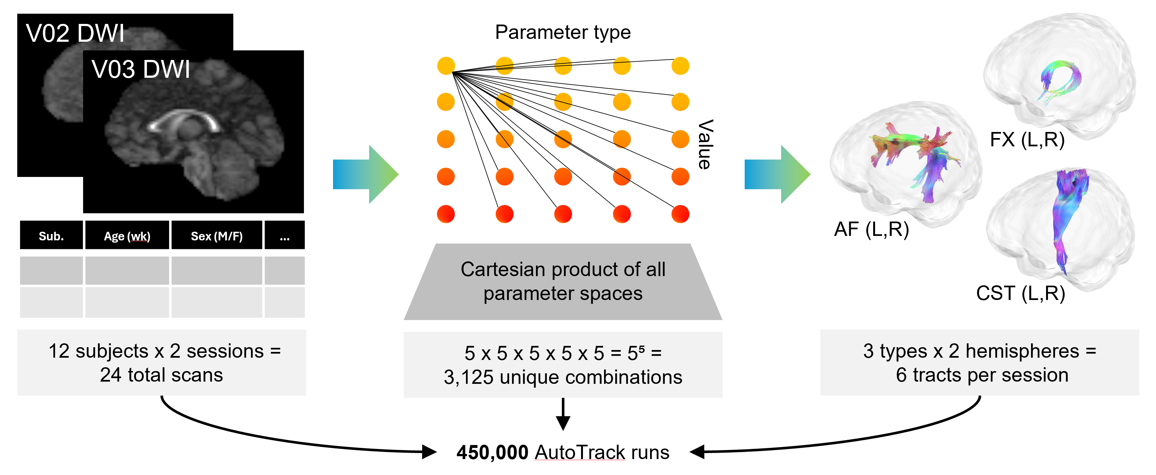
Figure 2. Architecture of the parameter-space tract extraction pipeline. Paired V02 and V03 DWI scans and relevant demographic information for 12 unique subjects serves as input to a custom Python script that runs DSI Studio’s AutoTrack once per parameter space over the cartesian product of all parameter spaces. Given a matrix of 5 parameters at 5 step values each, this yields 3,125 parameter combinations per tract. This process is repeated for 3 bilateral sets of tracts, producing a total of 450,000 individual AutoTrack outputs. (AF = arcuate fasciculus; FX = fornix; CST = corticospinal tract).

Analysis of extracted tracts and parameter spaces
A graphical overview of downstream analyses performed on the outputs of the extraction pipeline is provided in Figure 3. The analysis pipeline begins with the quantification of tract recovery; as mentioned above, a tract produced for a given parameter combination is treated as recovered when the run produces a tractogram file containing a non-zero number of streamlines. Recovery is summarized by the fraction of parameter combinations that produce a recovered tract. Among recovered instances, morphometry metrics are computed directly from each tractogram. Streamline count is given as the number of streamlines in the tractogram, and mean tract length is computed as the average arc length of all streamlines in millimeters, which is obtained by applying tractogram affine-to-RAS-millimeter coordinates. Tract volume is calculated as the volume of all voxels through which the tract passes, and surface area is estimated from the exposed faces of the binary tract-occupancy image, with face areas determined from the masked voxel dimensions. Streamline count, mean length, tract volume, and surface area measures per recovered parameter space are standardized using tract-level median and median absolute deviation, then the Euclidean distance from the standardized tract-level center is converted to a general shape similarity percentile score, where higher percentiles indicate morphometric profiles closer to the central recovered distribution for that tract across combinations. This process is repeated with the averaged measures sans Euclidean distance calculation to obtain an overall tract-size percentile. Together, these metrics are used to assess overall variance in tract morphometry across the parameter grid, agnostic to the relative anatomical fidelity of the profiles.
Anatomical fidelity for each recovered tract is evaluated against its requisite subject-session-specific reference tract via symmetric Hausdorff distance (HD), which is computed between AutoTrack-generated and reference streamline point clouds after limiting each point cloud to a maximum of 5,000 points. Collected HD measures are used to compute an additional “information-divergence” metric, which assesses whether a given parameter combination yields a tract with greater or lesser anatomical fidelity than the tract-wide distribution. To obtain this metric, HD values from all recovered combinations are first discretized into quantile bins. For each combination provided, Kullback-Leibler divergence compares the HD-bin distribution conditional on that combination with the marginal HD-bin distribution across all recovered runs, and the divergence measure is signed according to the difference between the tract-wide mean HD and the combination-specific mean HD, such that positive signed values (I > 0) indicate a shift toward lower HD – and thus, greater anatomical fidelity – for a given parameter combination relative to the tract-wide average.
These information-divergence scores serve as input to a scikit-learn²² RBF-kernel support vector machine (SVM), which isolates high-information combinations within each tract’s full parameter space. The SVM target label is assigned to recovered combinations whose signed information-divergence value is finite and greater than or equal to the 95th percentile of positive signed information-divergence values for that tract. Parameter features are encoded as ordered level indices scaled to [0, 1] and standardized using the scikit-learn tool StandardScaler. Hyperparameters are selected by grid search with repeated stratified cross-validation, using average precision as the default refit metric and balanced class weights. The result of this process is an isolated subset of the most anatomically plausible and informative tract-wide parameter combinations produced across runs.
Two additional analyses are performed to further characterize the parameter spaces within these tract-level high-information regions. First, to observe whether favored parameter value ranges among high-information regions differ between tracts, the smoothed probability of each parameter step-value inside the high-information region is compared against the smoothed probability of the same value across all recovered combinations, with the log2 ratio of these probabilities serving as a parameter-level “enrichment score”. Second, to probe parameter dependence within high-information regions, a search is conducted per-tract to discover a minimal order rule: for each rule order k = 1,...,5, the script enumerates all contiguous ranges involving exactly k parameters and identifies the best rule at that order, with rules ranked by precision, coverage, and high-information node count. The minimal order is defined as the smallest k for which the best rule satisfies the criteria outlined in Figure 3.
To visualize analysis metrics over the entire 5-dimensional parameter grid, fixed parameter-space embeddings were created with scikit-learn’s multi-dimensional scaling (MDS) features. Embedding coordinates for a given parameter p with ordered levels l₀,...,l_{(L-1)} are assigned according to Equation 1:
$$\begin{aligned}{\text{coord}}_{p}\left(x\right)=\frac{{\text{index}}_{p}\left(x_{p}\right)}{\text{max}\left(L_{p}-1,1\right)}\# \left(1\right)\end{aligned}$$
Coordinates are established independent of tract-specific outcomes, meaning that the same coordinate system can be reused across tracts to maintain comparable spatial positions among parameter combinations. Grid points that differ by one adjacent level in one parameter dimension are connected by visible edges.
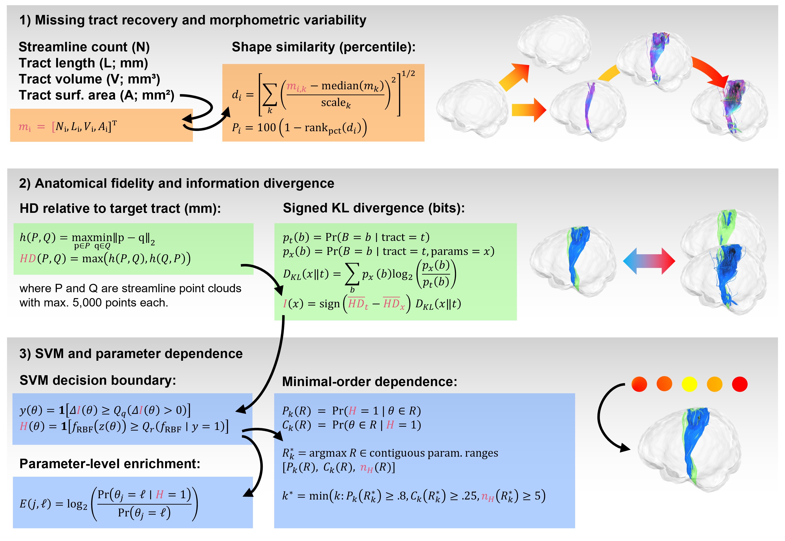
Figure 3. Overview of group-level analyses performed on AutoTrack pipeline outputs. All analyses are implemented in Python 3.12 via the scikit learn and statsmodels packages. (HD = Hausdorff distance; SVM = support vector machine; RBF = radial basis function kernel).

Results
Tract recovery and morphometric variability
Every tract was recovered under at least a subset of parameter combinations, both across the complete dataset and within each individual subject-session pair. Recovery nevertheless varied substantially by tract and by parameter level, with right CST and right FX exhibiting the highest overall recovery fractions (CST_R = 96.0% max. recovery, FX _R= 97.8% max. recovery; Figure 4A). AF was the most difficult tract family to recover – for both bilateral AF tracts, recovery improved as turning angle and tolerance moved into their more permissive ranges, with more permissive smoothing also driving recovery of left AF. Across tracts, the overall tract-size percentile and shape similarity percentile distributions were nearly exact spatial inverses of one another (Figure 4B). This relationship validates the idea that increases in tract size are accompanied by greater morphometric variance, placing those tract profiles farther from the tract-level center of the recovered shape/size distribution. Of particular interest is the finding that both FX tracts showed larger overall size percentiles and extremely low shape similarities within the tolerance-turning-angle parameter neighborhoods (Figure 4B). This pattern suggests that more permissive tolerance and turning-angle settings generated larger FX tract profiles that markedly diverged from the central tract-level morphometric profile.
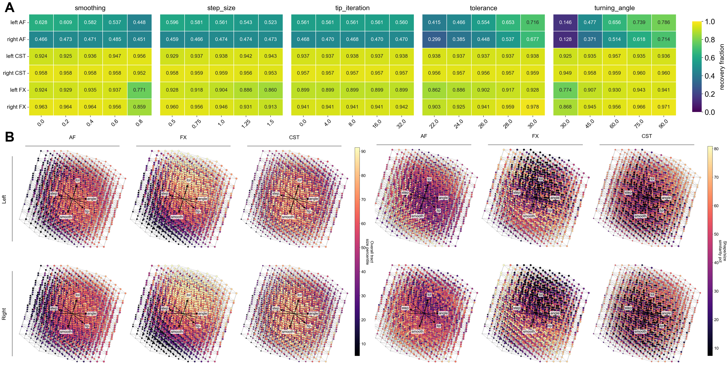
Figure 4. (A) Summary of recovery fraction per tract and swept parameter value. (B) Distribution of overall tract size percentile and computed shape similarity percentile per tract visualized across a 2-dimensional fixed embedding of all attempted parameter combinations. Gray nodes denote non-recovered parameter combinations. (AF = arcuate fasciculus; FX = fornix; CST = corticospinal tract).
Anatomical fidelity and information divergence
Signed information divergence revealed distinct tract- and hemisphere-specific patterns of anatomical fidelity (Figure 5). Left AF exhibited a band of higher information divergence across step-size-smoothing-tip-iteration combinations, whereas right AF showed a diffuse tolerance-turning-angle-tip-iteration hotspot with a smaller but more intensely positive step-size-smoothing cluster. Both FX tracts exhibited a highly consistent information-divergence trend across step size, tolerance, and turning angle, with more permissive values in these domains associated with higher information divergence and therefore lower HD. CST showed comparatively weak and diffuse information-divergence patterns across parameter directions (Figure 5), but lower-value combinations nearer the center of the parameter ranges tended to produce better fidelity in CST overall.
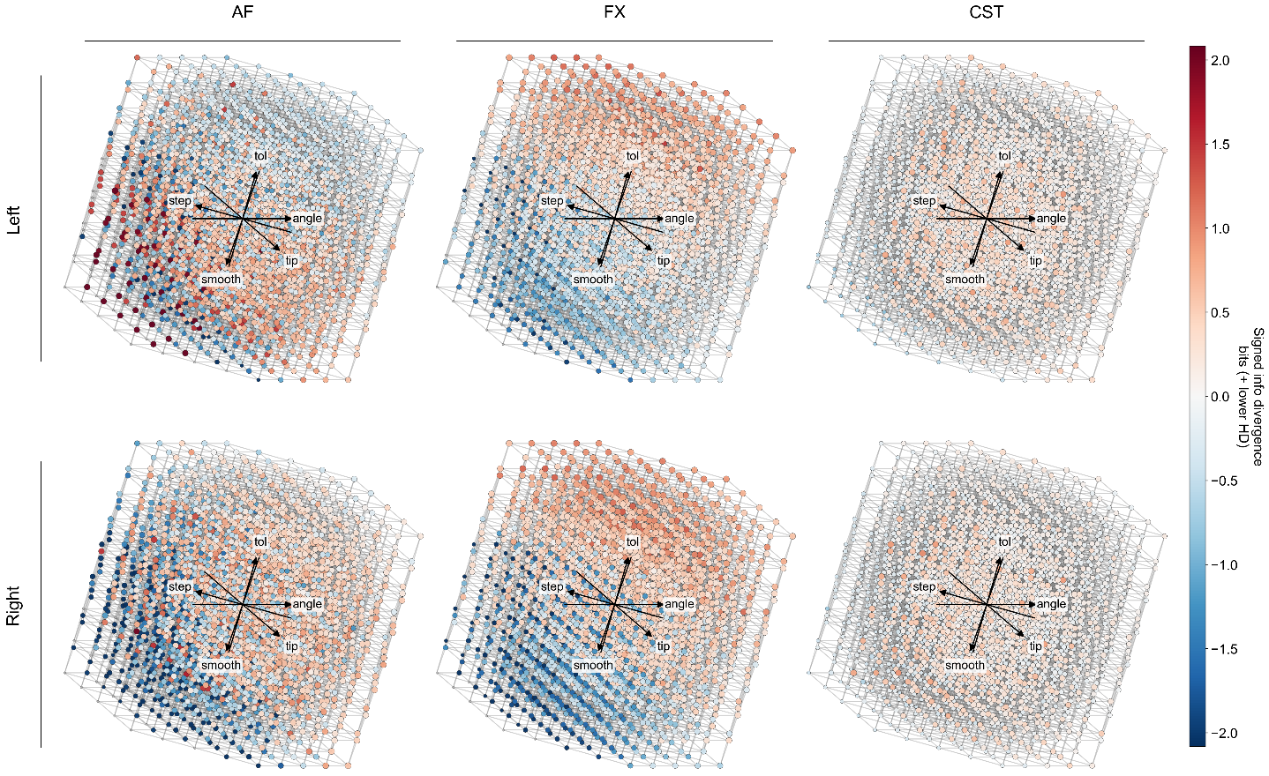
Figure 5. Distribution of signed information divergence per tract visualized across a 2-dimensional fixed embedding of all attempted parameter combinations. Gray nodes denote non-recovered parameter combinations. (AF = arcuate fasciculus; FX = fornix; CST = corticospinal tract).
SVM-derived decision boundaries and parameter dependence
SVM-derived decision boundaries reproduced the tract-specific structure observed in the signed information-divergence maps (Figure 6A). The left AF high-information cluster occupied the same step-size-smoothing-tip-iteration band observed in figure 5, while right AF produced a more dispersed cluster covering step-size, tolerance, and more central turning-angle regions. Bilateral FX tracts again showed broad high-information clusters across the more permissive regions of step size, turning angle, and tolerance. CST high-information combinations were more dispersed across parameter types but remained concentrated toward central, relatively strict values. The agreement between these patterns and Figure 5 supports the internal coherence of the SVM-derived high-information regions.
Parameter-level enrichment further clarified the tuning profiles of these regions (Figure 6B). Both AF tracts favored moderate turning angles (log2 enrichment = 1.81 for left AF at turning-angle = 30; 1.55 for right AF at turning-angle = 45). Furthermore, bilateral AF tracts tolerated greater pruning, whereas FX and CST favored lower tip-iteration values corresponding to less pruning or no pruning. FX showed strong enrichment for high tolerance (log2 enrichment = 2.02 for left FX; 2.02 for right FX at tolerance = 30), and CST favored greater smoothing than AF and FX (log2 enrichment = 1.78 for left CST; 1.94 for right CST at smoothing = 0.8). Minimal-order rules were obtained for left FX and bilateral CST tracts. Rules for left FX and left CST required 3 parameters, while the rule for right CST required 4 parameters (Figure 6C).
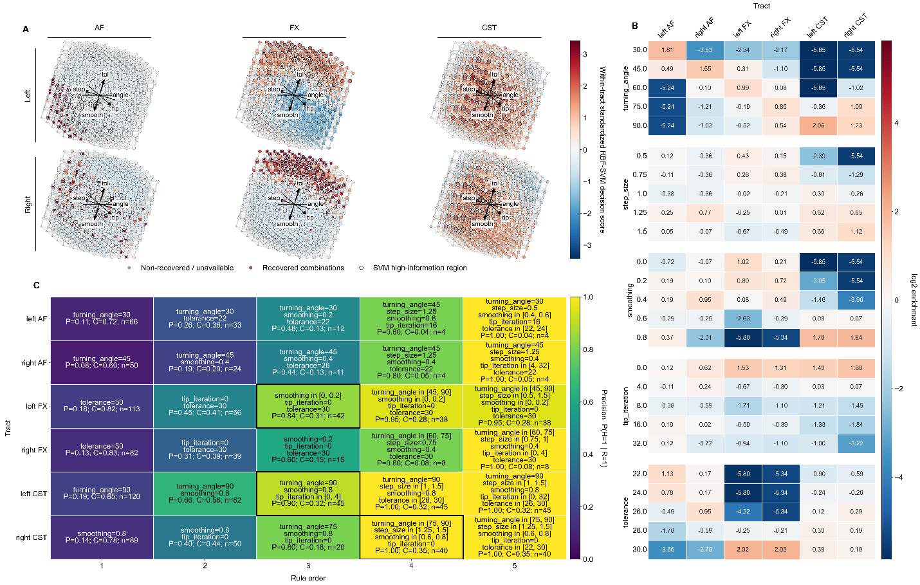
Figure 6. (A) Distribution of parameter combination nodes included in the SVM-derived high-information decision boundary for each tract, visualized across a 2-dimensional fixed embedding of all attempted parameter combinations. Gray nodes denote non-recovered parameter combinations. (B) A heatmap summarizing tract-level SVM-predicted high-information regions by parameter and level. Cell-wise enrichment values compare the smoothed probability of each parameter level inside the predicted region to the smoothed probability of that level in all attempted combinations for the tract. (C) A heatmap illustrating the minimal order rule for all contiguous parameter ranges, defined as the smallest number of combined parameters that satisfies all thresholds of precision (P) ≥ 0.8, coverage (C) ≥ 0.25, and high-information combination count (n) ≥ 5. (AF = arcuate fasciculus; FX = fornix; CST = corticospinal tract).

Discussion
For all tract-level and subject-session-level parameter spaces in which one or more combinations returned missing tracts, we found that the tract was recoverable elsewhere in parameter space. Thus, we were able to validate that shifting parameter sensitivity contributes directly to apparent tract missingness. Rather than reflecting genuine anatomical properties, these missing tracts reflected sources of instability in the automated extraction method that were reduced through tract-appropriate tuning. This is not to say, however, that all settings found to improve tract recovery also improved anatomical fidelity; a “recovered” tract could contain only streamlines corresponding to true pathway anatomy, only anatomically implausible false-positive streamlines, or a combination of the two. Furthermore, using a non-zero streamline count as the threshold for tract recovery provides little information about the relative size or density of recovered tracts, as a parameter combination that yields a single streamline is still labelled as having “recovered” that tract. These findings become more informative when taken in concert with the results of the downstream analyses, which characterize the influence of shifting parameters on the size, anatomical fidelity, and parameter dependence of the recovered tracts, respectively.
Across observed parameter space, bilateral FX tracts showed larger size percentiles and higher information-divergence toward the more permissive ends of step size, tolerance, and turning angle parameter neighborhoods. Additionally, SVM-derived high-information clusters in both FX pathways showed strong enrichment for high tolerance. Step size, tolerance, and turning angle are all size-enhancing settings when tuned in the permissive direction; as such, it appears that settings promoting larger tract profiles are beneficial for maximizing FX anatomical fidelity. Given FX’s tendency toward lower diffusion signal²¹, more permissive size-boosting settings may aid in capturing anatomical detail that is lost under more restrictive fixed settings.
This “bigger is better” trend does not hold true for all tracts, however: higher-information regions in right AF primarily included nodes near the center of its size distribution, suggesting that fidelity did not increase monotonically with tract size. While AF is also prone to weak diffusion signal due to its relatively late maturation⁴, its longer length and more branched geometry may elevate its susceptibility to false positive streamlines compared to FX¹³. Coupled with the enrichment-analysis findings that both AF tracts favored moderate turning angles and more pruning iterations, it is apparent that favorable parameter combinations occupy intermediate value ranges in AF, with anatomical fidelity declining sharply once size-boosting settings become overly permissive. Also of note is the fact that the higher-tolerance, higher-turning-angle region comprising right AF’s information-divergence hotspot instead showed negative information-divergence in left AF. This hemispheric difference may reflect emerging lateralization of AF organization, although the extent to which AF lateralization is established during infancy remains largely unresolved^{19,23}. This possibility is developmentally relevant given the role of left AF in language and reading, as prior studies have reported associations between neonatal AF microstructure and acquisition of receptive language skills later in development²⁴.
In bilateral CST, anatomical fidelity was broadly driven by low-to-moderate values across parameters, with diffuse information-divergence hotspots and high-information clusters appearing near the center of parameter space grids. Parameter enrichment analysis further elucidated these trends by revealing that CST high-information regions favored higher smoothing values. CST is both the largest and longest pathway observed in this study, and prior work indicates that longer pathways tend to encounter more obstacles along their length that inhibit streamline propagation. In practice, this means that accurate local propagation is crucial for longer pathways²⁵. Higher smoothing amplifies directional mixing effects¹⁸, which may improve the accuracy of local CST propagation over these obstacle points.
Although individual enriched parameters and parameter values demonstrably moved each tract toward its high-information region, the rule order analysis provided additional evidence that anatomically favorable combinations in bilateral CST and left FX were defined by coordinated constraints across parameters. Among these tracts, implicated parameters and associated value ranges aligned closely with individual findings from tract-level enrichment profiles, further validating the enrichment analysis. Minimal rules were not obtained for bilateral AF and right FX tracts, as high-precision rules for these tracts exhibited sub-threshold coverage and/or high-information count values. Given that minimal rule order depends on precision, coverage, and high-information-set size, a minimal rule cannot be found for a tract in which high-precision combinations are too few in number or distributed such that no single compact rule captures enough of the high-information region to qualify. Interpretation is also constrained by the small number of sampled values for each parameter. Similar parameter-space experiments conducted over broader and more granular value ranges are needed to determine whether apparent tract-specific parameter dependencies persist at finer resolution.

Conclusions
In this work, we quantified recovery, morphological variability, and anatomical fidelity of infant white matter tracts extracted over a broad parameter space grid. Tracts were recovered over a subset of attempted parameter combinations across all 6 pathways and every individual subject-session pair, supporting the idea that apparent missingness in automated infant tractography can be resolved through selection of appropriate parameters. Among recovered instances, morphometry and HD-derived anatomical fidelity varied substantially by tract, hemisphere, and parameter level. Analysis of SVM-derived high-information regions discovered tract-specific enrichment profiles and predominantly three- or four-parameter rules among qualifying pathways. Together, these findings demonstrate that anatomical plausibility in automated infant tractography is achieved through coordinated, tract-specific tuning across parameters.
Future analyses should evaluate how optimal parameter regions shift across a whole-brain set of white matter pathways, observing whether regional patterns of parameter sensitivity recur across tracts and to what extent these local patterns shift with age as infants continue to develop. These developments could be influential in producing a tract-informed template or set of anatomical priors that could be used to further improve automated tractography in infants.

Acknowledgements

Data used in the preparation of this article were obtained from the Healthy Brain and Child Development (HBCD) Study (Home - Healthy Brain and Child Development ). This is a multi-site, longitudinal study designed to recruit approximately 7,500 families and follow them from pregnancy to early childhood. The HBCD Study is supported by the National Institutes of Health and additional federal partners under award numbers U01DA055352, U01DA055353, U01DA055366, U01DA055365, U01DA055362, U01DA055342, U01DA055360, U01DA055350, U01DA055338, U01DA055355, U01DA055363, U01DA055349, U01DA055361, U01DA055316, U01DA055344, U01DA055322, U01DA055369, U01DA055358, U01DA055371, U01DA055359, U01DA055354, U01DA055370, U01DA055347, U01DA055357, U01DA055367, U24DA055325, U24DA055330. A full list of supporters is available at https://hbcdstudy.org/about/federal-partners/. A listing of participating sites and a complete listing of the study investigators can be found at Recruitment Sites - Healthy Brain and Child Development . HBCD consortium investigators designed and implemented the study and/or provided data but did not necessarily participate in the analysis or writing of this report. This manuscript reflects the views of the authors and may not reflect the opinions or views of the NIH or HBCD consortium investigators.

This work was supported in part by P50HD103537 VKC. The content is solely the responsibility of the authors and does not necessarily represent the official views of the NIH

We used generative artificial intelligence (AI) to create code segments based on task descriptions, as well as to debug and edit code. The conceptualization, ideation, and all prompts provided to the AI originated entirely from the authors’ creative and intellectual efforts. We take accountability for the review of all content generated by AI in this work.

This work has not been submitted for publication or presentation elsewhere.

References
[1] Kinney, H. C., Brody, B. A., Kloman, A. S. and Gilles, F. H., “Sequence of Central Nervous System Myelination in Human Infancy: II. Patterns of Myelination in Autopsied Infants,” J Neuropathol Exp Neurol 47(3), 217–234 (1988).
[2] Gao, W., Lin, W., Chen, Y., Gerig, G., Smith, J. K., Jewells, V. and Gilmore, J. H., “Temporal and Spatial Development of Axonal Maturation and Myelination of White Matter in the Developing Brain,” American Journal of Neuroradiology 30(2), 290–296 (2009).
[3] Brody, B. A., Kinney, H. C., Kloman, A. S. and Gilles, F. H., “Sequence of central nervous system myelination in human infancy. I. An autopsy study of myelination,” Journal of neuropathology and experimental neurology 46(3), 283–301 (1987).
[4] Grotheer, M., Rosenke, M., Wu, H., Kular, H., Querdasi, F. R., Natu, V. S., Yeatman, J. D. and Grill-Spector, K., “White matter myelination during early infancy is linked to spatial gradients and myelin content at birth,” Nature Communications 13(1) (2022).
[5] Verschuur, A. S., King, R., Tax, C. M. W., Boomsma, M. F., van Wezel-Meijler, G., Leemans, A. and Leijser, L. M., “Methodological considerations on diffusion MRI tractography in infants aged 0–2 years: a scoping review,” Pediatr Res 97(3), 880–897 (2025).
[6] McMaster, E. M., Kim, M. E., Newlin, N. R., Rudravaram, G., Saunders, A. M., Krishnan, A. R., Yoon, J., Kim, J. S., Geeraert, B. L., Perdue, M. V., Lebel, C., Moyer, D., Schilling, K. G., Cutting, L. E. and Landman, B. A., “Personalized White Matter Bundle Segmentation for Early Childhood,” arXiv:2602.05104 (2026).
[7] Gagnon, A., Boré, A., Caron, A. V., Edde, M., Thoumyre, S., Lepage, J.-F., Talati, A., Posner, J., Ouellet, A., Brunet, M. A., Takser, L., Rheault, F. and Descoteaux, M., “sf-pediatric: A robust and age-adaptable end-to-end pipeline for pediatric diffusion MRI,” bioRxiv, 2026.01.19.700454-2026.01.19.700454 (2026).
[8] Zöllei, L., Jaimes, C., Saliba, E., Grant, P. E. and Yendiki, A., “TRActs constrained by UnderLying INfant anatomy (TRACULInA): An automated probabilistic tractography tool with anatomical priors for use in the newborn brain,” NeuroImage 199, 1–17 (2019).
[9] Bastiani, M., Andersson, J. L. R., Cordero-Grande, L., Murgasova, M., Hutter, J., Price, A. N., Makropoulos, A., Fitzgibbon, S. P., Hughes, E., Rueckert, D., Victor, S., Rutherford, M., Edwards, A. D., Smith, S. M., Tournier, J.-D., Hajnal, J. V., Jbabdi, S. and Sotiropoulos, S. N., “Automated processing pipeline for neonatal diffusion MRI in the developing Human Connectome Project,” NeuroImage 185, 750–763 (2019).
[10] Anblagan, D., Bastin, M. E., Sparrow, S., Piyasena, C., Pataky, R., Moore, E. J., Serag, A., Wilkinson, A. G., Clayden, J. D., Semple, S. I. and Boardman, J. P., “Tract shape modeling detects changes associated with preterm birth and neuroprotective treatment effects,” Neuroimage Clin 8, 51–58 (2015).
[11] Cohen, A. H., Wang, R., Wilkinson, M., MacDonald, P., Lim, A. R. and Takahashi, E., “Development of human white matter fiber pathways: From newborn to adult ages,” International Journal of Developmental Neuroscience 50(1), 26–38 (2016).
[12] Knösche, T. R., Anwander, A., Liptrot, M. and Dyrby, T. B., “Validation of tractography: Comparison with manganese tracing,” Human Brain Mapping 36(10), 4116–4134 (2015).
[13] Schilling, K. G., Rheault, F. and Dyrby, T. B., “Tractography validation part 3: Lessons learned through validation studies,” Handbook of Diffusion MR Tractography: Imaging Methods, Biophysical Models, Algorithms and Applications, 543–564 (2025).
[14] Yeh, F.-C., “DSI Studio: an integrated tractography platform and fiber data hub for accelerating brain research,” Nat Methods 22(8), 1617–1619 (2025).
[15] Volkow, N. D., Gordon, J. A., Bianchi, D. W., Chiang, M. F., Clayton, J. A., Klein, W. M., Koob, G. F., Koroshetz, W. J., Pérez-Stable, E. J., Simoni, J. M., Tromberg, B. J., Woychik, R. P., Hommer, R., Spotts, E. L., Xu, B., Zehr, J. L., Cole, K. M., Dowling, G. J., Freund, M. P., et al., “The HEALthy Brain and Child Development Study (HBCD): NIH collaboration to understand the impacts of prenatal and early life experiences on brain development,” Dev Cogn Neurosci 69, 101423 (2024).
[16] Cai, L. Y., Yang, Q., Hansen, C. B., Nath, V., Ramadass, K., Johnson, G. W., Conrad, B. N., Boyd, B. D., Begnoche, J. P., Beason-Held, L. L., Shafer, A. T., Resnick, S. M., Taylor, W. D., Price, G. R., Morgan, V. L., Rogers, B. P., Schilling, K. G. and Landman, B. A., “PreQual: An automated pipeline for integrated preprocessing and quality assurance of diffusion weighted MRI images,” Magnetic Resonance in Medicine 86(1), 456–470 (2021).
[17] Cieslak, M., Irfanoglu, M. O., Meisler, S. L., Salo, T., Raikes, A., Cook, P. A., Chung, A. W., Lee, E. G., Li, R., Li, X., Pecheva, D., Fair, D. A., Smyser, C. D., Harms, M. P., Landman, B. A., Wisnowski, J., Huang, H., Alexander, A. L. and Satterthwaite, T. D., “Diffusion MRI Processing in the HEALthy Brain and Child Development Study: Innovations and Applications,” bioRxiv, 2025.11.10.687672-2025.11.10.687672 (2025).
[18] Yeh, F.-C., “Shape analysis of the human association pathways,” NeuroImage 223, 117329–117329 (2020).
[19] Dubois, J., Hertz-Pannier, L., Cachia, A., Mangin, J. F., Le Bihan, D. and Dehaene-Lambertz, G., “Structural Asymmetries in the Infant Language and Sensori-Motor Networks,” Cereb Cortex 19(2), 414–423 (2009).
[20] Risk, B., Li, L., Jones, W. and Shultz, S., “Dynamics of infant white matter maturation from birth to 6 months.”
[21] Concha, L., Gross, D. W. and Beaulieu, C., “Diffusion Tensor Tractography of the Limbic System,” American Journal of Neuroradiology 26(9), 2267–2274 (2005).
[22] Pedregosa, F., Varoquaux, G., Gramfort, A., Michel, V., Thirion, B., Grisel, O., Blondel, M., Prettenhofer, P., Weiss, R., Dubourg, V., Vanderplas, J., Passos, A., Cournapeau, D., Brucher, M., Perrot, M. and Duchesnay, É., “Scikit-learn: Machine Learning in Python,” Journal of Machine Learning Research 12(85), 2825–2830 (2011).
[23] Song, J. W., Mitchell, P. D., Kolasinski, J., Ellen Grant, P., Galaburda, A. M. and Takahashi, E., “Asymmetry of White Matter Pathways in Developing Human Brains,” Cereb Cortex 25(9), 2883–2893 (2015).
[24] Tamnes, C. K., Kelly, C., Krogsrud, S. K., Buss, C., Sket, G. M., Overfeld, J., Styner, M., Gilmore, J. H., Entringer, S., Wadhwa, P. D. and Rasmussen, J. M., “Neonatal White Matter Maturation Is Associated With Infant Language Development” (2019).
[25] Rheault, F., Poulin, P., Caron, A. V., St-Onge, E., Schilling, K. G., Petit, L., Dell’Acqua, F., Leemans, A. and Descoteaux, M., “Chapter 28 - Current challenges and opportunities for tractography,” [Handbook of Diffusion MR Tractography], F. Dell’Acqua, M. Descoteaux, and A. Leemans, Eds., Academic Press, 565–580 (2025).

