Referral Section in BuddyBoss

Add “Referrals” section to Member Profile:

* Upload your brokerage W9 (PDF)
* A checkbox: I agree/ do not agree to accept referrals.
* A button on agent profiles appears when “accept referrals” box is checked named “Send Referral” (next to “Connect Request” button)

A button that says “Referrals” linked in navigation sidebar

* Links to “Referrals” section for each member where they can view a table of their sent and received referrals. More details below.

When you select “Send Referral” button, you are prompted to enter in the following information in a form:

* Lead Name
* Lead Email
* Lead Phone
* Referral %
* Buyer/ Seller (select one)
* Additional Information (1000 characters)
* Press “Send Referral to Agent” to submit the referral
* The site should then display a confirmation page or pop-up for the member that the referral was sent successfully saying “Thank you! Your referral was sent. Make sure to message the agent later today to confirm that they received the referral and made contact with your lead.”

When you press “Send Referral to Agent” the receiving agent receives an email notification with the following information:

* Lead Name
* Lead Email
* Lead Phone
* Referral %
* Buyer/ Seller (select one)
* Additional Information (1000 characters)
* The referring agent’s name, email, and phone number
* An instruction to “Contact the lead immediately”
* An instruction to “Confirm receipt of the lead to the referring agent”

The lead information is stored in the “Referrals” section of the portal (referenced above).

* Referrals sent populate a table
* Referrals received form table (separate “tab” from Referrals sent form)
* Organized by Status: Received, had consult, working together, under contract, closed won, closed lost

Example of Table for Referral Sent/ Referrals Received:

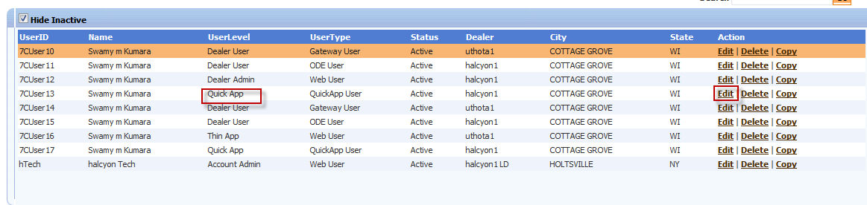

Columns on Table:

* Lead Name
* Lead Email
* Lead Phone Number
* Referral %
* Referral Agent Partner
* Status of Lead (Received, had consult, working together, under contract, closed won, closed lost) ← should have ability to sort this column by status
* Date sent
* Closing Price (updated by receiving agent)
* Address (updated by receiving agent)
* Buyer/ Seller (updated by receiving agent)
* Referral Amount (updated by receiving agent)