**Developing Soft and Parallel Programming Skills Using Project – Based Learning**

By

MASMters of the Universe:

Jay Bayless, Robert Quillian, Robert Hines, Divy Patel, Reshma Pravin

Fall-2018

|  |  |  |  |  |  |  |
| --- | --- | --- | --- | --- | --- | --- |
| Assignee Name | Email | Task | Duration (hours) | Dependency | Due Date | Note |
| Jay Bayless  (coordinator) | jbayless1@student.gsu.edu | Coordinator, creating Slack account as described in assignment. Teamwork report | 2 hours |  |  |  |
| Robert Quillian | [rquillian1@student.gsu.edu](mailto:rquillian1@student.gsu.edu) | ARM Assembly Programming | 2 hours |  |  |  |
| Robert Hines | [rhines7@student.gsu.edu](mailto:rhines7@student.gsu.edu) | ARM Assembly Programming and Report | 4 hours |  | 02/08/19 | Failed to attend first meeting and didn’t complete programming assignment so tasks were reshuffled and was tasked with writing the report. |
| Divy Patel | [dpatel147@student.gsu.edu](mailto:dpatel147@student.gsu.edu) | Video Presentation, editing, uploading, and creating the youtube channel. | 2 hours |  |  |  |
| Reshma Pravin | [rpravin1@student.gsu.edu](mailto:rpravin1@student.gsu.edu) | Creating the GitHub, installing RASPIAN, and initial PI setup. | 2 hours |  |  |  |

As the first project of the semester the founding of our team, the MASMters of the Universe, was a unique yet overall fulfilling experience. While we met with some mishaps at times, we eventually overcame and managed to come together to work through the issues that arose and set the framework for future cooperation. To begin with, we managed to settle on a schedule which we feel will allow us to not only coordinate and micromanage our tasks efficiently but also leave us with a slight leeway in case of emergency or a re-shuffling of priorities. Meeting as a group multiple times per project and promising the more difficult areas of the project to be submitted to the group for review and reflection as we complete them.

In fact, this is one of the more important basics of our teamwork dynamic to ensure that the task is completed effectively while guaranteeing team members are satisfied with minimal stress. Likewise, in order to minimize stress, we felt the best method of work distribution would be equal distribution through consensus. If any team member is unsatisfied or feels that they didn’t receive a task which suited them the group will work with them to give them a more suitable or enjoyable task on the next assignment; keeping a regular rotation of work and tasks so that everyone will get an opportunity to participate and hopefully keep their interests and motivation up. To keep the quality of work high, we will be posting semi-regular updates within our group chat and keeping communication as open as possible so that our peers can review and see how the work is progressing. With Slack, Github, and our email addresses being the primary methods of staying up to date and in touch with one another. Just as well, we will be making use of a facilitator who will remain in charge of keeping our group motivated and as on task as possible. The facilitator role will be rotated each project so that no one person is overly burdened with the responsibility of the group as a whole, while also allowing each participant to experience a variety of facilitator styles and to be given a chance to develop their own.

Due to the difficulties that can arise when working in a group, we’ve come to a consensus on how to deal with difficult behavior which may arise within the group. One decision we reached involves team members who may be prone to keeping to themselves or staying quiet in team discussions. Our plan is simply to work to draw the most out of each our team members; we seek to keep everyone engaged and active by sharing and seeking opinions and advice from the others. In the case of someone who is overly prone to complaints and unwillingness to cooperate, we’ve decided that our first course of action should be an analysis of the complaints to first see if there are any reasonable improvements that could be made in relation to them. If, however, the complaints are seemingly baseless or just excessive with no valuable criticism to be had then our next course of action would be to speak privately with the individual. Seeing if it can be sorted out politely, then reminding them that a large part of this assignment is learning cooperation and team-building skills.

Because much of this assignment is learning soft skills and how to work in a group, decision making proves to be of vital importance. Should we encounter a hold up or disagreement which prevents us from reaching a consensus than we plan to hold a group vote with the final say going to our group coordinator for that project. Anyone who may be disadvantaged or receive less than preferable treatment as a result of this decision will be given a slight priority in selecting their assignment during the next group project. We also have agreed that everyone will be given opportunity to have their thoughts and voices heard when making decisions within the group. This was done to give everyone a chance and to prevent anyone from coming to a split-second decision. Trying to shove a rushed decision to speed through the project without caring for the other members of our team is something we seek to prevent.

Within the same vein, our team is in solid agreement that we should each do our best to achieve the highest grade we possibly can. That said, as a semester continues, priorities shift and it can be difficult to keep everyone active and on the same page. So, to combat this, we agreed that instead of someone beginning to slack off or wane in concentration then they should contact the group immediately and discuss their concerns. If they feel that getting a “B” or even a “C” is acceptable for themselves while the others are seeking an “A” than they should inform the others as soon as possible. This way, as a group, we can work together and hopefully assign them some smaller, less important tasks, and redistribute the work appropriately among the remaining members. In this way, we can ensure that the project is completed and nobody is left expecting work to be completed by someone who has already given up.

After much deliberation and discussion, we finally managed to get our team plan down for this semester and focus on our next goal: the Raspberry PI and ARM programming. For this project the Raspberry PI installation was primarily handled by Reshma who made sure it was properly setup, got some good hands on experience with the small computer, and did some fairly extensive monitor testing to make sure that everything worked. Upon completion of her task, she promptly handed the Raspberry PI off to Robert Quillian. Robert was in charge of the ARM assembly program for this assignment.

For part 1 of the assignment, we made sure to follow the instructions and create a program which loaded 4 into the r1 register, subtracted 1, and added 4 to it thus giving it the result of 8. The r7 register was then loaded with a 1. Leaving the remaining registers as 0 because we did not load anything into them. When the program was run, there was no output on the screen as there was no print command issued within the code. If we wish to see what was in the registers than we needed to run the debugger and open the register information. Part 2 of the assignment also went smoothly. The program was written to produce the result of the arithmetic sequence A = (A + B) – (C * D). Robert first loaded the values of A, B, C, and D into separate registers and then proceeded with one operation at a time. Register r1, which correlated to A, had the answer of 7 after the program was run. While the other registers had various numbers according to what value was stored in them after execution.

APPENDIX A

<https://masmtersoftheuniverse.slack.com/threads/>

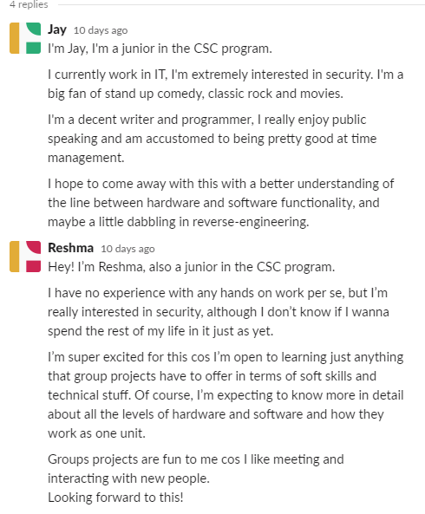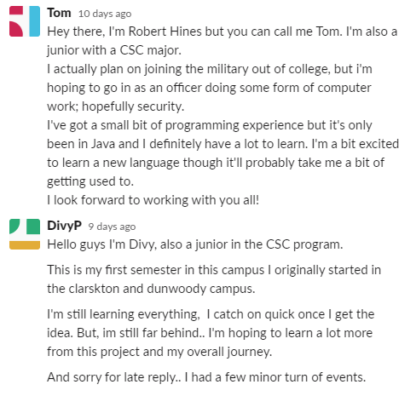

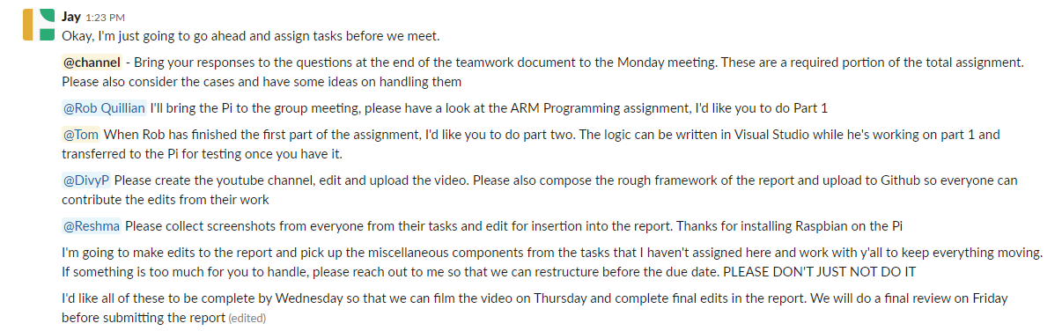

APPENDIX B

<https://github.com/MASMtersoftheUniverse>

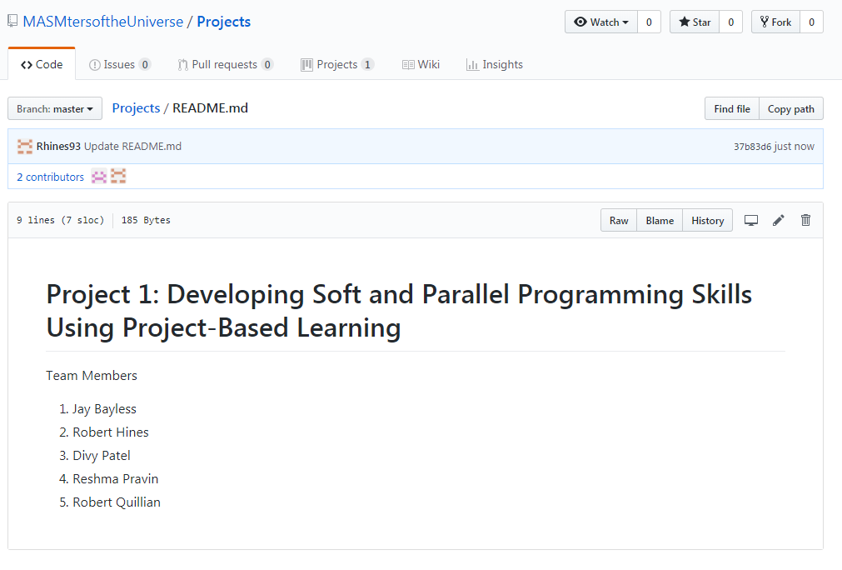

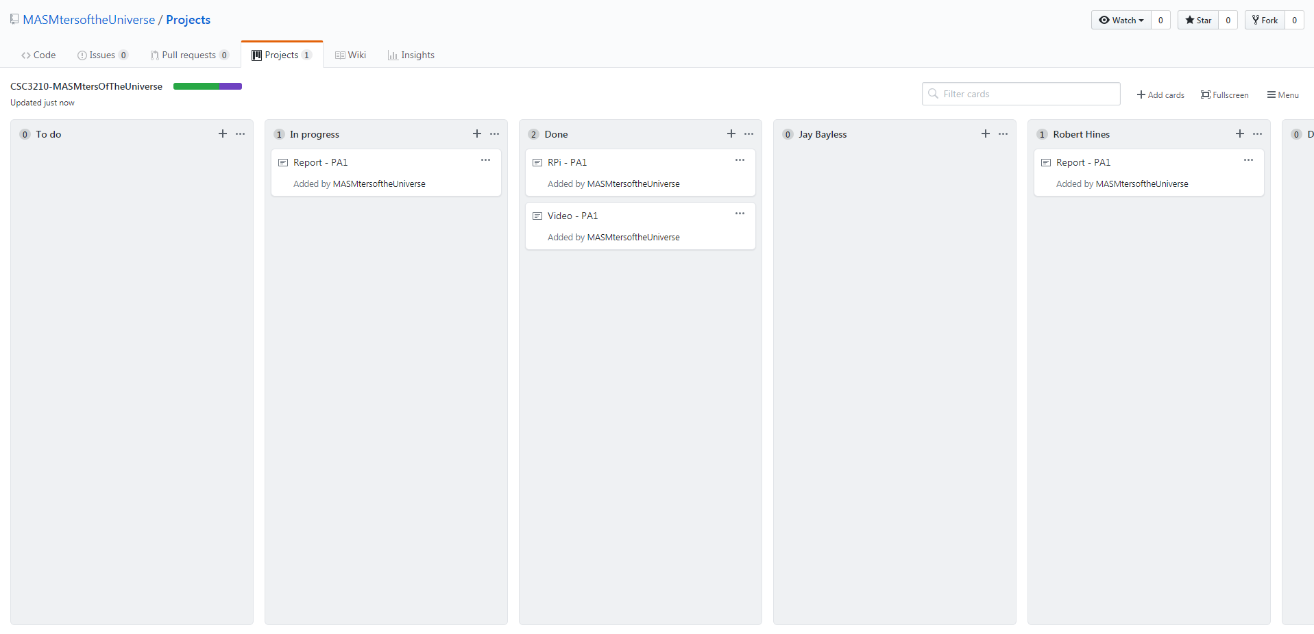

<https://www.youtube.com/watch?v=WDCw968qevo&feature=youtu.be>

APPENDIX C

