13. Query with AUTO_INCREMENT SEQUENCES
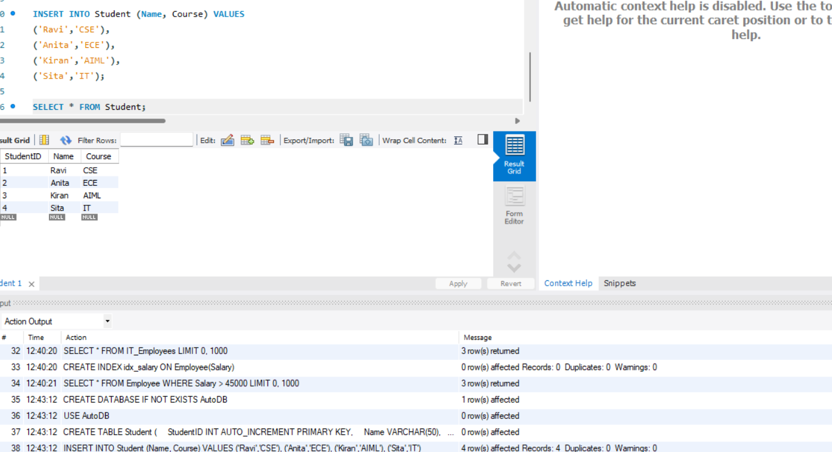
CREATE DATABASE IF NOT EXISTS AutoDB;
USE AutoDB;

CREATE TABLE Student (
StudentID INT AUTO_INCREMENT PRIMARY KEY,
Name VARCHAR(50),
Course VARCHAR(50)
);

INSERT INTO Student (Name, Course) VALUES
('Ravi','CSE'),
('Anita','ECE'),
('Kiran','AIML'),
('Sita','IT');

SELECT * FROM Student;

