14. Simple programming using REPEAT and WHILE

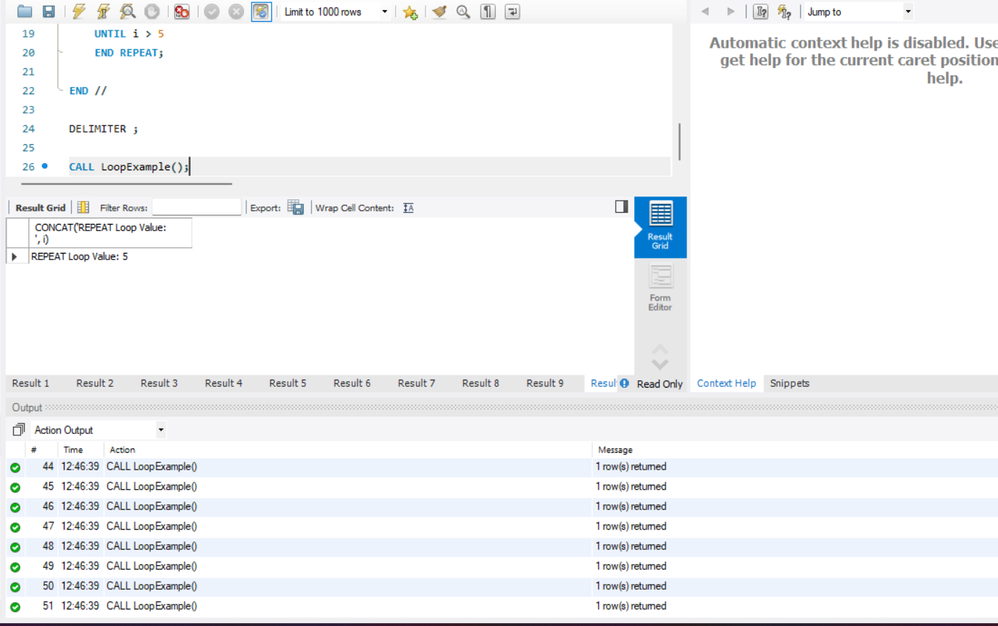
DELIMITER //

CREATE PROCEDURE LoopExample()
BEGIN
DECLARE i INT DEFAULT 1;

-- WHILE Loop
WHILE i <= 5 DO
SELECT CONCAT('WHILE Loop Value: ', i);
SET i = i + 1;
END WHILE;

SET i = 1;

-- REPEAT Loop
REPEAT
SELECT CONCAT('REPEAT Loop Value: ', i);
SET i = i + 1;
UNTIL i > 5
END REPEAT;

END //

DELIMITER ;

CALL LoopExample();

