15. Simple programming using CASE and LOOP
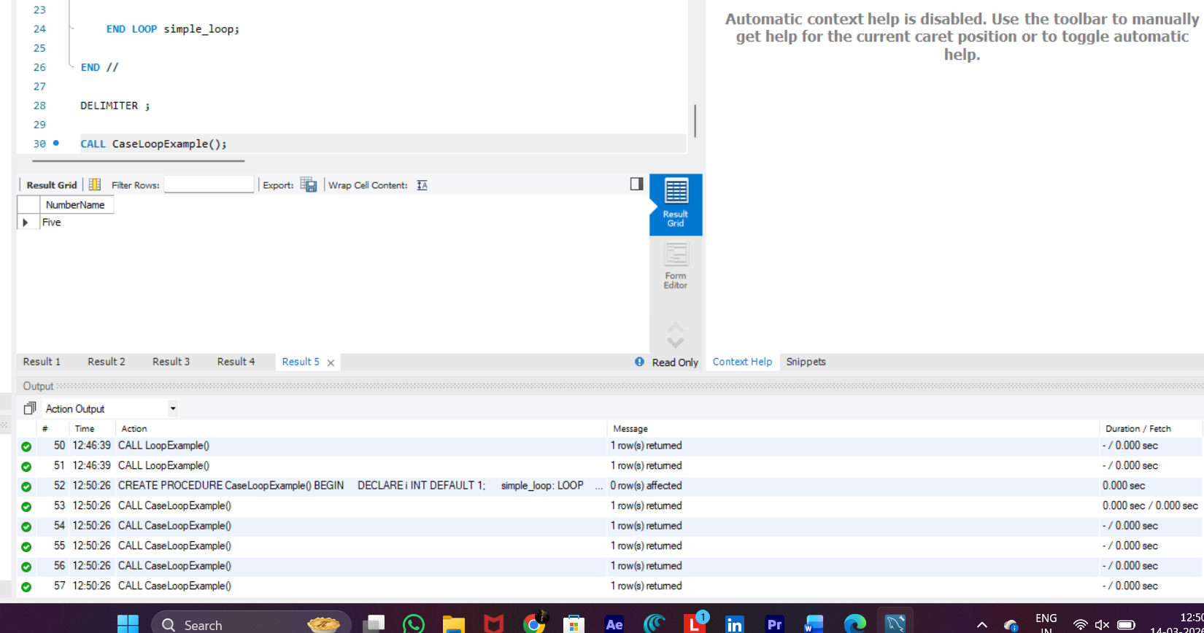
DELIMITER //

CREATE PROCEDURE CaseLoopExample()
BEGIN
DECLARE i INT DEFAULT 1;

simple_loop: LOOP

SELECT
CASE
WHEN i = 1 THEN 'One'
WHEN i = 2 THEN 'Two'
WHEN i = 3 THEN 'Three'
WHEN i = 4 THEN 'Four'
ELSE 'Five'
END AS NumberName;

SET i = i + 1;

IF i > 5 THEN
LEAVE simple_loop;
END IF;

END LOOP simple_loop;

END //

DELIMITER ;

CALL CaseLoopExample();

