Exp-6: DCL Commands – GRANT, REVOKE

CREATE DATABASE CompanyDB;
USE CompanyDB;
CREATE TABLE Employee (
Emp_ID INT PRIMARY KEY,
Name VARCHAR(50),
Department VARCHAR(50),
Salary INT
);
INSERT INTO Employee VALUES (101,'Ravi','HR',40000);
INSERT INTO Employee VALUES (102,'Anita','Finance',50000);
INSERT INTO Employee VALUES (103,'Kiran','IT',60000);
SELECT * FROM Employee;
GRANT SELECT, INSERT ON Employee TO user1;
REVOKE INSERT ON Employee FROM us
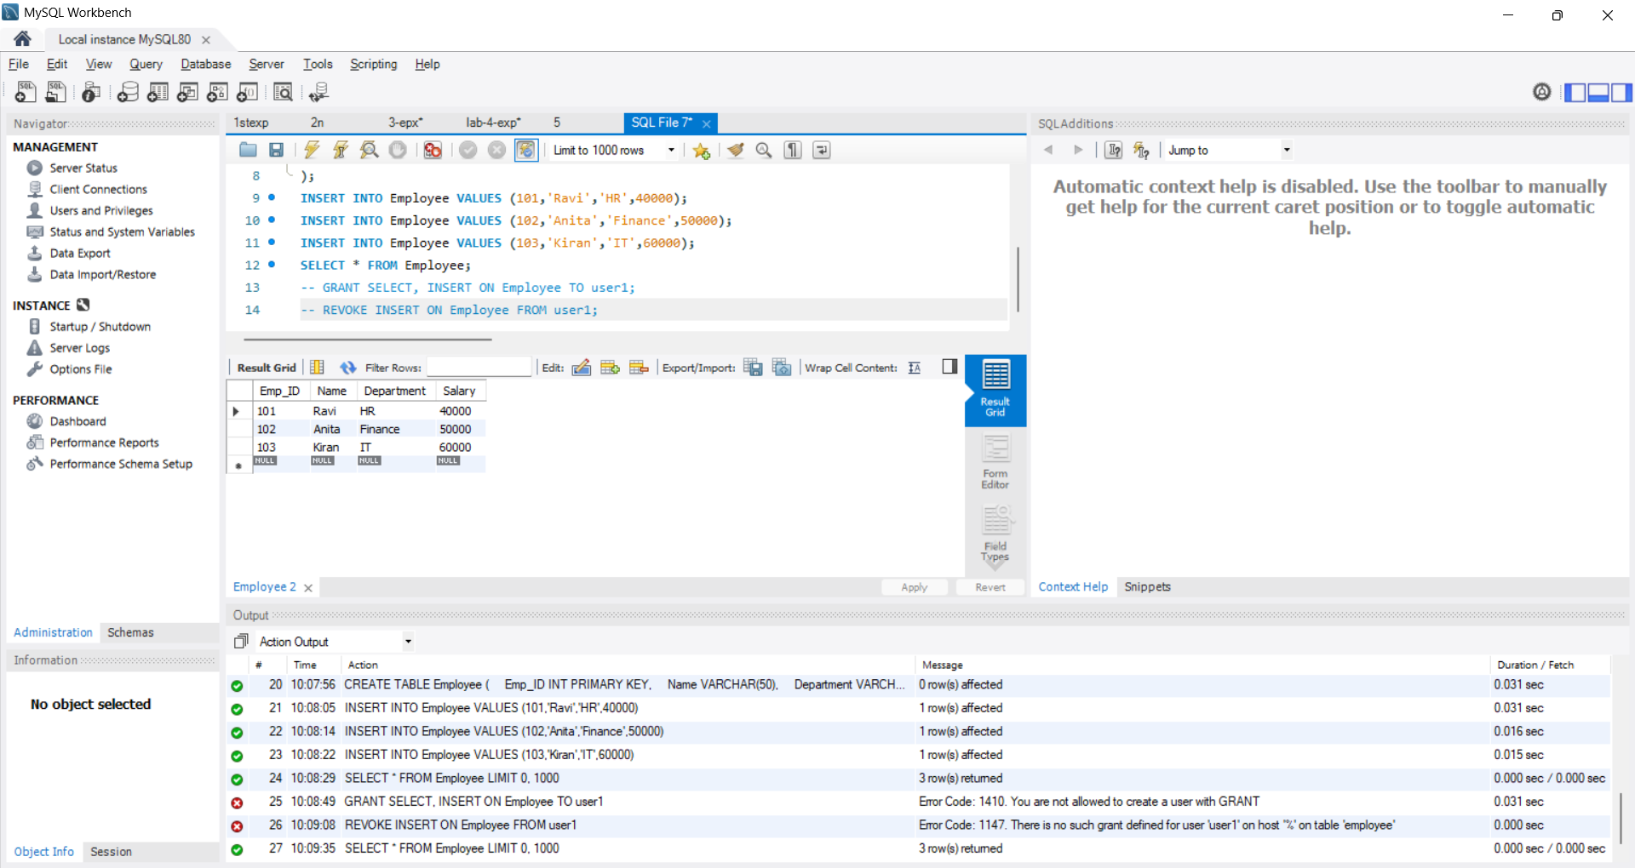er1;

