EXPERIMENT NO. 2
Setting up a Zoho Creator Account and Exploring the Platform Architecture and Interface
Name: Mathu Methaa . K Roll no:240701306

1. AIM
To create and configure a Zoho Creator account, develop a sample application using forms, reports and dashboards, and understand the platform architecture and interface through the Develop, Deploy and Manage sections.
2. SETTING UP ZOHO CREATOR
I) Create the Sample Application
- Open the Zoho Creator website and sign in using a Zoho account.
- From the Zoho Creator home page, select the option to create a new application.
- Choose a suitable application template or create an application from scratch.
- Enter an application name, for example, “Student Management System”, and create the application.
- Create a form named “Student Details” with fields such as Student Name, Register Number, Department, Year and Email.
- Create a report to display the submitted student records in a suitable format.
- Create a dashboard and add suitable components such as charts, summaries or reports to visualize the application data.
- Save the application and test the form, report and dashboard using the application preview.
II) Creating Form, Report and Dashboard – Screenshot and Explanation
Note: Insert your actual Zoho Creator screenshots in the spaces provided below. The screenshots should clearly show the form creation screen, report creation screen and dashboard creation screen.
Screenshot 1 – Creating a Form
[Insert screenshot here]
A form is used to collect and store data in the application. In this experiment, the Student Details form contains fields such as Student Name, Register Number, Department, Year and Email. When a user submits the form, the entered information is stored in the application's data source.
Screenshot 2 – Creating a Report
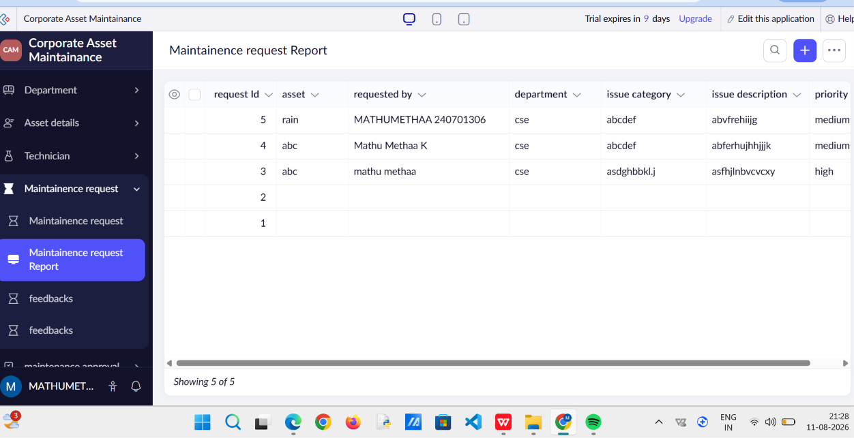
A report is used to display and analyze the data collected through a form. The Student Details report can display student records in a table or other suitable view. Reports make it easier to search, filter, sort and review application data.
Screenshot 3 – Creating a Dashboard
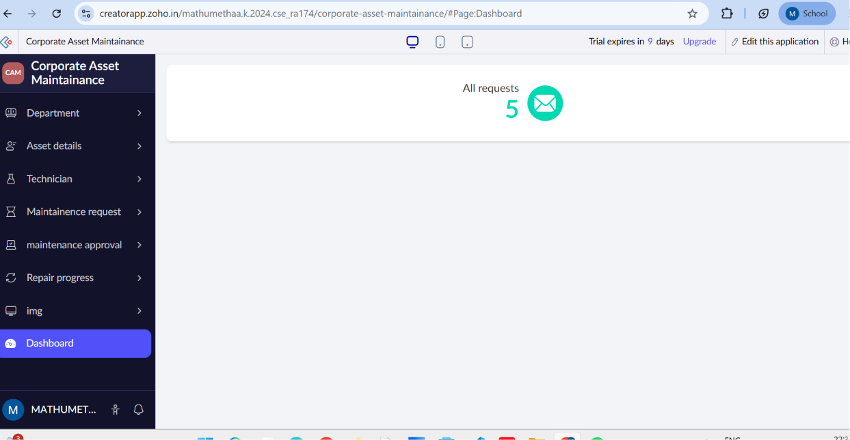
A dashboard provides a visual summary of application data. Charts, reports and summary components can be arranged on the dashboard to understand the data quickly. For example, a chart can show the number of students in different departments.
3. EXPLORING THE PLATFORM ARCHITECTURE AND INTERFACE
Develop
The Develop section is used to build the application by creating forms, reports, pages, workflows and other components. It provides the tools required to design the application's data collection and business logic. Developers can customize application components and use scripting when additional functionality is required.
Deploy
The Deploy section is used to make the application available to users. Applications can be tested and published with suitable access permissions for different users. Deployment helps move the developed application from the development stage to actual usage.
Manage
The Manage section is used to maintain and administer the application. It provides options for users, permissions, application settings and other administrative activities. It helps monitor and control the application after it has been developed and deployed.
RESULT
Thus, a Zoho Creator account was set up successfully, a sample application was created with a form, report and dashboard, and the Develop, Deploy and Manage sections of the Zoho Creator platform were explored.

