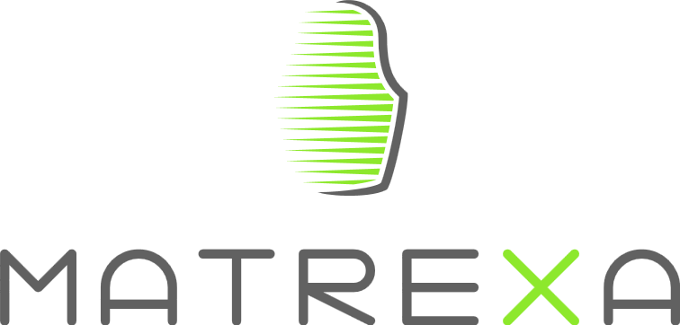

**White paper for the sale of tokens.**

**Simply as Matrexa**

**19.07.2017**

**MATREXA.IO**

**Preface**

Much time has passed since that moment as the beginning of crypto currency its march around the world. Advantages of crypto currencies are obvious to every user: anonymity, promptness of transfers, low or zero commissions for operations, reliability, security.

Crypto currency has the only drawback – a small prevalence. To date, there is no single system that is able to integrate the ability to instantly pay for goods or services using the crypto currency. Users are unable to pay for bulk goods or services because the provider does not have the technical and legal ability to accept payment in this format.

Payment system MATREXA will be a solution to this problem.

* 1. **Description of the system.**

**What is MATREXA?**

It is an international payment system that provides instant and lawful payment of any goods and services directly from your crypto currency wallet.

**Why you need a MATREXA?**

Each holder of crypto currency needs to be able to pay for her purchases. With the advent of MATREXA you disappear the infinite banking to withdraw funds and commissions. You can visit your favorite restaurant and pay the bill, or buy tickets through the Internet service using the crypto currency.

**Mission for MATREXA**

Team MATREXA considers its mission the provision of opportunities for the holder of the crypto currency to use crypto currency in everyday life.

* 1. **Main advantages of the payment system MATREXA**
* Payment of any goods or services without a fee to the buyer.
* To connect to the system, the user may not create a new wallet. You can use your wallet with your existing account crypto currency.
* Support most popular crypto currencies: Bitcoin, Ethereum, Bitcoin Cash, Ripple, Litecoin, NEM, IOTA, Dash, NEO, and Ethereum Classic.
* Currently, agreement has been reached about the installation of the payment system with the largest online trading platforms: Aliexpress, Ebay, Ozon, and Yoox.
* Currently, negotiations on the terms of cooperation with Burger King, Aeroflot, Crimea.
* The buyer pays for the purchase of crypto currency and the seller receives the usual Fiat.
* All investments are directed to the development and launch of the project.
  1. **Relevance of the project.**

Currently, the market capitalization of the Top-10 for a crypto currency is estimated to be about 132 billion U.S. dollars. Crypto currencies are attracting more number of interested people, updating the historical maximum rate. Today the number of active user’s wallets with crypto currency is about 11 million people.

Strong growth in interest of crypto currencies in society noted in the government structures and among the major private players in the banking market. The head of Sberbank, German Gref, said: "Russia needs to open up their markets for crypto currencies and to introduce careful regulation of bitcoin". Deputy Finance Minister of Russia Alexei Moiseev made a speech, offering to use the possibility of introducing a system of payments in crypto currency in the Republic of Crimea.

The relevance of the project due to the growth of the market of crypto currency and the necessity of introduction of uniform system of payment of goods and services for virtual sites and real-world trading platforms.

**2.1 Principle of operation of the payment system MATREXA.**

Payment for goods or services via the Internet

1. The process of selecting a product or service;
2. Filling the necessary data in the marketplace;
3. The choice of method of payment using MATREXA;
4. The assignment to the buyer and the product/service special ID;
5. The choice of crypto currency for payment;
6. The formation of a QR-code with the amount of payment;
7. Sending crypto currency to the system MATREXA;
8. Payment confirmation;
9. Sending payment to a seller of goods/services.

Payment of goods or services in real life

1. Ordering of goods/services;
2. The choice of method of payment using MATREXA;
3. Printout a QR-code of the seller/cashier;
4. Scanning the QR-code by the buyer;
5. Send payment for confirmation;
6. Receive a notification from the system about the necessary amount of crypto currency;
7. Payment to the seller.

**2.2 Technical aspect MATREXA.**

In the basic work of the payment system, the following elements can be distinguished:

Server/servers for data processing

Server/servers of private offices

Single database

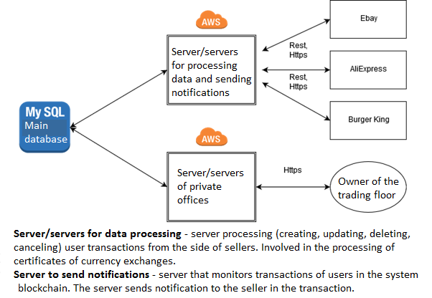

Server/servers for processing

Used development language for the server part: Java

Used platform: Amazon Aws

The combination of the technology used will ensure server stability and reliability of the system, providing all the necessary resources.

Task pane this server:

1. Validation of the keys;
2. Validation of requests from the API;
3. Execution of requests from the API;
4. Conducting transactions;
5. Informing the server of the seller about the status of the transaction;
6. Processing of payments.

We also plan to create a single standard and limit for query API – the input will be accepted JSON, and XML.

Server/servers of private offices

Used framework for the development of personal account: Phalcon (using Angular).

Used platform: Amazon Aws (using the technology of Elastic Beanstalk).

The functioning of the server private offices involves a separate process on a specified site. The choice of framework Phalcon is due to additional savings for the development. Use Angular will provide comfortable work with the interface. All requests to the Phalcon will be summarized under a single standard and the restriction.

Single database

Used engine: Amazon Aurora (RDS Aurora MySQL).

Using this engine provides the following benefits:

1. Higher bandwidth (up to 5 times compared to MySQL);
2. Automated monitoring and fault tolerance;
3. Up to 15 replicas for read;
4. Automatic scaling;

In the first phase we are planning to run only one replica to read, if not required otherwise.

**2.3 Description business and technical processes**

Block- scheme of user interaction with the server

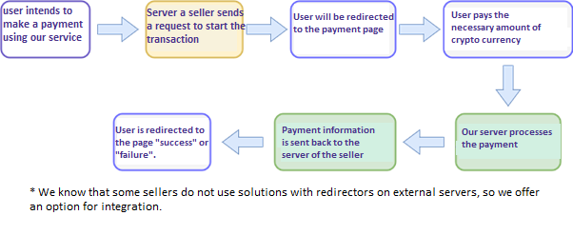

Variant of settlement with the seller

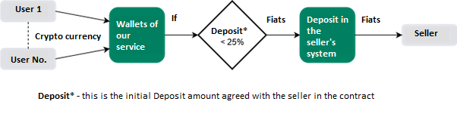

Cash flows in our system

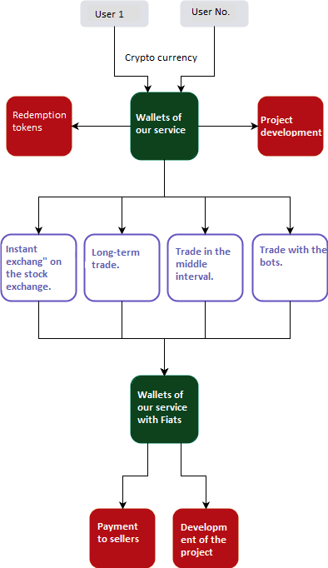

Variants of the interaction of the payment system MATREXA with R-Keeper.

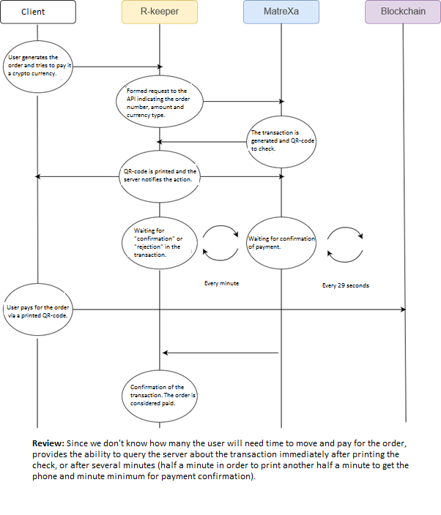

**3.1 Technology roadmapping (Road map)**

Development of software complex "MATREXA" (December 2017)

↓

Сonnection of the leading trading platforms (January 2018)

↓

Create MATREXA Blockchain (March 2018)

↓

Development of software for crypto- cash dispenser (April 2018)

↓

Creation of personal offices of the payment wallet MATREXA (introduction of cashback) (May 2018)

↓

Issue of plastic cards MATREXA (July 2018)

↓

Production and installation of crypto- cash dispenser (August 2018)

**3.2 Financial aspect MATREXA**

Monetization of the project

In these days, the amount of market capitalization of the Top-10 crypto currency is about 132 billion U.S. dollars. On the basis of the development strategy of the project MATREXA, about 1% ($1.3 billion) of the overall market crypto currency will be spent on the purchase of goods or services.

The MATREXA commission will be from 1% to 2%. The approximate annual fee is 13-26 million US dollars. In the future, we plan to optimize the turnover of the crypto currency. Current calculations show that the annualized optimization revenue will be 80 million US dollars.

**3.3 Description of the primary offer of the tokens**

MATREXA (MTRX) – token will be released in a certain amount (33 000 000). In the period from 17 September 2017 to 02 October 2017 ICO sale will be available for purchase.

Total number of tokens – 33 000 000 MTRX

**Course for token MTRX/USD**:

|  |  |
| --- | --- |
| 17.09.2017 – 18.09.2017 | $1,10 |
| 18.09.2017 – 20.09.2017 | $1,20 |
| 20.09.2017 – 23.09.2017 | $1,30 |
| 23.09.2017 – 27.09.2017 | $1,40 |
| 27.08.2017 – 02.10.2017 | $1,50 |

32 000 000 MRTX – maximum number of tokens available for sale on the ICO

1 000 000 MTRX – bounty, marketing, consultants, project team

9 500 – minimum number of ETN collected in the ICO (in case the specified amount will not be collected, will be returning)

With 02.01.2018 year MTRX token will be given to the exchange.

You will be able times for stock price once a month MTRX tokens to pay for goods and services in the amount of 10% of the total number of tokens MTRX, after connecting sellers to the payment system.

ICO project MATREXA and creating tokens MTRX will be using Ethereum Smart Contracts.

Participants wishing to support the development of the project MATREXA will send out Ether on the Ethereum address listed on ICO. ICO will end at the end of the last day or to achieve tax these investments.

A smart-contract after the launch of ICO will be available.

After conducting the ICO, the creation of tokens MTRX will be closed forever. Within three months after the end of ICO to security considerations, the transfer MTRX tokens will be limited. Tokens will be created for each customer in the required quantity.

The minimum number of attracted Ethereum – Ether 9 500 (if no specified number is not reached, the funds raised will be returned).

**4.1 FAQ (frequently asked questions)**

*1. What wallet should I use to store and receive MTRX tokens?*

Answer: MTRX is an ERC20 token on the Ethereum block system. Token holders can store and manage MTRX tokens using existing Etherair clients. You can use the official wallet Ethereum.

*2. I can participate in ICO without creating an address Ethereum?*

Answer: No, because MTRX is a token that is issued on the Ethereum block. You must have an Ethereum address (you can use any Ethereum purse) to receive and store MTRX tokens.

*3. US citizens can participate in the ICO?*

Answer: No, the residents of the United States cannot participate in the initial sale of tokens MTRX due to operating on the territory of the country legislation.

*4. How will the MTRX tokens be issued?*

Answer: Tokens will be sent to you automatically through smart contracts of the Ethereum network. The smart contract code on Github will be open and available for verification to anyone who wishes.

*5. What is the legal structure of the project MATREXA?*

Answer: MATREXA created in Singapore. Team MATREXA is international. Our staff and consultants are located around the world. Control comes from the city of Novorossiysk in Russia.

*6. MTRX tokens will be available at the exchange after ICO?*

A: Yes, tokens will be available 3 months after the end of ICO. This is done to limit the strong speculation and volatility.

*7. What happens in the case that not all existing tokens MTRX will be sold at ICO?*

Answer: Tokens will be created for each customer in the required quantity.

*8. Will there be additional releases of tokens MTRX after ICO?*

Answer: After the end of the ICO the creation of the token MTRX will be closed forever.

*9. Why your team does not conduct an active campaign ICO project MATREXA?*

Answer: We have the main investor, whose funds are used to connect the online trading platform Aliexpress. We have agreements with Ebay, Ozon, and Yoox. On the day we are negotiating with companies Burger King and Aeroflot on connectivity.

**5.1 Legal side of the project MATREXA**

The objective of this White paper is to present the project MATREXA potential holders of tokens in anticipation of the impending sentence tokens on ICO. The information given is not exhaustive and does not imply contractual obligations between the potential holders, management and team MATREXA.

The only goal is the ability to potential holders of tokens is important and sufficient details that will enable them to make a decision on further acquaintance with the company and offer tokens for their possible acquisition.

The sections of this White paper will not be construed as a prospectus or an investment proposal of any kind. Present a primary offer of tokens does not constitute an offer to sell or buy securities in any jurisdiction. This document has been prepared without regard to laws or regulations of any jurisdiction intended to protect investors and are not regulated.

Statements, calculations and financial indicators presented in this White paper are preliminary predictive information. So they can start from the known and unknown risks and uncertainties. The actual circumstances and results may differ significantly from those given in the White book of calculations and indicators, directly or indirectly, provided preliminary projected statements.

**6.1 Team for the project MATREXA**

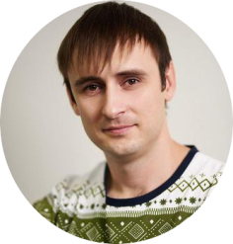

Founder - Lunev Vladimir Gennadievich

Has more than 12 year’s experience of running own business projects, management activities, negotiating and building effective teams.

Contacts: @Lunev_Vladimir (Telegram)

admin@matrexa.io

<https://vk.com/id221048166>

<https://www.facebook.com/bobah.nvrsk>

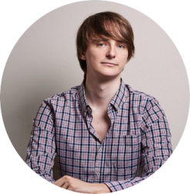

Evstratov Albert Nikolaevich

Director of information technology. Graduated from the State University of Kuban (faculty of applied mathematics). Has extensive experience automating business processes and creating new teams of developers.



Rubin Pavel Markovich

The developer of the smart-contract. Graduated from Moscow Institute of electronics and mathematics. More than 14 years of experience developing web services and high-loaded systems. 2016 is developing smart-contracts Ethereum. He is fond of science fiction and swimming.



Tolmasova Olga Alexandrovna

Web-designer. Graduated from the State University of Kuban (art and graphic faculty). Has 4 years of experience in the specialty. Love cats.



Kirill Kuleshov

Multimedia director. He graduated from the St. Petersburg Humanitarian University of Trade Unions (Faculty of Art), the Department of Multimedia Directing, has 5 years of experience in the specialty.

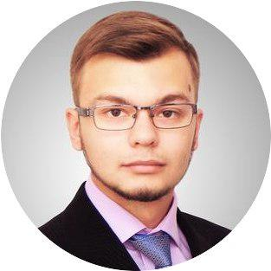

Besaga Vladislav Urievich

Specialist in public relations. Has a higher education in the specialty of "Public Relations". Has experience in advertising and marketing. Has more than 5 years’ experience of interaction with public authorities. 2 years worked as the head of the department of marketing and advertising.