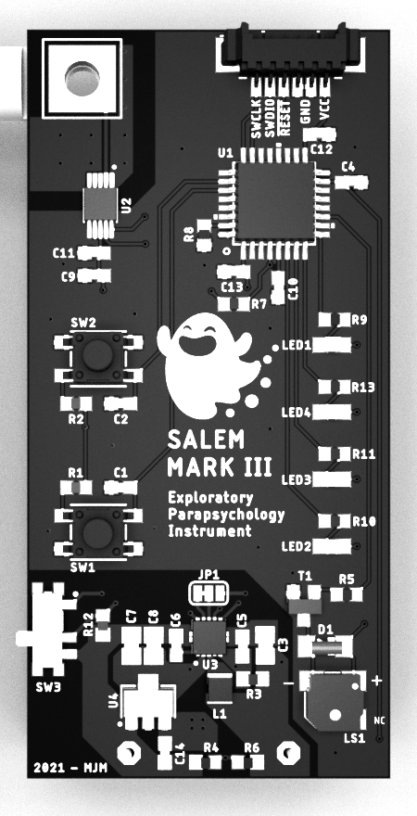

Salem Exploratory Parapsychology Instrument

Operating Characteristics:

Nominal voltage: 3.0V

Current Draw: 0.55mA – 4.55mA

Battery type: 2X AA [1.5V]

Alkaline batteries recommended for best result

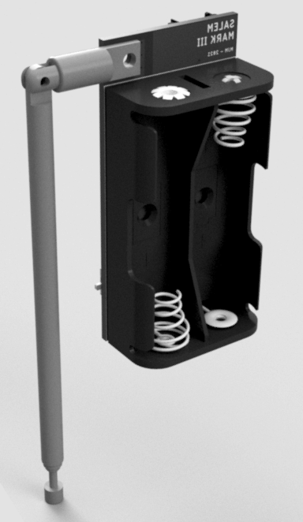**Before Operating the Device**

Hardware V3

Warning: This device has no reverse polarity protection, please insert the batteries correctly.

* Place the batteries into the device’s battery pack, please ensure the batteries are new.
* Allow the device to acclimate to the rooms ambient temperature to ensure an accurate reading during initialization.
* Extend the antenna to its maximum height.
* Place the device away from objects to avoid false readings.

**Powering your Device on for the first time**

*Initialization Sequence:*

Once the device is setup, power on the device. When power is first applied, the indicator lights will cycle up then back down. Following this light sequence, the battery level will be displayed.

*Battery Check:*

The voltage of the battery will be displayed via the indicators. The minimum operating voltage of the device is 1.8v. **Batteries providing less than 1.8v will cause the device to report an error**. This is to ensure the device has a stable voltage source for reliable operation.

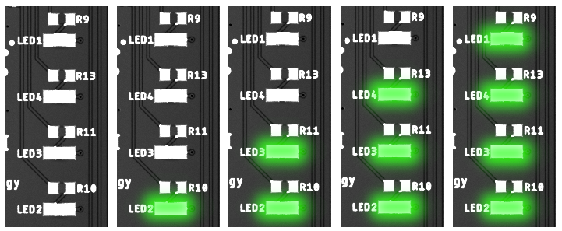

*Baseline Calibration:*

After the Battery check is complete, the device will take 100 samples of the environment to use as the “baseline”. This baseline will be what following measurements are compared against. **It is very important that the device be free of interference during this time. Please take a few steps back from the device while it is taking the baseline reading.**

**Once the device has sufficient environmental data, a tone will sound**. This indicates the device is now ready for field operation.

**Adjusting the Sensitivity Threshold**

After the device has completed the initialization sequence, you may choose to adjust the sensitivity threshold. This can be done with the up/down buttons. Pressing the buttons will result in a tone, holding the button will make multiple steps until the button is released.

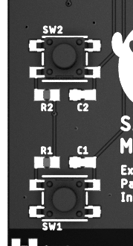

The **UP** button, raises the sensitivity threshold, **Decreasing** the devices sensitivity.

The **DOWN** button, lowers the sensitivity threshold, **Increasing** the devices sensitivity.

**Active Temperature Compensation**

Due to the nature of the device, fluctuations in temperature will affect the devices readings. To combat this, the device will actively adjust the baseline during idle state **IF** there is a measurable change in ambient temperature.

A correction due to temperature shift will result in the device sounding a tone. **A tone with increasing pitch will denote a positive temperature shift. A tone with decreasing pitch will denote a negative temperature shift.**

**Reading the Devices Indicators**

During normal operation the indicators will display proximity strength with respect to the baseline. In addition to the visual indicators, audible tones will also be present. The tones will increase / decrease in pitch based on proximity strength. **There are a total of 11 intensity steps that will be reflected on the device’s indicators.**

**Error State**

if at any point during the device’s operation a system check fails, the device will jump into an error state. This error state will be realized by flashing indicators.

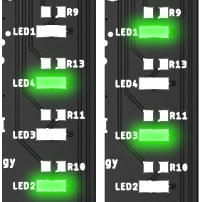

**Troubleshooting**

* The most common cause of an error state is “low battery”. This can be rectified by powering off the device, replacing the batteries, and powering the device on again.
* If there is an internal error, cycling the power should resolve the error states.
* If there is any damage to the device physically, the error state may have no resolution.

**Programming Header**

The programming header is meant for factory programming. Should an update scheme be realized, this programming header will be used for updating the device.

Loading unauthorized firmware is possible, but not recommended. Any damage to the device as a result of curiosity is the user’s responsibility.

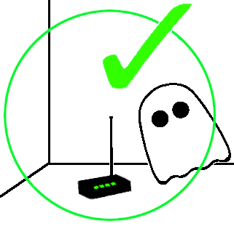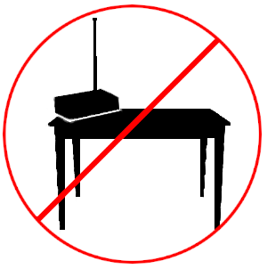**Recommended Operating Scenarios**