Salem Exploratory Parapsychology Instrument

**Quick Start**

1. Acclimate the device to the room’s ambient temperature.
2. Place the device on a smooth level surface and extend the antenna
3. Power on the device and step out of the detection zone.
4. Wait for the initialization sequence to complete (chirp).
5. Adjust the sensitivity threshold as needed (up / down).

Antenna

Programing Header

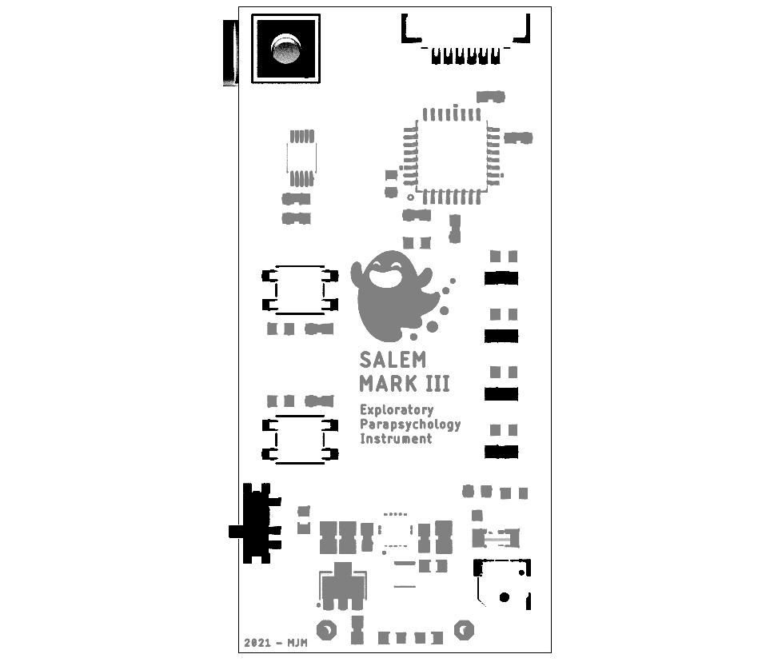

Button [UP]

LED Indicators

Button [DOWN]

Speaker

Power Switch

Hardware Version 3