**Computer Communications and Networks (COMN)**

**2022/23, Semester 1**

**Assignment 2 Worksheet**

|  |  |
| --- | --- |
| **Forename and Surname:** | Giles Matthew |
| **Matriculation Number:** | S2149988 |

**Question 1** – Number of retransmissions and throughput with different retransmission timeout values with stop-and-wait protocol. For each value of retransmission timeout, run the experiments for **5 times** and write down the **average number of retransmissions** and the **average throughput**.

|  |  |  |
| --- | --- | --- |
| **Retransmission timeout (ms)** | **Average number of**  **retransmissions** | **Average throughput**  **(Kilobytes per second)** |
| 5 | 5.4 | 140.5 |
| 10 | 4.6 | 143.1 |
| 15 | 4.2 | 727.5 |
| 20 | 5.6 | 3499.2 |
| 25 | 3.6 | 4082.6 |
| 30 | 2.8 | 4217.8 |
| 40 | 3.8 | 2897.6 |
| 50 | 5.0 | 2129.9 |
| 75 | 5.4 | 1358.0 |
| 100 | 3.6 | 1777.4 |

**Question 2** – Discuss the impact of retransmission timeout value on the number of retransmissions and throughput. Indicate the optimal timeout value from a communication efficiency viewpoint (i.e., the timeout that minimizes the number of retransmissions while ensuring a high throughput).

When the timeout is low ()

Average throughput increases as retransmission timeout increases up to 30ms, when the value is greater than 30ms it starts to decrease. The optimal retransmission timeout seems to be 30ms. This is probably because 30ms is the closest value to the end-to-end delay between the receiver and sender. This extra delay is due to the processing and transmitting delays. Processing delays include the reading of the chunks of the file; whilst the transmitting delay includes the pushing the data into the socket.

6

**Question 3** – Experimentation with Go-Back-N. For each value of window size, run the experiments for **5 times** and write down the **average throughput**.

|  |  |  |  |
| --- | --- | --- | --- |
|  | **Average throughput (Kilobytes per second)** | | |
| **Window** **Size** | **Delay = 5ms** | **Delay = 25ms** | **Delay = 100ms** |
| 1 |  |  |  |
| 2 |  |  |  |
| 4 |  |  |  |
| 8 |  |  |  |
| 16 |  |  |  |
| 32 |  |  |  |
| 64 |  |  |  |
| 128 |  |  |  |
| 256 |  |  |  |

Create a graph using the results from the above table (empty example graph shown below):

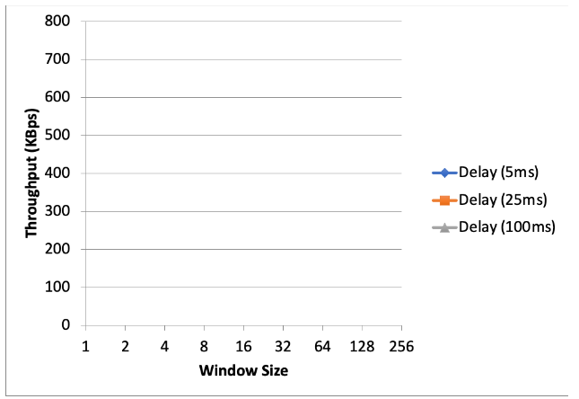

**Question 4** – Discuss your results from Question 3.

**Question 5** – Experimentation with Selective Repeat. For each value of window size, run the experiments for **5 times** and write down the **average throughput**.

|  |  |
| --- | --- |
|  | **Average throughput (Kilobytes per second)** |
| **Window Size** | **Delay = 25ms** |
| 1 |  |
| 2 |  |
| 4 |  |
| 8 |  |
| 16 |  |
| 32 |  |

**Question 6** - Compare the throughput obtained when using “Selective Repeat” with the corresponding results you got from the “Go Back N” experiment and explain the reasons behind any differences.

**Question 7** – Experimentation with *iperf*. For each value of window size, run the experiments for **5 times** and write down the **average throughput**.

|  |  |
| --- | --- |
|  | **Average throughput (Kilobytes per second)** |
| **Window Size (KB)** | **Delay = 25ms** |
| 1 |  |
| 2 |  |
| 4 |  |
| 8 |  |
| 16 |  |
| 32 |  |

**Question 8** - Compare the throughput obtained when using “Selective Repeat” and “Go Back N” with the corresponding results you got from the *iperf* experiment and explain the reasons behind any differences.