**Prompt used for generating test scenarios from software requirements**

give me the test scenarios for the above mentioned software requirements SR-001,SR-002,SR-003,SR-004,SR-005,SR-006,SR-007

Test Scenarios for Software Requirements

SR-001: Application Launch

**TS-001-01: Verify that the application is available for download on the Apple App Store.**

**TS-001-02: Verify that the application is available for download on the Google Play Store.**

**TS-001-03: Verify that the application installs successfully on an iOS device.**

**TS-001-04: Verify that the application installs successfully on an Android device.**

**TS-001-05: Verify that the application launches without errors on an iOS device.**

**TS-001-06: Verify that the application launches without errors on an Android device.**

SR-002: User Interface for Microscope Discovery

**TS-002-01: Verify that the main screen displays a "Scan for Devices" button.**

**TS-002-02: Verify that a loading indicator is shown while scanning for devices.**

**TS-002-03: Verify that the application displays a list of discovered microscopes with their names and statuses.**

**TS-002-04: Verify that the list updates dynamically as new microscopes are discovered.**

SR-003: Wi-Fi Network Scanning

**TS-003-01: Verify that the application initiates a network scan when the "Scan for Devices" button is tapped.**

**TS-003-02: Verify that the application identifies and lists all available surgical microscopes on the same Wi-Fi network.**

**TS-003-03: Verify that the application handles and displays an error message if no microscopes are found.**

**TS-003-04: Verify that the application handles and displays an error message if the scan fails.**

SR-004: Microscope Selection and Connection

**TS-004-01: Verify that the user can tap on a listed microscope to initiate a connection.**

**TS-004-02: Verify that the application displays a connection status indicator (e.g., connecting, connected, failed).**

**TS-004-03: Verify that the user is notified upon successful connection.**

**TS-004-04: Verify that the application displays an error message if the connection fails.**

SR-005: Connection Management

**TS-005-01: Verify that the application maintains the connection to the microscope once established.**

**TS-005-02: Verify that the application detects and notifies the user if the connection is lost.**

**TS-005-03: Verify that the application provides an option to retry the connection if it is lost.**

**TS-005-04: Verify that the application provides an option to disconnect manually.**

SR-006: Security and Permissions

**TS-006-01: Verify that the application requests Wi-Fi and network permissions during installation or first launch.**

**TS-006-02: Verify that the application uses secure protocols (e.g., HTTPS, WPA2) for communication with the microscope.**

**TS-006-03: Verify that the application handles permission denial gracefully and informs the user of required permissions.**

SR-007: Cross-Platform Compatibility

**TS-007-01: Verify that the application functions correctly on the latest version of iOS.**

**TS-007-02: Verify that the application functions correctly on the latest version of Android.**

**TS-007-03: Verify that the application supports various device screen sizes and orientations on iOS.**

**TS-007-04: Verify that the application supports various device screen sizes and orientations on Android.**

**TS-007-05: Verify that the application passes platform-specific guidelines and requirements for iOS.**

**TS-007-06: Verify that the application passes platform-specific guidelines and requirements for Android.**

These test scenarios cover the essential aspects of the software requirements, ensuring that the application meets the specified criteria and functions correctly on both iOS and Android platforms.

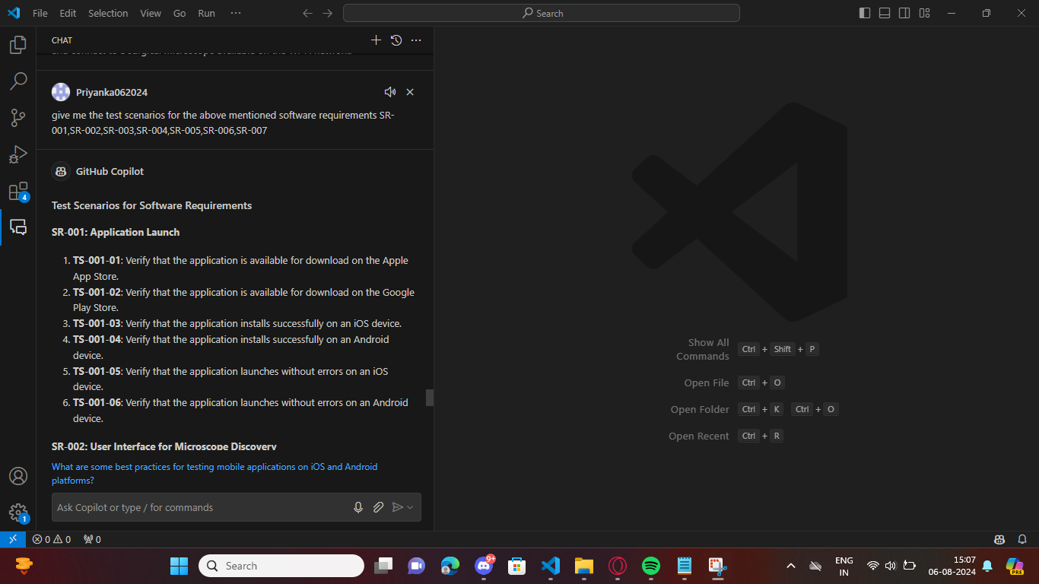

give me the test scenarios for the above mentioned software requirements SR-008,SR-009,SR-010,SR-011,SR-012,SR-013,SR-014,SR-015  
  
Test Scenarios for Software Requirements  
SR-008: Live Streaming Interface  
**TS-008-01: Verify that the "Start Live Stream" button is displayed when a microscope is connected.  
TS-008-02: Verify that the "Stop Live Stream" button is displayed when live streaming is active.  
TS-008-03: Verify that the live video feed from the microscope is displayed when streaming is active.  
TS-008-04: Verify that the "Start Live Stream" button is hidden when streaming is active.  
TS-008-05: Verify that the "Stop Live Stream" button is hidden when streaming is not active.  
SR-009: Live Streaming Initialization  
TS-009-01: Verify that tapping the "Start Live Stream" button initializes the live streaming session.  
TS-009-02: Verify that the app establishes a connection to the microscope's streaming service.  
TS-009-03: Verify that the app displays an error message if the streaming initialization fails.  
TS-009-04: Verify that the app notifies the user when the live streaming session has started successfully.**SR-010: Live Streaming Termination  
**TS-010-01: Verify that tapping the "Stop Live Stream" button terminates the live streaming session.  
TS-010-02: Verify that the app stops the video feed from the microscope.  
TS-010-03: Verify that the app releases any resources associated with the live streaming session.  
TS-010-04: Verify that the app notifies the user when the live streaming session has stopped** successfully.  
SR-011: Streaming Quality and Performance  
**TS-011-01: Verify that the app supports high-definition video streaming.  
TS-011-02: Verify that the app maintains a low-latency connection for real-time video feed.  
TS-011-03: Verify that the app adjusts the streaming quality based on network fluctuations.  
TS-011-04: Verify that the app handles network interruptions gracefully and resumes streaming when the connection is restored.**SR-012: User Feedback and Notifications  
**TS-012-01: Verify that the app displays notifications for successful start of live streaming.  
TS-012-02: Verify that the app displays notifications for successful stop of live streaming.  
TS-012-03: Verify that the app provides clear and concise error messages with possible actions for the user.  
TS-012-04: Verify that the app uses standard notification mechanisms for both iOS and Android platforms.**SR-013: Security and Permissions  
**TS-013-01: Verify that the app requests camera and microphone permissions during installation or first launch.  
TS-013-02: Verify that the app uses secure protocols (e.g., HTTPS, WPA2) for live streaming communication.  
TS-013-03: Verify that the app handles permission denial gracefully and informs the user of required permissions.  
TS-013-04: Verify that the app does not start live streaming if the necessary permissions are not granted.**SR-014: Cross-Platform Compatibility  
**TS-014-01: Verify that the app functions correctly on the latest version of iOS.  
TS-014-02: Verify that the app functions correctly on the latest version of Android.  
TS-014-03: Verify that the app supports various device screen sizes and orientations on iOS.  
TS-014-04: Verify that the app supports various device screen sizes and orientations on Android.  
TS-014-05: Verify that the app passes platform-specific guidelines and requirements for iOS.  
TS-014-06: Verify that the app passes platform-specific guidelines and requirements for Android.**SR-015: Connection Management  
**TS-015-01: Verify that the app maintains the connection to the microscope during live streaming.  
TS-015-02: Verify that the app detects and notifies the user if the connection is lost during streaming.  
TS-015-03: Verify that the app provides an option to retry the connection if it is lost during streaming.  
TS-015-04: Verify that the app provides an option to stop streaming if the connection is lost.  
TS-015-05: Verify that the app handles reconnection attempts gracefully and resumes streaming when the connection is restored.**These test scenarios cover the essential aspects of the software requirements, ensuring that the application meets the specified criteria for live streaming from the connected surgical microscope on both iOS and Android platforms.

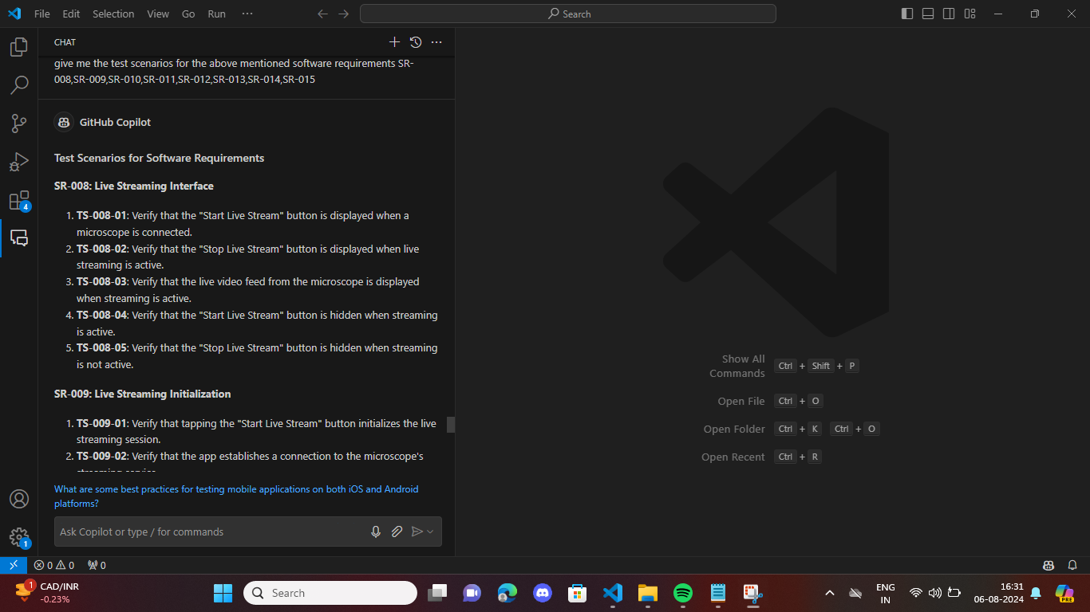

give me the test scenarios for the above mentioned software requirements SR-016,SR-017,SR-018,SR-019,SR-020,SR-021,SR-022,SR-023

Test Scenarios for Software Requirements  
  
SR-016: Capture Image from Live Stream  
**1. TS-016-01: Verify that the "Capture Image" button is available during live streaming.  
2. TS-016-02: Verify that an image is captured and saved to the device's gallery when the "Capture Image" button is pressed.  
3. TS-016-03: Verify that the user receives a notification when the image is successfully captured and saved.  
4. TS-016-04: Verify that an appropriate error message is displayed if the image capture fails.**SR-017: Record Video from Live Stream  
**1. TS-017-01: Verify that "Start Recording" and "Stop Recording" buttons are available during live streaming.  
2. TS-017-02: Verify that a video recording starts when the "Start Recording" button is pressed.  
3. TS-017-03: Verify that the video recording stops and is saved to the device's gallery when the "Stop Recording" button is pressed.  
4. TS-017-04: Verify that the user receives notifications when the video recording starts and stops successfully.  
5. TS-017-05: Verify that an appropriate error message is displayed if the video recording fails.**SR-018: Image and Video Quality  
**1. TS-018-01: Verify that captured images are saved in high resolution.  
2. TS-018-02: Verify that recorded videos are saved in high definition.  
3. TS-018-03: Verify that the user can configure the quality settings for images and videos.**  
SR-019: Storage Management  
**1. TS-019-01: Verify that the app checks for available storage space before capturing images.  
2. TS-019-02: Verify that the app checks for available storage space before recording videos.  
3. TS-019-03: Verify that the user receives a notification if there is insufficient storage space.  
4. TS-019-04: Verify that the app provides options to manage and delete captured images and recorded videos.**  
  
SR-020: User Feedback and Notifications  
**1. TS-020-01: Verify that the app displays notifications for successful image capture.  
2. TS-020-02: Verify that the app displays notifications for successful video recording.  
3. TS-020-03: Verify that the app provides clear and concise error messages with possible actions for the user.  
4. TS-020-04: Verify that the app uses standard notification mechanisms for both iOS and Android platforms.**  
SR-021: Security and Permissions  
**1. TS-021-01: Verify that the app requests storage permissions during installation or first launch.  
2. TS-021-02: Verify that the app handles permission denial gracefully and informs the user of required permissions.  
3. TS-021-03: Verify that captured images and recorded videos are stored securely.**  
SR-022: Cross-Platform Compatibility  
**1. TS-022-01: Verify that the app functions correctly on the latest versions of iOS.  
2. TS-022-02: Verify that the app functions correctly on the latest versions of Android.  
3. TS-022-03: Verify that the app supports a range of device screen sizes and orientations.  
4. TS-022-04: Verify that the app passes platform-specific guidelines and requirements for both iOS and Android.**  
SR-023: Connection Management  
**1. TS-023-01: Verify that the app maintains the connection to the microscope during image capture.  
2. TS-023-02: Verify that the app maintains the connection to the microscope during video recording.  
3. TS-023-03: Verify that the app detects and notifies the user if the connection is lost during image capture.  
4. TS-023-04: Verify that the app detects and notifies the user if the connection is lost during video recording.  
5. TS-023-05: Verify that the app provides an option to retry the connection or stop the operation if the connection is lost**.  
  
These test scenarios cover the various aspects of the software requirements to ensure that the application meets the specified functionalities and provides a seamless user experience.

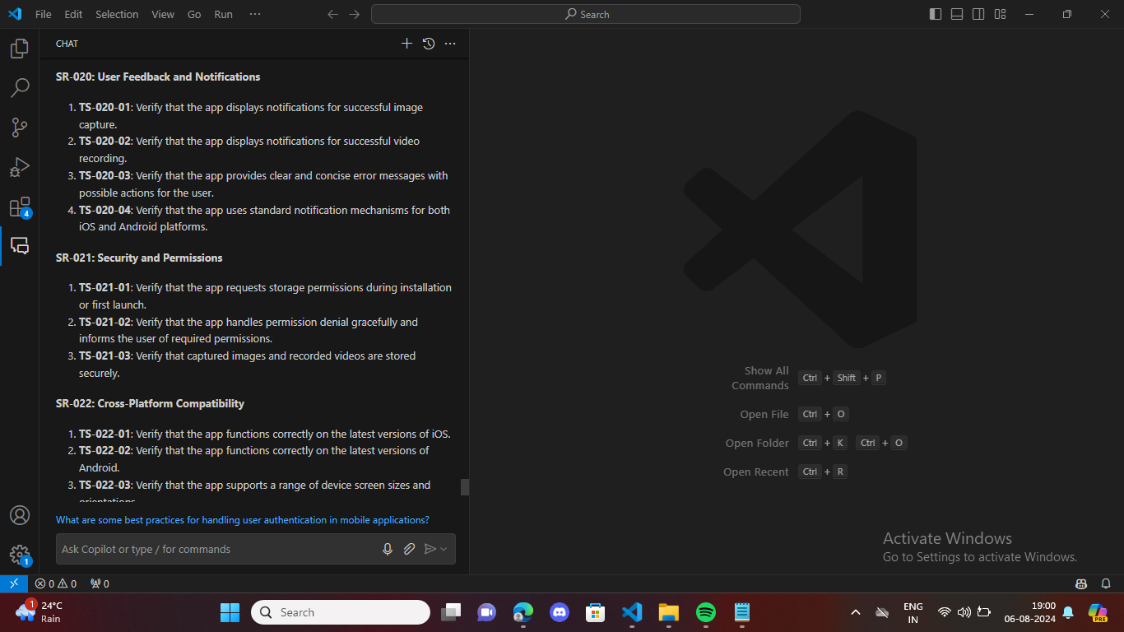

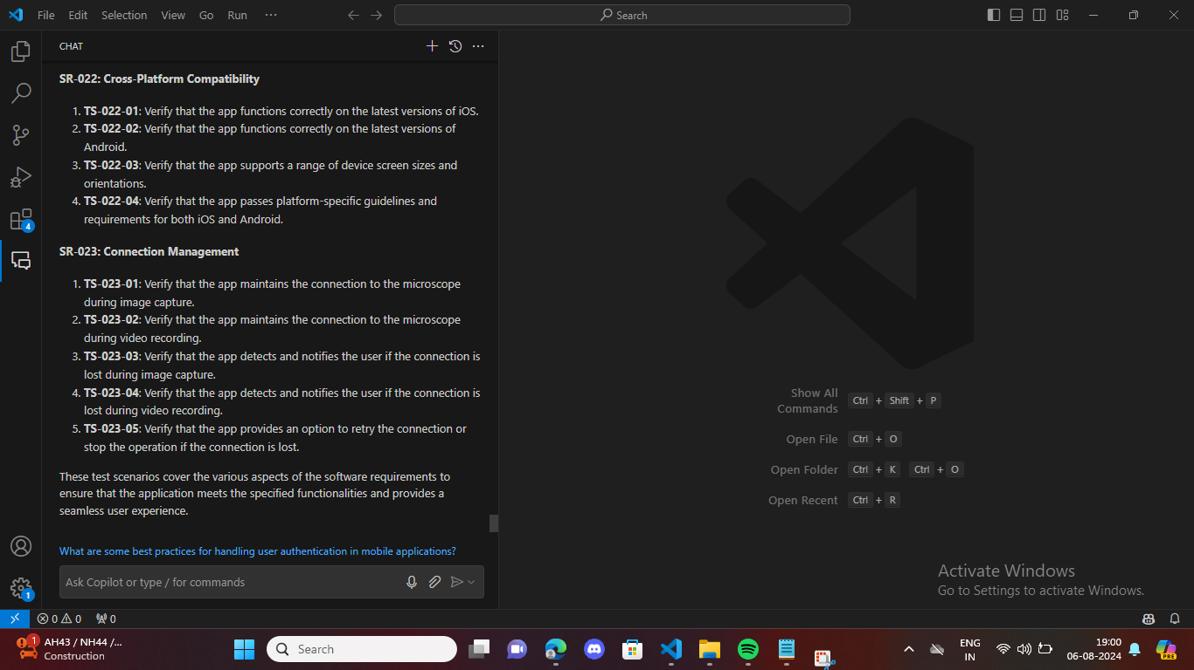

Give me the test scenarios for the above mentioned software requirements SR-001,SR-002,SR-003,SR-004,SR-005,SR-006,SR-007,SR-008

**Test Scenarios for Software Requirements**

SR-001: User Authentication

1. **TS-001-01: Verify that the login screen displays fields for username and password.**
2. **TS-001-02: Verify that the app validates the entered credentials against the cloud service.**
3. **TS-001-03: Verify that an error message is displayed if the credentials are invalid.**
4. **TS-001-04: Verify that the user can log in successfully with valid credentials**.

SR-002: Third-Party Authentication

1. **TS-002-01: Verify that the login screen provides options for third-party authentication (e.g., Google, Facebook, Apple).**
2. **TS-002-02: Verify that the app handles the authentication flow for Google login.**
3. **TS-002-03: Verify that the app handles the authentication flow for Facebook login.**
4. **TS-002-04: Verify that the app handles the authentication flow for Apple login.**
5. **TS-002-05: Verify that the app retrieves and stores the necessary authentication tokens for third-party logins.**

SR-003: Secure Communication

1. **TS-003-01: Verify that the app uses HTTPS for all communication with the cloud services.**
2. **TS-003-02: Verify that the app handles SSL/TLS certificates properly.**
3. **TS-003-03: Verify that sensitive data is encrypted during transmission.**

SR-004: Session Management

1. **TS-004-01: Verify that the app stores session tokens securely on the device.**
2. **TS-004-02: Verify that the app handles session expiration and prompts the user to re-login if necessary.**
3. **TS-004-03: Verify that the app provides a logout option to terminate the session.**

SR-005: Error Handling and Notifications

1. **TS-005-01: Verify that the app displays error messages for failed login attempts.**
2. **TS-005-02: Verify that the app provides clear instructions for resolving login issues.**
3. **TS-005-03: Verify that the app handles network errors gracefully and informs the user.**

SR-006: User Interface

1. **TS-006-01: Verify that the login screen is clean and intuitive.**
2. **TS-006-02: Verify that the app provides visual feedback during the login process (e.g., loading indicators).**
3. **TS-006-03: Verify that the app supports accessibility features (e.g., screen readers, high contrast).**

SR-007: Cross-Platform Compatibility

1. **TS-007-01: Verify that the app functions correctly on the latest versions of iOS.**
2. **TS-007-02: Verify that the app functions correctly on the latest versions of Android.**
3. **TS-007-03: Verify that the app supports a range of device screen sizes and orientations.**
4. **TS-007-04: Verify that the app passes platform-specific guidelines and requirements for both iOS and Android.**

SR-008: Security and Permissions

1. **TS-008-01: Verify that the app requests permissions for internet access.**
2. **TS-008-02: Verify that the app handles permission denial gracefully and informs the user of required permissions.**
3. **TS-008-03: Verify that user credentials are stored securely.**

These test scenarios cover the various aspects of the software requirements to ensure that the application meets the specified functionalities and provides a secure and seamless user experience.



