Table of Contents

Requirement 1

Tech stack 1

Architecture Diagram 2

Service details 2

Data model/ER diagram 2

UI/UX 3

API Documentation 5

# Requirement

Build Maveric Connect web application that has following features:

* 1. Login, Signup, Update Profile, Signout
  2. Create, view, update, delete posts
  3. Create, view, update, delete comments
  4. Create, view, update, delete likes

# Tech stack

|  |  |  |
| --- | --- | --- |
| **Application component** | **Tech stack** | **Comment** |
| Front end | Angular/ReactJs |  |
| Backend | Java Springboot |  |
| Architecture | Microservice based architecture |  |
| Springboot build tool | Maven |  |
| Source Code Management tools | Git, Github |  |
| Unit testing | Junit, Mockito |  |
| API Gateway | Spring Cloud Gateway |  |
| Service discovery | Eureka Server |  |
| Logging | ELK |  |
| API Security | JWT token |  |
| Database | MySQL, MongoDb |  |
| Static code analysis | SonarQube |  |
| Containerisation | Docker |  |
| API testing | Postman |  |
| IDE | IntelliJ CE, Visual Studio Code |  |

# Architecture Diagram

# Service details

Below table contains the list of microservices and web application that needs to be implemented. Make sure that the service/application name and port number are as mentioned in the below table

|  |  |  |  |
| --- | --- | --- | --- |
| Service name | Port number | Git repo name | Comment |
| authentication-authorization-service | 3000 | authentication-authorization-service | Service for authentication and authorisation |
| user-service | 3005 | user-service | Service for user management |
| post-service | 3010 | post-service | Service for managing posts |
| comment-service | 3015 | comment-service | Service for managing comments |
| like-service | 3020 | like-service | Service for managing likes |
| eureka-service | 8761 | eureka-service | Eureka service for service discovery |
| gateway-service | 8000 | gateway-service | Service for cloud gateway |
| maveric-connect-webapp | 8080 | maveric- connect-webapp | Angular/React web application |

# Data model/ER diagram

# UI/UX

|  |  |
| --- | --- |
| Color code for footer and buttons | #214e8f |
| Header logo file name | maveric-logo-updated.png |
| Footer logo image name | maveric-logo-white.png |
| Font family | Roboto |

# 

User Journey:

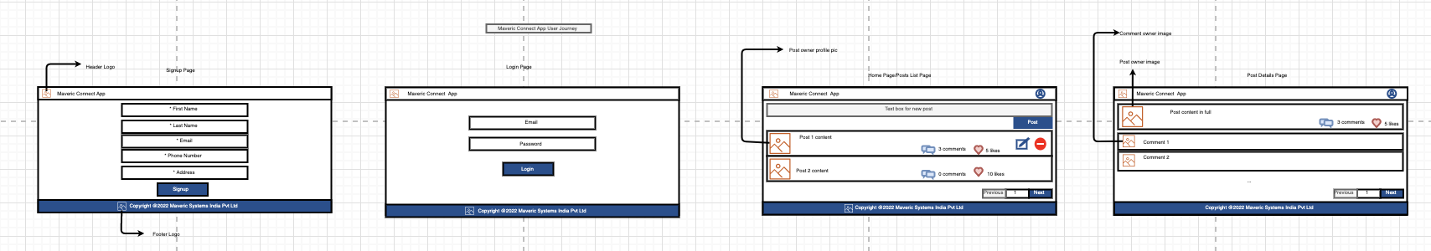

# API Documentation

Refer the swagger file for API definition