Table of Contents

Requirement 1

Tech stack 1

Architecture Diagram 2

Service details 2

Data model/ER diagram 2

UI/UX 3

API Documentation 5

# Requirement

Build a web application using Angular/ReactJS/VueJS for the Maveric bank customers so that they can manage their account information i.e, customer name, account id, balance and transaction information.

UI must look exactly same as mentioned in the below wireframe and all the necessary APIs must be implemented as per the given swagger file.

[Link to swagger]

# Tech stack

Below are the tech stack that we will be using in order to build our application

|  |  |  |
| --- | --- | --- |
| **Application component** | **Tech stack** | **Comment** |
| Front end | Angular/ReactJs/VueJs |  |
| Backend | Java 17  Springboot - |  |
| Architecture | Microservice based architecture |  |
| Springboot build tool | Maven |  |
| Source Code Management tools | Git, Github |  |
| Unit testing | Junit, Mockito |  |
| API Gateway | Spring Cloud Gateway |  |
| Service discovery | Eureka Server |  |
| Logging | SLF4J/Lombok |  |
| API Security | JWT token |  |
| Database | MongoDb |  |
| Static code analysis | SonarQube |  |
| Containerisation | Docker, DockerCompose |  |
| API testing | Postman |  |
| IDE | IntelliJ CE, Visual Studio Code |  |

# Architecture Diagram

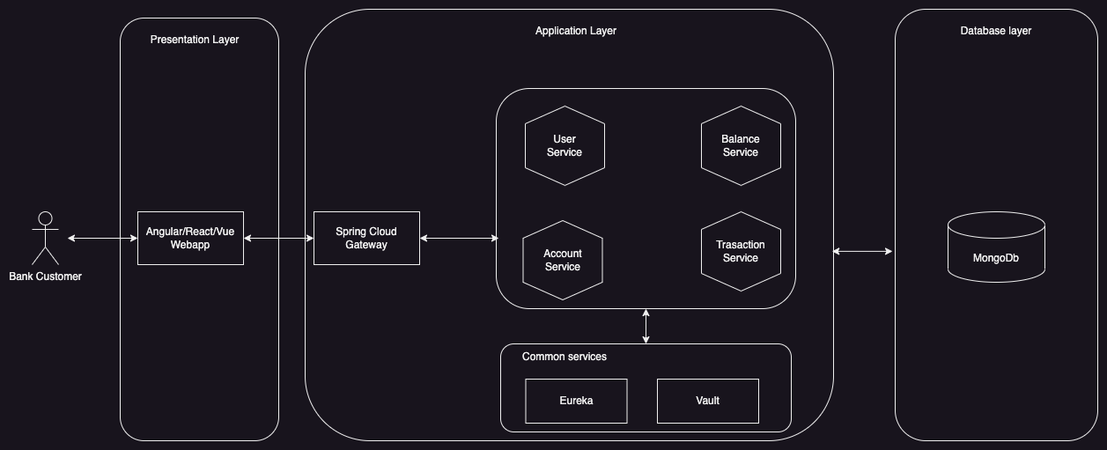

# Service details

Below table contains the list of microservices and web application that needs to be implemented. Make sure that the service/application name and port number are as mentioned in the below table

|  |  |  |  |
| --- | --- | --- | --- |
| Service name | Port number | Git repo name | Comment |
| user-service | 3005 | user-service | Service for user management |
| account-service | 3010 | account-service | Service for managing accounts |
| balance-service | 3015 | balance-service | Service for managing balances |
| transaction-service | 3020 | transaction-service | Service for managing transactions |
| eureka-service | 8761 | eureka-service | Eureka service for service discovery |
| gateway-service | 8000 | gateway-service | Service for cloud gateway |
| maveric-bank-webapp | 8080 | maveric- bank-webapp | Angular/ReactJs/VueJs web application |

# Data model/ER diagram

# UI/UX

|  |  |
| --- | --- |
| Color code for footer and buttons | #214e8f |
| Header logo file name | maveric-logo-updated.png |
| Footer logo image name | maveric-logo-white.png |
| Font family | Roboto |

# API Documentation

Refer the swagger file for API definition