The go1 motion program is automatically triggered after power on. If you want the robot to power on without triggering the motion program (or don't want the robot to stand up on its own) you need to do the following：

1. Access to the robot's pi system, either through ssh or by connecting to a monitor
2. Access the following paths： ~/Unitree/autostart/triggerSport
3. The triggersport.sh script file is the trigger program, let's rename it as follows

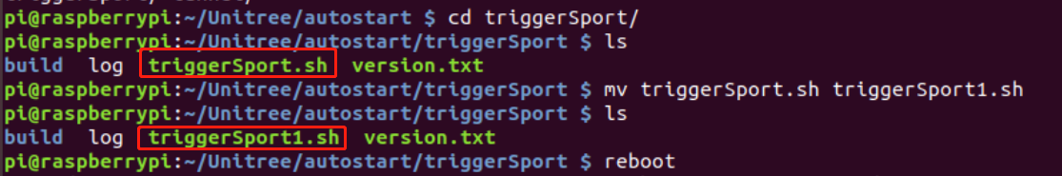

1. Reboot
2. When you turn the robot on again you will find that it will not stand up on its own.
3. If you want it to go into motion mode (or stand up) you need to press L1+Start on the remote control at the same time