.

**INTERNATIONAL SCHOOL**

**Project Name………..**

**Project Plan**

**Project Code:**

**Document Code: v.1.1**

**Mentor:** MSc. Thuan, Nguyen Trung

**Group:** …………. Team

1. SV 1…
2. SV 2…
3. …….

**Approved by**

**Project - Mentor:**

Name **Thuan, Nguyen Trung** Signature Date

**PROJECT INFORMATION**

|  |  |  |  |
| --- | --- | --- | --- |
| **Document Title** | Project Plan | | |
| **Lead Institution** | International School, Duy Tan University | | |
| **Project Mentor** | Msc. Thuan, Nguyen Trung | | |
| **Project Leader & contact details** | Trung, Dang Quang  Email: quangtrung061019@gmail.com  Tel: 0941981831 | | |
| **Partner Organization** |  | | |
| **Project Web URL** |  | | |
| **Team members** | Name | Email | Tel |
| Member, Product Owner | Trung, Dang Quang |  |  |
| Member | Trung, Luong Van |  |  |
| Member, Scrum master | Kiet, Nguyen Tuan |  |  |
| Member | Hieu, Le Nhu |  |  |

**SIGNATURE PAGE**

|  |  |  |
| --- | --- | --- |
| AUTHOR: | Kiet, Nguyen Tuan Scrum master | <Date> |
| REVIEWERS: | Trung, Dang Quang  Member | <Date> |
|  |  |  |
|  | Trung, Luong Van  Member | <Date> |
|  | Hieu, Le Nhu  Member | <Date> |
| MENTOR: | MSc. Thuan, Nguyen Trung  Mentor | <Date> |

**RECORD OF CHANGE**

*A - Added M - Modified D – Deleted

|  |  |  |  |
| --- | --- | --- | --- |
| **Effective Date** | **Changed Item** | **A* M, D** | **Change Description** |
| 26/08/2021 | Project plan | A | Create Project plan |
| 10/09/2021 | Agile/ Scrum Process | A | Add detail Scrum Process |
| 12/09/2021 | Detail Schedule | M | Update task mission and schedule of sprint |
| 20/09/2021 | Project Milestone & Deliverables | M | Modified target sprint |
| 23/09/2021 | WBS | A | Add WBS |
| 27/09/2021 | WBS | M | Modified WBS |

**Contents**

1. PROJECT OVERVIEW 8

1.1. Project Description 8

1.2. Scope and Purpose 8

1.2.1. Purpose 8

1.2.2. Scope 9

1.3. Project Objectives 9

1.3.1. Standard Objectives 9

1.3.2. Specific Objectives 10

1.4. Project Risk 10

2. PROJECT DEVELOPMENT APPROACH 12

2.1. Technical Process 12

2.1.1. Reasons for selecting 12

2.1.2. Agile Methodology 12

2.1.3. Scrum Process 13

2.2. Quality Management 14

2.2.1. Estimates of Defects to be detected 14

2.2.2. Measurements Program 16

2.3. Unit Testing Strategy 16

2.4. Integration Testing Strategy 17

2.5. System Testing Strategy 17

3. ESTIMATION 18

3.1. Effort 18

3.2. Schedule 19

3.2.1. *Project Milestone & Deliverables* 19

3.2.2. *Detailed Schedule* 20

3.3. Resource 43

3.4. Infrastructure 44

3.5. Training Plan 45

3.6. Finance 46

4. PROJECT ORGANIZATION 46

3.7. Organization Structure 47

3.8. Project Team 48

5. CONFIGURATION MANAGEMENT 55

6. SECURITY ASPECTS 56

7. REFERENCES 56

8. DEFINITIONS AND ACRONYMS 57

# PROJECT OVERVIEW

## Project Description

|  |  |  |  |
| --- | --- | --- | --- |
| **Project code** | CT E-learning | **Contract type** | Internal Contract |
| **Customer** | Dr. Man, Nguyen Duc | **End-user** | Subject teachers, Homeroom teachers,  school leaders, students  parents |
| **Project Type** | Internal Project | **Division** | C2SE.01 Team |
| **Project Category** | Development | **Scrum master** | Kiet Nguyen Tuan |
| **Application type** | Web application | **Business domain** | Support to solve the difficulties in controlling the learning situation of elementary students in the education sector |

## Scope and Purpose

### Purpose

This document provides a summary of the project objectives, tasks, milestones, resources required, overall timing and progress, and budget allocations used and based on owners. owned. Organic. object. Export documents to build secure online auction website applications on time, on request and on schedule.

### Scope

* Provide solutions to control students' learning situation as well as create an exciting learning environment when learning online, there are still many difficulties in interaction between parents and the school
* The focus of the project is to build the feature of a pair of friends to progress together, supporting each other in learning and development, creating excitement for students. Meanwhile, management functions are integrated to create the full picture of the application.
* The project will develop this system within 110 days with a budget of $5280 dollars for 4 members

## Project Objectives

### Standard Objectives

|  |  |  |  |
| --- | --- | --- | --- |
| **Metrics** | **Unit** | **Committed** | **Note** |
| Start Date | 15/08/2021 | Completed on time | 5 Springs of the Scrum Process. |
| End Date | 04/12/2021 |
| Duration | 110 days | can be completed sooner if possible |
| Team Size | 4 persons | Commit to enough members in the implementation process. | 4 dev:  2 back-end,  2 front-end,  1 data analysis |
| The number of working hours per member | 550 hours | each member works at least 4 hours per day | May work less on Sundays |
| Number of work hours per day for one engineer | 4.3 hours | at least 30 hours per week | will work overtime if not on schedule |

### Specific Objectives

* **Functional goals:** Meet the requirements from the school, students and parents.
* **Strategic goals:**
* Within half a year from the date of product launch, more than 50 primary schools must use and gain their trust and love.
* Within 1 year, the product will be developed on many platforms and will be applied to expand the product and reach 100 schools.
* Future goals of CTE-Learning are high reliability and popularity and passable by Booking.
* **Business goals:** Sales for the first year of a profitable product launch at an estimated cost of $82,100. Profits will continue to increase in the coming year.
* **Quality goals:** Minimize risks, limit errors arising.
* **Organizational goals:** Develop competencies, adopt new processes. Get familiar with cross-platform technologies.

## Project Risk

|  |  |  |  |  |
| --- | --- | --- | --- | --- |
| **Risk** | **Description** | **Probability** | **Impact** | **Mitigation Strategy** |
| **Security** | Hacked user information | 5 | 5 | Spend more time on security testing |
| **Performance** | The system is frozen for a short period of time | 5 | 5 | Spend a lot of time optimizing system integrations and testing on the server-cloud |
| **Security** | The projections are not uniform | 5 | 5 | Set the time for the system to back up data and receive notification-response |
| **Modifiability** | APIs often change in the future | 4 | 4 | Spend more time on maintenance and version updates |
| **Usability** | Users are unfamiliar with using CTE-Learning | 2 | 2 | the design will be simple and easy to understand, easy to use (can be based on the Booking page. |

# PROJECT DEVELOPMENT APPROACH

## Technical Process

* Operating System: Window
* Development Tools: Visual Studio Code,
* Version Control System: GitHub
* Language: JavaScript, Html/CSS
* Framework: ReactJS, Nodejs
* Database: Firebase

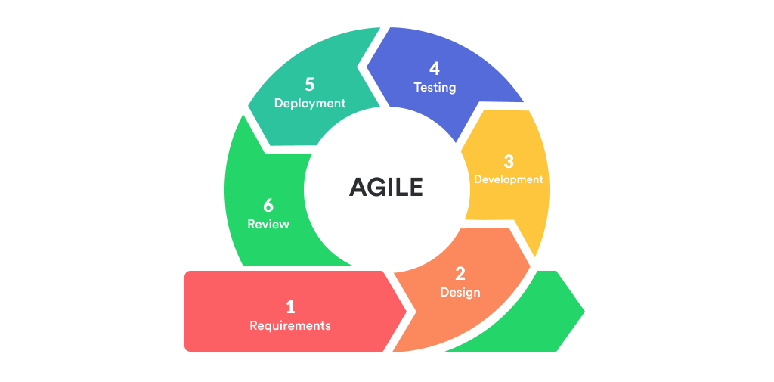 “***Agile Methodology- the SCRUM PROCESS”***

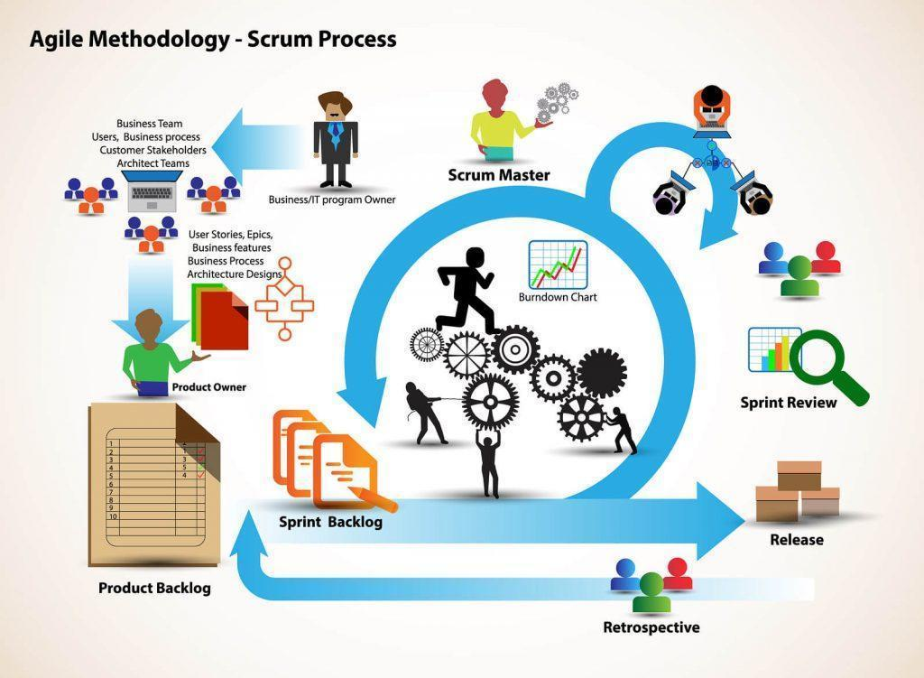



### Reasons for selecting

CTE-Learning is an educational web project that is constantly updated and regularly collects requests from stakeholders. Therefore, the SCRUM process is the most suitable method to apply project management because it is dynamic and flexible, easy to change, and makes it more convenient to manage project and team progress.

### Agile Methodology

* What is Agile Methodology?

Agile is an iterative approach to project management and software development that helps teams deliver value to their customers faster and with fewer headaches. Instead of betting everything on a "big bang" launch, an agile team delivers work in small, but consumable, increments. Requirements, plans, and results are evaluated continuously so teams have a natural mechanism for responding to change quickly.

* [Agile Manifesto](https://agilemanifesto.org/):
  + Individuals and interactions over processes and tools
  + Working software over comprehensive documentation
  + Working software over comprehensive documentation
  + Responding to change over following a plan
* Agile Life Cycle:
  + Project Initiation
  + Planning
  + Development
  + Production
  + Retirement

### Scrum Process

* Scrum is an iterative and incremental agile software development framework for managing software projects and product or application development.
* Scrum focuses on project management institutions where it is difficult to plan ahead.
* Mechanisms of empirical process control, where feedback loops that constitute the core management technique are used as opposed to traditional command- and-control management.
* Its approach to planning and managing projects is by bringing decision-making authority to the level of operation properties and certainties.
* Benefit of the methodology:
  + Project can respond easily to change.
  + Problems are identified early.
  + Customers get the most beneficial work first.
  + Work done will better meet the customer’s needs.
  + Improved productivity.
  + Ability to maintain a predictable schedule for delivery.

## Quality Management

### Estimates of Defects to be detected

**Pre-release review defects**

|  |  |  |
| --- | --- | --- |
| **Process** | **Planned found by review** | **Actual found by review** |
| **Requirement** | Not mentioned | NA |
| Requirement is not clear | NA |
| Complex requirements | Technology does not meet the problems of high complexity and related to user interests |
| Is changed | NA |
| **Design** | Rushed, not thorough | NA |
| Is changed | NA |
| Not user friendly | NA |
| **Coding** | Software complexity | NA |
| Poor documentation, not following the documentation | NA |
| Schedule pressure | NA |
| wrong code requires user | NA |
| Plain dumb mistakes | NA |
| **Total** | **12** | **1** |

### Measurements Program

|  |  |  |  |
| --- | --- | --- | --- |
| **Data to be collected** | **Purpose** | **Responsible** | **When** |
| Size: No. of KLOC// FP | Determine the cost of the project | SM | At the end of stages |
| Effort: 4 person/day | Estimate the amount of effort required to complete the project with inadequate, uncertain and no contradiction | Team members | Daily |
| Quality: No. defects detected | Identify causes of defects, improve processes to avoid repeating defects, improve product quality | Reviewer, Tester | Right after the review/test |
| Schedule | Complete the goal on time, meet the full working hours | SM | Weekly and at the end of stages |

## Unit Testing Strategy

The system is tested using Unit Testing, a testing technique that uses individual modules tested to determine if there are any problems caused by the developer himself. It is concerned with the functional correctness of the independent modules. And the project will be tested by the black box and white box technique of unit testing:

* Black Box Testing - Using which the user interface, input and output are tested.
* White Box Testing - used to test each one of those functions’ behaviors is tested.
* **Completion criteria:**

Acceptance criteria for product quality:

* User can register, login, logout successfully
* Users can post announcements about education-related activity
* Parents can view the student's score information, the timetable provided from the school
* Parents can contact teachers, schools.
* Students can take the test together through the class form
* **Influences might include:**
  + Need for non-test resources to support/participate in the test.
  + Need to have a personal computer connected to the network.
* **Testing may be stopped when:**
  + It becomes unproductive.
  + It requires a certain coverage.
  + It requires a certain number of errors to be found.
  + Schedule time runs out.

## Integration Testing Strategy

* The test is executed successfully when the combination of each module is unit tested and the functional test is combined. Once all the individual units are created and tested, we start combining the tested modules and start doing integration testing. The main goal here is to test the interfaces between units/modules.
* Testing may be stopped when:
* Out of funds
* Time up
* All test cases have been executed
* All defects have been fixed

## System Testing Strategy

* Tests performed successfully on a fully integrated system are based on an assessment of the system's compliance with its specific requirements.
* The test may be stopped when:
* Out of funds
* Time up
* All test cases have been executed
* All defects have been fixed

# ESTIMATION

## Effort

The Effort estimation is documented in **5040$**

|  |  |  |  |  |  |  |  |  |  |  |  |  |
| --- | --- | --- | --- | --- | --- | --- | --- | --- | --- | --- | --- | --- |
| **Activity/Process** | **Total budgeted Effort Usage (pd)** | **Total % budgeted Effort Usage (%)** | **<Stage 1/ Sprint 1>** | | **<Stage 2/ Sprint 2>** | | **<Stage 3 / sprint 3>** | | **<Stage 4/ sprint 4>** | | **<Stage 5/ sprint 5>** | |
| **No.** | **%** | **No.** | **%** | **No.** | **%** | **No.** | **%** | **No.** | **%** |
| Requirement | 252 | 5 % | 50.4 | 1% | 50.4 | 1% | 50.4 | 1% | 50.4 | 1% | 50.4 | 1% |
| Design | 252 | 5 % | 50.4 | 1% | 50.4 | 1% | 50.4 | 1% | 50.4 | 1% | 50.4 | 1% |
| Coding | 2520 | 50 % | 504 | 10% | 504 | 10% | 504 | 10% | 504 | 10% | 504 | 10% |
| Unit Testing | 252 | 5 % | 50.4 | 1% | 50.4 | 1% | 50.4 | 1% | 50.4 | 1% | 50.4 | 1% |
| Testing | 504 | 10% | 100.8 | 2% | 100.8 | 2% | 100.8 | 2% | 100.8 | 2% | 100.8 | 2% |
| Deployment | 151.2 | 3% | 30.24 | 0.6% | 30.24 | 0.6% | 30.24 | 0.6% | 30.24 | 0.6% | 30.24 | 0.6% |
| Support for Acceptance Test | 252 | 5% | 50.4 | 1% | 50.4 | 1% | 50.4 | 1% | 50.4 | 1% | 50.4 | 1% |
| Project Planning | 352.8 | 7% | 70.56 | 1.4% | 70.56 | 1.4% | 70.56 | 1.4% | 70.56 | 1.4% | 70.56 | 1.4% |
| Project monitoring | 100.8 | 2% | 20.16 | 0.4% | 20.16 | 0.4% | 20.16 | 0.4% | 20.16 | 0.4% | 20.16 | 0.4% |
| Quality Assurance | 252 | 5% | 50.4 | 1% | 50.4 | 1% | 50.4 | 1% | 50.4 | 1% | 50.4 | 1% |
| Training | 151.2 | 3% | 30.24 | 0.6% | 30.24 | 0.6% | 30.24 | 0.6% | 30.24 | 0.6% | 30.24 | 0.6% |
| **Total** | **5040** | **100%** | **1008** | **20%** | **1008** | **20%** | **1008** | **20%** | **1008** | **20%** | **1008** | **20%** |

## Schedule

### *Project Milestone & Deliverables*

|  |  |  |  |  |
| --- | --- | --- | --- | --- |
| **No.** | **Task name** | **Time** | **deliverables that belong to the Stage** | **Description** |
| 1 | Sprint 1 | 21 days | Interface, Create database | Release the first look of the product (version 1.0) with functions which have been committed in the contract |
| 2 | Sprint 2 | 21 days | Web, database design  (version 1.0) | Release the update for version 1.0 (version 1.1) with functions which have been approved by product owner |
| 3 | Sprint 3 | 28 days | Update  Web  (version 1.1, 1.2, ...) | Release the next update for version 1.1 (version 1.2) with functions which have been approved by product owner |
| 4 | Sprint 4 | 28 days | Update Web, Test (version 1.3,1.1,...) | Release updates of version 1.2 (version 1.3) through testing functions, systems, development via mobile app for Product Owner |

### *Detailed Schedule*

|  |  |  |  |  |  |
| --- | --- | --- | --- | --- | --- |
| **No** | **Task name** | **Duration (day(s))** | **Start** | **Finish** | **Resource names** |
| **1** | **Fit Style Mobile Application** | **110** | **15/8/2021** | **1/12/2021** | **All member** |
| **1.1** | **Initial** | **19** | **15/8/2021** | **2/9/2021** | **All member** |
| 1.1.1 | Project kick off meeting | 3 | 15/8/2021 | 17/8/2021 | All member |
| 1.1.2 | Discuss about project ideal | 6 | 18/8/2021 | 23/8/2021 | All member |
| 1.1.3 | Create Proposal document | 1 | 24/8/2021 | 24/8/2021 | All member |
| 1.1.4 | Create User Story document | 1 | 25/8/2021 | 25/8/2021 | All member |
| 1.1.5 | Create User Interface document | 1 | 26/8/2021 | 26/8/2021 | All member |
| 1.1.6 | Create Database document | 1 | 26/8/2021 | 26/8/2021 | All member |
| 1.1.8 | Create Product Backlog document | 1 | 28/8/2021 | 28/8/2021 | All member |
| 1.1.9 | Create Project Plan document | 2 | 29/8/2021 | 30/8/2021 | All member |
| 1.1.10 | Create Architecture document | 1 | 31/8/2021 | 31/8/2021 | All member |
| 1.1.11 | Pre-study | 2 | 1/9/2021 | 2/9/2021 | All member |
| **1.2** | **Development** | **98** | **3/9/2021** | **1/12/2021** | **All member** |
| **1.2.1** | **Sprint 1** | **21** | **26/8/2021** | **15/9/2021** | **All member** |
| **1.2.1.1** | **Sprint planning meeting** | **1** | **26/8/2021** | **26/8/2021** | **All member** |
| **1.2.1.2** | **Create Sprint Backlog for Sprint 1** | **1** | **26/8/2021** | **26/8/2021** | **All member** |
| **1.2.1.3** | **Create Test Plan document for Sprint 1** | **1** | **26/8/2021** | **26/8/2021** | **All member** |
| **1.2.1.4** | **Design UI** | **1** | **27/8/2021** | **28/8/2021** | **Hieu, V.Trung** |
| 1.2.1.4.1 | UI for the register page | 1 | 27/8/2021 | 27/8/2021 | Hieu |
| 1.2.1.4.2 | UI for login, forgot password page, chanpassword | 1 | 27/8/2021 | 27/8/2021 | Hieu |
| 1.2.1.4.3 | UI for the home page the system | 1 | 28/8/2021 | 28/8/2021 | Hieu |
| 1.2.1.4.4 | UI home page for student, subject teacher, teacher, parent, school | 1 | 28/8/2021 | 28/8/2021 | V.Trung |
|  | UI for the profile | 1 | 28/8/2021 | 28/8/2021 | V.Trung |
| **1.2.1.5** | **Design Test case** | **4** | **29/8/2021** | **2/9/2021** | **Q.Trung, Kiet** |
| 1.2.1.5.1 | Design test case [Server/Backend] Register for student, teacher. | 1 | 29/8/2021 | 29/8/2021 | Q.Trung |
| 1.2.1.5.2 | Design test case [Server/Backend] Login for student, homeroom teacher, subject teacher, school leadership, parent. | 1 | 30/8/2021 | 30/8/2021 | Q.Trung |
| 1.2.1.5.3 | Design test case [Frontend] UI dashboard for student. | 1 | 31/8/2021 | 31/8/2021 | Kiet |
| 1.2.1.5.4 | Design test case [Server/Backend] Show users page | 1 | 2/9/2021 | 2/9/2021 | Kiet |
| **1.2.1.6** | **Code** | **7** | **3/9/2021** | **9/9/2021** | **All member** |
| 1.2.1.6.1 | [Server/Backend] [Server/backend] Register for student, homeroom teacher, subject teacher, school leadership, parent. | 2 | 3/9/2021 | 4/9/2021 | Hieu |
| 1.2.1.6.2 | [Server/Backend] Forgot password | 1 | 4/9/2021 | 4/9/2021 | Hieu |
| 1.2.1.6.3 | [Server/Backend] Login for student, homeroom teacher, subject teacher, school leadership, parent. | 2 | 5/9/2021 | 6/9/2021 | Hieu |
| 1.2.1.6.4 | [Server/Backend] profile for student, homeroom teacher, subject teacher, school leadership, parent. | 2 | 5/9/2021 | 6/9/2021 | Kiet |
| 1.2.1.6.5 | [Frontend] UI dashboard for student, homeroom teacher, subject teacher, school leadership, parent. | 2 | 6/9/2021 | 7/9/2021 | Kiet |
| 1.2.1.6.6 | [Frontend] Show users page for admin. | 2 | 5/9/2021 | 6/9/2021 | V.Trung |
| 1.2.1.6.7 | [Frontend] Show the profile | 2 | 8/9/2021 | 9/9/2021 | Q.Trung |
| **1.2.1.7** | **Testing** | **4** | **10/9/2021** | **13/9/2021** | **Hieu, Kiet** |
| 1.2.1.7.1 | Test [Server/Backend] Register for student, homeroom teacher, subject teacher, school leadership, parent. | 1 | 10/9/2021 | 10/9/2021 | Kiet |
| 1.2.1.7.2 | Test [Server/Backend] Login for student, homeroom teacher, subject teacher, school leadership, parent. | 1 | 11/9/2021 | 11/9/2021 | Kiet |
| 1.2.1.7.3 | Test [Frontend] home page student, homeroom teacher, subject teacher, school leadership, parent. | 1 | 11/9/2021 | 12/9/2021 | Hieu |
| 1.2.1.7.4 | Test [Server/Backend] Show profile for student, homeroom teacher, subject teacher, school leadership, parent. | 1 | 13/9/2021 | 13/9/2021 | Hieu |
| **1.2.1.8** | **Fix bug** | **5** | **10/9/2021** | **14/9/2021** | **All member** |
| **1.2.1.9** | **Re-testing** | **1** | **14/9/2021** | **14/9/2021** | **All member** |
| **1.2.1.10** | **Release Sprint 1** | **1** | **15/9/2021** | **15/9/2021** | **All member** |
| 1.2.1.10.1 | Sprint review meeting | 1 | 15/9/2021 | 15/9/2021 | All member |
| 1.2.1.10.2 | Retrospective | 1 | 15/9/2021 | 15/9/2021 | All member |
| **1.2.2** | **Sprint 2** | **21** | **16/09/2021** | **06/10/2021** | **All member** |
| **1.2.2.1** | **Sprint planning meeting** | **1** | 16/9/2021 | 16/9/2021 | **All member** |
| **1.2.2.2** | **Create Sprint Backlog for Sprint 2** | **1** | 16/9/2021 | 16/9/2021 | **All member** |
| **1.2.2.3** | **Create Test Plan document for Sprint 2** | **1** | 16/9/2021 | 16/9/2021 | **All member** |
| **1.2.2.4** | **Design UI** | **4** | **17/9/2021** | **20/9/2021** | **Q.Trung, Kiet** |
| 1.2.2.4.1 | UI for the teamword | 2 | 17/9/2021 | 18/9/2021 | Q.Trung |
| 1.2.2.4.2 | UI for the schedule | 1 | 18/9/2021 | 18/9/2021 | Q.Trung |
| 1.2.2.4.3 | UI for the quiz&test ( homeroom teacher, subject teacher) | 1 | 19/9/2021 | 19/9/2021 | Q.Trung |
| 1.2.2.4.4 | UI for the conversation | 1 | 20/9/2021 | 20/9/2021 | Kiet |
| 1.2.2.4.5 | UI for the receive notification | 1 | 20/9/2021 | 20/9/2021 | Kiet |
| 1.2.2.4.6 | UI for edit profile | 1 | 20/9/2021 | 20/9/2021 | Kiet |
| **1.2.2.5** | **Design Test case** | **2** | **20/9/2021** | **21/9/2021** | **All member** |
| 1.2.2.5.1 | Design test case [Frontend] UI for the teamword | 1 | 20/9/2021 | 20/9/2021 | Hieu |
| 1.2.2.5.2 | Design test case [Frontend] UI for the schedule | 1 | 20/9/2021 | 20/9/2021 | Hieu |
| 1.2.2.5.3 | Design test case [Frontend] UI for show the quiz&test (homeroom teacher, subject teacher) | 1 | 20/9/2021 | 20/9/2021 | V.Trung |
| 1.2.2.5.4 | Design test case [Frontend] UI for edit profile | 1 | 20/9/2021 | 20/9/2021 | V.Trung |
| 1.2.2.5.5 | Design test case [Frontend] UI for the receive notification | 1 | 20/9/2021 | 20/9/2021 | Hieu |
| 1.2.2.5.6 | Design test case [Server/Backend] for quiz&test | 1 | 20/9/2021 | 20/9/2021 | Kiet |
| 1.2.2.5.7 | Design test case [Server/Backend] for the teamwork | 1 | 20/9/2021 | 20/9/2021 | Q.Trung |
| 1.2.2.5.8 | Design test case [Server/Backend] for the receive notification | 1 | 20/9/2021 | 20/9/2021 | Q.Trung |
| 1.2.2.5.9 | Design test case [Server/Backend] Edit profile | 1 | 21/9/2021 | 21/9/2021 | V.Trung |
| **1.2.2.6** | **Code** | **6** | **22/9/2021** | **27/9/2021** | **All member** |
| 1.2.2.6.1 | [Frontend] UI for show the schedule (student, homeroom teacher, subject teacher, school leadership, parent) | 3 | 22/9/2021 | 24/9/2021 | Kiet |
| 1.2.2.6.2 | [Frontend] UI for teamword (student) | 3 | 24/9/2021 | 26/9/2021 | Kiet |
| 1.2.2.6.3 | [Frontend] UI for conversation | 3 | 25/9/2021 | 27/9/2021 | Kiet |
| 1.2.2.6.4 | [Frontend] UI for receive notification | 3 | 22/9/2021 | 24/9/2021 | Hieu |
| 1.2.2.6.5 | [Frontend] UI for detail page to edit profile (student, homeroom teacher, subject teacher, school leadership, parent.) | 3 | 22/9/2021 | 24/9/2021 | Q.Trung |
| 1.2.2.6.6 | [Server/Backend] teamword | 3 | 22/9/2021 | 24/9/2021 | V.Trung |
| 1.2.2.6.7 | [Server/Backend] Edit profile | 3 | 25/9/2021 | 27/9/2021 | V.Trung |
| 1.2.2.6.8 | [Server/Backend] receive notification | 4 | 24/9/2021 | 26/9/2021 | Hieu |
| 1.2.2.6.9 | [Server/Backend] Show detail page to edit profile (student, homeroom teacher, subject teacher, school leadership, parent.) | 3 | 25/9/2021 | 27/9/2021 | Q.Trung |
| **1.2.2.7** | **Testing** | **5** | **28/9/2021** | **1/10/2021** | **All member** |
| 1.2.2.7.1 | Test [Server/Backend] the teamword | 1 | 28/9/2021 | 28/9/2021 | Hieu |
| 1.2.2.7.2 | Test [Server/Backend] for the schedule | 1 | 29/9/2021 | 29/9/2021 | Hieu |
| 1.2.2.7.3 | Test [Server/Backend] for the quiz&test | 4 | 29/9/2021 | 01/10/2021 | Hieu |
| 1.2.2.7.4 | Test [Server/Backend] receive notification | 2 | 28/9/2021 | 29/9/2021 | V.Trung |
| 1.2.2.7.5 | Test [Server/Backend] edit profile to the system | 4 | 29/9/2021 | 01/10/2021 | V.Trung |
| 1.2.2.7.6 | Test [Server/Backend] Update password (student, homeroom teacher, subject teacher, school leadership, parent.) | 3 | 28/9/2021 | 30/9/2021 | Kiet |
| **1.2.2.8** | **Fix bug** | **3** | **2/10/2021** | **4/10/2021** | **All member** |
| **1.2.2.9** | **Re-testing** | **1** | **5/10/2021** | **5/10/2021** | **All member** |
| **1.2.2.10** | **Release Sprint 2** | **1** | **6/10/2021** | **6/10/2021** | **All member** |
| 1.2.2.10.1 | Sprint review meeting | 1 | 6/10/2021 | 6/10/2021 | All member |
| 1.2.2.10.2 | Retrospective | 1 | 6/10/2021 | 6/10/2021 | All member |
| **1.2.3** | **Sprint 3** | **28** | **7/10/2021** | **3/11/2021** | **All member** |
| **1.2.3.1** | **Sprint planning meeting** | **1** | **7/10/2021** | **7/10/2021** | **All member** |
| **1.2.3.2** | **Create Sprint Backlog for Sprint 3** | **1** | **7/10/2021** | **7/10/2021** | **All member** |
| **1.2.3.3** | **Create Test Plan document for Sprint 3** | **1** | **7/10/2021** | **7/10/2021** | **All member** |
| **1.2.3.4** | **Design UI** | **2** | **08/10/2021** | **09/10/2021** | **All member** |
| 1.2.3.4.1 | UI for post announcements (school leadership) | 1 | 8/10/2021 | 8/10/2021 | Kiet |
| 1.2.3.4.2 | UI for the post information of the ministry | 1 | 08/10/2021 | 08/10/2021 | Kiet |
| 1.2.3.4.3 | UI for update learning results | 1 | 08/10/2021 | 08/10/2021 | V.Trung |
| 1.2.3.4.4 | UI for the online attendace | 1 | 09/10/2021 | 09/10/2021 | Hieu |
| 1.2.3.4.5 | UI for the summary of subject rankings | 1 | 09/10/2021 | 09/10/2021 | Q.Trung |
| **1.2.3.5** | **Design Test case** | **4** | **10/10/2021** | **13/10/2021** | **All member** |
| 1.2.3.5.1 | Design test case [Frontend] UI for post announcements | 1 | 10/10/2021 | 10/10/2021 | Kiet |
| 1.2.3.5.2 | Design test case [Frontend] UI for the post information of the ministry | 2 | 10/10/2021 | 11/10/2021 | Kiet |
| 1.2.3.5.3 | Design test case [Frontend] UI for update learning results | 1 | 12/10/2021 | 12/10/2021 | Kiet |
| 1.2.3.5.4 | Design test case  [Server/Backend] online attendance | 1 | 12/10/2021 | 12/10/2021 | Hieu |
| 1.2.3.5.5 | Design test case [Server/Backend] summary of subject rankings. | 1 | 13/10/2021 | 13/10/2021 | Q.Trung |
| **1.2.3.6** | **Code** | **7** | **14/10/2021** | **20/10/2021** | **All member** |
| 1.2.3.6.1 | [Frontend] online attendace (student) | 3 | 14/10/2021 | 16/10/2021 | Kiet |
| 1.2.3.6.2 | [Frontend] summary of subject rankings | 3 | 16/10/2021 | 18/10/2021 | Kiet |
| 1.2.3.6.3 | [Frontend] UI for update learning results | 4 | 14/10/2021 | 17/10/2021 | Hieu |
| 1.2.3.6.4 | [Frontend] UI for online attendace(homeroom teacher, subject teacher | 3 | 18/10/2021 | 20/10/2021 | Hieu |
| 1.2.3.6.5 | [Frontend] UI for summary of subject rankings | 3 | 15/10/2021 | 17/10/2021 | Q.Trung |
| 1.2.3.6.6 | [Server/Backend] post announcements | 3 | 18/10/2021 | 20/10/2021 | Q.Trung |
| 1.2.3.6.7 | [Server/Backend] post information of the ministry | 4 | 15/10/2021 | 18/10/2021 | V.Trung |
| 1.2.3.6.8 | [Server/Backend] update learning results | 1 | 18/10/2021 | 20/10/2021 | V.Trung |
| 1.2.3.6.9 | [Server/Backend] online attendace (student, homeroom teacher, subject teacher.) | 1 | 18/10/2021 | 20/10/2021 | Kiet |
| 1.2.3.6.10 | [Server/Backend] summary of subject rankings | 1 | 16/10/2021 | 20/10/2021 | Q.Trung |
| **1.2.3.7** | **Testing** | **3** | **21/10/2021** | **23/10/2021** | **All member** |
| 1.2.3.7.1 | Test [Server/Backend] post announcements | 1 | 21/10/2021 | 21/10/2021 | Hieu |
| 1.2.3.7.2 | Test [Server/Backend] update learning results | 1 | 21/10/2021 | 21/10/2021 | Kiet |
| 1.2.3.7.3 | Test [Server/Backend] online attendace | 1 | 21/10/2021 | 21/10/2021 | Kiet |
| 1.2.3.7.4 | Test [Server/Backend] summary of subject rankings | 1 | 22/10/2021 | 22/10/2021 | Hieu |
| 1.2.3.7.5 | Test [Frontend] post announcements | 1 | 21/10/2021 | 21/10/2021 | V.Trung |
| 1.2.3.7.6 | Test [Frontend] update learning results | 1 | 23/10/2021 | 23/10/2021 | Q.Trung |
| **1.2.3.8** | **Fix bug** | **5** | **25/10/2021** | **29/10/2021** | **All member** |
| **1.2.3.9** | **Re-testing** | **4** | **30/11/2021** | **2/11/2021** | **All member** |
| **1.2.3.10** | **Release Sprint 3** | **1** | **3/10/2021** | **3/10/2021** | **All member** |
| 1.2.3.10.1 | Sprint review meeting | 1 | 03/11/2021 | 03/11/2021 | All member |
| 1.2.3.10.2 | Retrospective | 1 | 03/11/2021 | 03/11/2021 | All member |
| **1.2.4** | **Sprint 4** | **28** | **04/11/2021** | **01/12/2021** | **All member** |
| **1.2.4.1** | **Sprint planning meeting** | **1** | **03/11/2021** | **03/11/2021** | **All member** |
| **1.2.4.2** | **Create Sprint Backlog for Sprint 4** | **1** | **03/11/2021** | **03/11/2021** | **All member** |
| **1.2.4.3** | **Create Test Plan document for Sprint 4** | **1** | **03/11/2021** | **03/11/2021** | **All member** |
| **1.2.4.4** | **Design UI** | **1** | **04/11/2021** | **04/11/2021** | **Hieu, Hien** |
| 1.2.4.4.1 | UI for take a day off | 1 | 04/11/2021 | 04/11/2021 | Kiet |
| 1.2.4.4.2 | UI for the update assessment | 1 | 04/11/2021 | 04/11/2021 | Kiet |
| 1.2.4.4.3 | UI for the send notifications to student | 1 | 04/11/2021 | 04/11/2021 | Kiet |
| **1.2.4.5** | **Design Test case** | **2** | **04/11/2021** | **05/11/2021** | **All member** |
| 1.2.4.5.1 | Design Test case[Frontend] Detail page to edit profile for student. | 1 | 04/11/2021 | 04/11/2021 | Kiet |
| 1.2.4.5.2 | Design Test case [Server/Backend] Update password for student, homeroom teacher, subject teacher, school leadership, parent. | 1 | 04/11/2021 | 04/11/2021 | Kiet |
| 1.2.4.5.3 | Design Test case [Fronted] take a day off | 1 | 04/11/2021 | 04/11/2021 | V.Trung |
| 1.2.4.5.4 | Design Test case [Frontend] update assessment | 1 | 05/11/2021 | 05/11/2021 | Hieu |
| 1.2.4.5.5 | Design Test case [Server/Backend] send notifications to student | 1 | 05/11/2021 | 05/11/2021 | Q.Trung |
| **1.2.4.6** | **Code** | **7** | **06/11/2021** | **12/11/2021** | **All member** |
| 1.2.4.6.1 | [Frontend] Detail page to take a day off | 1 | 06/11/2021 | 08/11/2021 | Kiet |
| 1.2.4.6.2 | [Server/Backend] Update update assessment homeroom teacher, subject teacher | 1 | 08/11/2021 | 10/11/2021 | Kiet |
| 1.2.4.6.3 | [Server/Backend] send notifications to student | 1 | 06/11/2021 | 09/11/2021 | V.Trung |
| 1.2.4.6.4 | [Frontend] UI for the take a day off. | 1 | 06/11/2021 | 09/11/2021 | Hieu |
| 1.2.4.6.5 | [Frontend] for the update assessment | 1 | 09/11/2021 | 11/11/2021 | Hieu |
| 1.2.4.6.6 | [Server/Backend] send notifications to studentreceiver. | 1 | 06/11/2021 | 11/11/2021 | Q.Trung |
| **1.2.4.7** | **Testing** | **4** | **13/11/2021** | **16/11/2021** | **All member** |
| 1.2.4.7.1 | Test [Server/Backend] Update assessment homeroom teacher, subject teacher | 1 | 13/11/2021 | 13/11/2021 | V.Trung |
| 1.2.4.7.2 | Test [Server/Backend] Update quiz test | 1 | 14/11/2021 | 14/11/2021 | V.Trung |
| 1.2.4.7.3 | Test [Server/Backend] update assessment | 1 | 14/11/2021 | 14/11/2021 | Kiet |
| 1.2.4.7.4 | Test [Server/Backend] send notifications to student receiver. | 1 | 15/11/2021 | 15/11/2021 | Hieu |
| 1.2.4.7.5 | Test [Frontend] UI for the take a day off. | 1 | 16/11/2021 | 16/11/2021 | Hieu |
| 1.2.4.7.6 | Test [Frontend] send notifications to student receiver. | 1 | 16/11/2021 | 16/11/2021 | Q.Trung |
| **1.2.4.8** | **Fix bug** | **4** | **17/11/2021** | **20/11/2021** | **All member** |
| **1.2.4.9** | **Re-testing** | **3** | **21/11/2021** | **23/11/2021** | **All member** |
| **1.2.4.10** | **Release Sprint 4** | **1** | **24/11/2021** | **24/11/2021** | **All member** |
| 1.2.4.10.1 | Sprint review meeting | 1 | 24/11/2021 | 24/11/2021 | **All member** |
| 1.2.4.10.2 | Retrospective | 1 | 24/11/2021 | 24/11/2021 | **All member** |
| **1.3** | **Project ‘s meeting** | **3** | **28/11/2021** | **30/11/2021** | **All member** |
| **1.4** | **Final Release** | **1** | **1/12/2021** | **1/12/2021** | **All member** |

* + 1. **Project Schedule**

|  |  |  |  |  |
| --- | --- | --- | --- | --- |
| **No.** | **Activity** | **Start date** | **Responsible** | **Note** |
| **Defect Prevention** | | | | |
| 1 | Software Requirements Analysis | August 15, 21 | Quang Trung, Kiet | Collect and analyze actual requirements. Select requirements that can be developed by the technique. |
| 2 | Reviews: Self-Review and Peer Review | August 18, 21 | All team member | Face-to-face meetings, project evaluation through other large project platforms that already have similar functions. |
| 3 | Defect Logging and Documentation | August 21, 21 | Quang Trung, Kiet, Van Trung, Truong | Mining documents, dividing tasks and adding information to logs, saving sprints activities. |
| 4 | Root Cause Analysis and Preventive Measures Determination | Mar 18, 21 | Quang Trung, Kiet | Make hypothetical problems, collect real problems and needs from customers, assessors, propose specific solutions and select feasibility. |
| 5 | Embedding Procedures into Software Development Process | Mar 20, 21 | Kiet | Work on Agile- Scrum process, split 4 sprints, embed the process in the document and start working on the task. |
| **Quality Control** | | | | |
| 1 | Input Quality Control | November 3, 21 | Kiet | NA |
| 2 | Process Quality Control | November 10, 21 | Kiet | NA |
| 3 | Output Quality Control | December 4, 21 | Kiet | NA |
| **Project Tracking** | | | | |
| 1 | Proposal Preparation | August 15, 21 | Team, Mentor | Hold face-to-face meetings, analyze scope, requirements, feasibility, cost estimates.. of the project. |
| 2 | Present Proposal and Approval Project | August 22, 21 | Team, Mentor, CMU | CTE-Learning approved by Dr. Man. |
| 3 | Midterm Report | December 15, 21 | Team, Mentor, CMU | Organize live mid-stage project reviews, progress tracking, and product demo reviews. |
| 4 | Final Submission | December 25, 21 | Team | Check all documents and packaging, wait for approval and print hard copy. |
| **Configuration Management** | | | | |
|  |  | August 8, 21 | Trung | NA |
| **QA** | | | | |
| 1 | Final Inspection: Deliverable 1 | November 13, 21 | Team | NA |
| 2 | Final Inspection: Deliverable 2 | December 4, 21 | Team | NA |
| 3 | Baseline audit: Startup | August 6, 21 | Team | NA |
| 4 | Baseline audit: Wrap-up | December 25, 21 | Team | NA |

## Resource

|  |  |  |  |
| --- | --- | --- | --- |
| **Full Name** | **Phone** | **Email** | **Position** |
| Thuan, Nguyen Trung | 0905558758 | nguyentrungthuan@gmail.com | Mentor |
| Hieu, Le Nhu | 0774568239 | Lenhuhieu121@gmail.com | Member |
| Trung, Dang Quang | 0941981831 | quangtrung061019@gmail.com | Product Owner |
| Trung, Luong Van | 0905338174 | trung26081999@gmail.com | Member |
| Kiet, Nguyen Tuan | 0976459539 | nguyentuankiet0105 @gmail.com | Scrum Master |

## Infrastructure

|  |  |  |  |
| --- | --- | --- | --- |
| **Work/Product** | **Purpose** | **Expected Availability by** | **Note** |
| **Development Environment** | | | |
| Windows 10 | Operating System | Initiation stage |  |
| Firebase | Database | Construction stage |  |
| JavaScript | Development language for Web interface | Construction stage |  |
| GitHub | Host server | Construction stage |  |
| **Hardware & Software** | | | |
| 1GB space on server |  | Construction stage |  |
| lucid chart | Design context diagram | Construction stage |  |
| Enterprise Architect | Design Architecture | Construction stage |  |
| **Other Tools** | | | |
| Excel | Effort logging | Construction stage |  |
| Android Studio | IDE Test | Definition stage |  |

## Training Plan

|  |  |  |  |
| --- | --- | --- | --- |
| **Training Area** | **Participants** | **When, Duration** | **Waiver Criteria** |
| **Technical** | | | |
| JavaScript Language | All team | 7 days | Mandatory |
| JavaScript Applets | Kiet, Nguyen Tuan | 2 days | If already trained |
| Firebase | All team | 4 days | Mandatory |
| GitHub | All team | 4.5 hours | Mandatory |
| **Business domain** | | | |
| Banking | All team | 7 days |  |
| Process | | | |
| Quality system | Hieu, Le Nhu | 3 hours | If already trained |
| Configuration management | Trung | 2 hours | If already trained for  CC. For others, on-the- job training |
| Enterprise Architect | Van Trung | 4 hours | If already trained |
| Lucid chart | Trung | 4.5 hours | If already trained |
| RUP methodology | Kiet | 2 hours | Mandatory |

## Finance

|  |  |  |  |  |  |  |  |  |  |  |  |  |  |  |
| --- | --- | --- | --- | --- | --- | --- | --- | --- | --- | --- | --- | --- | --- | --- |
| **Item** | **Total Budget** | **%**  **Budget** | **Budget in Period** | | | | | | | | | | | |
| **W1**  **-**  **F**  **e**  **b** | **W2**  **-**  **M**  **a**  **r** | **W3**  **-**  **Ma**  **r** | **W4**  **-**  **Ma**  **r** | **W1**  **-**  **Ma**  **r** | **W2**  **-**  **Ap**  **t** | **W3**  **-**  **A**  **p**  **t** | **W4**  **-**  **A**  **p**  **t** | **W1**  **-**  **Ap**  **t** | **W2**  **-**  **M**  **a**  **y** | **W3**  **-**  **Ma**  **y** | **W3**  **-**  **May** |
| Purchases (COTS) | 4200 | ~80% | 350 | 350 | 350 | 350 | 350 | 350 | 350 | 350 | 350 | 350 | 350 |  |
| Management (cost) | 840 | ~20% | 210 |  |  |  | 210 |  |  |  | 210 |  |  | 210 |
| **Total** | **5040** | **100%** | **560** | **350** | **350** | **350** | **560** | **350** | **350** | **350** | **560** | **350** | **350** | **560** |

# PROJECT ORGANIZATION

* Along with the rapid development of Information Technology, online learning is gradually being applied and more friendly in education. During the epidemic situation, online learning has completely replaced traditional learning. However, the problem is difficult to control the learning situation of students as well as create an exciting learning environment when learning online, there are many difficulties in the interaction between parents and the school. So, the project is created to build a website to solve the difficulties in controlling the learning situation of students as well as creating an exciting learning environment when learning online.
* Our web application ensures the clients will get a good service.Ensure all the information of the clients will keep the secret.
* The project team will develop this system within 110 days with a budget of $5280 dollars for 4 members. We ensure compliance with schedule, budget and on-time to delivery our product.

## Organization Structure

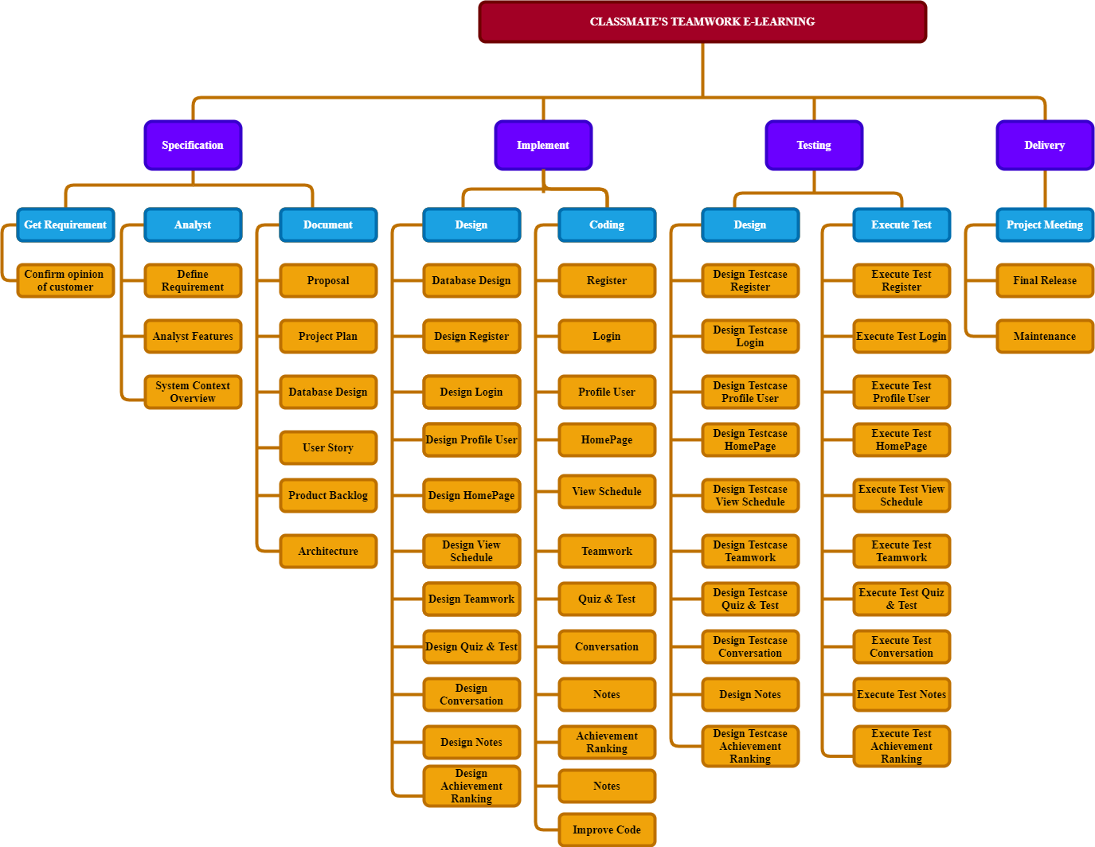

## Project Team

|  |  |  |
| --- | --- | --- |
| **Role** | **Responsibility** | **Name** |
| **Scrum Master** | - Project planning  - Make a schedule, divide specific stages  - Planning change and project development  - Estimating budgets and expenses  - Time allocation plan for each specific task.  - Identify the technologies to be used  - Planning for training and meeting | Kiet Nguyen Tuan |
| **Product Owner** | - Defining the vision  - Anticipating client needs  - Overseeing development stages  - Prioritizing needs  - Managing the product backlog  - Acting as a primary liaison between stakeholder and team member  - Evaluating product progress at each iteration | Team |
| **Stakeholder (Mentor)** | * Guide on the process. * Monitoring all activities of the Team. * Help with anything. * Reviews project documents   - Reviews product | Thuan Nguyen Trung |
| **Team member** | - Responsible for quality  - Responsible for delivering the potentially shippable product of the Application for each task in GitHub  - Report progress based on the remaining time  - Self-organized: The work itself comes randomly and is picked by team members  - The goal of team members is to get all the incoming work done as quickly as possible. | All  members |
| **Back end Developer** | - Design and plan the functions of the SmartTAP website.  - Plan and deploy integration of databases, developing functions of room rental, check-out, payment, adding, editing and deleting information, saving room-service-user information.  - Plan and deploy the function of viewing user information, room information, integrating Google-map.  - Develop chat box function, view cross- user information, and assign access rights. | Trung, Dang Quang |
| **Front end Developer** | - Design interface website CTE-Learning.  - Design interface Login, Register, UI.  - Design interface for detail homepage, animation. | Kiet Nguyen Tuan |
| **Business Analyst** | - Get requirements.  - Build problem model and solution model.  - Design Use-case, Work-flow Diagram, Component Diagram.  - High-fi mock-up.  - Test app, web, and write test cases.  - Documentation relates information to the project. | Trung, Luong Van  Hieu, Le Nhu |
| **Backend Developer** | * Backup data with firebase. * Plan and deploy functions of website CTE-Learning | Trung, Dang Quang |

COMMUNICATION & REPORTING

|  |  |  |  |  |
| --- | --- | --- | --- | --- |
| **Communication Type** | **Method / Tool** | **When** | **Information** | **Participants / Responsible** |
| **Project Task Tracking** | | | | |
| Task scheduling | MS Project | At the beginning of every stage and weekly  Refinement and  rescheduling as necessary | Evaluate and check the progress of each stage,  Flexible request collection and reasonable time adjustment | Kiet, Trung |
| Task assignment | In Excel file and via project weekly meeting | Weekly | Detailed small tasks statistics in sprints, calculate working hours and track progress, add backlog, implement burn down chart | Kiet, Trung |
| **Project Meeting** | | | | |
| Kick-off Meeting | Face to face | Initiation stage | Project introduction; Project plan review; Risk identification; Obtainment of commitment of relevant stakeholders | Mentor  Team member |
| Project Progress Review Meetings | Face to face | Every 2 weeks | Communicate project status  Communicate and resolve any open issue, risks, and changes  Discuss any suggested improvement | Mentor  Team Members  Product owner |
| Milestone Meetings | Face to face | Before milestones | Project objective review, evaluate project performance (quality, schedule, effort), Causal analysis, update project plan for next stage | Mentor  Team Members  Product owner |

|  |  |  |  |  |
| --- | --- | --- | --- | --- |
| **Communication Type** | **Method / Tool** | **When** | **Information** | **Participant/ Responsible** |
| Project Post-mortem Meeting | Face to face | Termination stage | Wrap-up  Evaluate project performance; Team performance; share experiences | Team Members |
| Transfer/Sharing of project documentation/ information |  | When available | All project documentation and information | Team Members |
| **Customer Communication and Reporting:** | | | | |
| Project Report | Agreed standard format between company and customer | 10PM Saturday, Weekly | Project status report, Issue requiring clarifications, escalation, if any | Scrum master  Product Owner |
| Requirement gathering/clarification | Email/TV meeting/Face to face  meeting | During requirement analysis phase | As in Q&A list | Van Trung |
| **Communication with Senior Management** | | | | |
| Review Project Plan & Project schedule | By email or attend project meeting | Significant changes to WO, PP and Project schedule (scope, objectives Organization, HR, major milestone, deliverables ) | Provide information to members about the time and plan of upcoming phases, evaluate the performance of the completed phases, implement the next phase in accordance with customer requirements | Q Trung |
| Project Progress Review | By email  and/or via Operation meeting at Group/ Division level | Weekly | Project status report, Issue requiring clarifications, escalation, if any | Mentor  Team member  Scrum Master |
| Project Milestone Review | By email and via project milestone review meeting | End of every stage | Project objective review, evaluate project performance (quality, schedule, effort), Causal analysis, update project plan for next stage | Mentor  Team member  Scrum Master |
| **Other Communication and Reporting:** | | | | |
| Raise issue or request service/support of BA groups (IT, Admin, QA, HR, Training,  Recruitment, ...) | Call log; email; phone | Upon request | Request content, expected completion date | Project Manager |

# CONFIGURATION MANAGEMENT

|  |  |  |
| --- | --- | --- |
| **No.** | **Tools** | **content** |
| 1 | Excel | Use this tool to track membership. At the end of each day, the group members will post on the Time Table and Scrum Master will check |
| 2 | Weekly meeting | Organize a meeting every week to assign tasks to each member.  If there are some emergencies but we cannot sit together, we can use Facebook, Discord to discuss online. |
| 3 | Document | All meetings must be recorded. |

# SECURITY ASPECTS

* Only the administrator has extensive access to the system and reconfigures the system.
* Project information will remain private.
* All project members must agree to respect the confidentiality of project information.

# REFERENCES

|  |  |  |  |
| --- | --- | --- | --- |
| **No** | **Reference item** | **Source** | **Note** |
| 1 | Proposal | 1. [Proposal](http://../1.%20Proposal/Proposal_Ver1.2.docx) |  |
| 2 | Product backlog | 4. [Product](http://../3.%20Product%20Backlog/ProductBacklog%20v1.1.xlsx) Backlog |  |
| 3 | Scrum Process | [Scrum.org](https://www.scrum.org/) |  |
| 4 | GitHub | <https://github.com/> |  |
| 5 | Reactjs | <https://reactjs.org/> |  |
| 5 | Nodejs | <https://nodejs.org/en/docs/> |  |

# DEFINITIONS AND ACRONYMS

|  |  |
| --- | --- |
| **Acronym** | **Definition** |
| **PM** | Project Manager |
| **PTL** | Project Technical Leader |
| **QA** | Quality Assurance Officer |
| **CC** | Infrastructure Configuration Controller |
| **DV** | Developer |
| **URD** | User Requirement Document |
| **SRS** | Software Requirement Specification |
| **ADD** | Architecture Design Document |
| **DDD** | Detail Design Document |
| **TP** | Test Plan |
| **TC** | Test Case |
| **SC** | Source Code |
| **CM** | Configuration Management |
| **CSCI** | Computer Software Configuration Items |
| **CI** | Configuration Item |
| **CCB** | Change Control Board |