Policy Need to Update – Run [gpedit.msc] Goto below path
[Local Computer Policy --> Administrative Templates --> Windows Components --> Windows Update]
- Configure Automation Updates
- Specify intranet Microsoft update service location
- Automatic updates detection frequency
- Allow non-administrator to receive update notification
- Turn on software notification
- No Auto-restart with logged on users for scheduled automatic updates installation
- Re-prompt for restart with scheduled installation

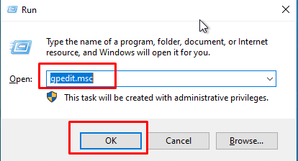
- Win+R – gpedit.msc
- Goto - Local Computer Policy --> Administrative Templates --> Windows Components --> Windows Update
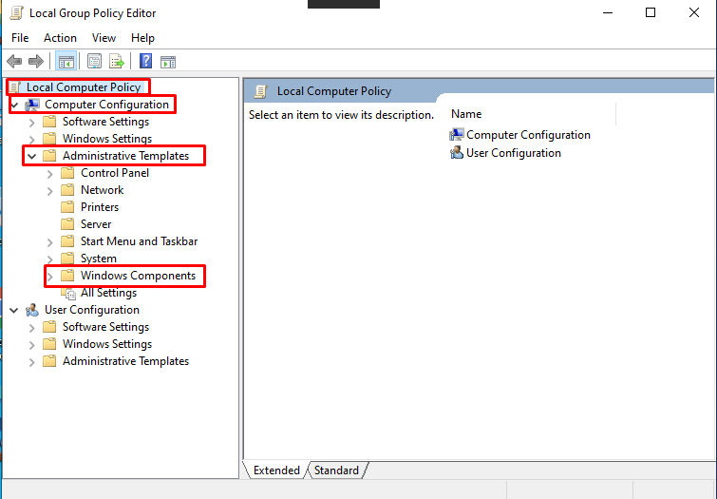

- Expend Windows Update and Enable those setting to get updates from WSUS.
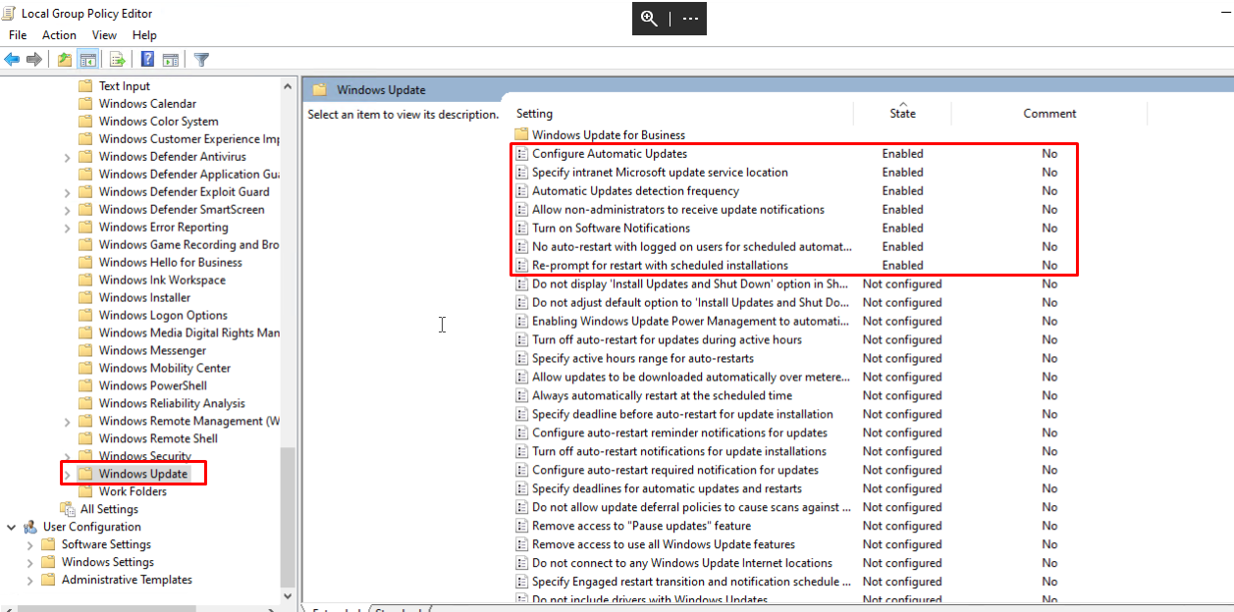

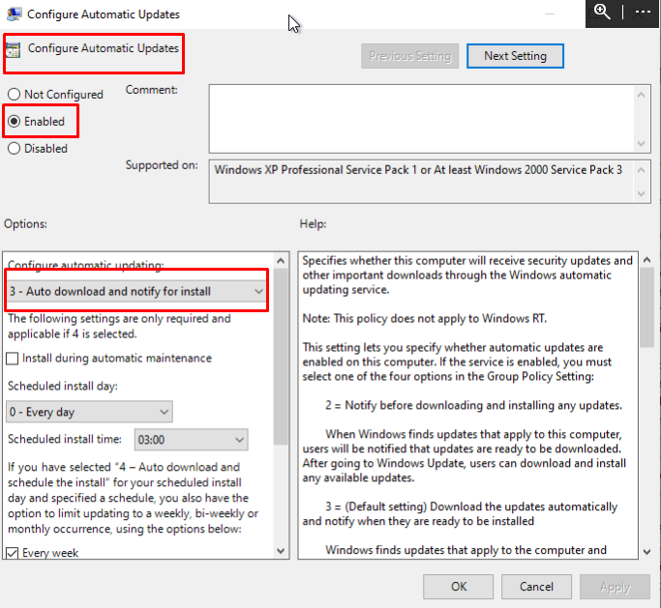
- Configure Automation Updates

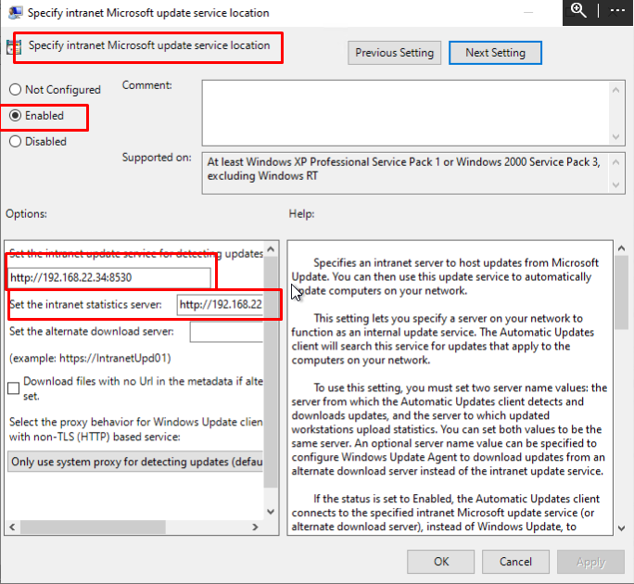
- Specify intranet Microsoft update service location

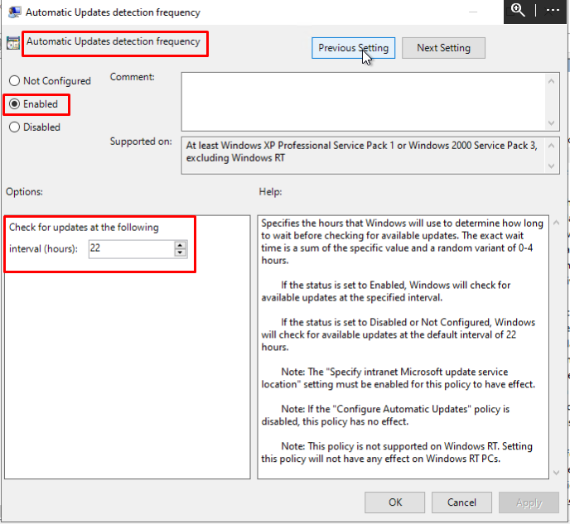
- Automatic updates detection frequency

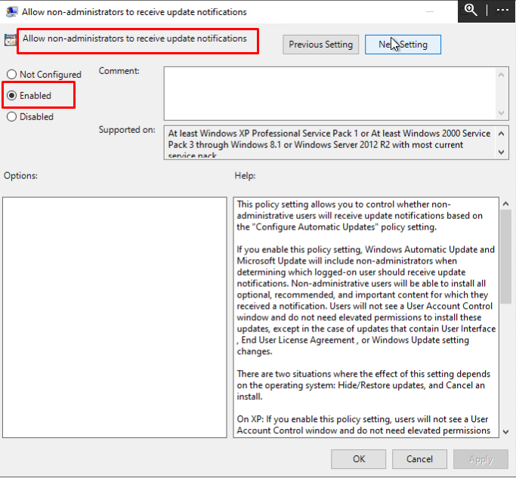
- Allow non-administrator to receive update notification

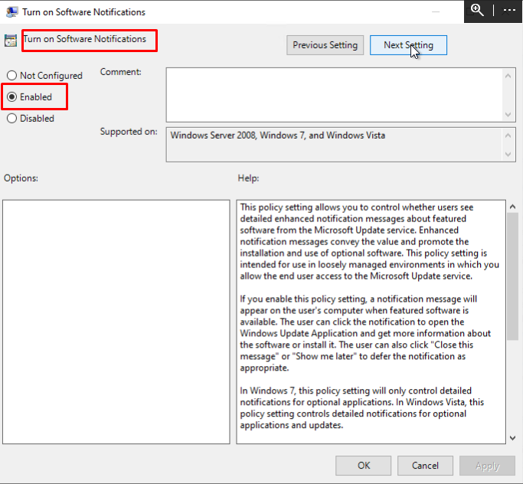
- Turn on software notification

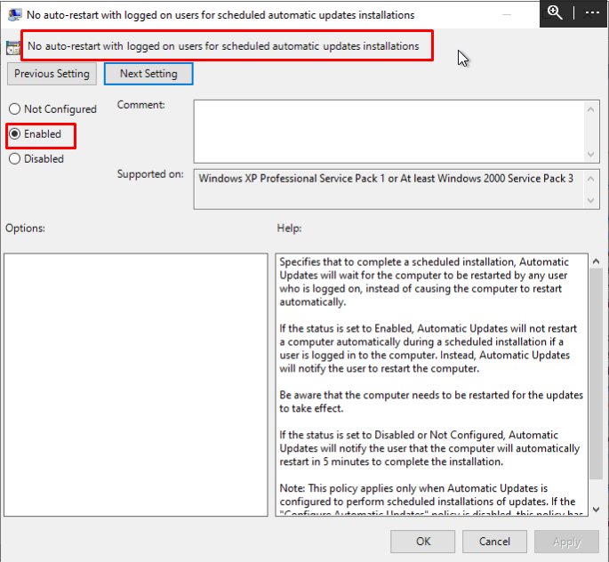
- No Auto-restart with logged on users for scheduled automatic updates installation

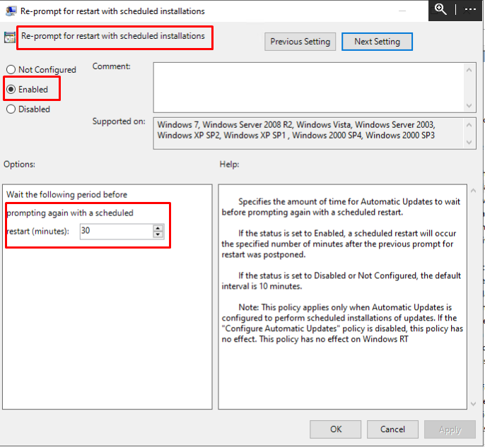
- Re-prompt for restart with scheduled installation

