Assignment-1
Q1 solution:
- Frontend Development: Handles the part of a website users see (UI/UX).
Example: The buttons, forms, and design you see on Amazon’s homepage.
- Backend Development: Manages server logic, databases, and user requests.
Example: When you log in to Amazon, backend code verifies your credentials.
- Full-Stack Development: Combines both frontend and backend skills.
Example: A developer who builds both the shopping cart interface and its database system.
Q2 solution:
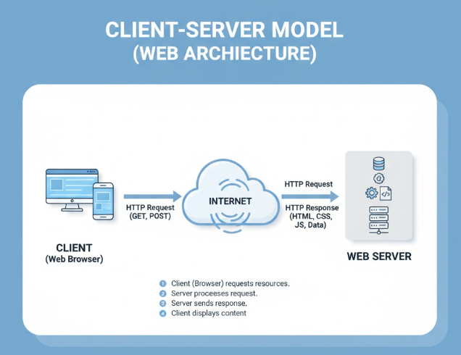
Q3 solution:
Web Page Request and Display Process
Request and Connection
The process starts when you enter a URL. The browser first uses the Domain Name System (DNS) to translate the domain name (e.g., google.com) into a numerical IP address. Using this IP address, the browser establishes a reliable connection with the server via the TCP three-way handshake. Once connected, the browser sends an HTTP request (usually a GET method) asking for the specific page.

Server Response
The web server receives the request, processes it, and constructs an HTTP response. This response includes a status code (e.g., 200 OK), relevant header information, and the requested data—primarily the HTML document.

Rendering and Display
Upon receiving the HTML, the browser begins the rendering process:
- Parsing: The browser parses the HTML to create the DOM (Document Object Model) and the CSS to create the CSSOM.
- Resource Fetching: It notices any links in the HTML to external resources (like images, CSS files, and JavaScript) and immediately sends new HTTP requests to download them.
- Layout: It combines the DOM and CSSOM to form the Render Tree, then calculates the exact size and position of every element on the screen (the "layout" or "reflow" step).
- Painting: Finally, the browser draws (or "paints") the elements to your screen, making the web page visible to you. JavaScript then runs to handle interactivity and any dynamic updates.
Q4 solution:
Setting up a web development environment requires several essential tools for writing, viewing, testing, and managing code.
Essential Web Development Tools
Tool Category | Specific Tool Examples | Purpose
Code Editor | Visual Studio Code (VS Code), Sublime Text, Atom | This is where you write all your code (HTML, CSS, JavaScript, etc.). A good editor provides syntax highlighting, autocomplete, and tools for debugging and integrating with version control.
Web Browser | Google Chrome, Firefox, Safari | You need a browser not just to view the final result, but also for debugging. Modern browsers include powerful Developer Tools (DevTools) for inspecting elements, viewing network traffic, and testing JavaScript.
Command Line Interface (CLI) | Terminal (macOS/Linux), Command Prompt/PowerShell (Windows) | The CLI is used to execute many development tasks, such as installing packages, running local servers, and interacting with Git.
Version Control System | Git | Git is essential for tracking changes in your code over time, managing collaboration, and reverting to previous stable versions.
Remote Hosting/Repository | GitHub, GitLab, Bitbucket | These web services are used to store your Git repositories remotely. They serve as a secure backup, a platform for team collaboration, and often integrate with deployment tools.
Runtime Environment / Package Manager | Node.js with npm (Node Package Manager) or yarn | Node.js allows JavaScript to run on the server side (backend) and is crucial for using modern build tools and frameworks. The package manager (npm/yarn) is used to install, manage, and share external libraries and dependencies.
Local Server | Built-in server in VS Code extensions (like Live Server) or Node.js frameworks (like Express) | A local server is needed to simulate a live web environment on your machine. This allows you to test server-side logic and ensures file paths and relative links work correctly before deployment.

Question 5:
A web server is a software application and the underlying hardware (the physical computer) that stores, processes, and delivers web content to clients (like web browsers) over the internet.¹ Its primary function is to accept HTTP requests from clients and return HTTP responses, usually consisting of HTML documents, images, stylesheets, and scripts.

What a Web Server Does
The web server acts as an intermediary between the client and the data needed to display a website.²
- Listens for Requests: It constantly monitors a specific port (usually port 80 for HTTP or 443 for HTTPS) for incoming client requests.³
- Processes Requests: When a request arrives (e.g., a browser asking for /index.html), the server locates the requested file or executes a necessary server-side script.
- Delivers Content: It packages the content (along with the correct HTTP status code) into an HTTP response and sends it back across the network to the client, which then renders the page.⁴
Web servers can deliver two main types of content:
- Static Content: Simple files like HTML, CSS, JavaScript, and images stored directly on the server's file system.⁵
- Dynamic Content: Content generated on-the-fly by running server-side code (like PHP, Python, or Node.js) that interacts with a database to produce a custom HTML page.⁶

Commonly Used Web Server Examples
Here are some of the most widely used web server applications:
- Apache HTTP Server: Often just called Apache, this is historically the most popular web server software.⁷ It is open-source, highly configurable, and widely used across Linux, Unix, and Windows platforms, powering a massive number of websites globally.⁸
- Nginx (pronounced Engine-X): A high-performance, open-source server known for its efficiency and low resource consumption.⁹ It excels at handling a large volume of concurrent connections and is frequently used as a reverse proxy, load balancer, and HTTP cache.¹⁰
- Microsoft IIS (Internet Information Services): Microsoft's web server software, tightly integrated with the Windows operating system.¹¹ It's commonly used in enterprise environments running Microsoft technologies like ASP.NET.¹²
- Lighttpd (Lighty):¹³ An open-source web server optimized for speed-critical environments.¹⁴ It uses less memory and CPU than other servers and is often chosen for high-performance hosting.
- Caddy: A modern, open-source web server known for being easy to configure and for automatically enabling HTTPS/SSL certificates by default using Let's Encrypt.
Q6 solution:
The three roles—Frontend Developer, Backend Developer, and Database Administrator (DBA)—each manage a critical layer of a modern software application.
Roles in a Project
1. Frontend Developer (Client-Side)
A Frontend Developer is responsible for everything the user sees and interacts with directly in their web browser or application interface. They focus on the user experience (UX) and the user interface (UI).
- Key Focus: Presentation, interactivity, accessibility, and performance on the client side.
- Technologies: HTML (structure), CSS (styling), and JavaScript (behavior/interactivity).
- Tasks:
  - Implementing the visual design from wireframes or mockups.
  - Building responsive and intuitive user interfaces.
  - Ensuring the application works correctly across different browsers and devices.
  - Integrating with backend APIs to display and send data.
  - Using frameworks like React, Angular, or Vue.js.

2. Backend Developer (Server-Side)
A Backend Developer is responsible for the server-side logic, the core application functionality, and ensuring data exchange between the application and the database. They work behind the scenes where the actual processing happens.
- Key Focus: Business logic, data processing, security, performance, and application architecture.
- Technologies: Programming languages like Python, Java, Node.js (JavaScript), Ruby, or PHP.
- Tasks:
  - Designing and implementing the server-side architecture and logic.
  - Creating and maintaining APIs (Application Programming Interfaces) that the frontend consumes.
  - Writing code for user authentication and authorization.
  - Handling integration with external services and third-party systems.
  - Managing server deployment and scaling.

3. Database Administrator (DBA) (Data Layer)
A Database Administrator focuses entirely on managing, maintaining, and protecting the data layer—the database system itself. They ensure data integrity, security, and availability.
- Key Focus: Data security, backup and recovery, performance tuning, and access control.
- Technologies: SQL and specific database systems like PostgreSQL, MySQL, MongoDB, or Oracle.
- Tasks:
  - Installing and configuring database servers.
  - Designing the database schema (tables, relationships, indexes).
  - Monitoring database performance and optimizing slow queries.
  - Implementing and managing backup and disaster recovery procedures.
  - Managing user access permissions and ensuring data compliance.

Q7 solution:
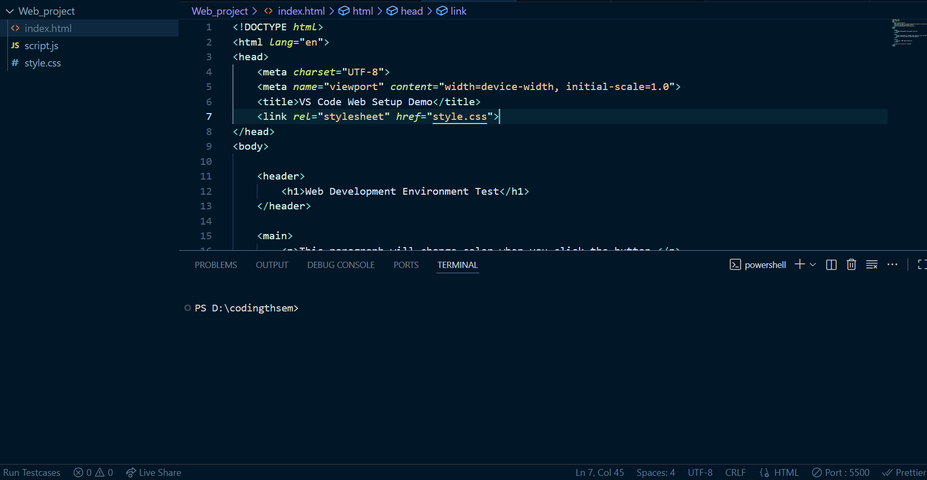
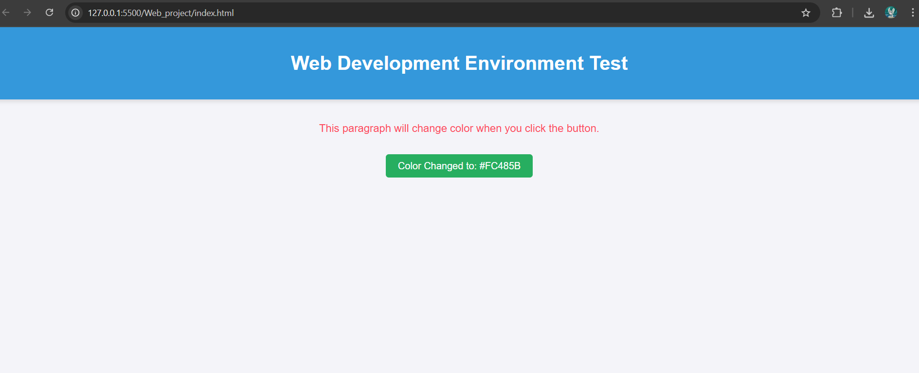

Q8 solution:
The fundamental difference between static and dynamic websites lies in when and how their content is generated and delivered to the user.

Static Websites
A static website delivers content to the user exactly as it is stored on the web server.² The content is fixed and built using plain files (HTML, CSS, JavaScript).
Feature | Description
Content Generation | Content is generated once at build time and stored as pre-built HTML files.
User Experience | The same content is shown to every user, regardless of location, time, or login status.
Technology | Client-side: HTML, CSS, and simple JavaScript. Requires no server-side processing or database.
Performance | Extremely fast, secure, and cheap to host because the server only needs to deliver files.
Example: A simple company brochure website or a personal portfolio where the information rarely changes and there are no login features or personalized user dashboards.

Dynamic Websites
A dynamic website generates content on demand in real-time, based on user input, database information, and server-side logic.
Feature | Description
Content Generation | Content is generated every time a page is requested by combining templates with data pulled from a database.
User Experience | Content is personalized, often showing different information based on the user's login, location, or recent activity.
Technology | Requires server-side scripting (like PHP, Python, Node.js) and a database (like MySQL or PostgreSQL) to process data.
Performance | Slower than static sites due to the processing time required to query the database and render the page.
Example: E-commerce sites (like Amazon), social media platforms (like Facebook), and online banking applications.⁶ These sites require user authentication and constantly updated, personalized data.

Q9 solution:
Here are five popular web browsers and an explanation of how their rendering engines differ.

Five Popular Web Browsers and Their Engines
Web Browser | Primary Rendering Engine | Engine Origin/Base
Google Chrome | Blink | Forked from WebKit
Mozilla Firefox | Gecko (Specifically Quantum) | Developed by Mozilla (Independent)
Microsoft Edge | Blink | Forked from WebKit
Apple Safari | WebKit | Developed by Apple
Opera | Blink | Previously used Presto, now uses Blink

Difference in Rendering Engines
The rendering engine (also called the layout engine) is the core software component of a browser responsible for taking the content (HTML, CSS) and displaying it visually on the screen. The primary differences between them lie in their development history, underlying code base, implementation of web standards, and performance characteristics.
1. WebKit
- Origin: Developed by Apple for the Safari browser, based on the KHTML engine.
- Key Feature: Known for its efficiency and is the required engine for all browsers on iOS devices. It strictly adheres to Apple's interpretation of web standards.
2. Blink
- Origin: Developed by Google and introduced in 2013 as a fork (split) of the WebKit engine.
- Key Feature: The dominant engine globally due to Chrome's popularity. Google often drives the implementation of new web features and standards through Blink, focusing on speed and modern JavaScript execution. Microsoft Edge and Opera now also use Blink, meaning they share this core rendering behavior.
3. Gecko (Quantum)
- Origin: Developed by Mozilla for the Firefox browser.
- Key Feature: The most prominent independently developed engine. Mozilla recently introduced major architectural changes under the Quantum initiative to improve parallel processing (using multiple CPU cores), significantly boosting speed and responsiveness while focusing on privacy and open web standards.
Why the Differences Matter
Since different engines are built by different teams with different priorities, they sometimes interpret and render the same HTML and CSS code in slightly different ways. This is why developers need to test websites on multiple browsers to ensure consistent display and functionality. However, modern engines are highly aligned thanks to shared international web standards (W3C).

Q10 solution:
