Student Performance Prediction Using Decision Tree Classification
Project Report for Data Mining and Data Warehousing
Mayank Pandey, Pushkar Lakshakar, Aabhash Rahut

Submission Details
Submitted By:
Mayank Pandey - 23BAI10479
Pushkar Lakshakar - 23BAI10421
Aabhash Rahut - 23BAI10416
Course / Subject: Data Mining and Data Warehousing
Project Title: Student Performance Prediction Using Decision Tree Classification
Dataset Used: UCI Student Performance Dataset (student-mat.csv)
Algorithm Used: Decision Tree Classifier (CART, Gini Index)

Abstract
This project presents a complete data mining workflow for predicting whether a student will pass or fail in Mathematics using the UCI Student Performance dataset. The dataset contains academic, demographic, family, and lifestyle information for 395 students. The main goal of the project is to study how different student-related factors influence final performance and to build an interpretable machine learning model that can classify students into pass and fail categories.
The project follows a standard pipeline consisting of data loading, preprocessing, exploratory data analysis, feature preparation, model building, evaluation, and interpretation. A binary target variable named Result was created from the final grade G3, where students scoring 10 or above were marked as pass and the remaining students were marked as fail. A Decision Tree classifier with Gini Index and maximum depth of 5 was trained on 70% of the data and tested on the remaining 30%.
The model achieved an accuracy of 86.55% on the test set, with good balance between precision and recall for both classes. Exploratory analysis showed that prior grades, study time, number of past failures, and family-education-related variables had meaningful influence on performance. Feature importance analysis highlighted G2 as the dominant predictor. The final report includes all generated graphs, model results, interpretation, limitations, and future scope.
Keywords: data mining, educational data mining, decision tree, student performance, classification, machine learning

1. Introduction
Data mining is the process of extracting useful patterns, trends, and relationships from raw data. It combines ideas from statistics, machine learning, databases, and visualization to support informed decision-making. In the education sector, data mining is especially useful because institutions collect large amounts of student-related data that can be analyzed to understand academic behavior and predict outcomes.
Student performance prediction is an important application of educational data mining. If institutions can identify at-risk students early, they can provide timely support such as tutoring, counseling, parental communication, and targeted academic intervention. Predictive systems also help teachers and administrators understand which factors most strongly affect performance.
In this project, the UCI Student Performance dataset has been analyzed to predict whether a student will pass or fail in the Mathematics subject. A Decision Tree classification model was selected because it is easy to understand, handles mixed-type educational data well, and provides clear rule-based interpretation.

2. Problem Statement and Objectives

2.1 Problem Statement
Educational institutions often need an explainable method to identify students who may struggle academically. Manual evaluation alone may miss important patterns hidden inside student data. This project addresses that problem by using data mining techniques to analyze student records and predict pass/fail outcomes.

2.2 Objectives
The major objectives of the project are:
- To load and understand the UCI Student Performance dataset.
- To preprocess the dataset and prepare it for machine learning.
- To perform exploratory data analysis using graphical visualization.
- To create a binary target variable for pass/fail classification.
- To train a Decision Tree classifier on the prepared dataset.
- To evaluate the model using accuracy, confusion matrix, and classification report.
- To identify the most important features affecting student performance.
- To present a proper academic report with graphs, observations, and conclusion.

3. Literature Review
Educational data mining has been widely used to predict student outcomes, identify at-risk learners, and improve teaching strategies. Some important studies related to this domain are summarized below.
No. | Authors | Year | Main Contribution
1 | Cortez and Silva | 2008 | Introduced the Student Performance dataset and showed that past academic grades are strong predictors of final performance.
2 | Romero and Ventura | 2010 | Presented a broad review of educational data mining methods used for prediction, feedback, and learning analytics.
3 | Baker and Yacef | 2009 | Discussed the state of educational data mining and the role of interpretable models in education.
4 | Kotsiantis et al. | 2004 | Compared multiple classification methods for predicting student performance in educational settings.
5 | Amrieh et al. | 2016 | Demonstrated the usefulness of behavioral and academic features for performance prediction.
6 | Shahiri et al. | 2015 | Reviewed machine learning techniques for student performance prediction and reported Decision Trees as one of the common practical choices.

Key Insights from Literature
- Decision Trees are widely used because they are interpretable and easy to explain to non-technical stakeholders.
- Previous academic grades consistently appear among the strongest predictors of final student performance.
- Study habits, failures, family background, and support systems also contribute to prediction quality.
- Classification accuracy between 70% and 90% is commonly reported in educational prediction studies.

4. Dataset Description

4.1 Dataset Source
The project uses the Student Performance Dataset from the UCI Machine Learning Repository. The student-mat.csv file contains records for Mathematics students from Portuguese secondary schools.

4.2 Dataset Size
Item | Value
Number of records | 395
Number of original attributes | 33
Number of model features used | 32
File used | archive/student-mat.csv

4.3 Attribute Categories
The dataset includes information from the following categories:
Category | Examples of Attributes
Demographic | school, sex, age, address
Family Background | famsize, Pstatus, Medu, Fedu, Mjob, Fjob, guardian
Academic and Study Habits | traveltime, studytime, failures, schoolsup, paid, higher
Social and Lifestyle | activities, internet, romantic, goout, Dalc, Walc
Health and Attendance | health, absences
Grades | G1, G2, G3

4.4 Important Statistics
Statistic | Age | Study Time | Absences | G1 | G2 | G3
Mean | 16.70 | 2.04 | 5.71 | 10.91 | 10.71 | 10.42
Standard Deviation | 1.28 | 0.84 | 8.00 | 3.32 | 3.76 | 4.58
Minimum | 15 | 1 | 0 | 3 | 0 | 0
Maximum | 22 | 4 | 75 | 19 | 19 | 20

5. Tools and Technologies Used
Category | Tools / Libraries
Programming Language | Python
Data Handling | pandas, numpy
Visualization | matplotlib, seaborn
Machine Learning | scikit-learn
Algorithm | Decision Tree Classification
Dataset | UCI Student Performance Dataset
Report Output | Markdown to DOCX using Pandoc

6. Methodology

6.1 Data Loading
The dataset was loaded from archive/student-mat.csv using pandas with semicolon (;) as the separator.

6.2 Data Preprocessing
The preprocessing steps followed in this project are listed below:
- The dataset was checked for missing values.
- No missing values were found in any column.
- All categorical columns were encoded using LabelEncoder.
- A binary target variable called Result was created from final grade G3.
- To avoid direct leakage from the target definition, G3 was removed from the input features before training.

Categorical Columns Encoded
The following 17 categorical columns were encoded:
school, sex, address, famsize, Pstatus, Mjob, Fjob, reason, guardian, schoolsup, famsup, paid, activities, nursery, higher, internet, romantic

6.3 Target Variable Definition
The target variable was defined as:
- Pass (1): G3 >= 10
- Fail (0): G3 < 10
The resulting class distribution is shown below:
Class | Number of Students | Percentage
Pass | 265 | 67.1%
Fail | 130 | 32.9%

6.4 Feature Selection and Data Split
After preprocessing:
- Total usable features: 32
- Training samples: 276
- Testing samples: 119
- Train/Test split: 70% / 30%
- Random state: 42

6.5 Algorithm Used
The Decision Tree classifier was configured as follows:
Parameter | Value
Algorithm Type | CART Decision Tree
Criterion | Gini Index
Maximum Depth | 5
Random State | 42

Why Decision Tree Was Chosen
- It is easy to interpret and visualize.
- It works well with both numerical and encoded categorical features.
- It does not require feature scaling.
- It provides feature importance values directly.
- It is suitable for academic projects where explanation matters as much as prediction.

7. Exploratory Data Analysis
Exploratory Data Analysis was performed to understand the grade distribution, class balance, correlations, and the effect of selected variables on student outcomes.

7.1 Distribution of Final Grade (G3)
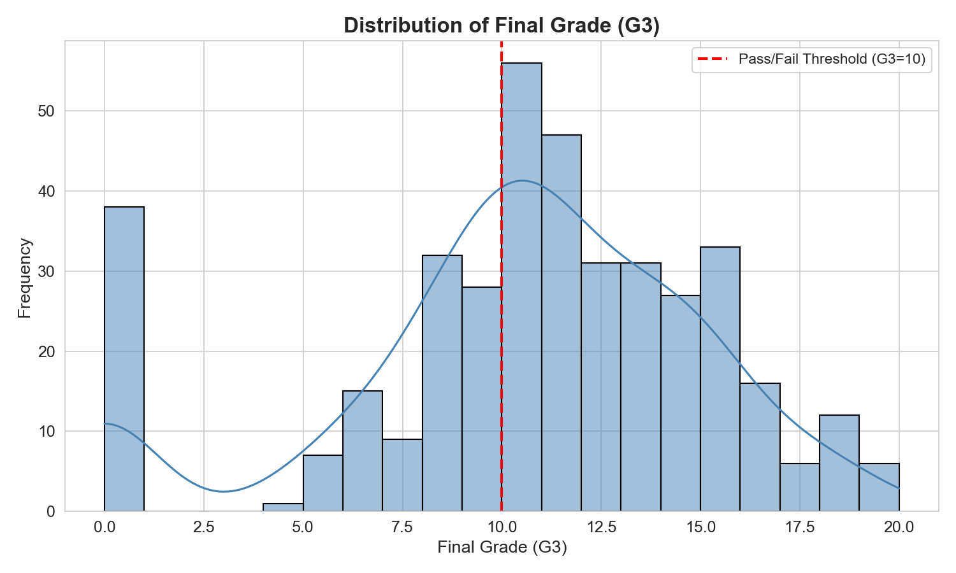
Figure 1. Distribution of final grade (G3) with pass/fail threshold.
Observation: The final grade distribution is centered around the middle grade range, with many students clustered close to the passing threshold of 10 marks. This indicates that a noticeable portion of students are academically vulnerable and may benefit from early support.

7.2 Pass vs Fail Distribution
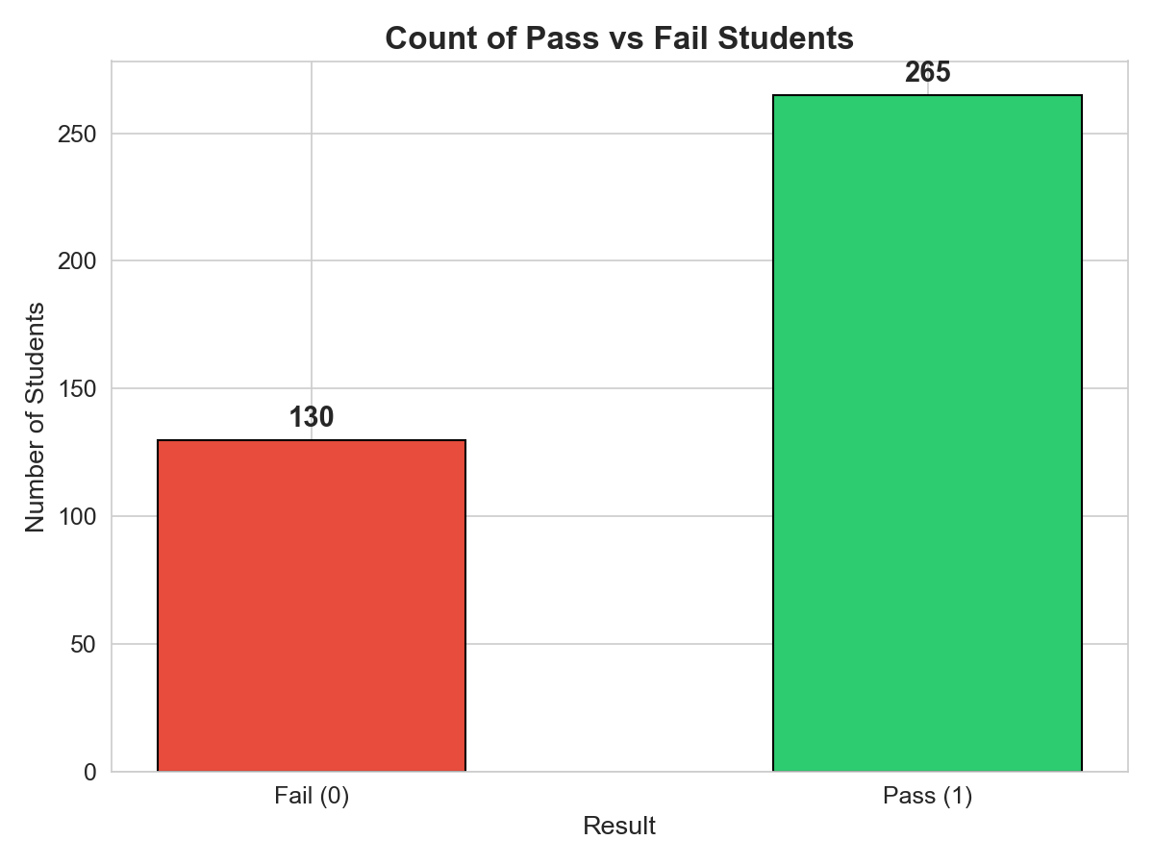
Figure 2. Pass and fail class distribution.
Observation: The dataset is moderately imbalanced but still suitable for standard classification. About two-thirds of the students passed and one-third failed.

7.3 Correlation Heatmap
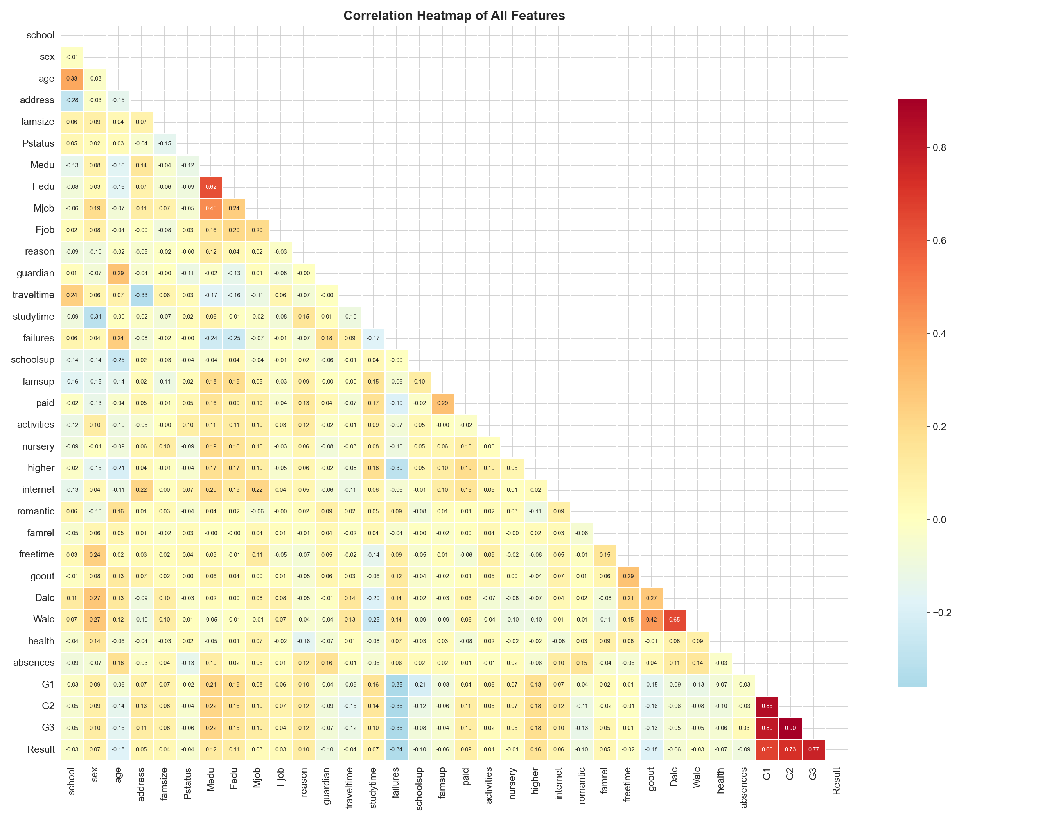
Figure 3. Correlation heatmap of all features.
Observation: G2 and G1 are strongly correlated with final grade G3, which is expected because they represent prior academic performance. Variables such as parental education also show mild positive association, while past failures have a negative relationship with final outcome.

Strong Correlations with Final Grade
Feature | Correlation with G3
G2 | 0.905
G1 | 0.801
Medu | 0.217
higher | 0.182
Fedu | 0.152

7.4 Study Time vs Pass Rate
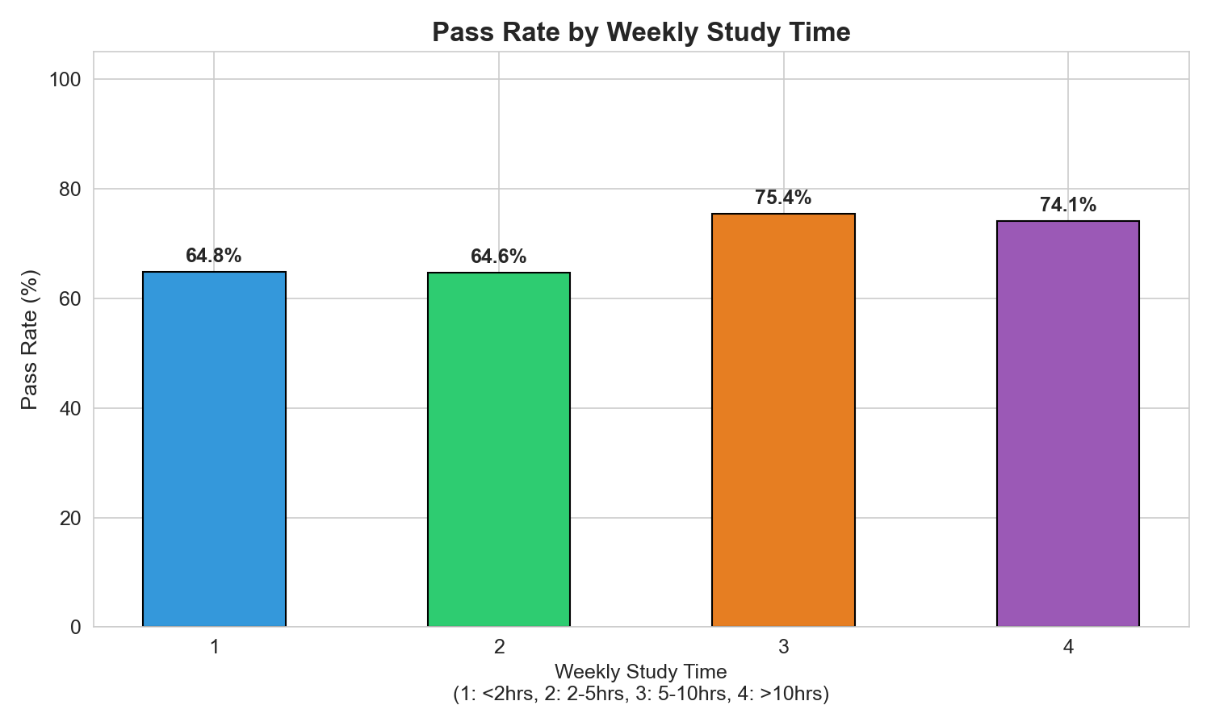
Figure 4. Pass rate by weekly study time.

Pass Rate by Study Time
Study Time Category | Pass Rate
1: Less than 2 hours | 64.8%
2: 2 to 5 hours | 64.6%
3: 5 to 10 hours | 75.4%
4: More than 10 hours | 74.1%
Observation: Students studying 5 or more hours per week had visibly better pass rates than those studying less. This supports the assumption that better study habits are associated with stronger academic performance.

7.5 Past Failures vs Pass Rate
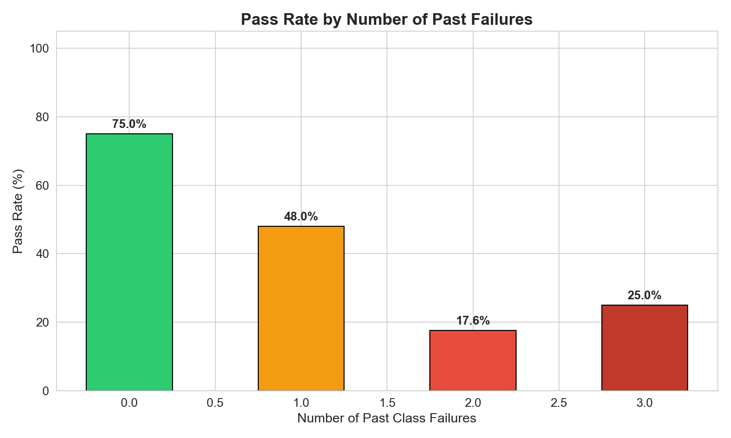
Figure 5. Pass rate by number of previous class failures.

Pass Rate by Number of Past Failures
Past Failures | Pass Rate
0 | 75.0%
1 | 48.0%
2 | 17.6%
3 | 25.0%
Observation: Students with no previous failures performed much better than those with one or more failures. A sharp drop is visible after the first failure, showing that academic history is a strong risk indicator.

8. Model Training and Evaluation

8.1 Model Summary
Item | Value
Model | Decision Tree Classifier
Criterion | Gini
Max Depth | 5
Number of Leaves | 16
Test Accuracy | 86.55%

8.2 Confusion Matrix
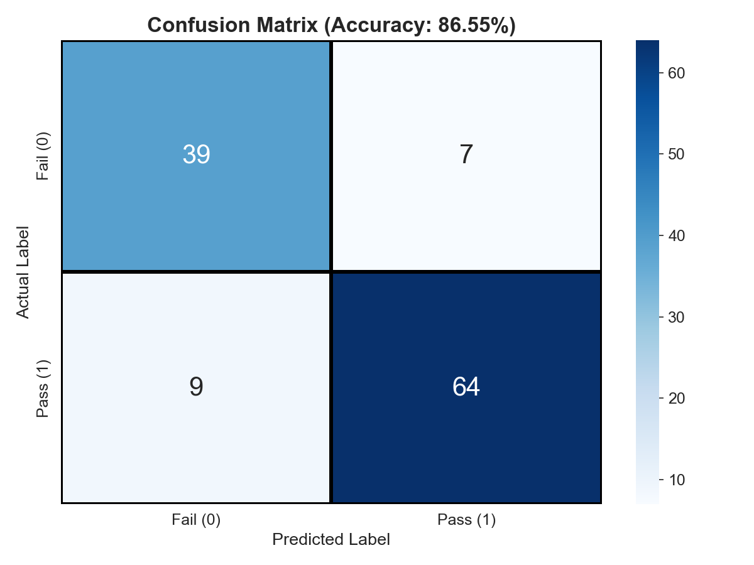
Figure 6. Confusion matrix of the Decision Tree model.
Actual / Predicted | Fail | Pass
Fail | 39 | 7
Pass | 9 | 64

Interpretation
- The model correctly identified 39 failing students.
- The model correctly identified 64 passing students.
- 7 failing students were wrongly classified as pass.
- 9 passing students were wrongly classified as fail.

8.3 Classification Report
Class | Precision | Recall | F1-Score | Support
Fail (0) | 0.81 | 0.85 | 0.83 | 46
Pass (1) | 0.90 | 0.88 | 0.89 | 73
Weighted Average | 0.87 | 0.87 | 0.87 | 119

Evaluation Discussion
The model performs well for both classes and shows a balanced predictive behavior. Precision for the pass class is high, which means the system is usually correct when it predicts that a student will pass. Recall for the fail class is also acceptable, which is important for identifying academically weaker students.

9. Feature Importance Analysis
Feature importance helps explain which variables had the greatest influence on model decisions.
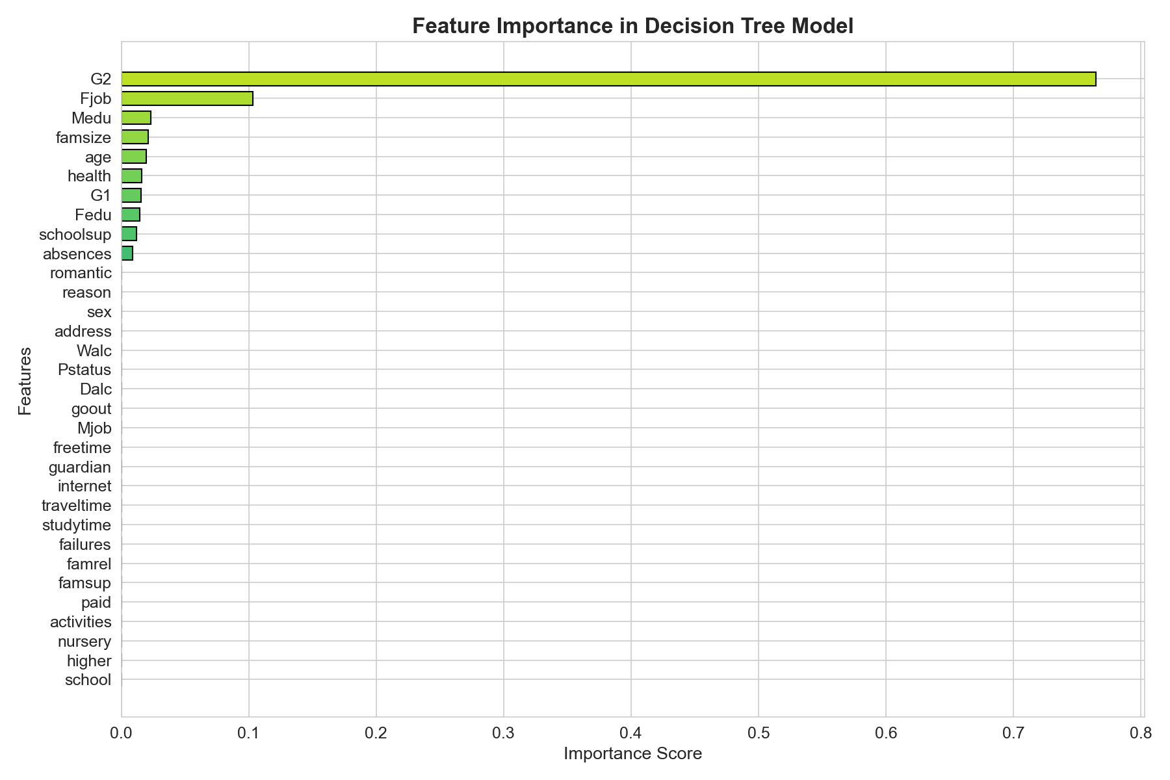
Figure 7. Feature importance scores from the Decision Tree model.

9.1 Top 10 Important Features
Rank | Feature | Importance Score
1 | G2 | 0.7648
2 | Fjob | 0.1033
3 | Medu | 0.0234
4 | famsize | 0.0213
5 | age | 0.0195
6 | health | 0.0161
7 | G1 | 0.0157
8 | Fedu | 0.0148
9 | schoolsup | 0.0121
10 | absences | 0.0090

9.2 Interpretation
The model is dominated by G2, the second-period grade, which alone contributes most of the predictive power. This is consistent with the literature because recent academic performance is usually the best indicator of final performance. Other features such as parental education, family size, school support, and attendance contribute smaller but still meaningful signals.

10. Decision Tree Visualization
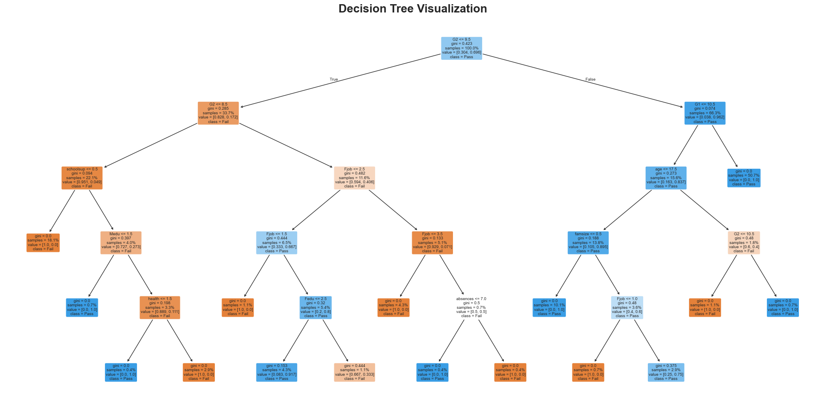
Figure 8. Visualization of the trained Decision Tree classifier.
The Decision Tree visually explains how the model separates passing and failing students. The root node splits on G2, confirming that prior performance is the strongest signal in the data. Subsequent splits involve variables such as G1, parental background, and attendance-related factors. Because the maximum depth is limited to 5, the tree remains understandable and avoids becoming excessively complex.

11. Major Findings
The most important findings from the project are:
- Previous grades are the strongest predictors of final result.
- Students with more study time generally have higher pass rates.
- Past failures strongly reduce the probability of passing.
- Family background variables such as parental education also contribute to prediction.
- The Decision Tree model achieved strong test performance while remaining interpretable.

12. Conclusion
This project successfully applied a Decision Tree classification model to the UCI Student Performance dataset for predicting student pass/fail outcomes. The complete workflow included preprocessing, visualization, classification, evaluation, and interpretation. The final model achieved 86.55% accuracy, which indicates that the selected approach is effective for this dataset.
From an educational perspective, the results show that academic history, especially earlier grades and previous failures, plays a major role in final performance. The model can therefore support early student monitoring and intervention planning. Since the model is interpretable, its outputs can be explained clearly to teachers, students, and administrators.

13. Limitations and Future Scope

13.1 Limitations
- The dataset size is relatively small with 395 records.
- The project uses only one dataset focused on Mathematics students.
- Since G1 and G2 are prior grades, the model is better suited for mid-course prediction than very early prediction.
- A single Decision Tree may be sensitive to small changes in data.

13.2 Future Scope
- Compare the Decision Tree with Random Forest, SVM, Naive Bayes, and Logistic Regression.
- Perform k-fold cross-validation for more robust evaluation.
- Use early-semester features only for earlier intervention prediction.
- Build a student risk dashboard for practical academic use.
- Extend the project to combine Mathematics and Portuguese datasets.

14. Files Generated in the Project
The project contains the following major output files:
File / Folder | Description
student_performance_analysis.py | Main analysis and model training script
archive/student-mat.csv | Input dataset used for the project
graphs/ | All generated visualizations
requirements.txt | Python dependencies needed to run the project
README.md | GitHub project overview and execution guide
College_Project_Report.md | Source file used to generate the DOCX report
Student_Performance_Project_Report.docx | Final report for submission
Project_Report.md, academic_report.md | Earlier report drafts kept for reference

15. How to Reproduce the Project
To run the project again:
python3 -m pip install -r requirements.txt
python3 student_performance_analysis.py
This command regenerates the graphs and evaluation outputs.
To regenerate the report document from the Markdown source:
pandoc College_Project_Report.md -o Student_Performance_Project_Report.docx

16. References
- Cortez, P., and Silva, A. (2008). Using Data Mining to Predict Secondary School Student Performance. Proceedings of FUBUTEC 2008.
- Romero, C., and Ventura, S. (2010). Educational Data Mining: A Review of the State of the Art. IEEE Transactions on Systems, Man, and Cybernetics, Part C.
- Baker, R. S. J. d., and Yacef, K. (2009). The State of Educational Data Mining in 2009: A Review and Future Visions. Journal of Educational Data Mining.
- Kotsiantis, S., Pierrakeas, C., and Pintelas, P. (2004). Predicting Students’ Performance in Distance Learning Using Machine Learning Techniques. Applied Artificial Intelligence.
- Amrieh, E. A., Hamtini, T., and Aljarah, I. (2016). Mining Educational Data to Predict Student’s Academic Performance Using Ensemble Methods. International Journal of Database Theory and Application.
- Shahiri, A. M., Husain, W., and Rashid, N. A. (2015). A Review on Predicting Student’s Performance Using Data Mining Techniques. Procedia Computer Science.
- UCI Machine Learning Repository. Student Performance Dataset.
- Scikit-learn Documentation. Decision Trees.

17. Appendix

17.1 Graphs Included in This Report
- Distribution of Final Grade (G3)
- Pass vs Fail Distribution
- Correlation Heatmap
- Study Time vs Pass Rate
- Past Failures vs Pass Rate
- Confusion Matrix
- Feature Importance
- Decision Tree Visualization

17.2 Final Project Summary
Summary Item | Value
Dataset Records | 395
Original Attributes | 33
Input Features Used | 32
Pass Students | 265
Fail Students | 130
Algorithm | Decision Tree
Accuracy | 86.55%
Tree Depth | 5
Leaf Nodes | 16

