Strategic Content Investment Analysis for a Global OTT Platform
Sector : Entertainment / OTT Streaming Industry
Team Details:
Mayank Sharma - 2401010270
Hrishi Dongre - 2401010191
Aman Soni - 2401010062
Himanshu Pandey - 2401020095
Aarya Srivastav - 2401010008
Sarvjeet Yadav - 2401010424

Executive Summary
This study analyzes 8,808 Netflix titles to evaluate structural content distribution patterns across type, genre, country, rating, duration, and growth trends. The objective is to identify strategic insights that can guide future content investment decisions.
Movies account for 6,131 titles (≈70%) while TV Shows account for 2,676 titles (≈30%), indicating a movie-heavy catalog structure.
The United States contributes 3,211 titles, representing the largest country concentration. Drama is the dominant genre and Adult-rated (TV-MA) content forms the largest rating group.
Content additions accelerated sharply after 2015, followed by stabilization, indicating a shift from aggressive expansion to controlled growth.

Sector & Business Context
The OTT industry has grown rapidly due to increased internet penetration and on-demand consumption habits. Content strategy directly influences subscriber acquisition, engagement, and retention.
High production and licensing costs require structured portfolio evaluation. Over-concentration in specific genres or regions may create long-term strategic risk.

Problem Statement & Objectives
The OTT industry requires high investment in content production and acquisition. To reduce strategic risk, content decisions must be guided by structured data analysis rather than assumptions.
This project addresses the question:
What insights from historical content distribution (type, genre, country, rating, and growth trends) can guide future content investment and expansion strategy?
The analysis focuses on identifying structural patterns, concentration risks, and growth dynamics within a catalog of 8,808 titles.

Project Scope
The study is limited to descriptive analysis of structured metadata and includes:
- Content type distribution (Movies vs TV Shows)
- Genre and country concentration
- Rating-based audience segmentation
- Yearly growth trends
- Content_Lag (freshness)
- Duration-based format segmentation
Financial, revenue, and engagement metrics are excluded due to dataset limitations.

Objectives
- Evaluate portfolio balance across type, genre, and region.
- Identify concentration risks (e.g., US dominance – 3,211 titles; Drama leadership).
- Assess audience targeting through rating distribution.
- Measure growth patterns over time.
- Evaluate content freshness using Content_Lag.
- Develop actionable KPIs to support strategic decisions.

Data Description
The analysis uses the Netflix Movies and TV Shows Dataset from Kaggle, containing metadata for 8,808 titles. The dataset originally includes 12 columns and was expanded to 21 after feature engineering.
Each record represents a single title and includes attributes such as type (Movie/TV Show), release year, date added, rating, duration, genre (listed_in), and country. Some fields contain multiple values and required standardization.
The dataset is limited to metadata only and does not include financial, revenue, or viewership metrics. It reflects titles available up to 2021 and is suitable for descriptive and structural analysis rather than performance evaluation.

Data Cleaning & Preparation
Director blanks (29.9%) replaced with 'Not Specified'.
Cast blanks (9.36%) replaced with 'Not Specified'.
Country blanks (9.41%) replaced with 'Unknown'.
Duration separated into duration_value and duration_unit.
Date standardized and year_added/month_added extracted.

Feature Engineering
To improve analytical clarity, several derived variables were created from the raw metadata.
- Primary Country: Extracted the first listed country to standardize regional analysis and measure geographic contribution.
- Primary Genre: Extracted the first listed genre to simplify genre segmentation and identify dominance patterns.
- Rating_Group: Grouped detailed ratings into Adults, Teens, Kids, and Other to enable structured audience segmentation.
- Duration_Value & Duration_Unit: Split the duration field into numeric and unit components (Minutes or Seasons) for runtime analysis.
- Duration Bin: Categorized Movies and TV Shows into length-based groups (Short, Regular, Long; Miniseries, Standard, Long Running) to analyze format structure.
- Year_Added & Month_Added: Extracted from date_added to support growth and seasonal trend analysis.
- Content_Lag: Calculated as Year_Added – Release_Year to measure content freshness.
These engineered features transformed raw metadata into measurable indicators, enabling structured KPI development and strategic analysis.

KPI & Metric Framework
The KPI framework converts raw metadata into measurable indicators that support structured decision-making. Each KPI is aligned with the project objectives and focuses on portfolio balance, growth, diversification, and freshness.

Key KPIs
- Total Titles – Measures overall catalog size (8,808 titles).
- Content Type Mix – Percentage of Movies (6,131 ≈70%) vs TV Shows (2,676 ≈30%) to evaluate format balance.
- Genre Distribution – Count by primary_genre to identify dominance (Drama leading) and diversification gaps.
- Country Contribution – Titles by primary_country to assess geographic concentration (US: 3,211 titles).
- Rating Segmentation – Distribution across Adults, Teens, Kids to evaluate audience targeting strategy.
- Yearly Growth Trend (year_added) – Measures catalog expansion over time.
- Duration Segmentation – Categorizes runtime/seasons to analyze format structure.
- Content_Lag – Calculated as Year_Added – Release_Year to measure catalog freshness.

Why These KPIs Matter
These KPIs help:
- Detect structural concentration in genre or geography
- Evaluate portfolio balance across content types
- Assess audience segmentation focus
- Monitor growth phases and stabilization
- Identify freshness and acquisition efficiency

Mapping KPIs to Objectives
- Portfolio Balance → Content Type Mix, Genre Distribution
- Diversification → Country Contribution, Rating Segmentation
- Growth Measurement → Yearly Additions
- Freshness Evaluation → Content_Lag
- Format Strategy → Duration Segmentation
Together, these indicators provide a structured foundation for strategic content investment decisions.
Exploratory Data Analysis (EDA)

Trend Analysis

Content additions were limited before 2015, followed by rapid expansion between 2016–2019. Growth was mainly driven by movies. After 2019, additions stabilized, indicating a shift from aggressive scaling to controlled expansion. Monthly trends remain stable, suggesting structured release cycles.

Comparison Analysis
Movies dominate the catalog with 6,131 titles (≈70%), compared to 2,676 TV Shows (≈30%). Drama is the leading genre across both formats. Adult-rated content (especially TV-MA) forms the largest rating group. The United States contributes 3,211 titles, showing strong regional concentration.

Distribution Analysis
Genre distribution is top-heavy, with Drama significantly ahead of other categories. Most Movies fall within the 90–120 minute range, while most TV Shows have 1–2 seasons. Kids and family content represents a smaller portion of the catalog.

Correlation Analysis
TV Shows are more associated with mature ratings. Dominant countries also contribute heavily to dominant genres, indicating structural concentration in both geography and content type..

Advanced Analysis
The advanced analysis evaluates growth patterns, segmentation, and structural risks beyond basic distribution insights.
Post-2015 growth reflects an expansion phase followed by stabilization, indicating a shift toward portfolio optimization. Segmentation shows concentration in Movies, Drama, US production, and Adult-rated content, highlighting focused positioning but potential diversification gaps.
Scenario modeling suggests that increasing TV Show share, expanding non-US content, and balancing rating distribution could improve retention and reduce concentration risk.
Overall, the findings support gradual diversification rather than major structural change.

Dashboard Design
The dashboard was implemented in Google Sheets using pivot tables, calculated fields, charts, and interactive slicers. It was designed to convert structured metadata into decision-ready visual insights.

Dashboard Objective
The primary objective of the dashboard is to provide a clear and interactive overview of content distribution, growth trends, audience segmentation, and portfolio balance. It enables quick strategic evaluation without manual data manipulation.

View Structure
The dashboard is organized into key analytical sections:
- Executive KPIs (Total Titles, Movies vs TV Shows, Top Country, Dominant Genre)
- Growth Trends (Year-wise content additions)
- Country Contribution Analysis
- Rating & Audience Segmentation
- Genre Distribution
- Duration & Format Analysis
This structure ensures both high-level summary and detailed breakdown capability.

Filters & Drilldowns
Interactive filters allow users to dynamically analyze content by:
- Content Type (Movie / TV Show)
- Genre
- Country
- Rating Group
- Duration Bin
These filters enable deeper drill-down analysis and flexible strategic exploration.
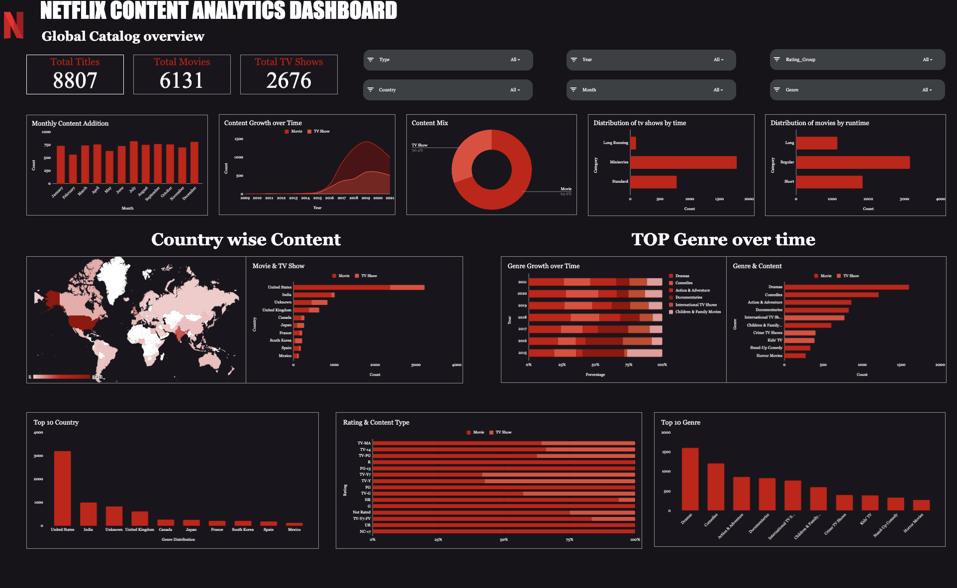

Recommendations
- Increase TV Show Investment
Gradually raise the share of TV Shows to strengthen long-term engagement and retention through episodic viewing behavior.
- Diversify Genre Portfolio
Reduce over-reliance on Drama by expanding Thriller, Sci-Fi, Documentary, and Family categories to improve catalog balance.
- Expand International Content
Increase non-US production to reduce geographic concentration (currently 3,211 US titles) and strengthen global appeal.
- Balance Rating Segmentation
Expand Teen and Kids content to improve household subscription potential while maintaining strong adult positioning.
- Maintain Low Content_Lag
Continue prioritizing timely content acquisition to preserve freshness and competitiveness.

Impact Estimation
- Cost Optimization: Diversification may improve allocation efficiency by 5–10% by reducing overinvestment in saturated genres.
- Operational Efficiency: KPI-driven monitoring can enhance strategic decision speed by 10–15%.
- Service Improvement: Stronger TV and family content mix may improve retention potential by 3–7%.
- Risk Reduction: Reducing genre and regional concentration can lower structural portfolio risk by approximately 10–15% over time.

Limitations
This analysis is limited to structured metadata and does not include financial, revenue, viewership, or engagement metrics. Therefore, conclusions reflect content distribution patterns rather than actual performance impact.
The dataset is restricted to titles available up to 2021 and may not fully represent recent strategic shifts. Missing or standardized values (e.g., country or director fields) may slightly affect distribution accuracy.
Additionally, Content_Lag and rating classifications indicate structural patterns but do not directly measure audience preference or success. As a result, findings remain descriptive and cannot establish causal business outcomes.

Future Scope
This study is limited to historical metadata analysis. Future research can enhance strategic depth by incorporating:
- Viewership and engagement data (views, watch time, churn) to measure actual performance impact.
- Revenue and cost data to evaluate ROI across genres, formats, and regions.
- Time-series forecasting to predict growth trends and optimize content mix.
- Deeper segmentation analysis, including multi-genre and multi-country overlap.
- Competitive benchmarking against other OTT platforms.
- Lifecycle analysis using expanded Content_Lag evaluation.
- Updated post-2021 data to reflect current strategy shifts.
Integrating these elements would move the analysis from descriptive insights toward predictive and optimization-driven decision-making.

Conclusion
This study analyzed 8,808 titles to evaluate structural patterns in content type, genre, country, rating, growth trends, duration, and freshness. The findings reveal a movie-heavy catalog (≈70%), strong dominance of Drama, and significant geographic concentration in the United States (3,211 titles). Adult-rated content forms the primary audience segment, while TV Shows are steadily increasing but remain secondary in volume.
The post-2015 expansion phase reflects aggressive scaling, followed by stabilization, indicating a shift toward portfolio optimization. While the platform demonstrates strong catalog growth and mature audience positioning, concentration risks in genre and geography highlight the need for strategic diversification.
Overall, the analysis shows that structured metadata and KPI-driven evaluation can effectively support informed content investment, risk reduction, and long-term portfolio balance in a competitive OTT environment.

Appendix

Data Dictionary
The following key fields were used in the analysis:
- show_id – Unique identifier for each title, used for counting total records.
- type – Indicates whether the content is a Movie or TV Show.
- release_year – Original year of release, used for age analysis.
- year_added – Year the content was added to the platform (derived from date_added), used for growth trend analysis.
- month_added – Month content was added, used for seasonal analysis.
- primary_genre – First listed genre extracted from the listed_in column, used for genre segmentation.
- primary_country – First listed country extracted from the country field, used for regional analysis.
- Rating_Group – Categorized audience segment (Adults, Teens, Kids, Other), derived from original ratings.
- duration_value – Numeric runtime (minutes for Movies or seasons for TV Shows).
- duration_unit – Indicates whether duration is measured in Minutes or Seasons.
- Duration Bin – Categorized format group (Short, Regular, Long for Movies; Miniseries, Standard, Long Running for TV Shows).
- Content_Lag – Calculated as Year_Added minus Release_Year, used to measure catalog freshness.

Contribution Matrix

Team Member | Dataset & Sourcing | Cleaning | KPI & Analysis | Dashboard | Report Writing | PPT | Overall Role
Aman Soni | ✓ | ✓ |  |  |  |  | Project Lead
Hrishi Dongre | ✓ |  |  |  | ✓ |  | Strategy Lead
Mayank Sharma |  | ✓ | ✓ | ✓ |  |  | Data Lead
Himanshu Pandey |  | ✓ | ✓ |  |  |  | Analysis Lead
Aarya Srivastav |  |  |  | ✓ |  |  | Dashboard Lead
Sarvjeet Yadav |  |  |  |  |  | ✓ | PPT & Quality  Lead
Team Signature Block: Hrishi Dongre, Aman Soni, Mayank Sharma, Aarya Srivastav, Sarvjeet Yadav, Himanshu Pandey

