Лютов Александр Владимирович №в5130904/30022

Вариант 31

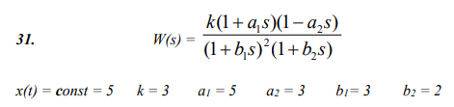

Замена переменных:

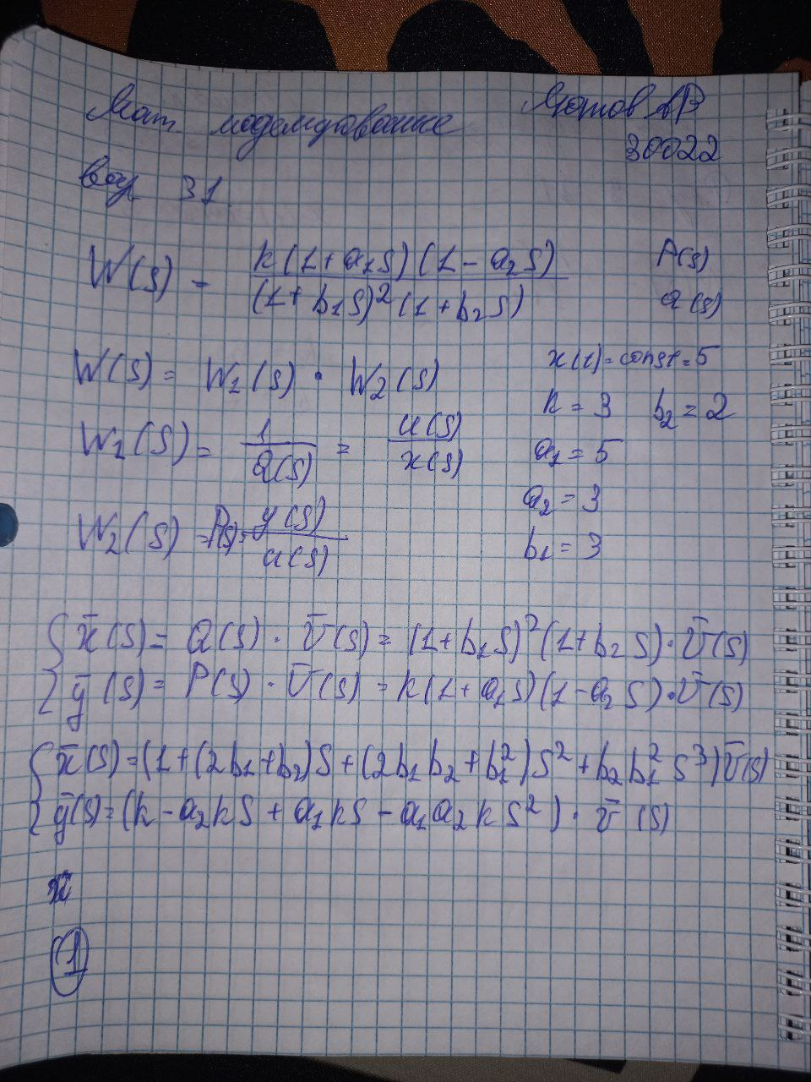

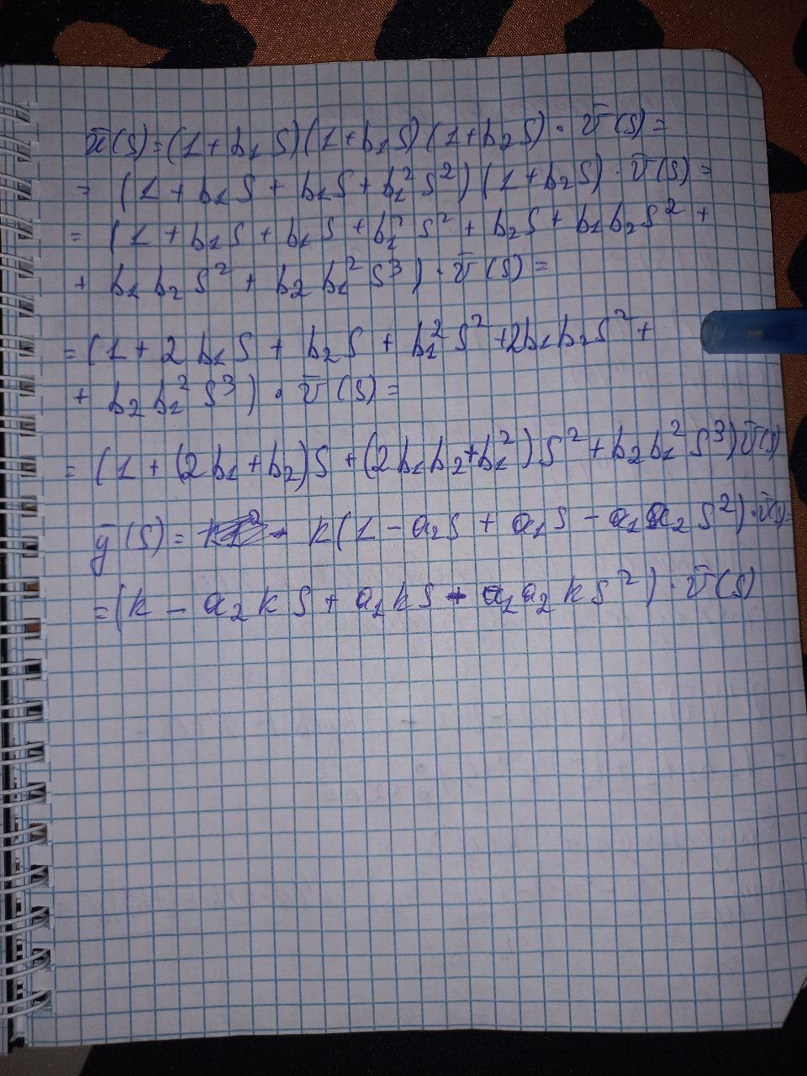

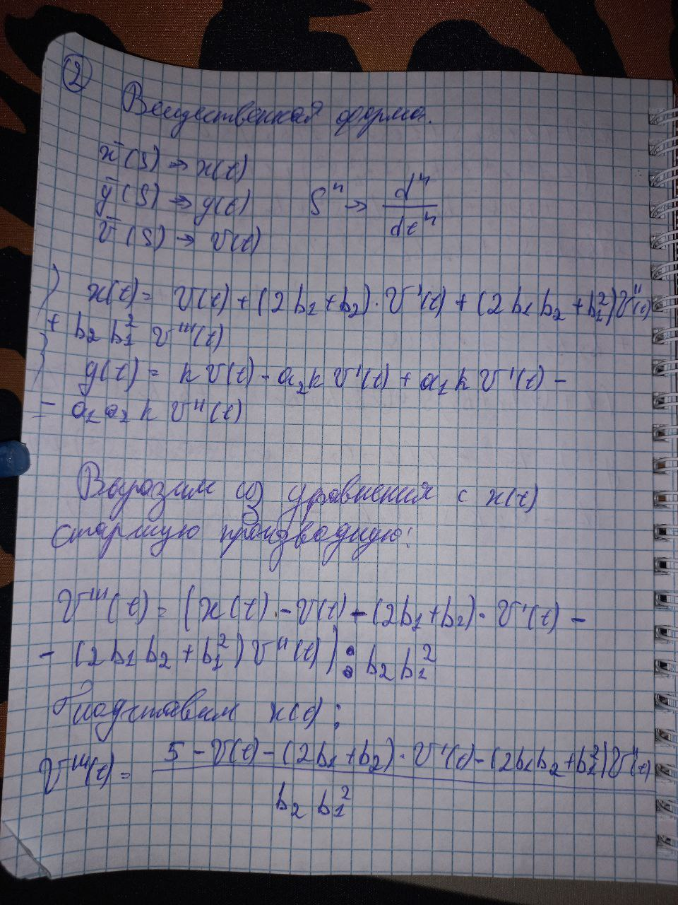

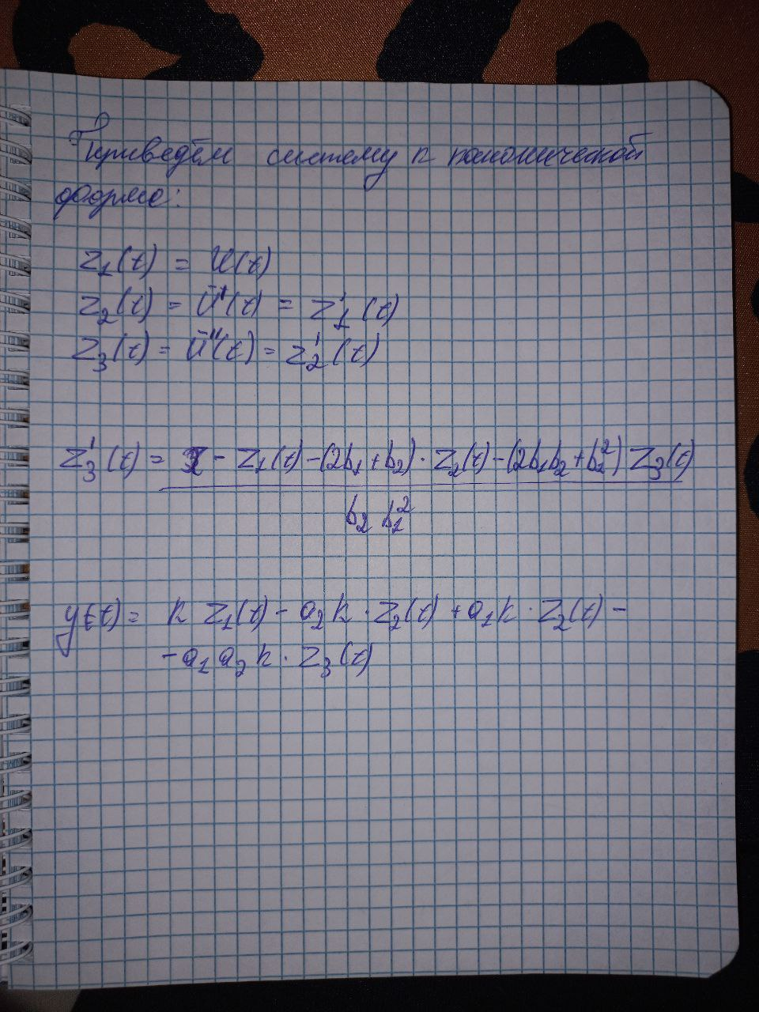

Таблица выходных значений

|  |  |
| --- | --- |
| **t** | **Y(t)** |
| 0 | 0 |
| 2 | -0,625 |
| 4 | -1,7547 |
| 6 | -2,73421 |
| 8 | -3,57512 |
| 10 | -4,28826 |
| 12 | -4,88376 |
| 14 | -5,37111 |
| 16 | -5,75916 |
| 18 | -6,05617 |
| 20 | -6,26988 |
| 22 | -6,40749 |
| 24 | -6,47571 |
| 26 | -6,48083 |
| 28 | -6,42866 |
| 30 | -6,32466 |
| 32 | -6,17386 |
| 34 | -5,98098 |
| 36 | -5,75038 |
| 38 | -5,48611 |
| 40 | -5,19193 |
| 42 | -4,87134 |
| 44 | -4,52755 |
| 46 | -4,16356 |
| 48 | -3,78212 |
| 50 | -3,38578 |
| 52 | -2,97689 |
| 54 | -2,55761 |
| 56 | -2,12993 |
| 58 | -1,69568 |
| 60 | -1,25653 |
| 62 | -0,814019 |
| 64 | -0,369545 |
| 66 | 0,0756132 |
| 68 | 0,520294 |
| 70 | 0,963443 |
| 72 | 1,4041 |
| 74 | 1,84141 |
| 76 | 2,2746 |
| 78 | 2,70296 |
| 80 | 3,12588 |
| 82 | 3,54281 |
| 84 | 3,95326 |
| 86 | 4,3568 |
| 88 | 4,75306 |
| 90 | 5,14172 |
| 92 | 5,5225 |
| 94 | 5,89517 |
| 96 | 6,25955 |
| 98 | 6,61548 |
| 100 | 6,96283 |
| 102 | 7,30152 |
| 104 | 7,63149 |
| 106 | 7,9527 |
| 108 | 8,26515 |
| 110 | 8,56884 |
| 112 | 8,8638 |
| 114 | 9,15008 |
| 116 | 9,42774 |
| 118 | 9,69687 |
| 120 | 9,95756 |
| 122 | 10,2099 |
| 124 | 10,454 |
| 126 | 10,69 |
| 128 | 10,9181 |
| 130 | 11,1383 |
| 132 | 11,3508 |
| 134 | 11,5557 |
| 136 | 11,7533 |
| 138 | 11,9437 |
| 140 | 12,1269 |
| 142 | 12,3033 |
| 144 | 12,4729 |
| 146 | 12,636 |
| 148 | 12,7926 |
| 150 | 12,943 |
| 152 | 13,0873 |
| 154 | 13,2256 |
| 156 | 13,3583 |
| 158 | 13,4853 |
| 160 | 13,607 |
| 162 | 13,7233 |
| 164 | 13,8346 |
| 166 | 13,9409 |
| 168 | 14,0425 |
| 170 | 14,1394 |
| 172 | 14,2318 |
| 174 | 14,3198 |
| 176 | 14,4037 |
| 178 | 14,4836 |
| 180 | 14,5595 |
| 182 | 14,6316 |
| 184 | 14,7001 |
| 186 | 14,7651 |
| 188 | 14,8267 |
| 190 | 14,885 |
| 192 | 14,9402 |
| 194 | 14,9924 |
| 196 | 15,0417 |
| 198 | 15,0881 |
| 200 | 15,1319 |
| 202 | 15,1731 |
| 204 | 15,2118 |
| 206 | 15,2482 |
| 208 | 15,2822 |
| 210 | 15,3141 |
| 212 | 15,3439 |
| 214 | 15,3716 |
| 216 | 15,3975 |
| 218 | 15,4215 |
| 220 | 15,4437 |
| 222 | 15,4642 |
| 224 | 15,4832 |
| 226 | 15,5006 |
| 228 | 15,5165 |
| 230 | 15,5311 |
| 232 | 15,5443 |
| 234 | 15,5562 |
| 236 | 15,5669 |
| 238 | 15,5765 |
| 240 | 15,585 |
| 242 | 15,5924 |
| 244 | 15,5988 |
| 246 | 15,6043 |
| 248 | 15,6089 |
| 250 | 15,6127 |
| 252 | 15,6157 |
| 254 | 15,6179 |
| 256 | 15,6194 |
| 258 | 15,6202 |
| 260 | 15,6204 |
| 262 | 15,62 |
| 264 | 15,619 |
| 266 | 15,6175 |
| 268 | 15,6155 |
| 270 | 15,613 |
| 272 | 15,6101 |
| 274 | 15,6068 |
| 276 | 15,603 |
| 278 | 15,599 |
| 280 | 15,5946 |
| 282 | 15,5899 |
| 284 | 15,5849 |
| 286 | 15,5796 |
| 288 | 15,5741 |
| 290 | 15,5683 |
| 292 | 15,5624 |
| 294 | 15,5563 |
| 296 | 15,55 |
| 298 | 15,5435 |
| 300 | 15,5369 |
| 302 | 15,5302 |
| 304 | 15,5234 |
| 306 | 15,5164 |
| 308 | 15,5094 |
| 310 | 15,5023 |
| 312 | 15,4952 |
| 314 | 15,488 |
| 316 | 15,4807 |
| 318 | 15,4734 |
| 320 | 15,4661 |
| 322 | 15,4588 |
| 324 | 15,4515 |
| 326 | 15,4442 |
| 328 | 15,4369 |
| 330 | 15,4295 |
| 332 | 15,4223 |
| 334 | 15,415 |
| 336 | 15,4078 |
| 338 | 15,4006 |
| 340 | 15,3935 |
| 342 | 15,3864 |
| 344 | 15,3793 |
| 346 | 15,3723 |
| 348 | 15,3654 |
| 350 | 15,3585 |
| 352 | 15,3517 |
| 354 | 15,345 |
| 356 | 15,3383 |
| 358 | 15,3317 |
| 360 | 15,3252 |
| 362 | 15,3187 |
| 364 | 15,3123 |
| 366 | 15,306 |
| 368 | 15,2998 |
| 370 | 15,2937 |
| 372 | 15,2877 |
| 374 | 15,2817 |
| 376 | 15,2758 |
| 378 | 15,27 |
| 380 | 15,2643 |
| 382 | 15,2587 |
| 384 | 15,2532 |
| 386 | 15,2477 |
| 388 | 15,2424 |
| 390 | 15,2371 |
| 392 | 15,2319 |
| 394 | 15,2268 |
| 396 | 15,2218 |
| 398 | 15,2169 |
| 400 | 15,212 |
| 402 | 15,2073 |
| 404 | 15,2026 |
| 406 | 15,198 |
| 408 | 15,1935 |
| 410 | 15,1891 |
| 412 | 15,1848 |
| 414 | 15,1805 |
| 416 | 15,1764 |
| 418 | 15,1723 |
| 420 | 15,1683 |
| 422 | 15,1643 |
| 424 | 15,1605 |
| 426 | 15,1567 |
| 428 | 15,153 |
| 430 | 15,1494 |
| 432 | 15,1458 |
| 434 | 15,1423 |
| 436 | 15,1389 |
| 438 | 15,1356 |
| 440 | 15,1323 |
| 442 | 15,1291 |
| 444 | 15,126 |
| 446 | 15,1229 |
| 448 | 15,1199 |
| 450 | 15,117 |
| 452 | 15,1141 |
| 454 | 15,1113 |
| 456 | 15,1085 |
| 458 | 15,1059 |
| 460 | 15,1032 |
| 462 | 15,1007 |
| 464 | 15,0982 |
| 466 | 15,0957 |
| 468 | 15,0933 |
| 470 | 15,091 |
| 472 | 15,0887 |
| 474 | 15,0864 |
| 476 | 15,0842 |
| 478 | 15,0821 |
| 480 | 15,08 |
| 482 | 15,078 |
| 484 | 15,076 |
| 486 | 15,0741 |
| 488 | 15,0722 |
| 490 | 15,0703 |
| 492 | 15,0685 |
| 494 | 15,0667 |
| 496 | 15,065 |
| 498 | 15,0633 |
| 500 | 15,0617 |
| 502 | 15,0601 |
| 504 | 15,0585 |
| 506 | 15,057 |
| 508 | 15,0555 |
| 510 | 15,054 |
| 512 | 15,0526 |
| 514 | 15,0512 |
| 516 | 15,0499 |
| 518 | 15,0486 |
| 520 | 15,0473 |
| 522 | 15,046 |
| 524 | 15,0448 |
| 526 | 15,0436 |
| 528 | 15,0425 |
| 530 | 15,0414 |
| 532 | 15,0402 |
| 534 | 15,0392 |
| 536 | 15,0381 |
| 538 | 15,0371 |
| 540 | 15,0361 |
| 542 | 15,0351 |
| 544 | 15,0342 |
| 546 | 15,0333 |
| 548 | 15,0324 |
| 550 | 15,0315 |
| 552 | 15,0307 |
| 554 | 15,0298 |
| 556 | 15,029 |
| 558 | 15,0282 |
| 560 | 15,0275 |
| 562 | 15,0267 |
| 564 | 15,026 |
| 566 | 15,0253 |
| 568 | 15,0246 |
| 570 | 15,0239 |
| 572 | 15,0233 |
| 574 | 15,0226 |
| 576 | 15,022 |

График выходных значений

Проверка при помощи вычисления предела:

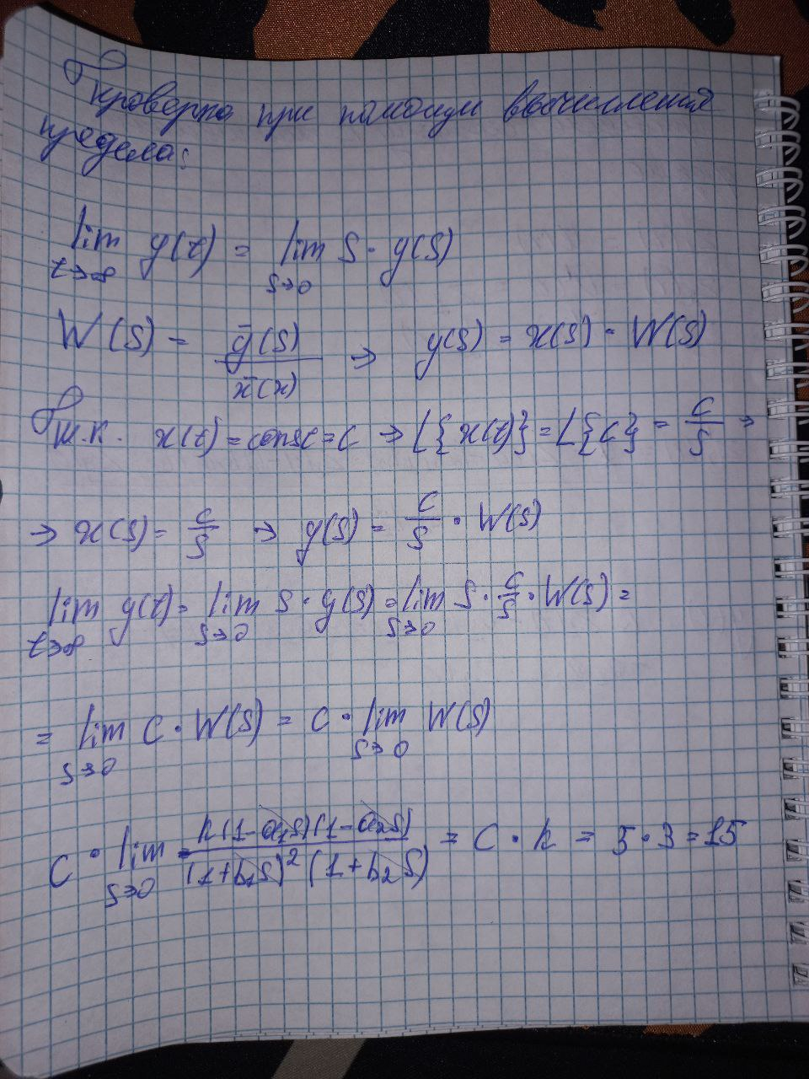

Вывод:

Переходный период для выходных значений Y(t) заканчивается при значении t = 526

Код программы:

#include <iostream>

#include <fstream>

#include <vector>

struct Point {

int t = 0;

double y = 0.0;

};

std::vector<Point> AilerCalc(double x, double k, double a1, double a2, double b1, double b2, int nIter = 1000, double h = 0.05) {

std::vector<Point> res(nIter);

double z1 = 0;

double z2 = 0;

double z3 = 0;

double dz1 = 0;

double dz2 = 0;

double dz3 = 0;

Point yRes;

for (int i = 1; i < nIter; ++i) {

dz1 = z1 + h * z2;

dz2 = z2 + h * z3;

dz3 = z3 + h * ((x - z1 - (2 * b1 + b2) * z2 - (2 * b1 * b2 + b1 * b1) * z3) / (b2 * b1 * b1));

res[i] = { i, k * z1 - a2 * k * z2 + a1 * k * z2 - a1 * a2 * k * z3 };

z1 = dz1;

z2 = dz2;

z3 = dz3;

}

return res;

}

int main()

{

const int x = 5;

const int k = 3;

const int a1 = 5;

const int a2 = 3;

const int b1 = 3;

const int b2 = 2;

std::ofstream file("outputData.txt");

if (!file.is_open()) {

std::cout << "Error open file!";

return 1;

}

std::vector<Point> data = AilerCalc(x, k, a1, a2, b1, b2);

file << "t" << "\t" << "y" << "\n";

for (const auto& p : data) {

file << p.t << "\t" << p.y << "\n";

}

return 0;

}