

Terminology of Neural Network and Types of Activation Functions
Artificial Neural Networks (ANNs)

Introduction
Artificial Neural Networks (ANNs) are computational models inspired by the structure and functioning of the human brain. They are widely used in Machine Learning and Artificial Intelligence for tasks such as image recognition, speech processing, natural language processing, and prediction systems. A neural network consists of interconnected nodes called neurons that work together to process information and learn patterns from data.

Terminology of Neural Network
Understanding the basic terminology of neural networks is essential for learning deep learning concepts.

1. Neuron (Node)
A neuron is the fundamental processing unit of a neural network. It receives inputs, processes them, and produces an output. Similar to biological neurons, artificial neurons communicate with each other through connections.
- Receives input data
- Multiplies inputs by weights
- Adds bias
- Applies an activation function
- Produces output

2. Input Layer
The input layer is the first layer of a neural network. It receives raw data from the outside world and passes it to the hidden layers.
- Image pixels
- Text data
- Sensor readings

3. Hidden Layer
Hidden layers are located between the input and output layers. These layers perform computations and extract important features from the data.
- Learn complex patterns
- Improve prediction accuracy
- Enable deep learning models

4. Output Layer
The output layer provides the final result of the neural network.
- Classification of images
- Prediction of prices
- Sentiment analysis results

5. Weights
Weights determine the importance of each input. During training, the network adjusts weights to minimize errors.
- Higher weight → greater influence
- Lower weight → lesser influence

6. Bias
Bias is an additional parameter added to neurons. It helps the network fit the data more effectively and improves learning capability.
- Increases flexibility
- Improves accuracy
- Helps in shifting activation functions

7. Activation Function
An activation function determines whether a neuron should be activated or not. It introduces non-linearity into the network.
- Enables learning of complex patterns
- Helps make decisions
- Improves model performance

8. Epoch
An epoch represents one complete cycle through the entire training dataset.
- Example: If a dataset contains 1000 samples and the network processes all samples once, it completes one epoch.

9. Learning Rate
The learning rate controls how much the weights are updated during training.
- High learning rate: Faster learning but may miss optimal solutions.
- Low learning rate: Slower learning but more accurate.

10. Loss Function
A loss function measures the difference between actual output and predicted output.
- Mean Squared Error (MSE)
- Cross Entropy Loss
- Hinge Loss

Types of Activation Functions
Activation functions play a crucial role in neural networks. They decide how information flows through the network.

1. Binary Step Function
The Binary Step Function produces either 0 or 1 as output.
Formula:
- Output = 1 if x ≥ 0
- Output = 0 if x < 0
Advantages:
- Simple implementation
- Easy to understand
Disadvantages:
- Cannot handle complex problems
- Not suitable for deep learning

2. Linear Activation Function
The output is directly proportional to the input.
Formula:
- f(x) = x
Advantages:
- Simple computation
Disadvantages:
- Cannot solve non-linear problems
- Limited learning capability

3. Sigmoid Function
The Sigmoid function converts values into a range between 0 and 1.
Formula:
- f(x) = 1 / (1 + e⁻ˣ)
Advantages:
- Useful for binary classification
- Produces probability values
Disadvantages:
- Vanishing gradient problem
- Slow convergence

4. Tanh Function
The Tanh function outputs values between -1 and 1.
Formula:
- f(x) = tanh(x)
Advantages:
- Zero-centered output
- Better than sigmoid in many cases
Disadvantages:
- Still suffers from vanishing gradients

5. ReLU (Rectified Linear Unit)
ReLU is one of the most widely used activation functions.
Formula:
- f(x) = max(0, x)
Advantages:
- Fast computation
- Reduces vanishing gradient problem
- Widely used in deep learning
Disadvantages:
- Dead neuron problem

6. Leaky ReLU
Leaky ReLU allows small negative values instead of zero.
Formula:
- f(x) = x, if x > 0
- f(x) = 0.01x, if x < 0
Advantages:
- Solves dead neuron problem
- Better gradient flow
Disadvantages:
- Slightly more complex

7. Softmax Function
Softmax converts outputs into probability values whose sum equals 1.
Applications:
- Multi-class classification
- Image recognition
- Language processing
Advantages:
- Provides probability distribution
- Useful for classification tasks

Activation Function Illustrations
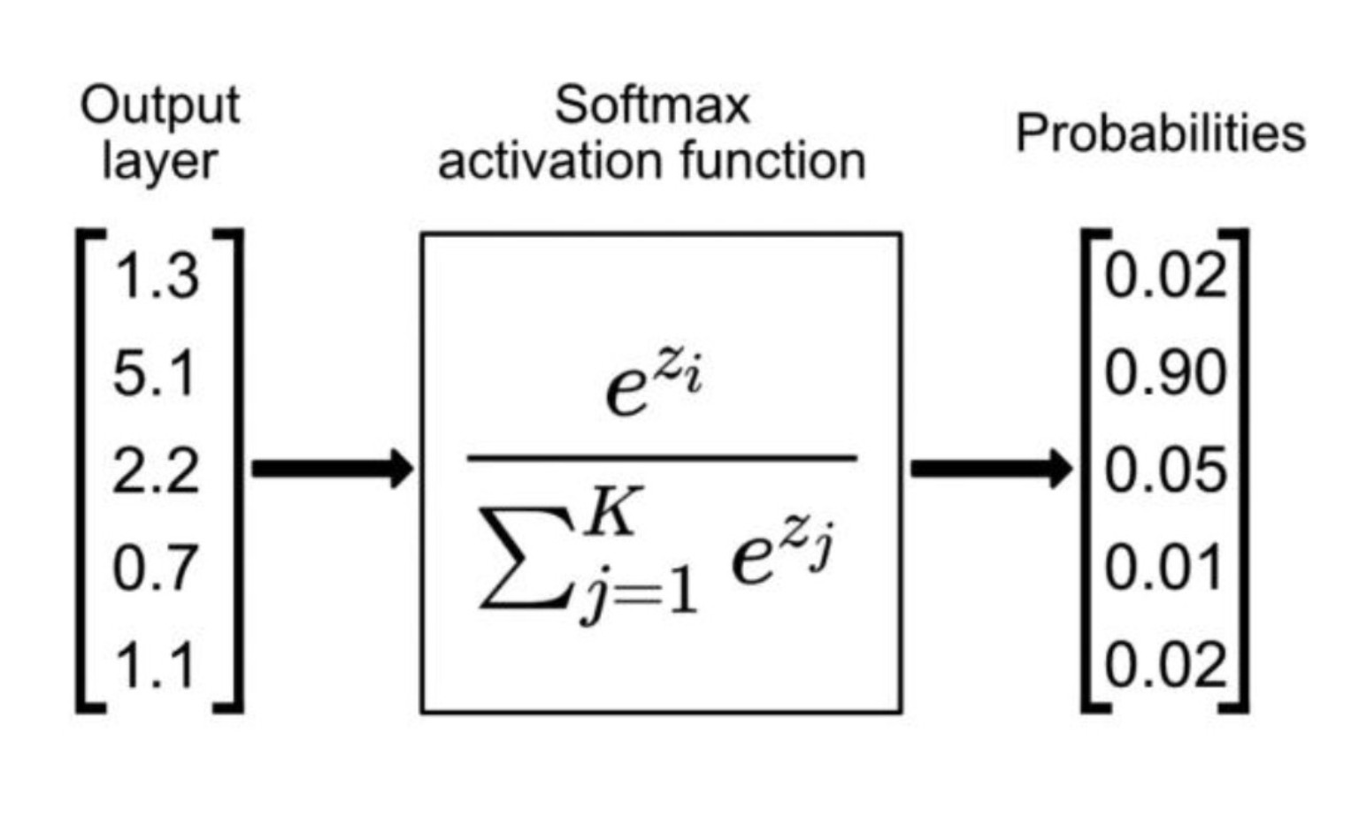
Figure 1: Softmax activation and probability distribution
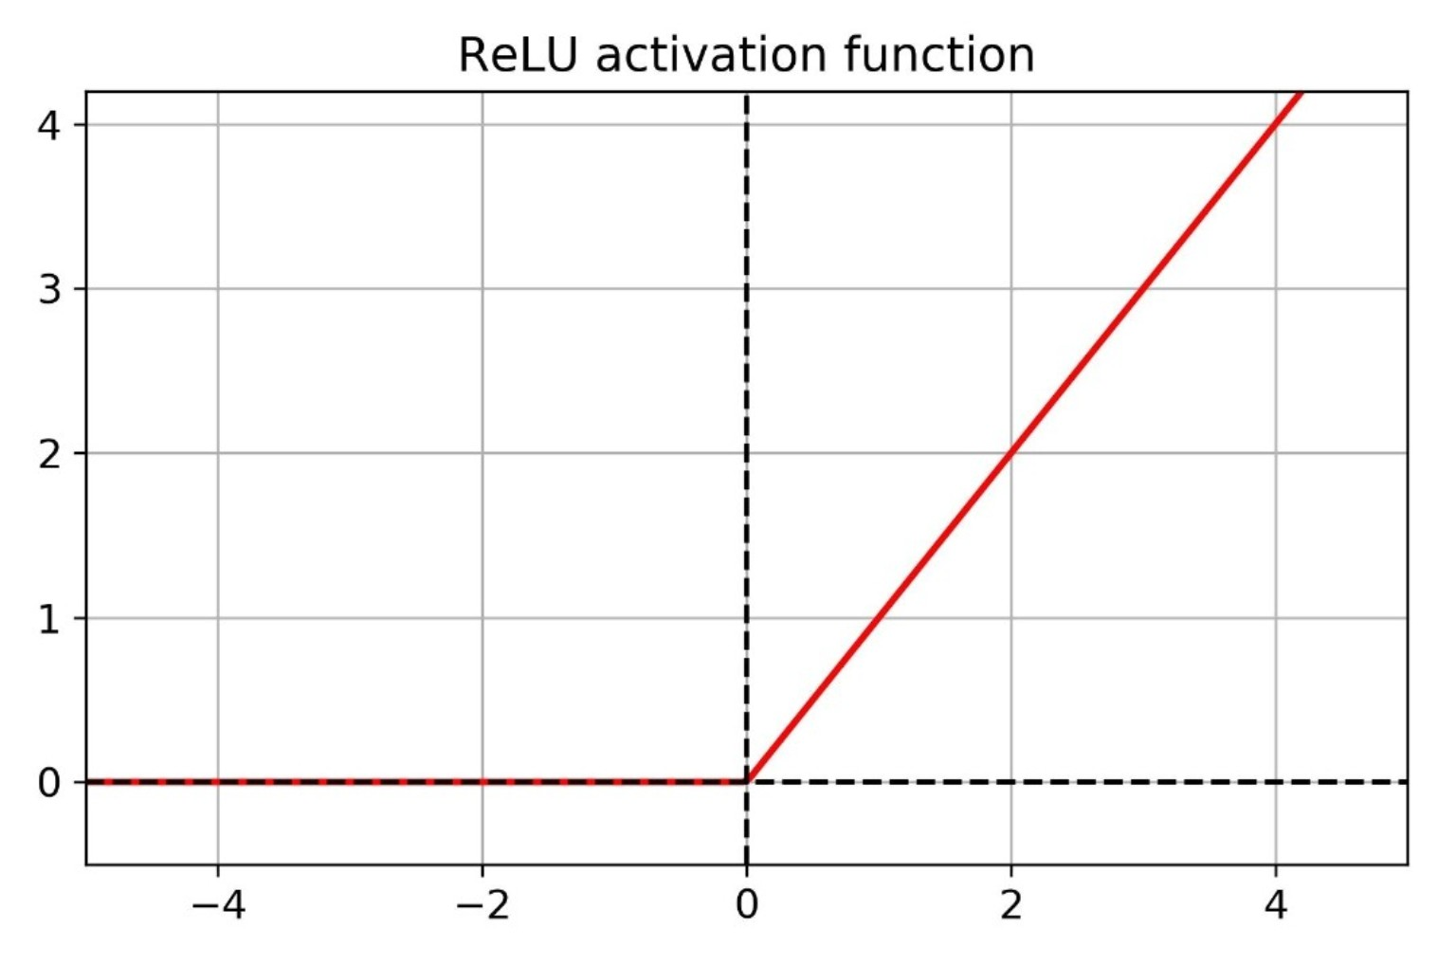
Figure 2: ReLU activation function
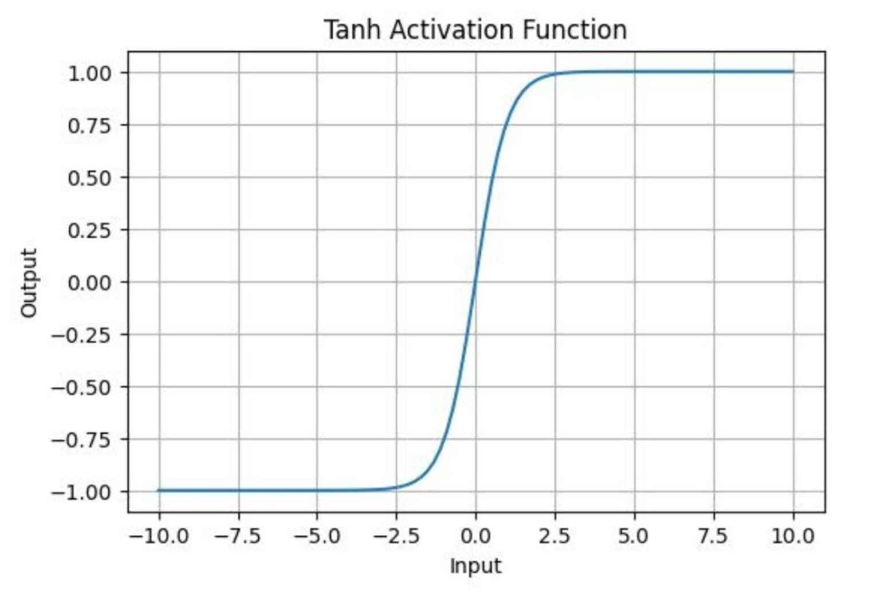
Figure 3: Tanh activation function
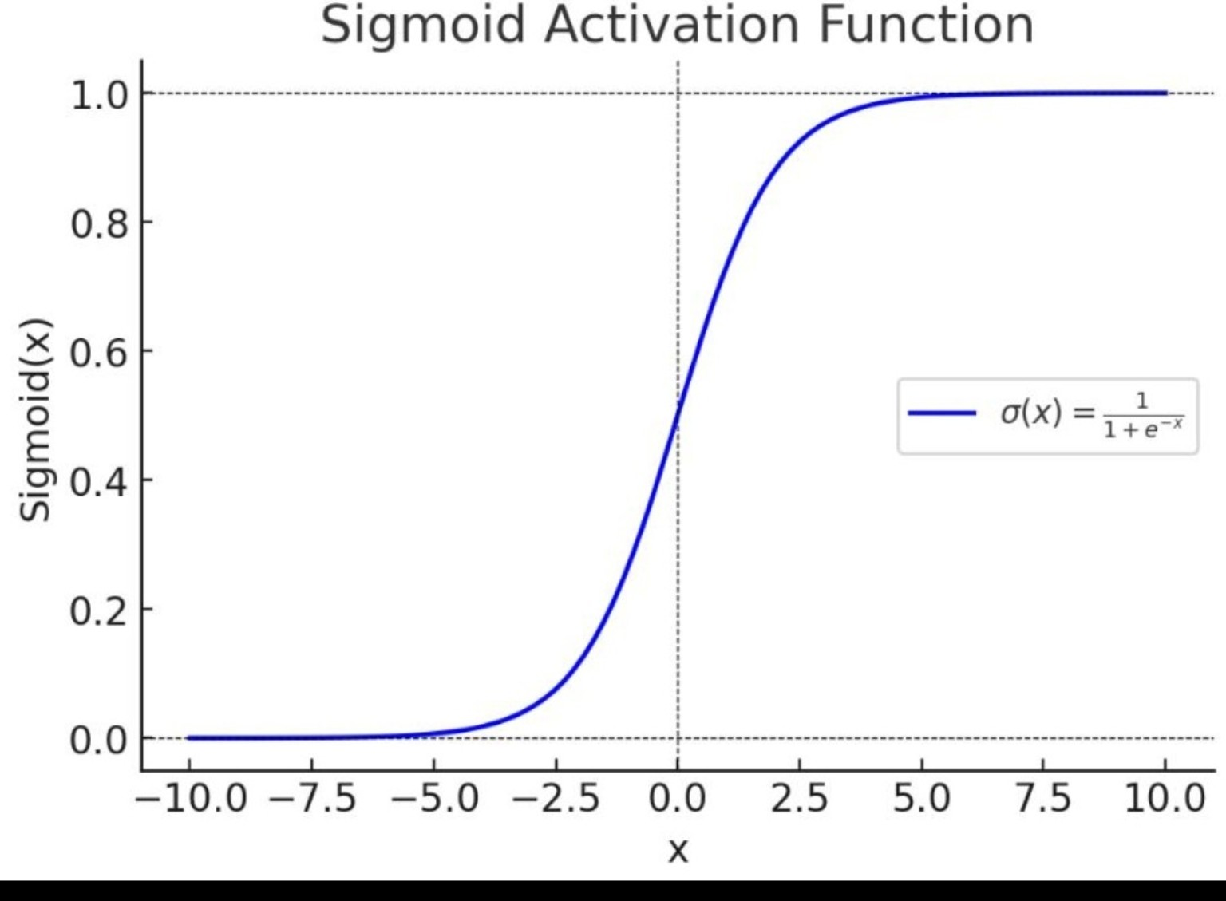
Figure 4: Sigmoid activation function

Applications of Neural Networks
- Image Recognition
- Speech Recognition
- Medical Diagnosis
- Fraud Detection
- Self-Driving Cars
- Recommendation Systems
- Natural Language Processing
- Robotics

Advantages of Neural Networks
- Learns complex patterns
- Handles large datasets
- High prediction accuracy
- Supports automation
- Useful in AI applications

Conclusion
Neural Networks are powerful machine learning models inspired by the human brain. They consist of neurons, layers, weights, biases, activation functions, and learning mechanisms that enable intelligent decision-making. Activation functions such as Sigmoid, Tanh, ReLU, Leaky ReLU, and Softmax play a vital role in improving network performance. Due to their ability to learn from data and solve complex problems, neural networks have become a foundation of modern Artificial Intelligence and Deep Learning systems.

