**Functional requirement**

**1. Registration process**

* The user cannot be using our web application without login

***2. Efficient Task Creation:***

* The system should provide a "Create Task" functionality.
* Users must be able to input task details, including task name, description, and priority.

***3. Task Assignment:***

* The system should allow task assignment to specific team members.
* Users should be able to view and manage their assigned tasks.
* An option for reassignment of tasks should be provided.

***4. Deadline Management:***

* Users should be able to set deadlines for tasks during task creation or later modification.
* The system must send notifications or reminders for approaching deadlines.

***4.* Show Tasks**

* The system should be able to show tasks for user smoothly

**6. Task Done**

* The user can assign that the task is Done

**Non-Functional requirement**

***1. Performance:***

* The system should respond to user actions within a maximum of 2 seconds.
* It should be capable of handling concurrent users without significant performance degradation.

***2. Scalability:***

* The system should scale horizontally to accommodate an increasing number of users and tasks.
* It should handle a growing database of tasks and users without a significant impact on performance.

***3. Reliability:***

* The system should have an uptime of at least 99.9%.
* Regular backups should be performed, and data recovery procedures should be in place.

***4. Security:***

* The system must comply with industry standards for data security and privacy.
* Protection against common security threats such as SQL injection and cross-site scripting.

***5. Usability:***

* The user interface should be consistent across different devices and browsers.
* The system should be accessible to users with disabilities, following accessibility standards.

***6. Availability:***

* The system should be available 24/7, with planned maintenance communicated to users in advance.
* Redundancy and failover mechanisms should be in place to ensure continuous availability.

***8. Compatibility:***

* The system should be compatible with the latest versions of common web browsers.
* Compatibility with mobile devices and responsive design for various screen sizes.

***9. Documentation:***

* Comprehensive documentation for users, administrators, and developers.
* Clear guidelines on system setup, configuration, and troubleshooting.

***10. User-Friendly Interface:***

* The interface should be intuitive and easy to navigate.
* Responsive design for various devices.

***11. Customization of Task Shape:***

* Users should have the option to customize the visual representation of tasks, including shapes.
* A user-friendly interface for selecting and changing the shape of tasks.
* Support for various shapes, such as circles, rectangles, and custom shapes.

Use Cases Diagram

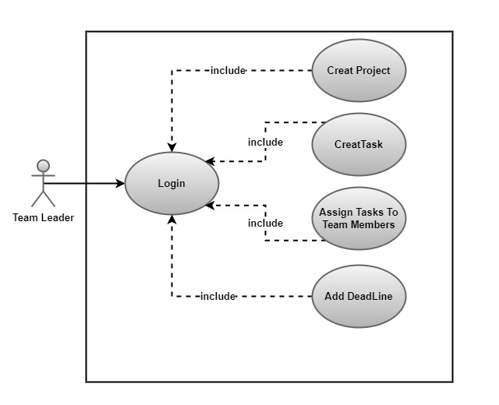

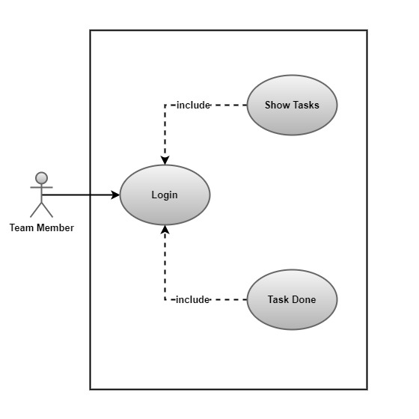

Use Cases Scenario

**Use Case**: Create Task

**Primary Actor**: User

**Preconditions:**

The user is logged into the task management system.

**happy Flow:**

* The user navigates to the "Create Task" section of the task management system.
* The user writes a title of the task and description
* The user submits the task creation form.
* The system validates the entered information to ensure it meets the required criteria (e.g., no empty fields, valid due date format).
* If validation is successful, the system creates a new task
* The user is redirected to the task list, where the newly created task is now visible.

**Post conditions:**

* A new task is successfully created and added to the user's task list.

**Alternative Flows:**

Alternative Flow 1: Task Creation Cancelled

* After navigating to the "Create Task" section, the user decides to cancel the task creation.
* The user clicks on the "Cancel" button.
* The system confirms the cancellation, discards the entered information, and redirects the user back to the task list without creating a new task.

Alternative Flow 2: Title and Description Editing

* After submitting the task creation form, the system validates the entered information.
* If the validation fails, the system displays error messages and highlights the specific issues.
* The user decides to edit the title and description to address the validation errors.
* The user makes the necessary edits and resubmits the form.
* The system re-validates the entered information, and if successful, creates the new task and redirects the user to the task list.

Alternative Flow3: System Error and network issues

* After submitting the task creation form, the system encounters an internal error.
* The system displays a generic error message and apologizes for the inconvenience.
* The user is advised to contact support for further assistance.
* The entered information is not saved, and the user is redirected back to the task list without creating a new task.
* After submitting the task creation form, the system encounters network connection issues.
* The system displays an error message indicating the connectivity problem.

**Use Case**: Login

**Primary Actor**: User

**happy Flow:**

* The user opens the task management system application.
* The user enters their valid credentials.
* The system verifies the entered credentials against the stored user data.

**Alternative Flows:**

Alternative Flow 1: Account Lockout

* After entering invalid credentials multiple times, the system detects suspicious activity.
* The system temporarily locks the user's account for security reasons.
* The user is notified about the account lockout and provided with instructions on how to unlock their account (e.g., through a password reset or contacting support).
* The user follows the instructions to unlock their account.

Alternative Flow 2: Password Expiry

* The user logs in successfully, but the system detects that the user's password has expired.
* The system prompts the user to change their password before proceeding.
* The user enters a new password that meets the system's password policy requirements.
* The system updates the password and allows the user to access the task management system.

Alternative Flow 3: Social Login

* The task management system supports social login options (e.g., logging in with Google or Facebook).
* The user chooses the social login option instead of entering traditional credentials.
* The system redirects the user to the chosen social platform's login page.
* The user logs in through the social platform, and the system verifies the provided credentials.
* Upon successful verification, the user is redirected back to the task management system with access granted.

**Post conditions:**

The user is successfully logged into the task management system and gains access to their personalized dashboard.

**Use Case**: Assign Task

**Primary Actor**: User (who assigns the task)

**Preconditions:**

The user is logged into the task management system.

**happy Flow:**

* The user navigates to the task list or details page.
* The user selects a specific task that needs to be assigned to another user.
* The system displays options for task actions, including "Assign" or a similar action.
* The user selects the "Assign" option.
* The user selects the intended assignee from the list or search results.
* The user confirms the assignment, and the system updates the task's information to reflect the new assignee.
* The system notifies both the user who assigned the task and the assigned user about the task assignment.

**Alternative Flow:**

Alternative Flow 1: Invalid Assignee Selection

* After selecting the "Assign" option, the user attempts to assign the task to an invalid or non-existent user.
* The system displays an error message indicating that the selected assignee is not valid.
* The user is prompted to choose a valid assignee or correct the selection.
* Once the user provides a valid assignee, the system proceeds with the assignment.

Alternative Flow 2: Reassignment of Already Assigned Task

* The user attempts to assign a task that is already assigned to another user.
* The system displays a confirmation message indicating that the task is currently assigned to a different user.
* The user decides whether to proceed with the reassignment, cancel the operation, or go back to the task list.
* If the user proceeds, the system updates the task's assignee to the newly selected user, and notifications are sent to both the old and new assignees.

Alternative Flow 3: Task Unavailability

* While attempting to assign a task, the system detects that the task is no longer available or has been completed.
* The system displays a message notifying the user that the task cannot be assigned due to its current status.
* The user is prompted to choose a different task or go back to the task list.

Alternative Flow 4: Task Assignment Cancellation

* After selecting the "Assign" option, the user decides to cancel the assignment.
* The user clicks on the "Cancel" or "Go Back" option.
* The system confirms the cancellation, and the assignment operation is aborted.
* The system returns the user to the task details page without making any changes.

**Post conditions:**

The task is successfully assigned to the selected user, and the task details are updated to reflect the new assignee.

**Use Case**: Assign Task with Deadline

**Primary Actor**: User (who assigns the task)

**Preconditions:**

The user is logged into the task management system.

**happy Flow:**

* The user navigates to the task list or details page.
* The user selects a specific task that needs to be assigned to another user.
* The system displays options for task actions, including "Assign" or a similar action.
* The user selects the "Assign" option.
* The system presents a list of users or a search to find the user to whom the task it’s
* The user selects the intended assignee from the list or search results.
* The user sets a deadline for the task, either by selecting a date from a calendar or entering it manually.
* The system notifies both the user who assigned the task and the assigned user about the task assignment and deadline.

**Alternative Flow:**

Alternative Flow 1: Invalid Deadline

* After setting the deadline for the task, the user enters an invalid date (e.g., a past date).
* The system displays an error message indicating that the entered deadline is not valid.
* The user is prompted to correct the deadline by selecting a future date.
* Once the user provides a valid deadline, the system proceeds with the assignment, and notifications are sent to both the user who assigned the task and the assigned user.

Alternative Flow 2: Deadline Modification

* After setting the initial deadline, the user decides to modify the deadline before confirming the assignment.
* The user edits the deadline by either selecting a new date or adjusting the previously entered date.
* The system validates the updated deadline.
* If the new deadline is valid, the system proceeds with the assignment using the modified deadline.
* Notifications are sent to both the user who assigned the task and the assigned user with the updated deadline information.

Alternative Flow 3: Network Connection Issues

* After confirming the assignment with a deadline, the system encounters network connection issues.
* The system displays an error message indicating the connectivity problem.
* The user is advised to check their internet connection and try assigning the task again.
* Once the connection is restored, the user can retry the assignment with the deadline, and the system updates the task details accordingly.

**Post conditions:**

The task is successfully assigned to the selected user with the specified deadline, and the task details are updated accordingly.

**Use Case:** Assign Task to Team Member with Deadline

**Primary Actor:** Team Lead or User with Team Management Permissions

**Preconditions:**

* The user is logged into the task management system.
* The user has team management permissions or is a team lead.

**happy Flow:**

* The user navigates to the team management or task list section.
* The user selects a specific task that needs to be assigned to a team member.
* The system displays options for task actions, including "Assign" or a similar action.
* The user selects the "Assign" option.
* The system presents a list of team members or a search functionality to find the team member to whom the task will be assigned.
* The user selects the intended team member from the list or search results.
* The user sets a deadline for the task, either by selecting a date from a calendar or entering it manually.

**Alternative Flow:**

Alternative Flow 1: Team Member Unavailability

* After selecting the intended team member for task assignment, the system detects that the selected team member is currently unavailable or has a conflicting schedule.
* The system displays a message notifying the user that the task assignment may not be feasible due to the team member's unavailability.
* The user is prompted to either choose a different team member or adjust the task's deadline to accommodate the team member's availability.
* Once the user makes the necessary adjustments, the system proceeds with the assignment.

Alternative Flow 2: Task Assignment with Subtasks

* The task to be assigned has subtasks associated with it.
* The user, while assigning the task, is prompted to decide whether the subtasks should be automatically assigned to the same team member or assigned separately.
* The user makes a selection, and the system updates the task and subtask assignments accordingly.
* Notifications are sent to both the user who assigned the task and the assigned team member(s).

Alternative Flow 3: Task Reassignment to Another Team Member

* After successfully assigning a task to a team member, the user decides to reassign the task to another team member.
* The user selects the assigned task and chooses the "Reassign" option.
* The system presents the list of team members or search functionality again.
* The user selects the new team member, updates the deadline if necessary, and confirms the reassignment.
* The system updates the task details and notifies both the user who reassigned the task and the newly assigned team member.

Alternative Flow 4: Team Member Deactivation

* While attempting to assign a task, the system detects that the intended team member is currently deactivated or no longer part of the team.
* The system displays a message notifying the user about the team member's status.
* The user is prompted to either reactivate the team member, choose a different team member, or go back to the task list.

Alternative Flow 5: Network Connection Issues

* After confirming the assignment with a deadline, the system encounters network connection issues.
* The system displays an error message indicating the connectivity problem.
* The user is advised to check their internet connection and try assigning the task again.
* Once the connection is restored, the user can retry the assignment with the deadline, and the system updates the task details accordingly.

**Post conditions:**

The task is successfully assigned to the selected team member with the specified deadline, and the task details are updated accordingly.

**Use Case:** Show Tasks

**Primary Actor:** User

**Preconditions:**

The user is logged into the task management system.

**happy Flow:**

* The user navigates to the task dashboard or task list section.
* The system retrieves and displays a list of tasks associated with the user.
* The user can apply filters or sorting options to customize the view of the tasks based on criteria such as status, priority, or due date.
* The system presents the filtered or sorted list of tasks to the user.

**Alternative Flow:**

Alternative Flow 1: Empty Task List

* After navigating to the task dashboard or task list section, the system retrieves and displays an empty list of tasks.
* The user sees a message indicating that there are no tasks currently assigned or associated with their account.
* The user may choose to create a new task or go back to the task list later.

Alternative Flow 2: Task List Update

* While viewing the list of tasks, the system detects that updates have been made to the tasks (e.g., status changes, new tasks added).
* The system automatically refreshes the task list to reflect the latest changes.
* The user can also manually trigger a refresh if needed.

Alternative Flow 3: Task List Filtering by Project or Team

* The user, instead of applying individual filters, navigates to a specific project or team section.
* The system automatically filters the task list to show only tasks associated with the selected project or team.
* The user can then apply additional filters within the context of the selected project or team

**Post conditions:**

The user can see a comprehensive and customized list of tasks based on their preferences and filters.

Sequence Diagram

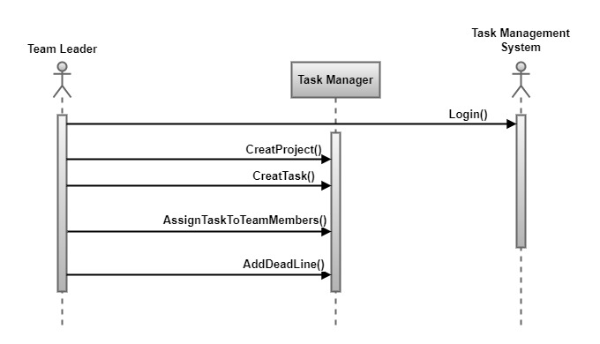

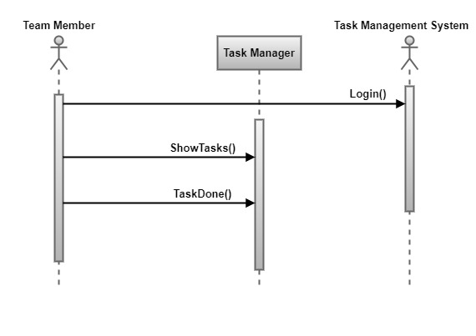

ERD

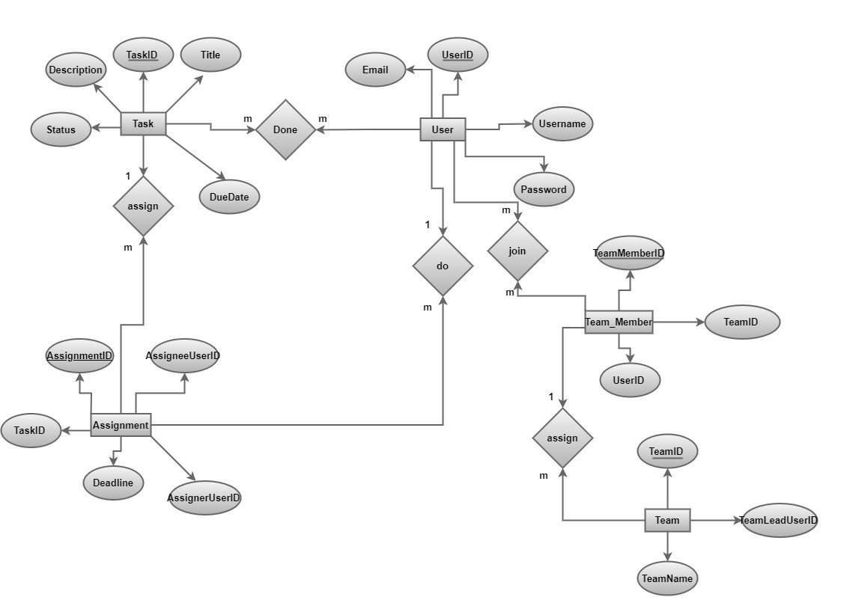

Class Diagram

