Computer Architecture Lab
(EL-2012)
LABORATORY REPORT

Fall 2026

(Lab#09)
Implementation of a Register File using ModelSim

Student Name: Muhammad Abdullah Tanveer Roll No: 24i-6508 Section: A

Date performed:21,10, 2026
MARKS AWARDED: ________ / 10

Signature and date of Instructor: _________________
Lab Instructors: Dr. Nasir Ali Shah, Engr. Fasih Ahmad

______________________________________________________________________________________________________________________________________________________

NATIONAL UNIVERSITY OF COMPUTER AND EMERGING SCIENCES, ISLAMABAD
Prepared by: | Fasih Ahmad |  | Version: 1.0
Verified by: | Dr. Nasir Ali Shah |  | Updated: Fall 2026

Task 01 & 02:

Description:
In this task, we designed a 4-bit register file consisting of four registers. We added a decoder and multiplexers (MUXes) to select the required register data and provide it as input to the ALU. Additionally, we implemented a write decoder along with a write data input to enable data to be written into the selected register.
Code:
module decoder_2_to4(output reg [3:0] dec_out, input [1:0] wr, input write_enable);
always @(*) begin
if (write_enable) begin
if (wr == 2'b00)
dec_out = 4'b0001;
else if (wr == 2'b01)
dec_out = 4'b0010;
else if (wr == 2'b10)
dec_out = 4'b0100;
else if (wr == 2'b11)
dec_out = 4'b1000;
else
dec_out = 4'b0000;
end
else
dec_out = 4'b0000;
end
endmodule

module mux4_1(output reg [3:0] out, input [3:0] in0, in1, in2, in3, input [1:0] sel);
always @(*) begin
if (sel == 2'b00)
out = in0;
else if (sel == 2'b01)
out = in1;
else if (sel == 2'b10)
out = in2;
else if (sel == 2'b11)
out = in3;
else
out = 4'b0000;
end
endmodule

module register_4bit(output reg [3:0] q, input [3:0] d, input load, input clk);
always @(posedge clk) begin
if (load)
q <= d;
end
endmodule

module register_file_4x4(data_out1, data_out2, data_in, wr, write_enable, rd1, rd2, clk);
output [3:0] data_out1, data_out2;
input [3:0] data_in;
input [1:0] wr, rd1, rd2;
input write_enable, clk;
wire [3:0] dec_out, q0, q1, q2, q3;

decoder_2_to4 decoder(dec_out, wr, write_enable);

register_4bit reg0(q0, data_in, dec_out[0], clk);
register_4bit reg1(q1, data_in, dec_out[1], clk);
register_4bit reg2(q2, data_in, dec_out[2], clk);
register_4bit reg3(q3, data_in, dec_out[3], clk);

mux4_1 mux1(data_out1, q0, q1, q2, q3, rd1);
mux4_1 mux2(data_out2, q0, q1, q2, q3, rd2);
endmodule

module tb;
reg [3:0] data_in;
reg [1:0] wr, rd1, rd2;
reg write_enable, clk;
wire [3:0] data_out1, data_out2;
register_file_4x4 reg_file(data_out1, data_out2, data_in, wr, write_enable, rd1, rd2, clk);
initial begin
clk = 0;
forever #5 clk = ~clk;
end
initial begin
write_enable = 0;
data_in = 0;
wr = 0;

rd1 = 0;
rd2 = 0;

write_enable = 1;
wr = 2'b01;
data_in = 4'b0110;
#10;
wr = 2'b10;
data_in = 4'b0011;
#10;
wr = 2'b11;
data_in = 4'b1101;
#10;
write_enable = 0;
rd1 = 2'b01;
rd2 = 2'b10;
#10;
end
endmodule
Output:
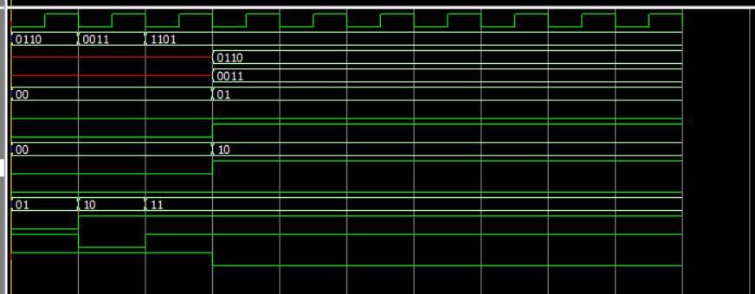
Task 03:

Description:
Similar to Task 1, with a modification in the register file configuration. The design consists of 32 registers, each 32 bits wide. It also includes one write port and two read ports, allowing data to be stored and retrieved efficiently.
Code:
module decoder5_32(output [31:0] dec_out,input [4:0] wr,input write_enable);
assign dec_out = write_enable ? (32'b1 << wr) : 32'b0;
endmodule

module mux32_1(output reg [31:0] out,input [4:0] sel,input [31:0] in0,in1,in2,in3,in4,in5,in6,in7,in8,in9,in10,in11,in12,in13,in14,in15,in16,in17,in18,in19,in20,in21,in22,in23,in24,in25,in26,in27,in28,in29,in30,in31);
always @(*) begin
case(sel)
5'd0: out=in0;
5'd1: out=in1;
5'd2: out=in2;
5'd3: out=in3;
5'd4: out=in4;
5'd5: out=in5;
5'd6: out=in6;
5'd7: out=in7;
5'd8: out=in8;
5'd9: out=in9;
5'd10: out=in10;
5'd11: out=in11;
5'd12: out=in12;
5'd13: out=in13;
5'd14: out=in14;
5'd15: out=in15;
5'd16: out=in16;
5'd17: out=in17;
5'd18: out=in18;
5'd19: out=in19;
5'd20: out=in20;
5'd21: out=in21;
5'd22: out=in22;
5'd23: out=in23;
5'd24: out=in24;
5'd25: out=in25;
5'd26: out=in26;
5'd27: out=in27;
5'd28: out=in28;
5'd29: out=in29;
5'd30: out=in30;
5'd31: out=in31;
default: out=32'b0;
endcase
end
endmodule

module register_32bit(output reg [31:0] q, input [31:0] d, input load, input clk);
initial begin
q= 32'd0;
end
always @(posedge clk) begin
if (load)
q <= d;
end
endmodule

module register_file_32x32(output [31:0] data_out1,output [31:0] data_out2,input [31:0] data_in,input [4:0] wr,input write_enable,input [4:0] rd1,input [4:0] rd2,input clk);
wire [31:0] dec_out;
wire [31:0] q [0:31];

decoder5_32 decoder(dec_out,wr,write_enable);

genvar i;
generate
for(i=0;i<32;i=i+1) begin : reg_loop
register_32bit reg_inst(q[i],data_in,dec_out[i],clk);
end
endgenerate

mux32_1
mux1(data_out1,rd1,q[0],q[1],q[2],q[3],q[4],q[5],q[6],q[7],q[8],q[9],q[10],q[11],q[12],q[13],q[14],q[15],q[16],q[17],q[18],q[19],q[20],q[21],q[22],q[23],q[24],q[25],q[26],q[27],q[28],q[29],q[30],q[31]);

mux32_1
mux2(data_out2,rd2,q[0],q[1],q[2],q[3],q[4],q[5],q[6],q[7],q[8],q[9],q[10],q[11],q[12],q[13],q[14],q[15],q[16],q[17],q[18],q[19],q[20],q[21],q[22],q[23],q[24],q[25],q[26],q[27],q[28],q[29],q[30],q[31]);
endmodule

module tb3;
reg [31:0] data_in;
reg [4:0] wr,rd1,rd2;
reg write_enable,clk;
wire [31:0] data_out1,data_out2;

register_file_32x32
register_file(.data_out1(data_out1),.data_out2(data_out2),.data_in(data_in),.wr(wr),.write_enable(write_enable),.rd1(rd1),.rd2(rd2),.clk(clk));

initial begin
clk=0;
forever #5 clk=~clk;
end

initial begin
data_in=0;
wr=0;
rd1=0;
rd2=0;
write_enable=0;
#10
write_enable=1;
wr=5'd0;
data_in=32'd10;
#10
write_enable=1;
wr=5'd1;
data_in=32'd12;
#10
write_enable=0;
rd1=5'd2;
rd2=5'd10;
#2;

end
endmodule
Output:
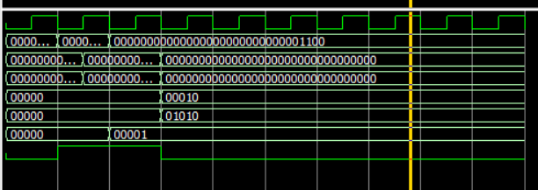

Task 04:

Diagram
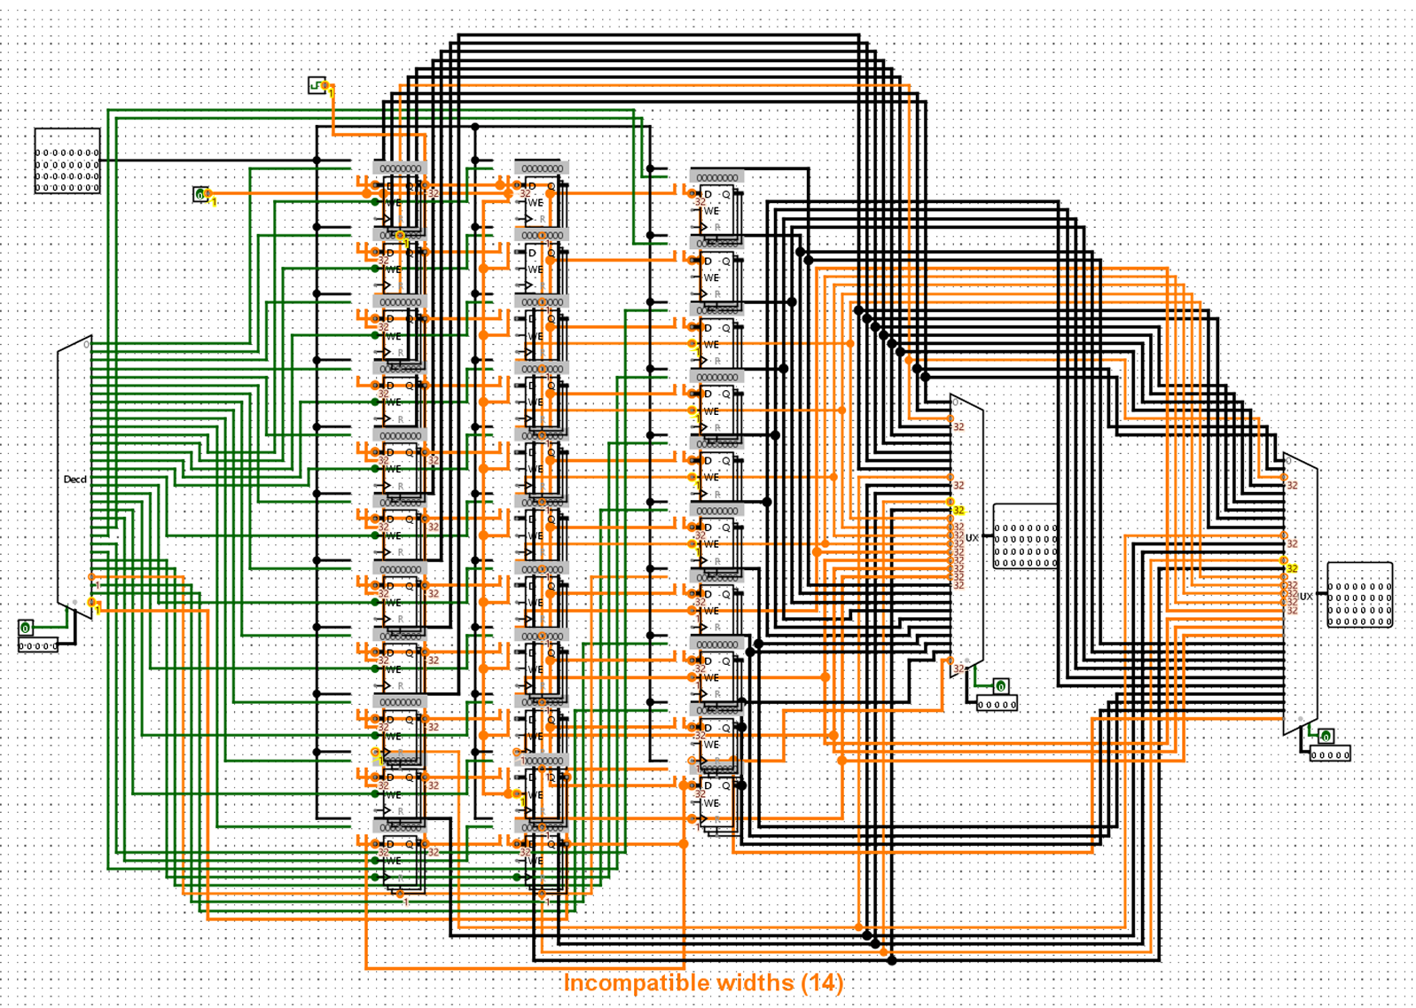

Task 04:

Description:
Code:
Output:
Circuit Diagram:

