**MACHINE LEARNING**

ASSIGNMENT: 1

|  |  |
| --- | --- |
| **NAME** | **MALIK ABDULLAH AWAN** |
| **CMS** | **54042** |

|  |  |
| --- | --- |
| **DEPARTMENT :** | **SE 5TH** |

**TASK NO 1: Run Anaconda and the terminal :**

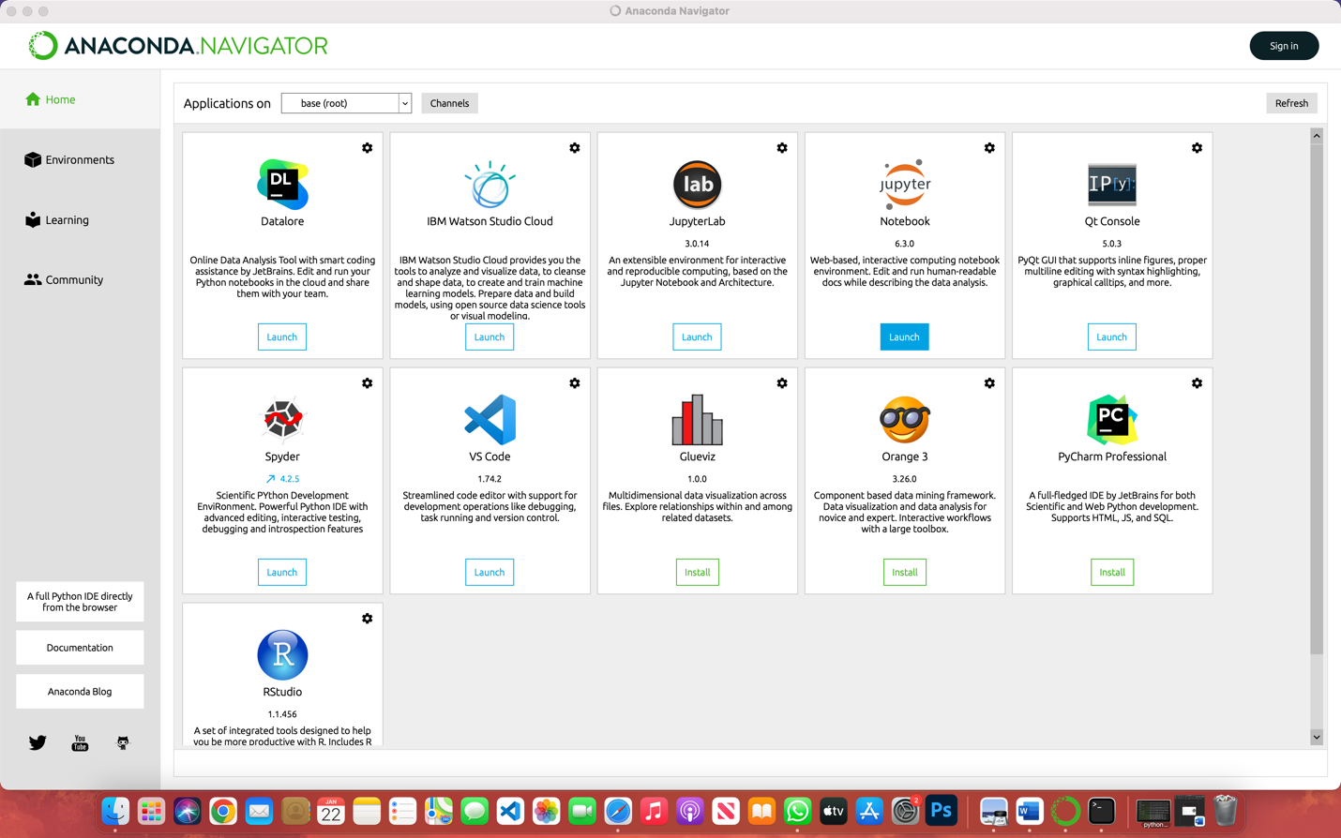

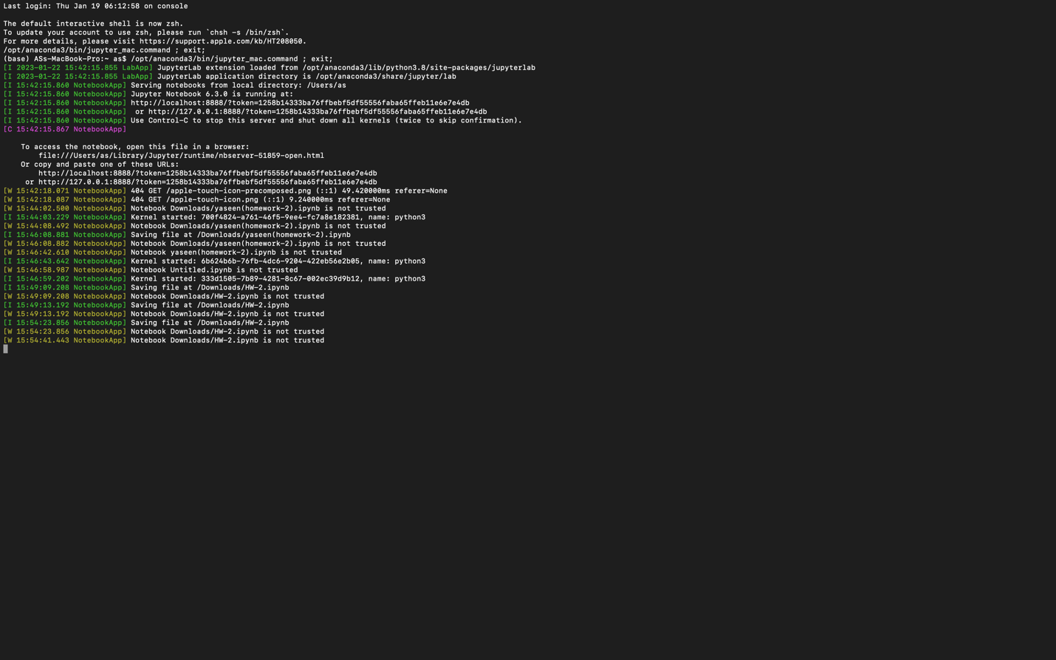

**TASK NO 2:** The result of below code:

Import matplotlib .pyplot as plt

Plt.plot ([1,2,3,4,],[1,2,7,14])

Plt.plot ([0, 6, 0,20])

Plt. Show( )

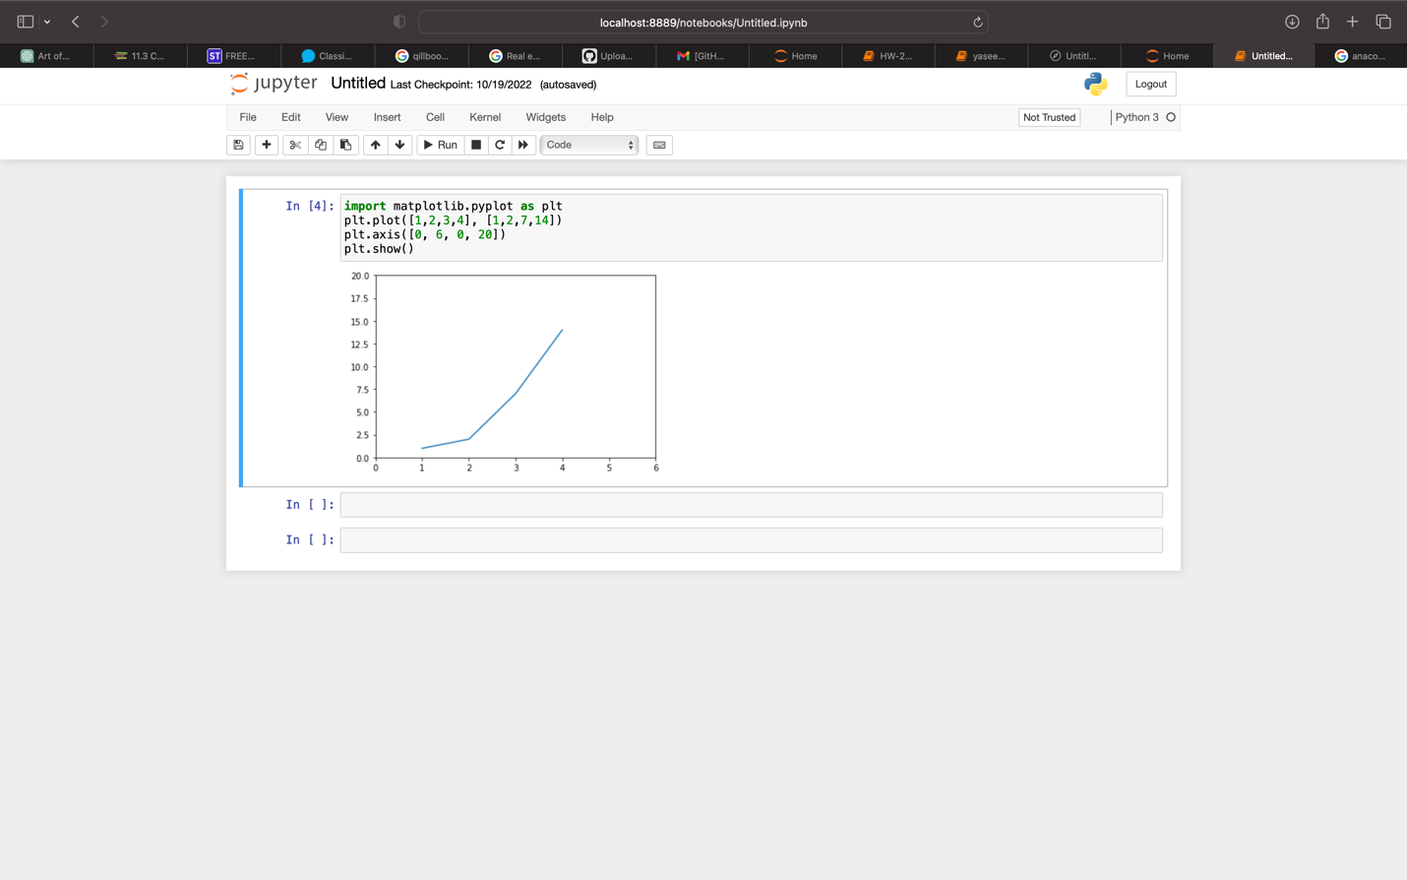

**TASK NO 3:**

Own choice code result like this :

Import matplotlib .pyplot as plt

Plt.plot ([12,13,4,5,9],[1,2,0,7,23])

Plt.plot ([10, 1, 12,0])

Plt. Show( ) :

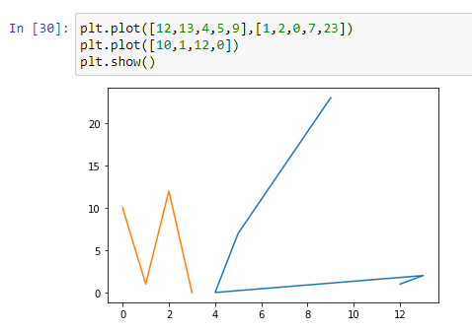

**TASK NO 4: Create a GitHub account:**

