

Name | Muhammad Abdullah
Roll id | 242744
Section | BSCSev-5C
Assignment No | Lab02
Subject | Full Stack Development Lab
Date | 22-09-2026

For task 7 , changing in index.html:justify-content-between to justify-content-center
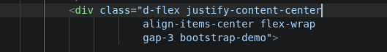

Github link:
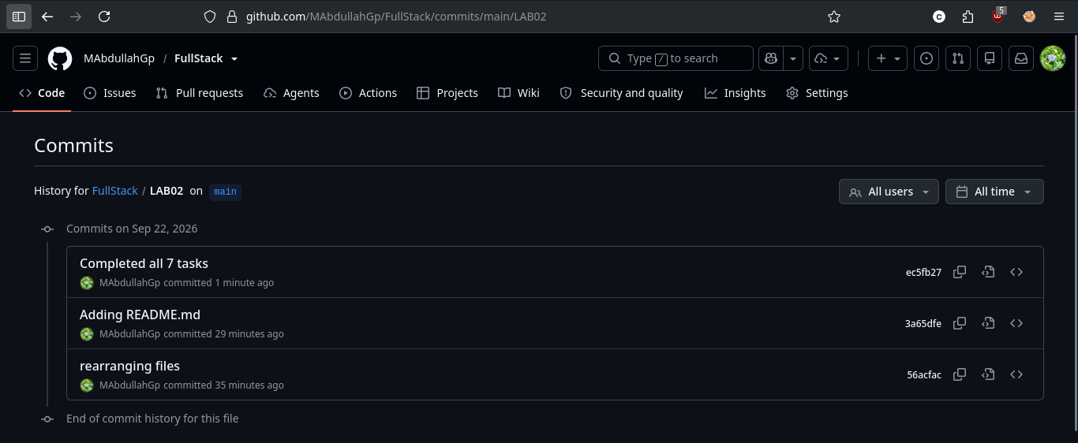
https://github.com/MAbdullahGp/FullStack/tree/main/LAB02

Screenshots:

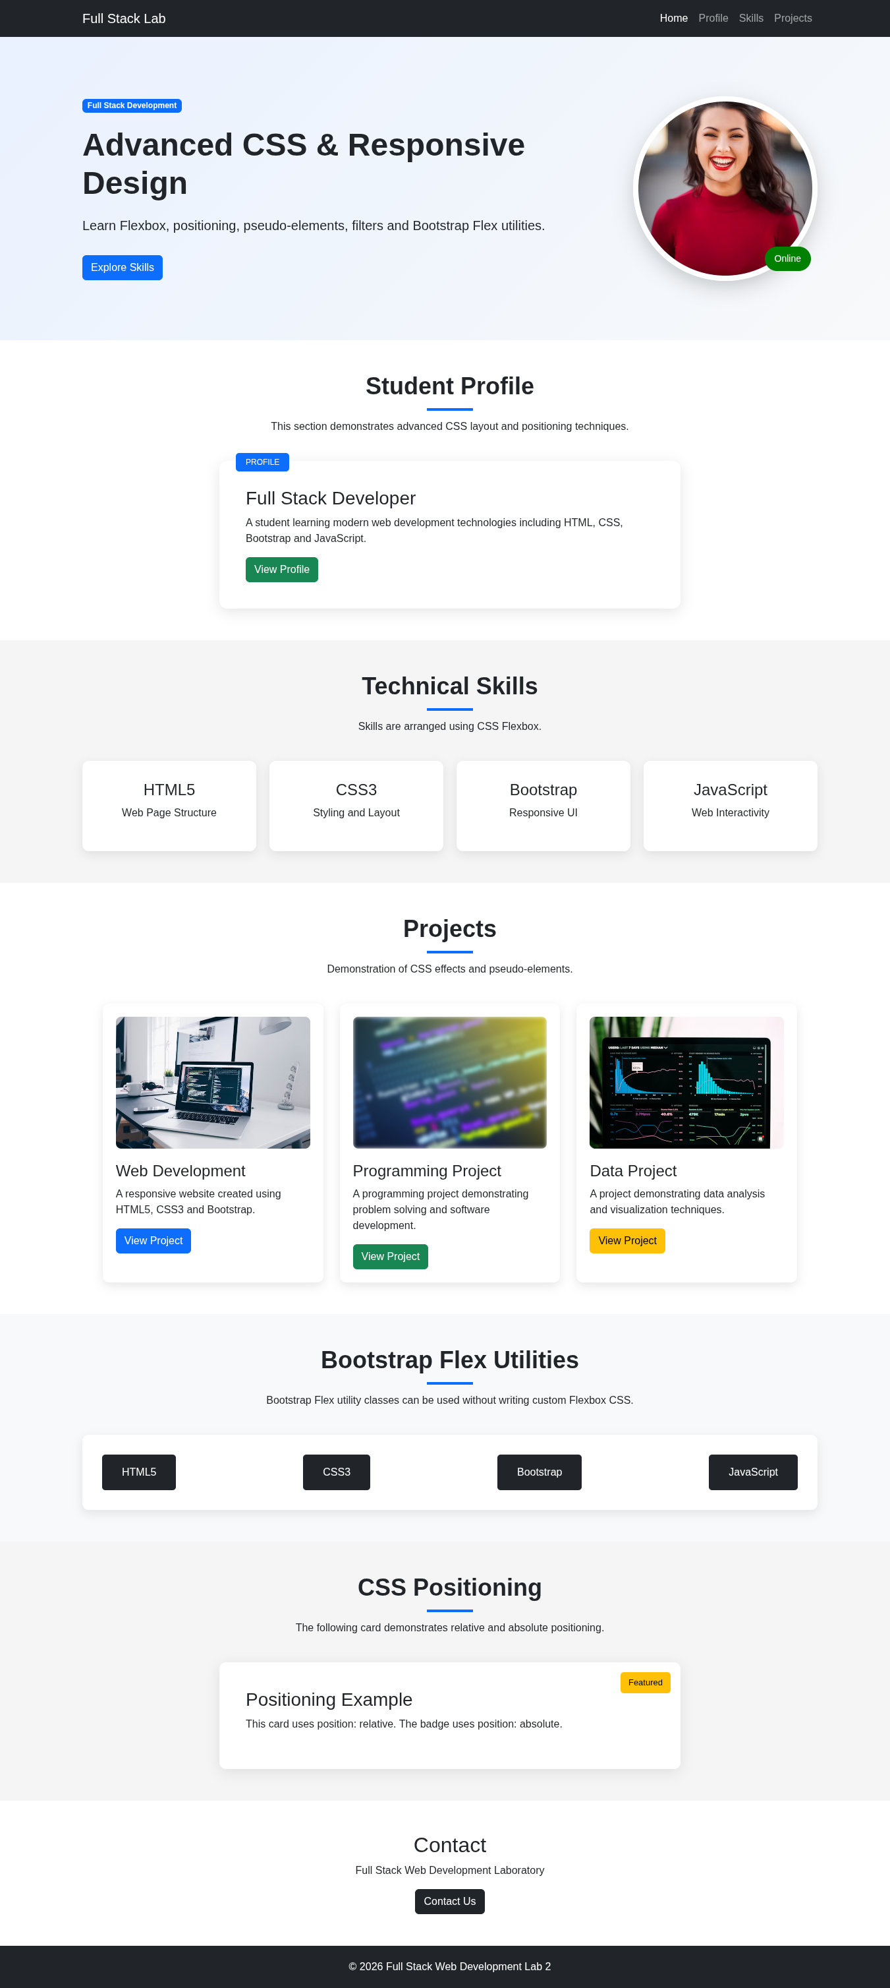

Updated style.css with 6 task completed :
/* =========================================
GENERAL STYLING
========================================= */
body {
font-family: Arial, sans-serif;
margin: 0;
padding: 0;
color: #212529;
}

/* =========================================
HERO SECTION
========================================= */
.hero-section {
background: linear-gradient(
135deg,
#e9f2ff,
#f8f9fa
);
padding: 90px 20px;
}

/* CSS FLEXBOX */
.hero-content {
display: flex;
justify-content: space-between;
align-items: center;
gap: 50px;
}

/* =========================================
HERO TEXT
========================================= */
.hero-content h1 {
font-size: 48px;
font-weight: bold;
margin-top: 20px;
margin-bottom: 20px;
}

.hero-content p {
font-size: 20px;
margin-bottom: 30px;
}

/* =========================================
PROFILE IMAGE
========================================= */
.profile-image-container {
position: relative;
}

/* CSS FILTER */
.profile-image {
width: 280px;
height: 280px;
object-fit: cover;
border-radius: 50%;
border: 8px solid white;
box-shadow:
0 10px 30px rgba(0, 0, 0, 0.2);
filter: saturate(1.2);
}

/* =========================================
TASK 3 - POSITIONING (tested, reverted for final design)
Changing position: absolute; to position: relative; was tested:
the badge left normal document flow's anchor to
.profile-image-container and instead stayed in flow, with
bottom/right only nudging it slightly from its natural spot -
which pushed it toward the left instead of the photo's corner.
Reverted back to absolute so the badge sits correctly on the
right side of the profile photo.
========================================= */
.online-badge {
position: absolute;
bottom: 15px;
right: 10px;
background: green;
color: white;
padding: 8px 15px;
border-radius: 20px;
font-size: 14px;
}

/* =========================================
SECTION HEADING
========================================= */
.section-heading {
text-align: center;
margin-bottom: 40px;
}

.section-heading h2 {
font-size: 36px;
font-weight: bold;
}

/* =========================================
PSEUDO ELEMENTS
========================================= */
.section-heading h2::after {
content: "";
display: block;
width: 70px;
height: 4px;
background: #0d6efd;
margin: 12px auto;
}

/* =========================================
PROFILE CARD
========================================= */
.profile-card {
max-width: 700px;
margin: auto;
padding: 40px;
background: white;
border-radius: 12px;
box-shadow:
0 5px 20px rgba(0, 0, 0, 0.1);
position: relative;
}

/* =========================================
TASK 4 - PSEUDO-ELEMENT
Changed .profile-card::before to .profile-card::after
The "PROFILE" generated content now appears after the card's
actual content in the DOM/content order instead of before it.
========================================= */
.profile-card::after {
content: "PROFILE";
position: absolute;
top: -12px;
left: 25px;
background: #0d6efd;
color: white;
padding: 5px 15px;
border-radius: 5px;
font-size: 12px;
}

/* =========================================
SKILLS SECTION
========================================= */
.skills-section {
background: #f5f5f5;
}

/* =========================================
TASK 1 - FLEXBOX (justify-content)
Changed from justify-content: center; to justify-content: space-between;
First item hugs the left edge, last item hugs the right edge, and
remaining space is distributed only between items.
========================================= */
/* =========================================
TASK 2 - FLEX DIRECTION
flex-direction: column; was tested (stacks skill boxes vertically),
then returned to row so the boxes sit in a horizontal line again.
========================================= */
.skills-container {
display: flex;
justify-content: space-between;
align-items: stretch;
flex-direction: row;
flex-wrap: wrap;
gap: 20px;
}

.skill-box {
flex: 1 1 200px;
background: white;
padding: 30px;
text-align: center;
border-radius: 10px;
box-shadow:
0 5px 15px rgba(0, 0, 0, 0.1);
transition:
transform 0.3s ease,
box-shadow 0.3s ease;
}

/* CSS EFFECT */
.skill-box:hover {
transform: translateY(-8px);
box-shadow:
0 10px 25px rgba(0, 0, 0, 0.2);
}

/* =========================================
PROJECT SECTION
========================================= */
.project-container {
display: flex;
flex-wrap: wrap;
justify-content: center;
gap: 25px;
}

.project-card {
width: 30%;
min-width: 280px;
padding: 20px;
border-radius: 10px;
background: white;
box-shadow:
0 5px 15px rgba(0, 0, 0, 0.1);
transition: transform 0.3s ease;
}

/* =========================================
TASK 6 - TRANSFORM
Changed from transform: translateY(-10px); to transform: scale(1.05);
The card now grows to 105% of its size in place on hover instead
of sliding upward.
========================================= */
.project-card:hover {
transform: scale(1.05);
}

/* =========================================
PROJECT IMAGE
========================================= */
.project-image {
overflow: hidden;
border-radius: 8px;
margin-bottom: 20px;
}

.project-image img {
width: 100%;
height: 200px;
object-fit: cover;
transition: transform 0.4s ease;
}

.project-image:hover img {
transform: scale(1.08);
}

/* =========================================
TASK 5 - CSS FILTER
Changed from filter: grayscale(100%); to filter: blur(3px);
brightness(70%) was also tested (dims the image without blurring).
========================================= */
.grayscale img {
filter: blur(3px);
}

.grayscale:hover img {
filter: grayscale(0%);
}

/* =========================================
BOOTSTRAP FLEX SECTION
========================================= */
.bootstrap-flex-section {
background: #f8f9fa;
}

.bootstrap-demo {
background: white;
padding: 30px;
border-radius: 10px;
box-shadow:
0 5px 15px rgba(0, 0, 0, 0.1);
}

.flex-item {
background: #212529;
color: white;
padding: 15px 30px;
border-radius: 5px;
text-align: center;
}

/* =========================================
POSITIONING
========================================= */
.position-section {
background: #f5f5f5;
}

.position-card {
position: relative;
max-width: 700px;
margin: auto;
padding: 40px;
background: white;
border-radius: 10px;
box-shadow:
0 5px 20px rgba(0, 0, 0, 0.1);
}

.featured-badge {
position: absolute;
top: 15px;
right: 15px;
background: #ffc107;
color: black;
padding: 6px 12px;
border-radius: 5px;
font-size: 13px;
}

/* =========================================
CONTACT
========================================= */
.contact-section {
background: white;
}

/* =========================================
FOOTER
========================================= */
.footer {
background: #212529;
color: white;
padding: 20px 0;
}

.footer p {
margin: 0;
}

/* =========================================
RESPONSIVE DESIGN
========================================= */
@media (max-width: 768px) {
.hero-content {
flex-direction: column;
text-align: center;
}

.hero-content h1 {
font-size: 35px;
}

.hero-content p {
font-size: 17px;
}

.profile-image {
width: 220px;
height: 220px;
}

.project-card {
width: 100%;
}

.flex-item {
width: 100%;
}
}

