

Name | Muhammad Abdullah
Roll id | 242744
Section | BSCSev-5C
Assignment No | Lab5
Subject | Full Stack Development
Date | 03-10-2026

Task1 Output:
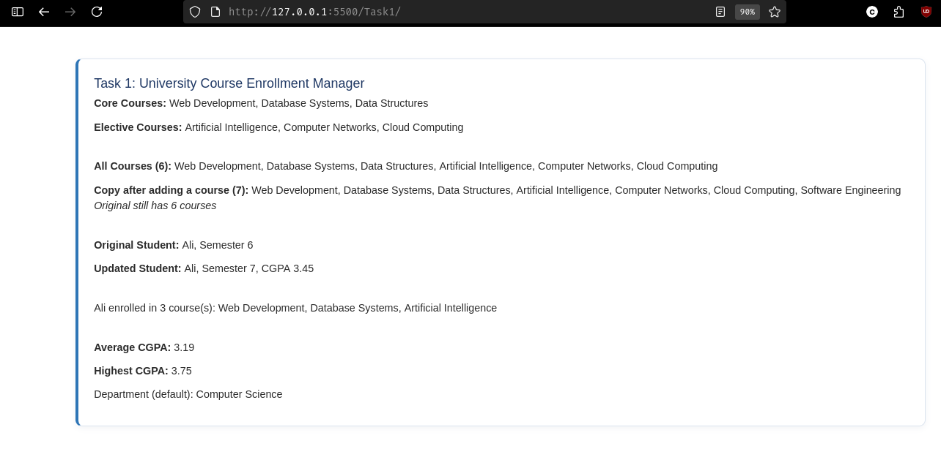
Task2 Output:
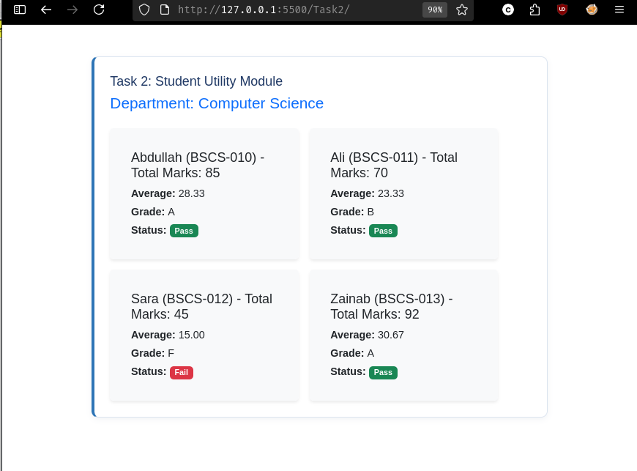

Task3 Output:
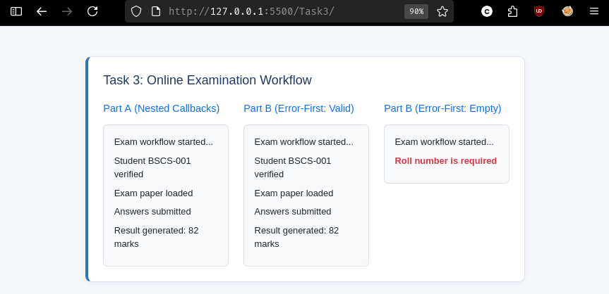
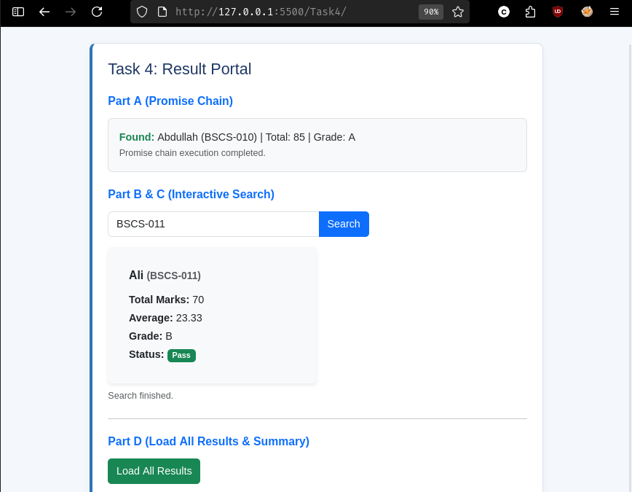

Task4 Output:
